Ahmed Farooq Al-Jaf
(C.V.)
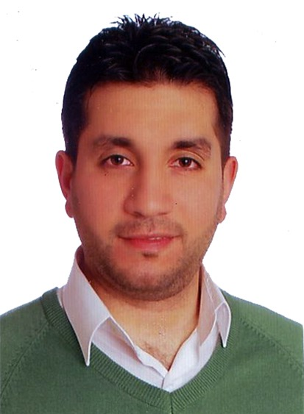
Name: Ahmed Farooq Mohammed Salih Al-Jaf
Scientific Grade: Assistant Lecturer
Department: Conservative Dentistry
Eductional Backgrond:
- 2005 Bachelor’s degree in Dental surgery, at University of Al-Mustansiriya.
- 2011 Master of Science in Conservative Dentistry, at University of Baghdad, College Of Dentistry
Speciality: Conservative Dentistry.
Interests:
- Esthetic Dentistry (Direct And In-direct)
Private Practice: Cosmetic Dentist at Baghdad Smile Center
Experience:
- Esthetic Dentistry, Veneers
- Crown and Bridge Restorations
- Direct Aesthetic Restorations.
- Root Canal Therapy.
- Operative Dentistry
Memberships:
- Member of Iraqi Dental Association
- Member of Iraqi Endodontic Society
Contact information:
- Mobile: +9647901893574
- E-mail: Ahmed.aljaff@yahoo.com

