Nagham hameed mohammed jawad
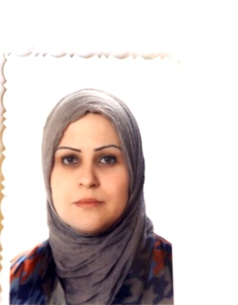
Name: Nagham hameed
Scientific Grade: Lecturer assistant
Department: Preventive dentistry
Eductional Backgrond:
• 2000 B.D.S College of
dentistry/University of Baghdad

• 2013 Master degree in preventive
Dentistry, at University of Baghdad.

Speciality:Preventive dentistry
Interests:
•prvention of dental caries
• Esthetic Dentistry
•pediatric dentistry
Experience:
- preventive measures of all oral diseases
- Root Canal Therapy for pediatric patients
- Operative Dentistry
Memberships:
• Member of Iraqi Dental Association
Contact information:
• Mobile: +9647901478164

