Ola A. Al-Mohammedawi
(C.V.)
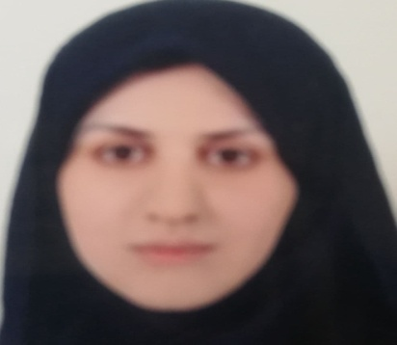
Name: Ola A. Al-Mohammedawi
Scientific Grade: Teacher assistant
Department: Oral Medicine
Eductional Backgrond:
- 2010 Bachelor’s degree in Dental surgery, at University of Mustansirya .
- 2015 Master of Science in Oral Medicine, at University of Mustansirya.
.
Speciality: Oral Medicine
Interests:
- oral Diagnosis

Experience:
- Oral medicine

Memberships:
- Member of Iraqi Dental Association
Contact information:
- Mobile: +9647902180326
- E-mail: aulaali1987@yahoo.com

