Alternative Classifications of Costs
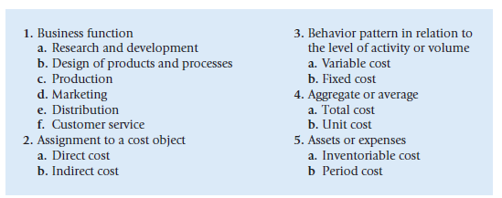
Cost Estimation Methods:
1- Account Analysis Method
2- A graphical Method
3- Industrial Engineering Method
4- High – Low Method
5- Regression analysis Method

