۞Kingdom : Fungi۞
Fungi: Eukaryotic organisms, structure Thallus , spread in different places in wet soil and dry in the fresh and salt water in the air and attacked many of them plant, animal and human also used some of them as a food and is one of the micro-organism-free chlorophyll so fungi are heterotrophy .
Fungi thallus have two phases:
- Somatic phase (vegetative phase ): (unicellular , filamentous).
- Reproductive unites ( gametes , spores , conidia ).
Mycology: the science who study specializes structure and the classification and methods of reproduction of different types of fungi and economic importance to them.
Common characteristics between fungi and other living organisms
Organisms | Similarity | differences
Fungi and Plant | - Contain cell wall .  - Inability to move .  - Nutrition absorbency | - Fungi Don’t contain Pigment chlorophyll .  - Fungi Don’t contain complex vascular system  - Storage carbohydrate in fungi are Glycogen while the plants are stored as starch
Fungi and Bacteria | - Both contain a cell membrane and cell wall . | 1-bacteria prokaryotic while fungi Eukaryotic .  2- bacteria can be autotrophs as well as heterotrophs while fungi are heterotrophs.
Fungi and Animal | Both use as food sources contain a high percentage of protein | Animals have only plasma membrane while fungi have cell wall in addition to the plasma.
Fungi and Algae | - Both algae and fungi form thallus .  - Algae and fungi tend to growth in moist or wet environments. | - algae are autotrophy containing chlorophylls while fungi are heterotrophy .  - Algae are incapable of living in the dark while Fungi are capable of living in the dark.

۞morphology of fungi۞
Fungi bodies consists either of unicellular ( Yeasts) or filament minutes microscopic size know (Hypha) may be divided into cells or undivided and this(Hypha) The hypha extends by tip growth, and multiplies by branching, creating a fine network called a Mycelium . . Hypha be colorless but in some fungi take several different colors and this is due to the nature of the nutrients stored or to presence some of the different dyes. Each Hypha consists of an outer wall thinning and an internal cavity is full material Protoplasm , and in some fungi to a number of fungal cells separated by cross walls called Septa , And the cross walls between the cells have a small hole central that allows connection Protoplasm between the cell and other. Hypha in some Fungi are undivided or no septa called Coenocytic .

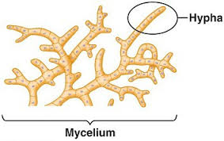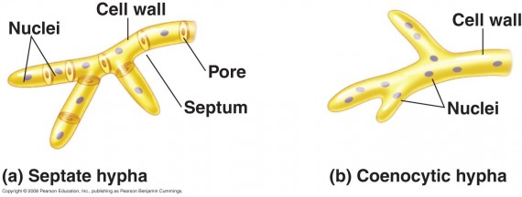
Mycelium Coenocytic
۞ Fungi Nutrition ۞
The nutrition in fungi are absorptive, use Enzyme to break down a large Complex molecules in to small organic compounds , then absorbed it.
Type of fungi Nutrition
Nutrition in fungi divided into three divisions :
- Saprophytism Nutrition: Living on the remains organisms (plants and animals) live on dead cells .
1-Obligate Saprophytism: Living only on dead cells ex: Penicillium sp. , bread mold .
2-Facultative Saprophytism: Usually living parasitic but if not find the host lived Saprophytic ex : Smut fungi .
- Parasitism Nutrition: Living on or inside Tissues of organisms causing diseases .
1-Obligate parasitism: Lived only on living cells ex : Rust fungi , Downy mildew .
2-Facultative parasitism: Usually living Saprophytic , if not find proper material (dead cells) they lived parasitic ex: Fusarium sp.
- Symbiosis Nutrition: also called commensal , Fungus live beneficial relationship with another organism, such as :
Lichens: benefit relationship between fungus and algae .
Mycorrhiza: benefit relationship between fungus and plant root.

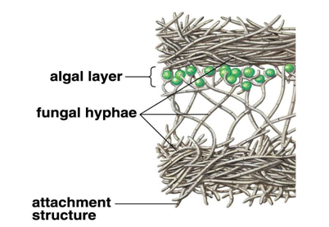
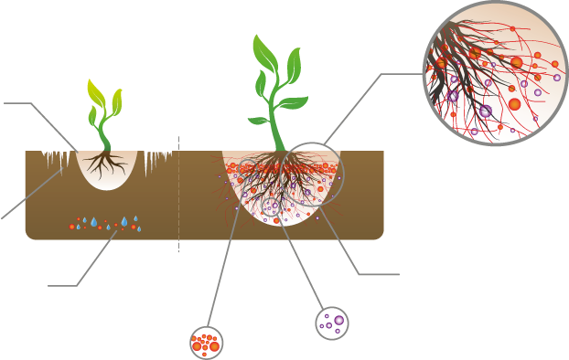
Lichens Mycorrhiza

۞Reproduction in Fungi۞
At the time of reproduction fungi when all somatic phase converted into reproductive structure. Such a condition is known as Holocarpic .. But if only part of the somatic phase converted into reproductive structure , it is called Eucarpic.
Types of Reproduction in fungi :
- Asexual Reproduction(Anamorph) : Also known somatic or vegetative Reproduction , Occurs in all kinds of fungus with the provide proper conditions , This reproduction is achieved in several ways :
- Fragmentation forming Arthrospore .
- Simple diffusion like yeast .
- Budding forming Blastospores .
- Forming Chlamydospores .
- Forming Spores .
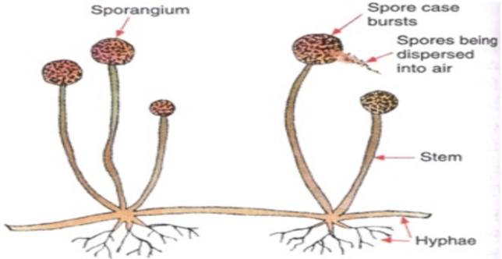
Forming Spores .
- If the Spores inside Fruit bodies known Sporangium or Sporangia called Sporangiospores, carried on Sporangiophore .
- If the spores produced at the tips or sides the hypha they called Conidia carried on Conidiophore .
- Type spores are Zoospores , Aplanospores .
- Sexual Reproduction (Telemorph) : Must pass through three stages :
- Plasmogamy (cell fusion) .
- Karyogamy (nuclear fusion ) .
- Meiosis (reduction division ) .
- Reproductive organs called gametangia contain a sexual cells called gametes , This reproduction is achieved in several ways :
- Planogamtic Copulation . 4- Spermatization
- Gamitangial Copulation . 5- Somatogamy
- Gamitangial Contact .

