Phylum : myxomycota
Class: myxomycetes
- True slime mold
- No cell wall.
Life cycle are four stages or four types of cells:
- Three cells uninucleated ,one of them flagellated
- Somatic phase as plasmodium multinucleated
- Somatic phase resisted to environment condition called sclerotium .
- Reproductive phase as sporophores which contain inside of it spores that have cell wall .
- Peridium : non-cellular envelope covers spores inside sporophore.

Type of sporophores (fruiting body)
- Sporangium : consist of
- Peridium d- Stalk
- Columella e- Hypothallus
- Capillitium f- Spores
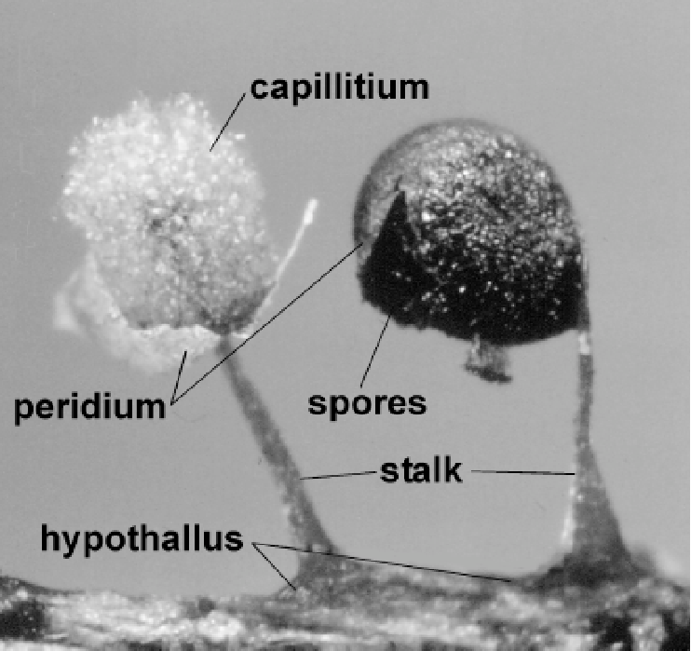
Figure(1) Sporangium consist of slime molds

- Aethalium : big like cushion shape .
- Pseudoaethalium : accumulation of several sporangium .
- Plasmodiocarp : like plasmodium .
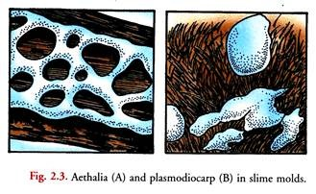
Figure (2) Aethalia and plasmodiocarp of slime molds
- Sub class : ceratiomyxomycetidae
Order : Ceratiomyxales
Family : Ceratiomyxaceae
Genus : Ceratiomyxa sp.
- Forming exospores , no sporophores . cell wall
- Sub class : Stemonitomycetidae
Order : Stemonitales
Family : Stemonitaceae
Genus : Stemonitia sp.
- Plasmodium kind Aphanoplasmodium , sporangium , violet spores
- Sub class : Myxogasteromycetidae
- Order : Liceaceae
Licea sp.
Lycogala sp.
- Plasmodium kind Protoplasmodium and Aphanoplasmodium, spores light colors, Aethalium.
- Order : Trichiales
Metatrichia sp. (wasp nest slime mold )
Trichia sp.
Arcyria sp.
- Plasmodium kind Protoplasmodium and Aphanoplasmodium , sporangium ,spores light or red colors.

Phylum 2 : plasmodiophoromycota
Class : plasmodiophoromycetes
Order : plasmodiophorales
Family : plasmodiophoraceae

General characteristics of this Division:
- Somatic phase is plasmodium , no cell wall .
- Multi nuclei .
- Endobiotic or Endoparasitic on vascular plants or on kingdom Stramenopila.
- Necrotrophic meaning :kill the host cell before feeding . not phagotrophic .
- Forming zoospore, have two flagella type whiplash and unequal length .
- Presence nuclear division Cruciform .

Economic importance :
- Plasmodiophora brassicae parasitic on Cabbage causing club root.
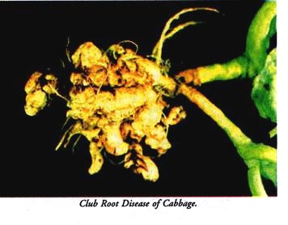
Figure (3) Plasmodiophora brassicae causing club root on Cabbage

- Spongospora sp. parasitic on potato causing powdery scab .

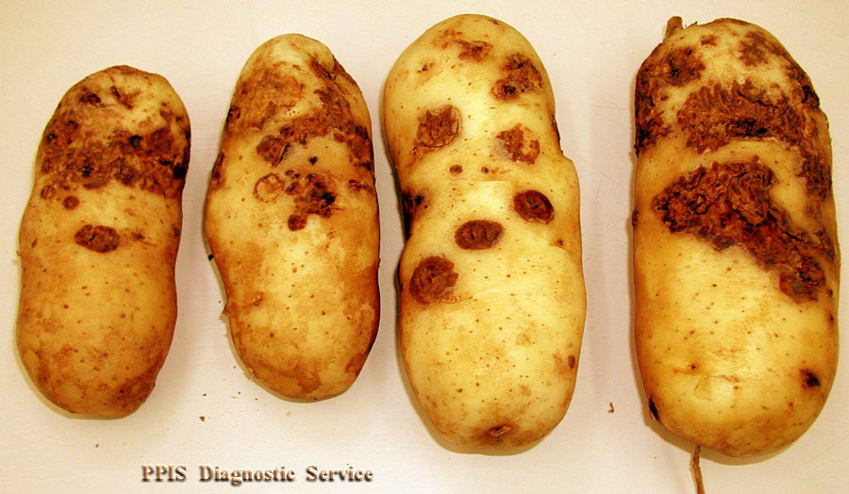
Figure (4) Spongospora sp. causing powdery scab on potato

- Parasitic on water mold (Oomycota) Saprolegnia sp. which parasitic on fish and their eggs, so it used as biological control .
- Viruses transporter that cause plant disease .
- Some of them are parasitic on fresh water algae .

