إعداد
أ.م.د.عمار كوتي
م.عاطفة جليل

تعاريف :
1 – الحل المقبول ( feasible solution ):
هو متجه X حيث ان X = ( X₁ , X₂ , ………., X_{n} ) الذي يحقق كافة القيود الواردة في المسألة .
2- الحل الاساسي المقبول ( Basic .f.s ) :
اذا كان عدد المتغيرات الموجبة لايتجاوز عدد القيود الواردة في المسألة ( m ) .
3 – الحل الامثل ( optimal solution ) :
هو الحل المقبول والذي يحقق كافة القيود الواردة في المسألة إضافة لذلك يجعل قيمة دالة الهدف في نهايتها العظمى او الصغرى .
4- حالة التفكك ( الاحلال ) ( degeneracy case )
يسمى الحل مجزأ او مفكك ( إحلال ) عندما تكون قيمة أحد او اغلب المتغيرات الاساسية مساوية للصفر وسبب ذلك وجود قيود اضافية تمر بنقطة الحل الامثل .
5- الحل الغير محدود ( unbounded solution ) :
تحدث هذه الحالة عندما تكون منطقة الحل غير محدودة لذلك تزداد قيمة دالة الهدف بصورة غير محدودة ويمكن توضيح ذلك عندما تكون معاملات المتغير الداخل في جميع القيود سالبة أو صفرية في أية دورة تكرارية من الحسابات .
6- الحلول المثلى البديلة (Alternative o. s ) :
في بعض الاحيان يكون لمسألة البرمجة الخطية عدة حلول مثلى جميعها تعطي قيمة واحدة لدالة الهدف وتحصل هذه الحالة عندما توازي دالة الهدف احد القيود الهيكلية المحايدة , ويمكن التعرف على هذه الحالة من خلال ملاحظة معاملات المتغيرات غير الاساسية في دالة الهدف عند الحصول على الحل الامثل فاذا كان احدها مساوي للصفر في دالة الهدف فهو مؤشر على وجود حل بديل آخر .
7- عدم وجود حل مقبول للمسألة ( non existing f. s ) :
وذلك عندما تكون قيود المسألة بصيغة بحيث لاتوجد نقطة تحققها في هذه الحالة تكون منطقة تقاطع القيود عبارة عن مجموعة خالية , في مثل هذه الحالة لاتوجد حلول مقبولة للمسألة ويمكن التعرف على تلك الحالة رياضيا اذا احتوى الحل الامثل على متغيرات اصطناعية (R_{i}) موجبة فهو مؤشر على عدم وجود حل مقبول يحقق جميع قيود المسألة .

الطريقة المبسطة ( simplex method ) :
تعتبر هذه الطريقة ذات كفاءة عالية في إيجاد الحلول لمسائل البرمجة الخطية التي يكون عدد متغيراتها اكبر او يساوي اثنان .
A- في حالة جميع القيود من النوع ( ≥ ) اقل او يساوي :
1- تحول القيود من الصيغة العامة الى الصيغة القياسية .
2- تظهر المتغيرات الاساسية ( s_{i} ) في دالة الهدف بمعاملات صفرية اما المتغيرات غير الاساسية ( X_{j} ) فتظهر بمعاملات عددية في دالة الهدف .
3- يتم تحديد المتغير الداخل من بين عدد المتغيرات غير الاساسية وهو المتغير الذي يقابل اكبر رقم بالسالب ( اكبر رقم بغض النظر عن الاشارة ) في دالة الهدف اذا كانت الدالة ( Max ) او اكبر قيمة موجبة اذا كانت الدالة ( Min ) .
4- يتم تحديد المتغير الخارج من بين عدد المتغيرات الاساسية وهو ذلك المتغير الذي يقابل اصغر نسبة والناتجة من قسمة عناصر الطرف الايمن على عناصر عمود المتغير الداخل مع إهمال القيم السالبة والصفرية في عناصر العمود الداخل .
5- يتم تحديد العنصر المحوري ( pivot element ) وهو العنصر الناتج من تقاطع عناصر عمود المتغير الداخل مع عناصر صف المتغير الخارج .
6- يتم استخراج المعادلة المحورية الجديدة والتي تمثل حاصل قسمة صف المتغير الخارج على العنصر المحوري .
7- يتم استخراج عناصر بقية الصفوف وذلك بتطبيق العلاقة :
( المعادلة المحورية الجديدة ) x ( معاملات العمود الداخل عكس الاشارة ) + المعادلة التي اختير منها ذلك المعامل .
8- بعد إجراء العمليات الحسابية نلاحظ معاملات المتغيرات غير الاساسية في دالة الهدف فاذا كانت جميعها ( 0 ≤ ( وكانت الدالة من النوع (Max ) فهذا يعني التوصل للحل الامثل وبخلاف ذلك اذا كانت الدالة من النوع ( Min ) .

مثال / اوجد الحل الامثل لمسألة البرمجة الخطية التالية :
X₃ - Min z = -2 X₁ + X₂
S . to: X₁ + X₂ + X₃ ≤ 6
X₁ + 2 X₂ ≤ 4
X₂ ≤ 2
0 ≥ X₃ , X₂, X₁
الحل :
X₃ + 0 [S₁+S₂+S₃] - Min z = -2 X₁ + X₂
S . to: X₁ + X₂ + X₃ + S₁ = 6 X₁ + 2 X₂ + S₂ = 4
X₂ + S₃ = 2
0 ≥ S₃ , S₂ , S₁ , X₃ , X₂, X₁

RATIO | R.S | S₃ | S₂ | S₁ | X₃ | X₂ | X₁ | B.V
6 | 6 | 0 | 0 | 1 | 1 | 1 | 1 | S₁
4 | 4 | 0 | 1 | 0 | 0 | 2 | 1 | S₂
يهمل | 2 | 1 | 0 | 0 | 0 | 1 | 0 | S₃
 | 0 | 0 | 0 | 0 | 1 | -1 | 2 | Z
2 | 2 | 0 | -1 | 1 | 1 | -1 | 0 | S₁
يهمل | 4 | 0 | 1 | 0 | 0 | 2 | 1 | X₁
يهمل | 2 | 1 | 0 | 0 | 0 | 1 | 0 | S₃
 | -8 | 0 | -2 | 0 | 1 | -5 | 0 | Z
 | 2 | 0 | -1 | 1 | 1 | -1 | 0 | X₃
 | 4 | 0 | 1 | 0 | 0 | 2 | 1 | X₁
 | 2 | 1 | 0 | 0 | 0 | 1 | 0 | S₃
 | -10 | 0 | -1 | -1 | 0 | -4 | 0 | Z
The optimal solution is :
= -10 Z , 2 = X₃ , 0 = X₂ , = 4 X₁

مثال / اوجد الحل الامثل لمسألة البرمجة الخطية التالية :
Max z = 3 X₁ + 2 X₂
S . to: X₁ + 2 X₂ ≤ 6
2 X₁ + X₂ ≤ 8
- X₁ + X₂ ≤ 1
X₂ ≤ 2
0 ≥ X₂, X₁

الحل :
+ 0 [S₁+S₂+S₃ + S₄] Max z = 3 X₁ + 2 X₂
S . to: X₁ + 2 X₂ + S₁ = 6
2 X₁ + X₂ + S₂ = 8
- X₁ + X₂+ S₃ = 1
X₂ + S₄ = 2
0 ≥ S₄ , S₃ , S₂ , S₁ , X₂, X₁

RATIO | R.S | S₄ | S₃ | S₂ | S₁ | X₂ | X₁ | B.V
6 | 6 | 0 | 0 | 0 | 1 | 2 | 1 | S₁
4 | 8 | 0 | 0 | 1 | 0 | 1 | 2 | S₂
يهمل | 1 | 0 | 1 | 0 | 0 | 1 | -1 | S₃
يهمل | 2 | 1 | 0 | 0 | 0 | 1 | 0 | S₄
 | 0 | 0 | 0 | 0 | 0 | -2 | -3 | Z
3/4 | 2 | 0 | 0 | 2/1 - | 1 | 2/3 | 0 | S₁
8 | 4 | 0 | 0 | 2/1 | 0 | 2/1 | 1 | X₁
3/10 | 5 | 0 | 1 | 2/1 | 0 | 2/3 | 0 | S₃
2 | 2 | 1 | 0 | 0 | 0 | 1 | 0 | S₄
 | 12 | 0 | 0 | 2/3 | 0 | 2/1 - | 0 | Z
 | 3/4 | 0 | 0 | 3/1 - | 3/2 | 1 | 0 | X₂
 | 3/10 | 0 | 0 | 3/2 | 3/1 - | 0 | 1 | X₁
 | 3 | 0 | 1 | 1 | -1 | 0 | 0 | S₃
 | 3/2 | 1 | 0 | 3/1 | 3/2- | 0 | 0 | S₄
 | 3/38 | 0 | 0 | 3/4 | 3/1 | 0 | 0 | Z

The optimal solution is :
3/2 S₄ = , 3 = S₃ , 3/4 = X₂ , 3/10 = X₁
3/38 = Z

مثال / اوجد الحل الامثل لمسألة البرمجة الخطية التالية باستخدام المتغيرات X₆ , X₅, X₄ كمتغيرات اساسية في أول حل اساسي مقبول .
2 X₃ + Max z = 3 X₁ + X₂
S . to: 12 X₁ + 3 X₂ + 6 X₃ + 3 X₄ = 9 8 X₁ + X₂ - 4 X₃ + 2 X₅ = 10 3 X₁ - X₆ = 0
0 ≥ X₆ , X₅, X₄ , X₃ , X₂, X₁
الحل : يجب ان نجعل معاملات المتغيرات الاساسية ( X₆ , X₅, X₄ ) في جميع القيود مساوية الى (1) وذلك حسب الخصائص وكما يلي :
RATIO | R.S | X₆ | X₅ | X₄ | X₃ | X₂ | X₁ | B.V
4 /3 | 3 | 0 | 0 | 1 | 2 | 1 | 4 | X₄
4/5 | 5 | 0 | 1 | 0 | 2- | 2/1 | 4 | X₅
يهمل | 0 | 1 | 0 | 0 | 0 | 0 | -3 | X₆
 | 0 | 0 | 0 | 0 | -2 | -1 | -3 | Z
2/3 | 4/3 | 0 | 0 | 4/1 | 2/1 | 4/1 | 1 | X₁
يهمل | 2 | 0 | 1 | -1 | -4 | 2/1- | 0 | X₅
2/3 | 4/9 | 1 | 0 | 4/3 | 2/3 | 4/3 | 0 | X₆
 | 4/9 | 0 | 0 | 4/3 | 2/1- | 4/1- | 0 | Z
 | 0 | 3/1- | 0 | 0 | 0 | 0 | 1 | X₁
 | 8 | 3/8 | 1 | 1 | 0 | 2/3 | 0 | X₅
 | 2/3 | 3/2 | 0 | 2/1 | 1 | 2/1 | 0 | X₃
 | 3 | 3/1 | 0 | 1 | 0 | 0 | 0 | Z

The optimal solution is :
0= X₄ , 2/3 = X₃ , 0 = X₂ , = 0 X₁
= 3 Z , 0 = X₆ , 8 = X₅

مثال / اوجد الحل الامثل لمسألة البرمجة الخطية التالية باستخدام المتغيرات ( X₄, X₃) كمتغيرات اساسية في أول حل اساسي مقبول .
4 X₃ - 3 X₄ + Max z = 2 X₁ + 4 X₂
S . to: X₁ + X₂ + X₃ = 4
X₁ + 4 X₂ + X₄ = 8
0 ≥ X₄ , X₃ , X₂, X₁
الحل : يجب ان يكون معامل ( X₄, X₃) في دالة الهدف مساوي الى (0 ) حسب الخصائص
من القيد الاول والثاني سوف يكون لدينا :
X₁ - X₂ - X₃ = 4
X₁ - 4 X₂ - X₄ = 8
وبتعويض اقيام كل من المتغيرات ( X₄, X₃) في دالة الهدف سوف تكون دالة الهدف بالشكل
Max z = X₁ + 12 X₂ - 8

RATIO | R.S | X₄ | X₃ | X₂ | X₁ | B.V
4 | 4 | 0 | 1 | 1 | 1 | X₃
2 | 8 | 1 | 0 | 4 | 1 | X₄
 | 8- | 0 | 0 | 12- | 1- | Z
 | 2 | 4/1 | 1 | 0 | 4/3 | X₃
 | 2 | 4/1 | 0 | 1 | 4/1 | X₂
 | 16 | 3 | 0 | 0 | 2 | Z

The optimal solution is :
Z= 16, 0= X₄ , 2 = X₃ , 2 = X₂ , = 0 X₁

B- في حالة وجود قيود من النوع (≤) او (=) اكبر او يساوي او مساواة:
عندما تكون قيود مسألة البرمجة الخطية بهذه الحالة سوف يتم استخدام المتغيرات الاصطناعية(variable Artificial ) ويرمز لها ( R_{i} ) , حيث يتم إضافتها الى دالة الهدف بمعاملات مقدارها ( M+ ) اذا كانت الدالة من النوع (Min ) او تطرح منها بمعاملات مقدارها (M - ) اذا كانت الدالة من النوع (Max ) حيث ان ( M) كمية كبيرة جدا
( 0 < M) , وبعد الحصول على الحل الامثل يجب التخلص من هذه المتغيرات (الاصطناعية ) لان بقاءها في مراحل حل طريقة ( Simplex ) هو علامة غير صحيحة للحصول على الحل الامثل ولمعالجة تلك الحالة سوف يتم استخدام طريقة (M الكبيرة )او (method - M-Big ) .

مثال / اوجد الحل الامثل لمسألة البرمجة الخطية التالية :
X₃ + Min z = -3 X₁ + X₂
S . to: X₁ - 2 X₂ + X₃ ≤ 11 4 X₁ + X₂ + 2 X₃ ≥ 3 - 2 X₁ - X₃ = 3
0 ≥ X₃ , X₂, X₁
الحل :
+ 0 [S₁+S₂] + MR₁ + MR₂ X₃ + Min z = - 3 X₁ + X₂

S . to: X₁ - 2 X₂ + X₃+ S₁ = 11
4 X₁ + X₂ + 2 X₃ – S₂ + R₁ = 3 -
2 X₁ + X3 + R₂ = 1 -
0 ≥ R2 , R₁ , S₂ , S_{1,} X₃ , X2,X₁

RATIO | R.S | R₂ | R₁ | S₂ | S₁ | X₃ | X₂ | X₁ | B.V
11 | 11 | 0 | 0 | 0 | 1 | 1 | 2- | 1 | S₁
1.5 | 3 | 0 | 1 | 1- | 0 | 2 | 1 | 4- | R₁
1 | 1 | 1 | 0 | 0 | 0 | 1 | 0 | 2- | R₂
 | 0 | M- | M- | 0 | 0 | 1- | 1- | 3 | Z
 | 3M | 0 | M | M- | 0 | 2M | M | 4M- | MR₁
 | M | M | 0 | 0 | 0 | M | 0 | -2M | MR₂
 | 4M | 0 | 0 | M- | 0 | -1+3M | -1+M | 3-6M | Z
يهمل | 10 | 1- | 0 | 0 | 1 | 0 | 2- | 3 | S₁
1 | 1 | 2- | 1 | 1- | 0 | 0 | 1 | 0 | R₁
يهمل | 1 | 1 | 0 | 0 | 0 | 1 | 0 | 2- | X₃
 | 1+M | 1-3M | 0 | M- | 0 | 0 | -1+M | 1 | Z
4 | 12 | 5- | 2 | 2- | 1 | 0 | 0 | 3 | S₁
يهمل | 1 | 2- | 1 | 1- | 0 | 0 | 1 | 0 | X₂
يهمل | 1 | 1 | 0 | 0 | 0 | 1 | 0 | 2- | X₃
 | 2 | 1-M - | 1-M | 1- | 0 | 0 | 0 | 1 | Z
 | 4 | 3/5- | 3/2 | 3/2- | 3/1 | 0 | 0 | 1 | X₁
 | 1 | 2- | 1 | 1- | 0 | 0 | 1 | 0 | X₂
 | 9 | 3/7- | 3/4 | 3/4- | 3/2 | 1 | 0 | 0 | X₃
 | 2- | 3- M/2 | 3- M/1 | 3/1- | 3/1- | 0 | 0 | 0 | Z

The optimal solution is:
2- Z = , 9 = X₃ , 1 = X₂ , = 4 X₁

مثال / اوجد الحل الامثل لمسألة البرمجة الخطية التالية :

Min z = 4X₁ + X₂
S . to: 3 X₁ + X₂ = 3 4 X₁ + 3 X₂ ≥ 6 X₁ + 2 X₂ ≤4
0 ≥ X₂, X₁

الحل :
+ 0 [S₁+S₂] + MR₁ + MR₂ Min z = 4 X₁ + X₂
S . to: 3 X₁ + X₂ + R₁ = 3
4 X₁ + 3 X₂ – S₁+ R₂ = 6
X₁ + 2 X₂ + S₂ =4
0 ≥ R₁ , R₂, , S₂ S_{1,} X₂ ,X₁

RATIO | R.S | R₂ | R₁ | S₂ | S₁ | X₂ | X₁ | B.V
1 | 3 | 0 | 1 | 0 | 0 | 1 | 3 | R₁
6 ̷̷ 4 | 6 | 1 | 0 | 0 | 1- | 3 | 4 | R₂
4 | 4 | 0 | 0 | 1 | 0 | 2 | 1 | S₂
 | 0 | M- | M- | 0 | 0 | 1- | - 4 | Z
 | 3M | 0 | M | 0 | 0 | M | 3M | MR₁
 | 6M | M | 0 | 0 | M- | 3M | 4M | MR₂
 | 9M | 0 | 0 | 0 | -M | -1+4M | - 4+7M | Z
3 | 1 | 0 | 1 ̷̷ 3 | 0 | 0 | 1 ̷̷ 3 | 1 | X₁ | _{محورية م}
6 ̷̷ 5 | 2 | 1 | 4 ̷̷ 3- | 0 | 1- | 5 ̷̷ 3 | 0 | R₂
9 ̷̷ 5 | 3 | 0 | 1 ̷̷ 3- | 1 | 0 | 5 ̷̷ 3 | 0 | S₂
 | 4+2M | 0 | 4 ̷̷ 3 –7 ̷̷ 3 M | 0 | M- | 1 ̷̷ 3+ 5M | 0 | Z
25 ̷̷ 3 | 3 ̷̷ 5 | 1 ̷̷ 5- | 3 ̷̷ 5 | 0 | 1 ̷̷ 5 | 0 | 1 | X₁
يهمل | 6 ̷̷ 5 | 3 ̷̷ 5 | 4 ̷̷ 5- | 0 | -3 ̷̷ 5 | 1 | 0 | X₂ | _{محورية}
1 | 1 | 1- | 1 | 1 | 1 | 0 | 0 | S₂
 | 18 ̷̷ 5 | 1 ̷̷ 5- M- | 8 ̷̷ 5- M | 0 | 1 ̷̷ 5 | 0 | 0 | Z
 | 2 ̷̷ 5 | 0 | 2 ̷̷ 5 | 1 ̷̷ 5- | 0 | 0 | 1 | X₁
 | 9 ̷̷ 5 | 0 | 1 ̷̷ 5- | 3 ̷̷ 5 | 0 | 1 | 0 | X₂
 | 1 | 1- | 1 | 1 | 1 | 0 | 0 | S₁ | _{محورية}
 | 17 ̷̷ 5 | M- | 7 ̷̷ 5- M | 1 ̷̷ 5- | 0 | 0 | 0 | Z

The optimal solution is:
17 ̷̷ 5 Z = , 1 = S₁ , 9 ̷̷ 5 = X₂ , = 2 ̷̷ 5 X₁

النموذج الثنائي (المقابل ) ( Dual model ) :
إن لكل نموذج من نماذج البرمجة الخطية هنالك نموذجين يسمى أحد النموذجين بالنموذج الاولي (model primal ) بينما يسمى النموذج الآخر بالثنائي .
يوجد الكثير من الصفات المشتركة بين النموذجين , ومن اهم تلك الصفات في حالة وجود الحل الامثل لاحد النموذجين فأنه سوف يعطي معلومات كاملة عن الحل الامثل للنموذج الآخر .
بالامكان كتابة الصيغ العامة للنموذجين كما بالشكل التالي :
الصيغة العامة العامة للنموذج الابتدائي (model primal ) تكون بالشكل :
Max z $=\sum_{j=1}^{n}{Cj Xj}$
b_{i} ≥ X_{j} a_{ij} ∑

Properties of a Game

- There are finite numbers of competitors called ‘players’
- Each player has a finite number of possible courses of action called ‘strategies’
- All the strategies and their effects are known to the players but player does not know which strategy is to be chosen.
- A game is played when each player chooses one of his strategies. The strategies are assumed to be made simultaneously with an outcome such that no player knows his opponents strategy until he decides his own strategy.
- The game is a combination of the strategies and in certain units which determines the gain or loss.
- The figures shown as the outcomes of strategies in a matrix form are called ‘pay-off matrix’.
- The player playing the game always tries to choose the best course of action which results in optimal pay off called ‘optimal strategy’.
- The expected pay off when all the players of the game follow their optimal strategies is known as ‘value of the game’. The main objective of a problem of a game is to find the value of the game.
- The game is said to be ‘fair’ game if the value of the game is zero otherwise it s known as ‘unfair’.

Characteristics of Game Theory

. Competitive game
A competitive situation is called a competitive game if it has the following four properties
- There are finite number of competitors such that n ≥ 2. In case n = 2, it is called a two-person game and in case n > 2, it is referred as n-person game.
- Each player has a list of finite number of possible activities.
- A play is said to occur when each player chooses one of his activities. The choices are assumed to be made simultaneously i.e. no player knows the choice of the other until he has decided on his own.
- Every combination of activities determines an outcome which results in a gain of payments to each player, provided each player is playing uncompromisingly to get as much as possible. Negative gain implies the loss of same amount.

. Strategy
The strategy of a player is the predetermined rule by which player decides his course of action from his own list during the game. The two types of strategy are
- Pure strategy
- Mixed strategy

Pure Strategy
If a player knows exactly what the other player is going to do, a deterministic situation is obtained and objective function is to maximize the gain. Therefore, the pure strategy is a decision rule always to select a particular course of action.

Mixed Strategy
If a player is guessing as to which activity is to be selected by the other on any particular occasion, a probabilistic situation is obtained and objective function is to maximize the expected gain. Thus the mixed strategy is a selection among pure strategies with fixed probabilities.

Repeated Game Strategies
- In repeated games, the sequential nature of the relationship allows for the adoption of strategies that are contingent on the actions chosen in previous plays of the game.
- Most contingent strategies are of the type known as "trigger" strategies.
- Example trigger strategies
  - In prisoners' dilemma: Initially play doesn’t confess. If your opponent plays Confess, then play Confess in the next round. If your opponent plays don’t confess, then play doesn’t confess in the next round. This is known as the "tit for tat" strategy.
  - In the investment game, if you are the sender: Initially play Send. Play Send as long as the receiver plays Return. If the receiver plays keep, never play Send again. This is known as the "grim trigger" strategy.

. Number of persons
A game is called ‘n’ person game if the number of persons playing is ‘n’. The person means an individual or a group aiming at a particular objective.

Two-person, zero-sum game
A game with only two players (player A and player B) is called a ‘two-person, zero-sum game’, if the losses of one player are equivalent to the gains of the other so that the sum of their net gains is zero.
Two-person, zero-sum games are also called rectangular games as these are usually represented by a payoff matrix in a rectangular form.

Number of activities
The activities may be finite or infinite.

Payoff
The quantitative measure of satisfaction a person gets at the end of each play is called a payoff

. Payoff matrix
Suppose the player A has ‘m’ activities and the player B has ‘n’ activities. Then a payoff matrix can be formed by adopting the following rules
- Row designations for each matrix are the activities available to player A
- Column designations for each matrix are the activities available to player B
- Cell entry V_{ij} is the payment to player A in A’s payoff matrix when A chooses the activity i and B chooses the activity j.
- With a zero-sum, two-person game, the cell entry in the player B’s payoff matrix will be negative of the corresponding cell entry V_{ij} in the player A’s payoff matrix so that sum of payoff matrices for player A and player B is ultimately zero.

Value of the game
Value of the game is the maximum guaranteed game to player A (maximizing player) if both the players uses their best strategies. It is generally denoted by ‘V’ and it is unique.

Classification of Games
- Games where players choose actions simultaneously are simultaneous move games.
  - Examples: Prisoners' Dilemma, Sealed-Bid Auctions.
  - Must anticipate what your opponent will do right now, recognizing that your opponent is doing the same.
- Games where players choose actions in a particular sequence are sequential move games.
  - Examples: Chess, Bargaining/Negotiations.
  - Must look ahead in order to know what action to choose now.
  - Many sequential move games have deadlines/ time limits on moves.
- Many strategic situations involve both sequential and simultaneous moves.

One-Shot versus Repeated Games
- One-shot: play of the game occurs once.
  - Players likely to not know much about one another.
  - Example - tipping on your vacation
- Repeated: play of the game is repeated with the same players.
  - Indefinitely versus finitely repeated games
  - Reputational concerns matter; opportunities for cooperative behavior may arise.
- Advise: If you plan to pursue an aggressive strategy, ask yourself whether you are in a one-shot or in a repeated game. If a repeated game, think again.

Generally games are classified into
- Pure strategy games
- Mixed strategy games

The method for solving these two types varies. By solving a game, we need to find best strategies for both the players and also to find the value of the game.

Pure strategy games can be solved by saddle point method.

The different methods for solving a mixed strategy game are
- Analytical method
- Graphical method
- Dominance rule
- Simplex method

Limitations of game theory
The major limitations are
- The assumption that the players have the knowledge about their own payoffs and others is rather unrealistic.
- As the number of players increase in the game, the analysis of the gaming strategies become increasingly complex and difficult.
- The assumptions of maximin and minimax show that the players are risk-averse and have complete knowledge of the strategies. It doesn’t seem practical.
- Rather than each player in an oligopoly situation working under uncertain conditions, the players will allow each other to share the secrets of business in order to work out collusion. Then the mixed strategies are not very useful.

Solving Two-Person and Zero-Sum Game

Two-person zero-sum games may be deterministic or probabilistic. The deterministic games will have saddle points and pure strategies exist in such games. In contrast, the probabilistic games will have no saddle points and mixed strategies are taken with the help of probabilities.

Definition of saddle point
A saddle point of a matrix is the position of such an element in the payoff matrix, which is minimum in its row and the maximum in its column.

Procedure to find the saddle point
- Select the minimum element of each row of the payoff matrix and mark them with circles.
- Select the maximum element of each column of the payoff matrix and mark them with squares.
- If their appears an element in the payoff matrix with a circle and a square together then that position is called saddle point and the element is the value of the game.

Solution of games with saddle point
To obtain a solution of a game with a saddle point, it is feasible to find out
- Best strategy for player A
- Best strategy for player B
- The value of the game

The best strategies for player A and B will be those which correspond to the row and column respectively through the saddle point.
Examples
Solve the payoff matrix
1.
Player A | Player B
 |  | B1 | B2 | B3
 | A1 | 2 | 4 | 5
 | A2 | 10 | 7 | 9
 | A3 | 4 | 5 | 6

Solution
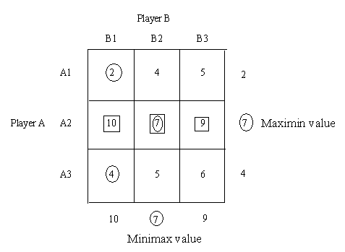
Strategy of player A – A2
Strategy of player B – B2
Value of the game = 7

2.

 | Player B
Player A |  | I | II | III | IV | V
 | I | -2 | 0 | 0 | 5 | 3
 | II | 3 | 2 | 1 | 2 | 2
 | III | -4 | -3 | 0 | -2 | 6
 | IV | 5 | 3 | -4 | 2 | -6

Solution
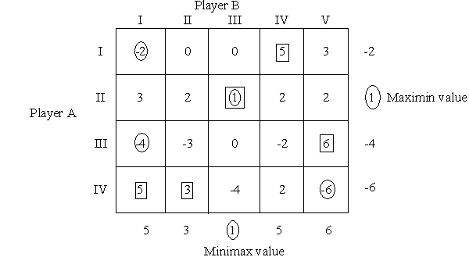
Strategy of player A – II
Strategy of player B - III
Value of the game = 1

3..

 | B1 | B2 | B3 | B4
A1 | 1 | 7 | 3 | 4
A2 | 5 | 6 | 4 | 5
A3 | 7 | 2 | 0 | 3

Solution

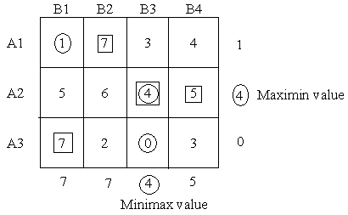

Strategy of player A – A2
Strategy of player B – B3
Value of the game = 4

4.

 | B’s Strategy
A’s Strategy |  | B1 | B2 | B3 | B4 | B5
 | A1 | 8 | 10 | -3 | -8 | -12
 | A2 | 3 | 6 | 0 | 6 | 12
 | A3 | 7 | 5 | -2 | -8 | 17
 | A4 | -11 | 12 | -10 | 10 | 20
 | A5 | -7 | 0 | 0 | 6 | 2

Solution

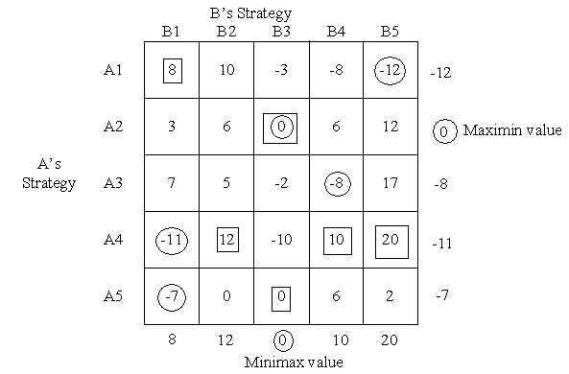

Strategy of player A – A2
Strategy of player B – B3
Value of the game = 0

5.
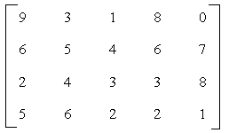

Solution
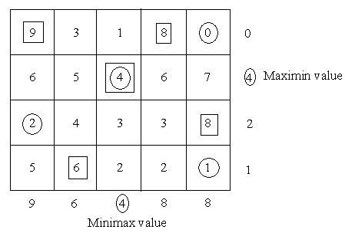

Value of the game = 4

Exercise
- Explain the concept of game theory.
- What is a rectangular game?
- What is a saddle point?
- Define pure and mixed strategy in a game.
- What are the characteristics of game theory?
- Explain two-person zero-sum game giving suitable examples.
- What are the limitations of game theory?
- Explain the following terms
  - Competitive Game
  - Strategy
  - Value of the game
  - Pay-off-matrix
  - Optimal strategy
- Explain Maximin and Minimax used in game theory
- For the game with payoff matrix
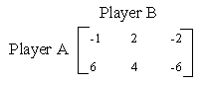
Determine the best strategies for player A and B and also the value of the game.

Games with Mixed Strategies

In certain cases, no pure strategy solutions exist for the game. In other words, saddle point does not exist. In all such game, both players may adopt an optimal blend of the strategies called Mixed Strategy to find a saddle point. The optimal mix for each player may be determined by assigning each strategy a probability of it being chosen. Thus these mixed strategies are probabilistic combinations of available better strategies and these games hence called Probabilistic games.

The probabilistic mixed strategy games without saddle points are commonly solved by any of the following methods

Sl. No. | Method | Applicable to
1 | Analytical Method | 2x2 games
2 | Graphical Method | 2x2, mx2 and 2xn games
3 | Simplex Method | 2x2, mx2, 2xn and mxn games

Analytical Method

A 2 x 2 payoff matrix where there is no saddle point can be solved by analytical method.
Given the matrix
Value of the game is
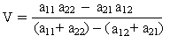

With the coordinates
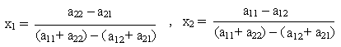

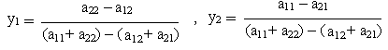

Alternative procedure to solve the strategy

- Find the difference of two numbers in column 1 and enter the resultant under column 2. Neglect the negative sign if it occurs.
- Find the difference of two numbers in column 2 and enter the resultant under column 1. Neglect the negative sign if it occurs.
- Repeat the same procedure for the two rows.

1. Solve
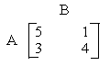

Solution
It is a 2 x 2 matrix and no saddle point exists. We can solve by analytical method
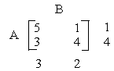

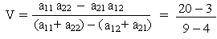

V = 17 / 5
S_{A} = (x₁, x₂) = (1/5, 4 /5)
S_{B} = (y₁, y₂) = (3/5, 2 /5)

2. Solve the given matrix
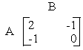
Solution
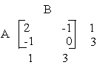

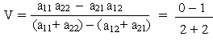
V = - 1 / 4
S_{A} = (x₁, x₂) = (1/4, 3 /4)
S_{B} = (y₁, y₂) = (1/4, 3 /4)

Graphical method

The graphical method is used to solve the games whose payoff matrix has
- Two rows and n columns (2 x n)
- m rows and two columns (m x 2)

Algorithm for solving 2 x n matrix games

- Draw two vertical axes 1 unit apart. The two lines are x₁ = 0, x₁ = 1
- Take the points of the first row in the payoff matrix on the vertical line x₁ = 1 and the points of the second row in the payoff matrix on the vertical line x₁ = 0.
- The point a_{1j} on axis x₁ = 1 is then joined to the point a_{2j} on the axis x₁ = 0 to give a straight line. Draw ‘n’ straight lines for j=1, 2… n and determine the highest point of the lower envelope obtained. This will be the maximin point.
- The two or more lines passing through the maximin point determines the required 2 x 2 payoff matrix. This in turn gives the optimum solution by making use of analytical method.

Example 1
Solve by graphical method
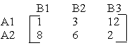

Solution
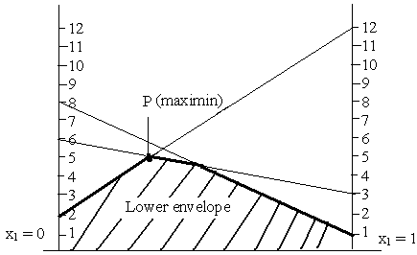

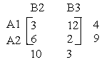
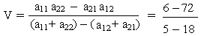

V = 66/13
S_{A} = (4/13, 9 /13)
S_{B} = (0, 10/13, 3 /13)

Example 2

Solve by graphical method
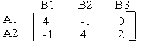

Solution
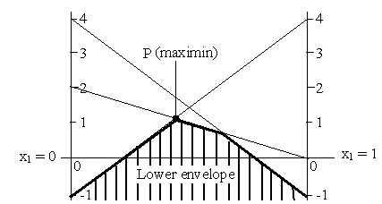

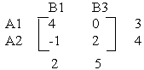

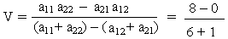

V = 8/7
S_{A} = (3/7, 4 /7)
S_{B} = (2/7, 0, 5 /7)

Algorithm for solving m x 2 matrix games

- Draw two vertical axes 1 unit apart. The two lines are x₁ =0, x₁ = 1
- Take the points of the first row in the payoff matrix on the vertical line x₁ = 1 and the points of the second row in the payoff matrix on the vertical line x₁ = 0.
- The point a_{1j} on axis x₁ = 1 is then joined to the point a_{2j} on the axis x₁ = 0 to give a straight line. Draw ‘n’ straight lines for j=1, 2… n and determine the lowest point of the upper envelope obtained. This will be the minimax point.
- The two or more lines passing through the minimax point determines the required 2 x 2 payoff matrix. This in turn gives the optimum solution by making use of analytical method.

Example 1
Solve by graphical method
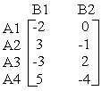

Solution
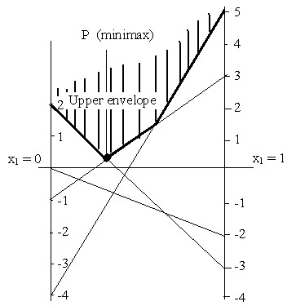
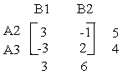
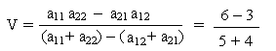

V = 3/9 = 1/3
S_{A} = (0, 5 /9, 4/9, 0)
S_{B} = (3/9, 6 /9)

Example 2

Solve by graphical method
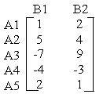

Solution
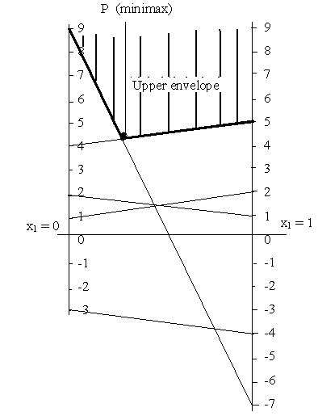
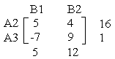
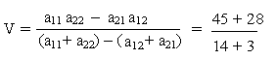

V = 73/17
S_{A} = (0, 16/17, 1/17, 0, 0)
S_{B} = (5/17, 12 /17)

