Down Syndrome
Down syndrome is a congenital disorder stemming from a chromosomal abnormality appearing in about one of every 800 births. This syndrome occurs when one chromosome has an extra “part,” and an error occurs in cell division, or an extra chromosome exists, resulting in 47 chromosomes. Most people are born with 23 pairs of chromosomes, for a total of 46. When the body produces an extra chromosome or genetic material, it alters the way the body develops. Babies with Down syndrome are likely to develop more slowly than other babies. They may learn to walk and talk much later than typically developing babies. Some have stomach problems that affect digestion and elimination. Infections may affect lungs and breathing, and other infections in the ears or eyes may last longer. Some may even develop leukemia. Each person with Down syndrome is different, and may have just a few or many of these problems. Most people with Down syndrome have very recognizable characteristics and physical features. They may have a flatter face, eyes that slant upward, a mouth that turns downward, and sometimes a larger tongue. Physical features, in addition to the eyes and face, may reveal small or misshapen ears, large spaces between the big toe and second toe, and a deep crease across the palms of the hands. Few or all of these features may exist.
There are three types of Down syndrome: trisomy 21 (nondisjunction), translocation and mosaicism:
1.Trisomy 21 (nondisjunction): Down syndrome is usually caused by an error in cell division called "nondisjunction." Nondisjunction results in an embryo with three copies of chromosome 21 instead of the usual two. Prior to or at conception, a pair of 21st chromosomes in either the sperm or the egg fails to separate. As the embryo develops, the extra chromosome is replicated in every cell of the body. This type of Down syndrome, which accounts for 95% of cases, is called trisomy 21.

TYPICAL CELL DIVISION

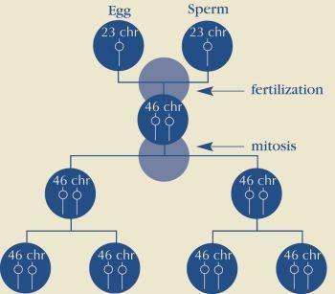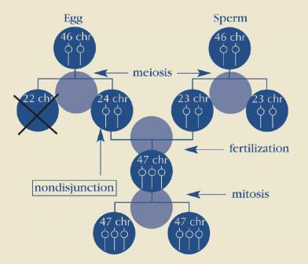

2. Mosaicism
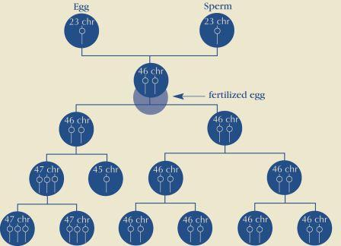
Mosaicism (or mosaic Down syndrome) is diagnosed when there is a mixture of two types of cells, some containing the usual 46 chromosomes and some containing 47. Those cells with 47 chromosomes contain an extra chromosome 21. Mosaicism is the least common form of Down syndrome and accounts for only about 1% of all cases of Down syndrome. Research has indicated that individuals with mosaic Down syndrome may have fewer characteristics of Down syndrome than those with other types of Down syndrome. However, broad generalizations are not possible due to the wide range of abilities people with Down syndrome possess.
3. Translocation : In translocation, which accounts for about 4% of cases of Down syndrome, the total number of chromosomes in the cells remains 46; however, an additional full or partial copy of chromosome 21 attaches to another chromosome, usually chromosome 14. The presence of the extra full or partial chromosome 21 causes the characteristics of Down syndrome.

