المرحلة الثانية / فيزياء المحاضرة الثالثة E-Te rminology
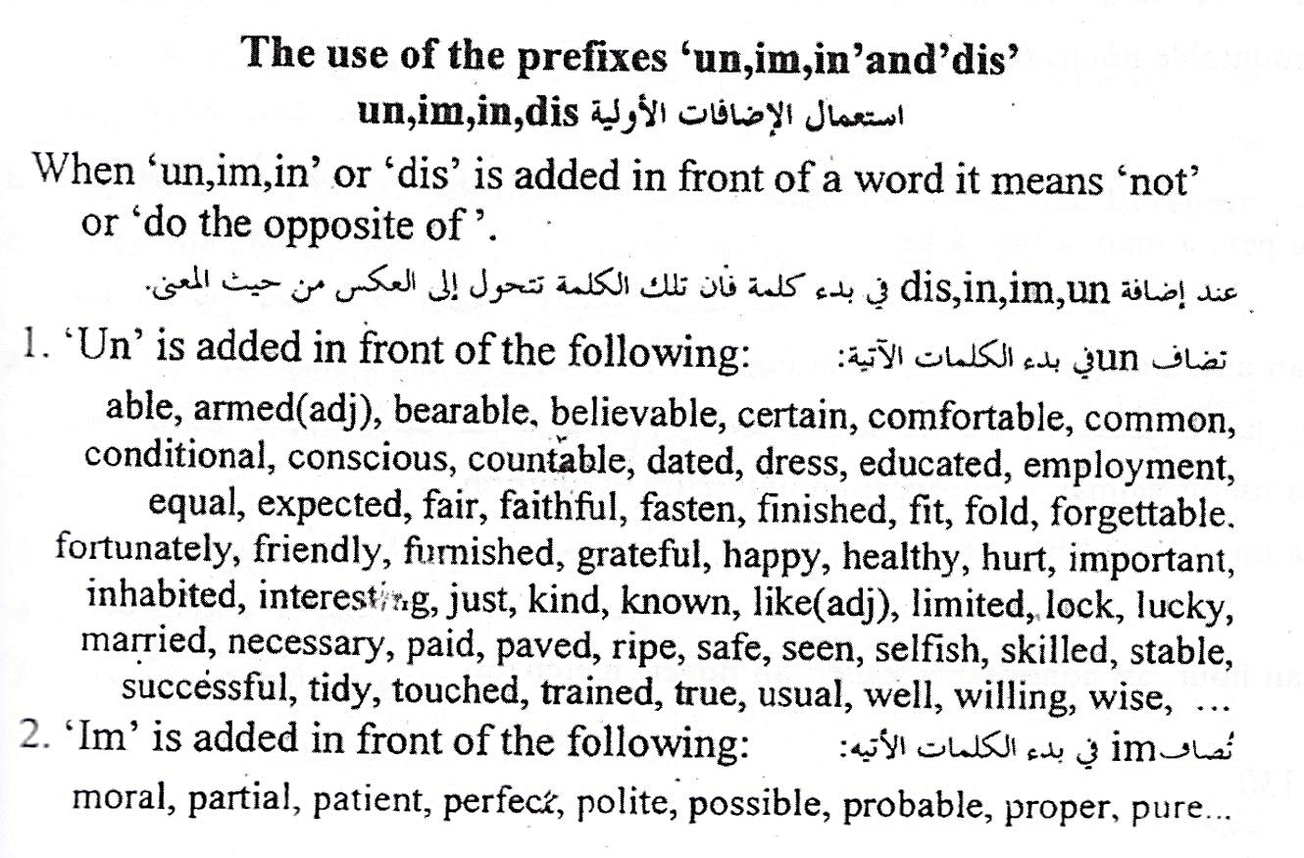
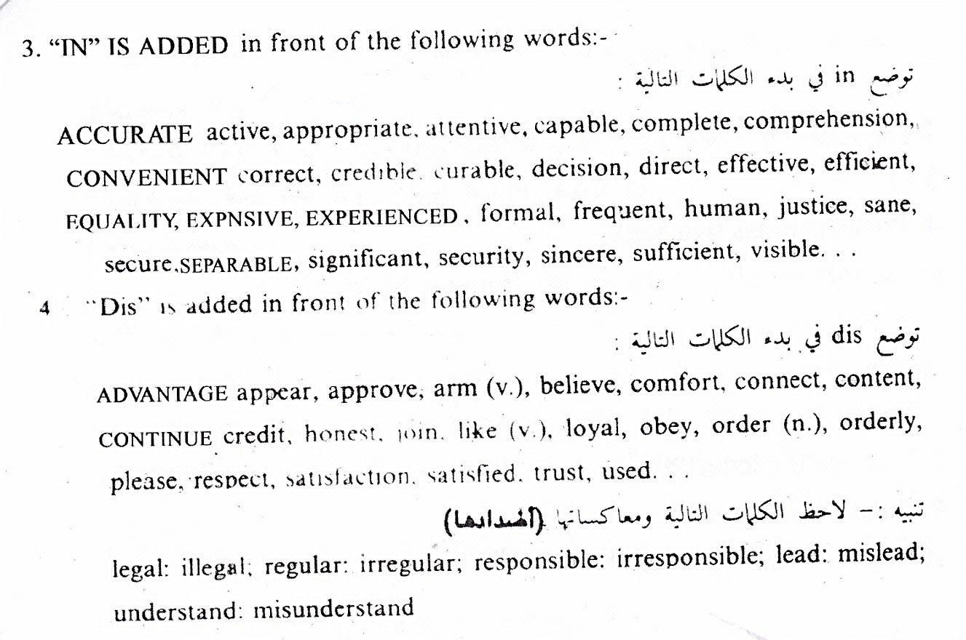

(انك- ف/3-9)

What are Prefixes and Suffixes?
Prefixes and suffixes are grammatical and lingual "affixes." Prefixes are affixed before and suffixes after a base word or word stem to add information. For example, with the word "prehistoric," the prefix is "pre-" meaning "before," the base word is "history" meaning "recorded events and knowledge", and the suffix is "-ic" meaning "relating to the science of."
In other words, "prefix" simply refers to an attachment before or in front of, in this case, a shorter word or stem. In lingual terms, a "stem" is the main part of a word to which prefixes and suffixes can be added and may not necessarily be a word itself, such as "dod" in "doddle."
Similarly, "suffix" refers to an attachment after the end of an existing word or stem, serving to form a new word or functioning as an inflectional ending, for example, “s” or “es” to make for plurality.

Is an Affix a Single Syllable?
No, a prefix or suffix can be one or more syllables, depending on the root word from Latin or Greek or from any one of a host of other English lingual influences.

Inflectional Suffixes:

Are Endings such as "-ed," "-ing," and "-s" Suffixes?
Yes, endings that are creating different forms of the same word are called "inflectional suffixes." There are very few inflectional suffixes but they occur rather frequently. They are:

- –s/ -es/ -ies | plural | Boys, cars/ dresses, mixes, watches/ studies, files, copies
- -s | 3rd person singular present | Layla's book, Ali's pensile
- -ed | past tense | Called, lived, ended
- -en | past participle | Bitten, broken, beaten
- -en | plural (irregular) | Children, women
- -ing | progressive/continuous | Going, washing, coming
- -er | comparative | Smaller, cooler
- -est | superlative | Tallest, biggest, longest
- -n't | negative (contraction) | Dose'nt, wouldn't, can't

(انك- ف/3-10)

Derivational Suffixes:

Are Endings such as "-ism," "-ful," and "-fy" Suffixes?
Endings that change the meaning of the word are called "derivational suffixes." Some are:

(10) -ism | forms a noun | Tourism, mechanism
(11) -ist | noun | Dentist, chemist, socialist
(12) -ful | noun | Careful, beautiful, harmful
(13) -able | adjective | Portable, remarkable, movable
(14) -ation | noun | Combination, precipitation, crystallization
(15) -ness | noun | Brittleness, happiness
(16) -ment | noun | Movement, government
(17) -ify | verb | Simplify, qualify
(18) -fy | adjective | Satisfy, purify
(19) -ity | noun | Security, activity, generosity, ability
(20) -ly | adverb | Firmly, warmly, openly, lonely
(21) -ise, -ize | verb | Compromise

Derivational suffixes can combine, providing flexibility in creating other words, but such activity can lead to spelling complications. For example, "-ity" can combine with "-able," but the result is "-ability" (desirability, predictability), and when "-ly" is added to a word ending in "-ic" to make an adverb, the result is usually "-ically" (historically, mechanically).

