المرحلة الثانية / فيزياء المحاضرة الرابعة E-Terminology قسم العلوم
Tenses
- The Present Simple Tense:
- This tense is used to express a fact:
- Stars shine at night.
- A cow gives milk.
- January is the first month of the year.
- It is also used to express a general habit. The following adverbs are usually used with this tense:
(every morning, every day,…..etc)
- My father goes to the office every day.
- This pilot flies to Paris twice a week.
- The past Simple Tense:
This tense is used to express an event that happened in the past.
The following adverbs are used with the past tense:
(yesterday, ago, last week, in the past…etc)
- I bought this mobile yesterday.
- Two weeks ago Wisam was in Kuwait.
- Tom and Mary were not at the party last Sunday.
- I did not meet him at the station yesterday.
- Where were you last night?
- Did Mr. black leave for India last summer?
- The Future Simple Tense:
- To form this tense, 'shall' or 'will' is used followed by base:
(shall go, will have, will be, will not do...etc)
- The future simple tense is used to show that an action will happen in the future. The following adverbs are used with the future tense to express futurity:
(tomorrow, next week, soon, in the future….etc)
- He will work (or: He is going to work) in Kuwait next year.
- We shall not visit (or: We are not going to visit) Beirut next summer.

(انك- ف/4-12)

- The Present Continuous (or: Progressive) Tense:
- To form this tense, "am, is" or "are" is used followed by present participle.
- I am waiting for him.
- He is sitting at the table.
- They are working.
- The present continuous is used to describe an action that is taking place now and not yet complete. (now, at the moment, today, at present)
- The Past Continuous (or: Progressive) Tense:
- To form this tense, "was" or "were" is used followed by present participle. (was reading, were sitting…etc).
- The past continuous is used to describe an action that was going on at a certain time in the past. The conjunctions "when, while, as" are normally used with this tense.
- When I arrived, he was still sleeping.
- While he was running after the train, he fell down.
- It begun to rain as they were playing football.
- What were you doing when I phoned you last night?
- The Present Perfect Tense:
- To form this tense, "have" or "has" is used followed by the past participle of the verb.
- I have eaten an apple.
- He has written a letter.
- We have played volleyball.
- The present perfect tense is used:
- To describe an action that finished in the past without mentioning an adverb of the past.
- I have finished my work.
- The train has arrived.
- It has become hot.
- You have made a mistake.
- He has taken his medicine.

(انك- ف/4-13)

- To describe an action that has just finished. The adverbs "just, already, yet" are usually used with this form:
- I have just written him a letter.
- The rain has just stopped.
- I have found my lost watch already.
- The police have not caught the thief yet.
- To express an action that began at some point of time in the past and extends until the present. "Since" and "for" are usually used with this form.
- I have not seen a good film since last month.
- He has been in Egypt for the last two months.
- The Present Perfect Continuous Tense:
- To form this tense, "have been" or "has been" is used followed by present participle. (have been working, has been waiting)
- The present perfect continuous is used to show that an action began in the past and is still going on at present. "Since" or "for" is usually used with this tense.
- It has been raining since yesterday.
- They have been swimming for the last two hours.
- The Past perfect Tense:
- To form this tense, "had" is used followed by past participle. (had been, had put, had sold…etc).
- When two actions happen in the past, the past perfect is used for the first action and the past tense for the second.
- After I (put) out the light, I went to bed.
After I had put out the light, I went to bed.
- He (leave) for London after he (get) the passport yesterday.
He left for London after he had got the passport yesterday.

(انك- ف/4-14)

Passive Voice
- First Pattern: (Present)
- They sell eggs at this shop. (active voice)
Eggs are sold at this shop. (Passive voice)
- People drink a lot of water in summer.
A lot of water is drunk in summer.
- Second Pattern: (Past)
- A thief stole her hand bag yesterday.
Her hand bag was stolen yesterday.
- The hunter killed two lions.
Two lions were killed by the hunter.
- Third Pattern: (future)
- They will send him to London next month.
He will be sent to London next month.
- They are going to sell the flat next year.
The flat is going to be sold next year.
- Fourth Pattern: (Continuous)
- If the active verb is in the present continuous tense:
- She is washing up the dishes now.
The dishes are being washed up now
- (past continuous tense)
- He was feeding the chickens.
The chickens were being fed.
- Fifth Pattern: (Present Perfect)
- He has grown some flowers in the garden.
Some flowers have been grown in the garden.
- They have repaired your car.
Your car has been repaired.

(انك- ف/4-15)
EXERCISES
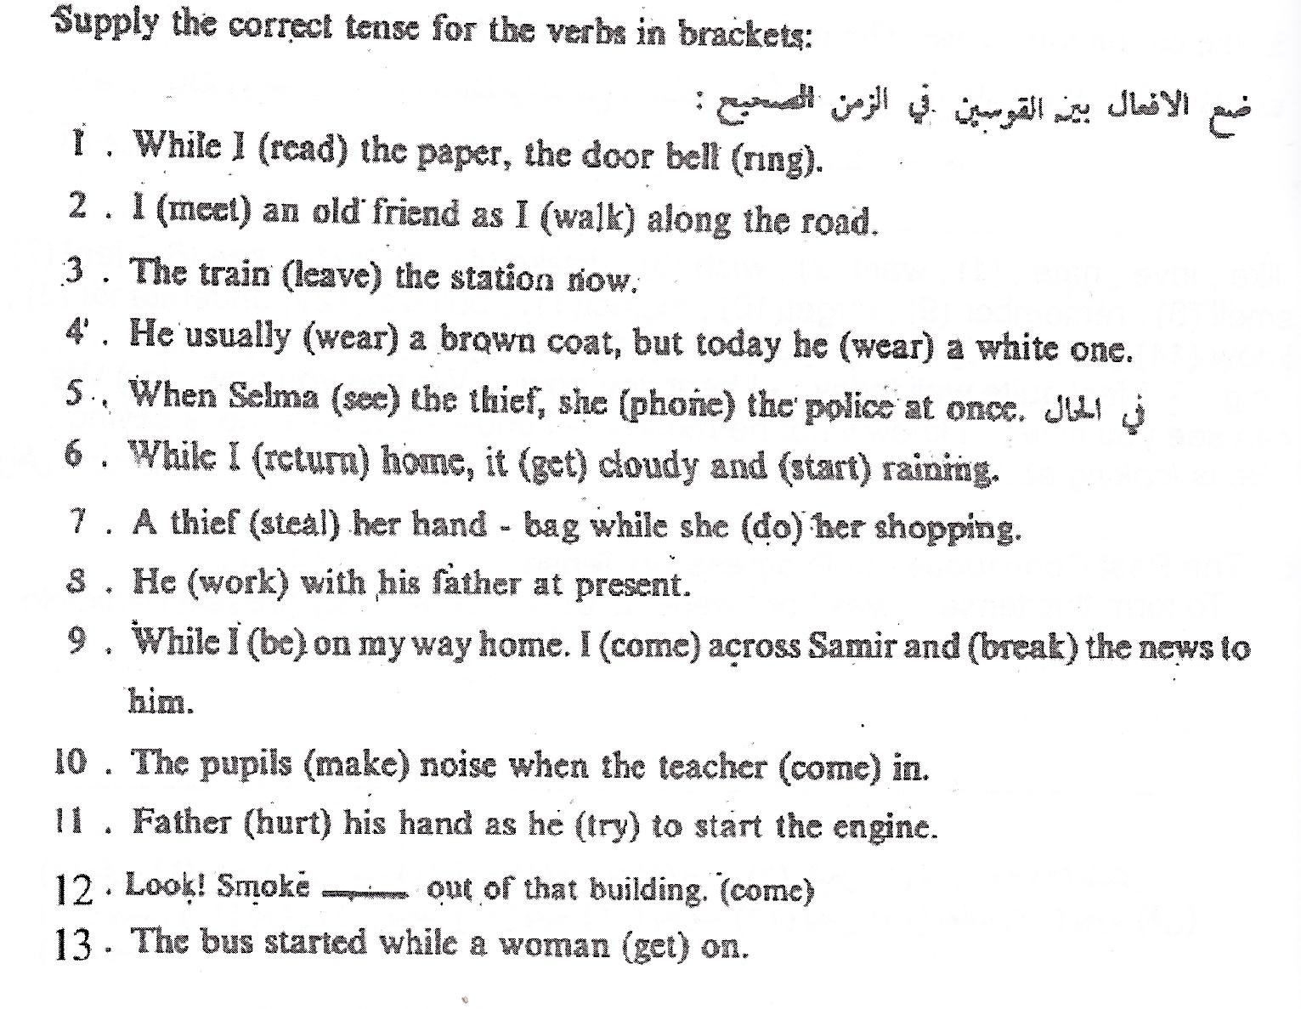

(انك- ف/4-16)

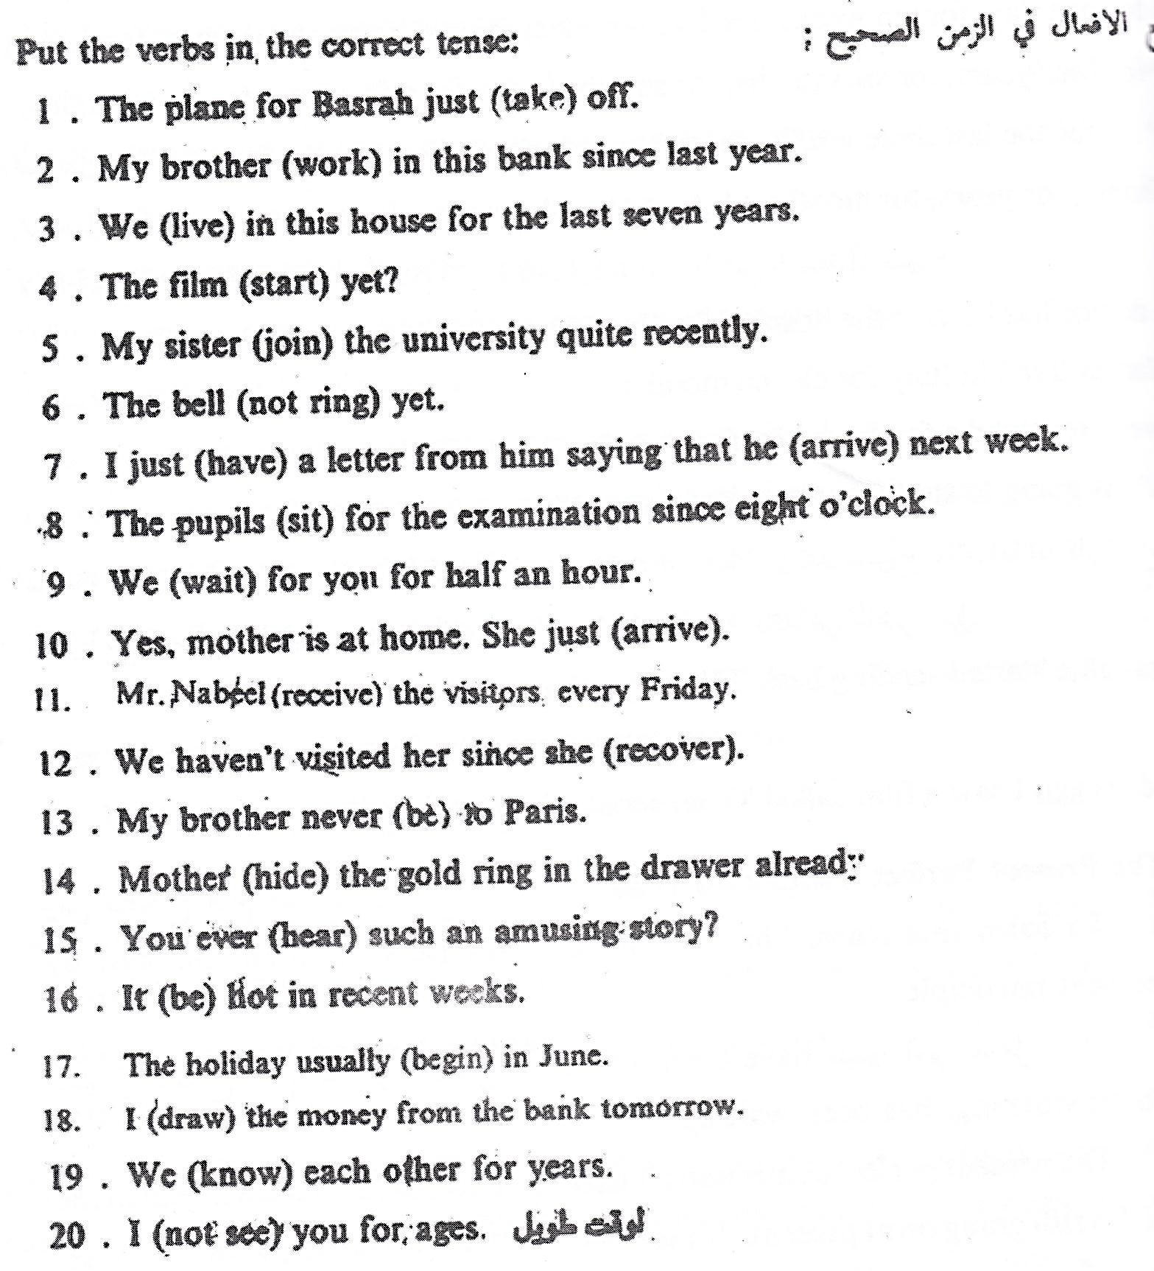

(انك- ف/4-17)

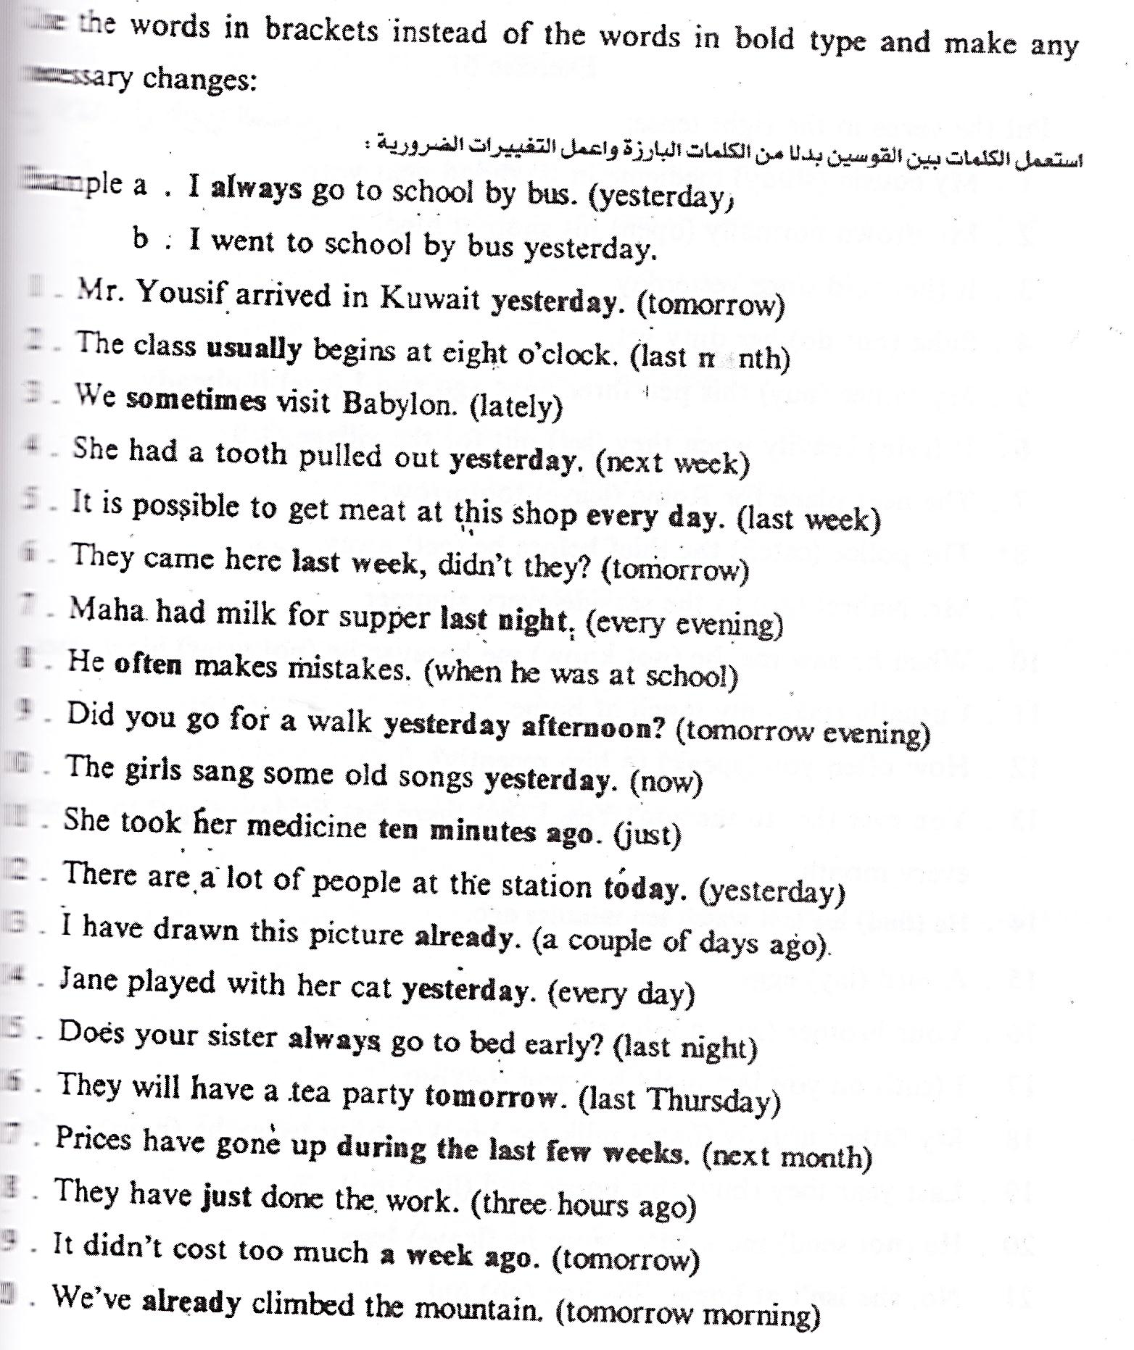

(انك- ف/4-18)

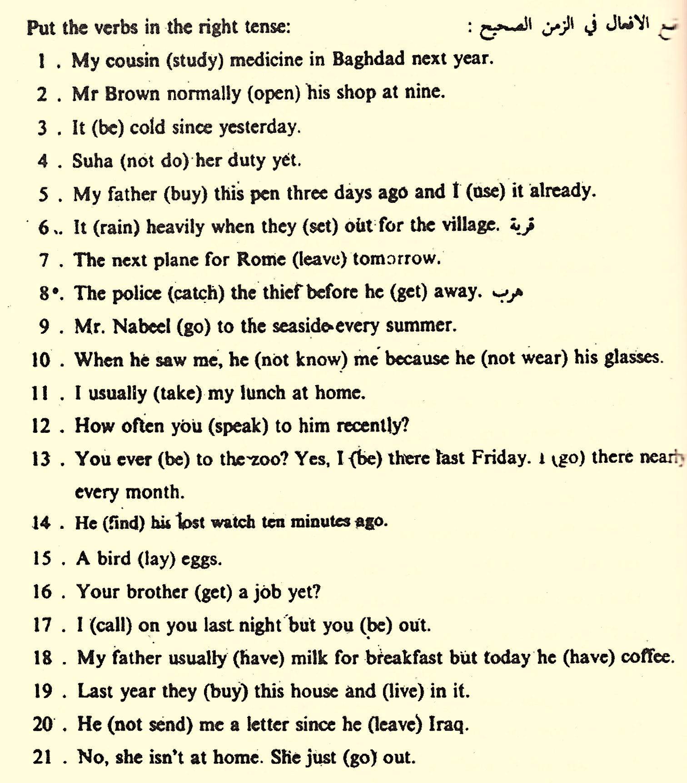

(انك- ف/4-19)

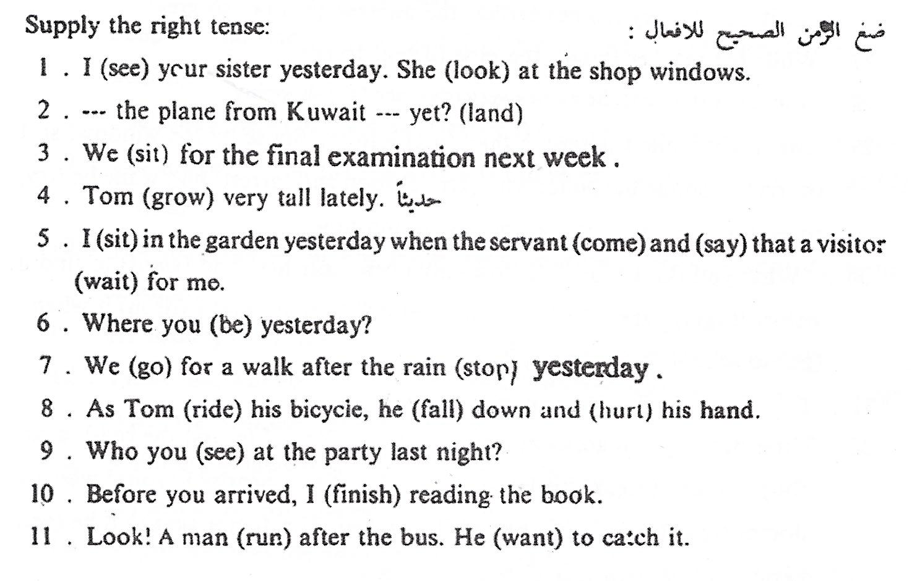

(انك- ف/4-20)

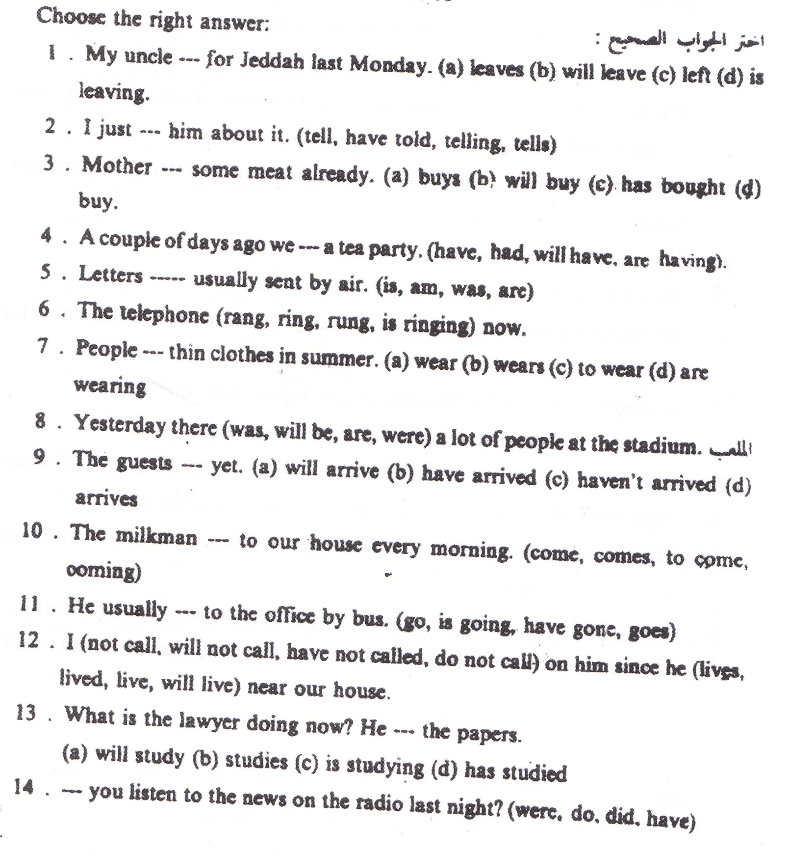

(انك- ف/4-21)

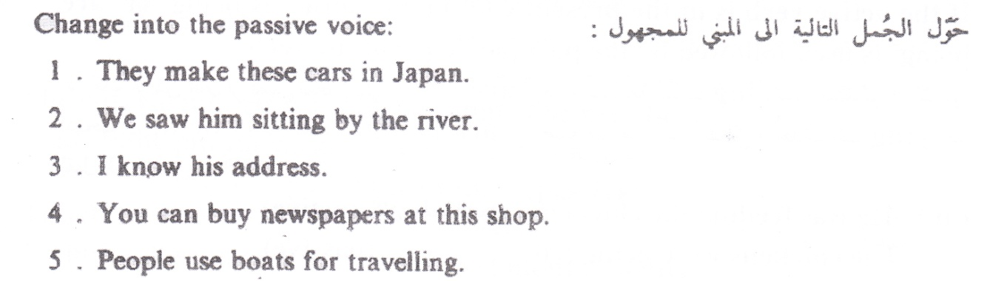
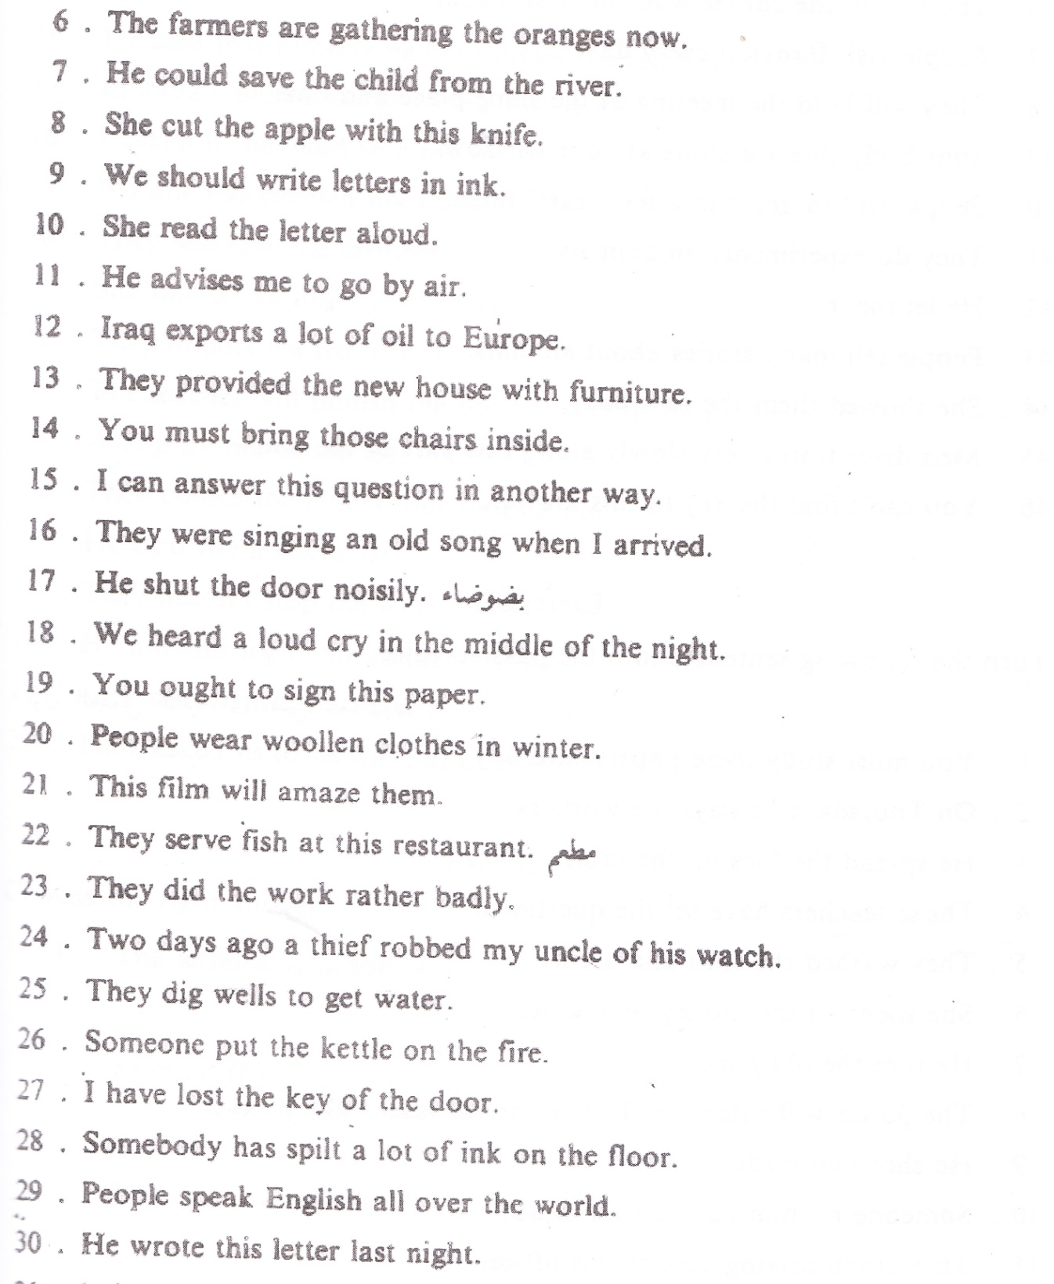

(انك- ف/4-22)

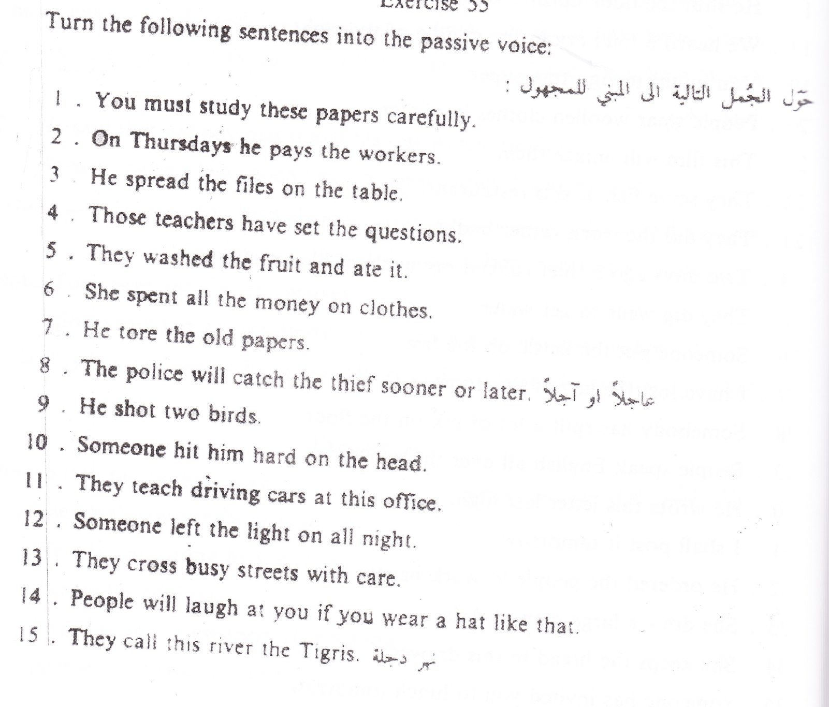

(انك- ف/4-23)

