**1.Introduction to image processing**

1.1What is an image?

An image is an array, or a matrix, of square pixels (picture elements) arranged in columns and rows.

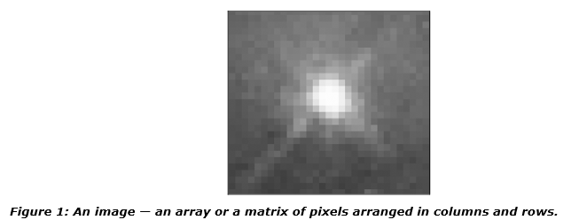

In a (8-bit) grayscale image each picture element has an assigned intensity that ranges from 0 to 255. A grey scale image is what people normally call a black and white image, but the name emphasizes that such an image will also include many shades of grey.

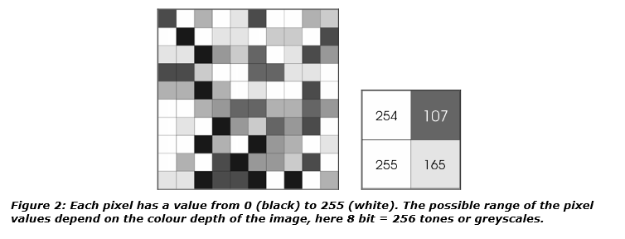

A normal greyscale image has 8bit color depth = 256 greyscales. A “true color” image has 24 bit color depth = 8 x 8x 8 bits = 256 x 256 x 256 colors = ~16million colors.

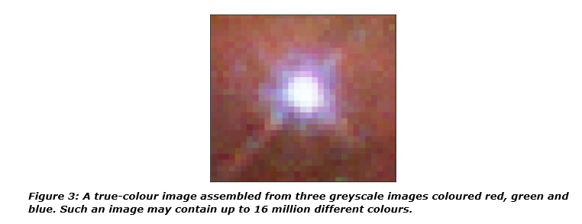

Some greyscale images have more greyscales, for instance 16 bit = 65536 greyscales. In principle three greyscale images can be combined to form an image with 281,474,976,710,656 greyscales.

**1.2. How a digital image is formed**

Since capturing an image from a camera is a physical process. The sunlight is used as a source of energy. A sensor array is used for the acquisition of the image. So when the sunlight falls upon the object, then the amount of light reflected by that object is sensed by the sensors, and a continuous voltage signal is generated by the amount of sensed data. In order to create a digital image , we need to convert this data into a digital form. This involves sampling and quantization. (They are discussed later on). The result of sampling and quantization results in an two dimensional array or matrix of numbers which are nothing but a digital image.

**1.2.1. A Simple model of image formation:**

* The scene is illuminated by a single source.
* The scene reflects radiation towards the camera.
* The camera senses it via solid state cells (CCD cameras)

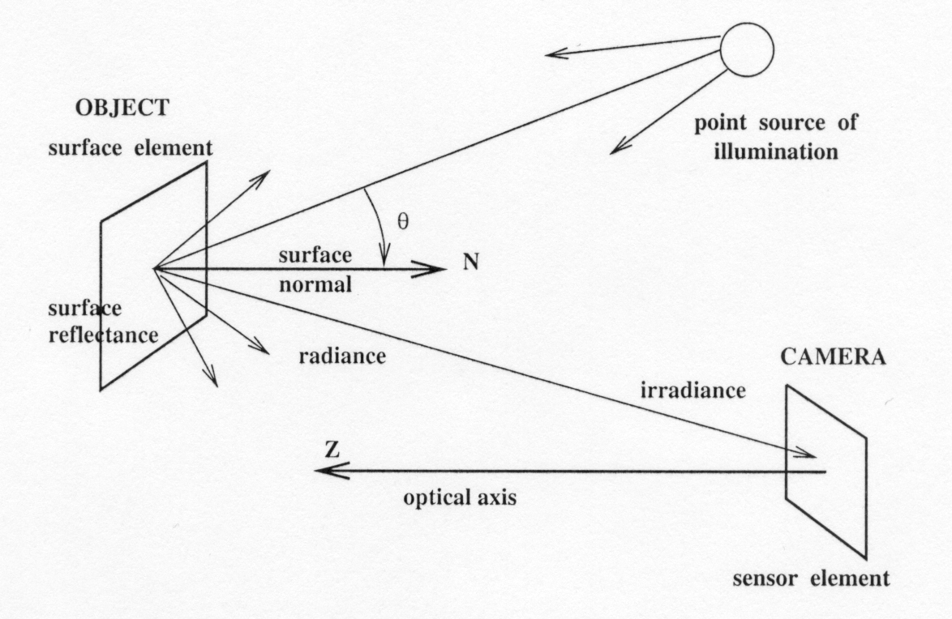

Figure 4: **image formation**

There are two parts to the image formation process:

* 1. The **geometry**, which determines where in the image plane the projection of a point in the scene will be located.

(2) The **physics of light**, which determines the brightness of a point in the image plane.

Simple model: **f(x,y) = i(x,y) r(x,y)**

i: illumination(السطوع), r: reflectance(الانعكاس)

**1.3. Image Representation**

The image can now be accessed as a two-dimension array of data, where each data point is referred to a pixel(picture element) for digital images we will use the following notation:

I(x,y)= The brightness of image at the point (x,y)

Where x= row and y= column.

"when we have the data in digital form, we can use the software to process the data".

The digital image is 2D-array as



In above image matrix, the image size is (NXN) [matrix dimension]then :

Ng=2m

Where Ng denote the number of gray level m is the no. of bits contains in digital image matrix.

**Example**: If we have (6 bit)in 128x128 image. Find the no. of gray levels to represent it, then find the no. of bit in this image?

**Solusion**

Ng=26

Ng =64 Gray level

Nb =128*128*6=9.8304*104 bit.

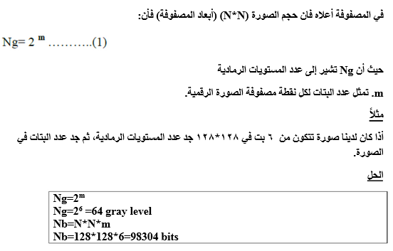

**1.4 Image Processing**

Image processing is computer imaging where application involves a human being in the visual loop. In other words the image are to be examined and a acted upon by people. The major topics within the field of image processing include:

1. Image restoration.

2. Image enhancement.

3. Image compression.

**1.4.1.Image Restoration**

Is the process of taking an image with some known, or estimated degradation, and restoring it to its original appearance. Image restoration is often used in the field of photography or publishing where an image was somehow degraded but needs to be improved before it can be printed.

**1.4.2. Image Enhancement**

Involves taking an image and improving it visually, typically by taking advantages of human Visual Systems responses. One of the simplest enhancement techniques is to simply stretch the contrast of an image. Enhancement methods tend to be problem specific. For example, a method that is used to enhance satellite images may not suitable for enhancing medical images.

**1.4.3. Image Compression**

Involves reducing the typically massive amount of data needed to represent an image. This done by eliminating data that are visually unnecessary and by taking advantage of the redundancy that is inherent in most images. Image data can be reduced 10 to 50 times, and motion image data (video) can be reduced by factors of 100 or even 200.