3.Some Basic Relationships between Pixels

3.1.Neighbors of a pixel
1.N₄ (p): 4-neighbors of p.
•Any pixel p(x, y)has two vertical and two horizontal neighbors, given by
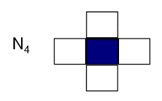
(x+1,y), (x-1, y), (x, y+1), (x, y-1)
•This set of pixels are called the 4-neighborsof P, and is denoted by N₄(P)
•Each of them is at a unit distance from P.
2.N_{D}(p)
•N_{D}(p): four diagonal neighbors of p have coordinates:

(x+1,y+1), (x+1,y-1), (x-1,y+1), (x-1,y-1)

3.N₈(p): 8-neighbors of p .
•N₄(P)and N_{D}(p) together are called 8-neighbors of p , denoted by N₈(p).
•N₈= N₄UN_{D}
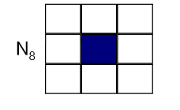
•Some of the points in the N₄ , N_{D} and N₈ may fall outside image when P lies on the border of image.

F(x-1, y-1) | F(x-1, y) | F(x-1, y+1)
F(x, y-1) | F(x,y) | F(x, y+1)
F(x+1, y-1) | F(x+1, y) | F(x+1, y+1)

Fig : Sub-image of size 3x3 of 8- neighbor
3.2.Adjacency
•Two pixels are connected if they are neighbors and their gray levels satisfy some specified criterion of similarity.
For example, in a binary image two pixels are connected if they are 4-neighbors and have same value (0/1)
•Let v:a set of intensity values used to define adjacency and connectivity.
•In a binary Image v={1},if we are referring to adjacency of pixels with value 1.
•In a Gray scale image , the idea is the same, but v typically contains more elements,
•If the possible intensity values 0 to 255, v set could be any subset of these 256 values.

Types of adjacency
1. 4-adjacency: Two pixels p and q with values from v are 4-adjacent if q is in the set N₄(p).
q
e.x: v={0,1}
p
1 | 1 | 0
1 | 1 | 0
1 | 0 | 1

2. 8-adjacency: Two pixels p and q with values from v are 8-adjacent if q is in the set N₈(p).
q

p
0 | 1 | 1
0 | 2 | 0
0 | 0 | 1
e.x: v={1,2}

3.m-adjacency(mixed):two pixels p and q with values from v are m-adjacent if:
- q is in N₄(p) , OR
- q is in N_{D}(P)and The set N₄(p) ∩N₄(q) has no pixel whose values are from v (No intersection).

•Mixed adjacency is a modification of 8-adjacency.

e.x: v={1}
0_{a} | 1_{b} | 1_{c}
0_{d} | 1_{e} | 0_{f}
0_{g} | 0_{h} | 1_{i}

Sol:
- q is in N₄(p):
b & c are m-adjacent
- q is in N₄(p):
b & e are m-adjacent
3- q is in N_{D}(P)and The set N₄(p) ∩N₄(q) has no pixel whose values are from v (No intersection).
e & i are m-adjacent
- q is in N_{D}(P)and The set N₄(p) ∩N₄(q) has no pixel whose values are from v (No intersection).
e & c are NOT m-adjacent

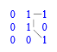
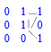
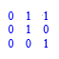

Fig.(a) Fig(b) Fig(b)
8- adjacency m-adjacency

3.3. Path
A digital path (or curve) from pixel p with coordinate (x,y)to pixel q with coordinate
(s,t) is a sequence of distinct pixels with coordinates
(x₀, y₀), (x₁, y₁),..., (x_{n}, y_{n}),
where
(x₀, y₀)=(x,y),
and (x_{n}, y_{n})=(s,t)
And (x_{i}, y_{i})is adjacent pixel (x_{i-1}, y_{i-1})for 1≤ i ≤n,

In this case, n is the length of the path.

•If (x₀, y₀)=(x_{n}, y_{n}):the path is closed path.

•We can define 4- ,8- , or m-paths depending on the type of adjacency specified.

Example
Consider the image segment shown in figure. Compute length of the shortest-4, shortest-8 & shortest-m paths between pixels p& q where,
v={1,2}

4 | 2 | 3 | 2q
3 | 3 | 1 | 3
2 | 3 | 2 | 2
P2 | 1 | 2 | 3

SOL:
1- shortest-4path

4 | 2 | 3 | 2q
3 | 3 | 1 | 3
2 | 3 | 2 | 2
P2 | 1 | 2 | 3

So ,path does not exist

2- shortest-8path

4 | 2 | 3 | 2q
3 | 3 | 1 | 3
2 | 3 | 2 | 2
P2 | 1 | 2 | 3
So,shortest-8path =4

3- shortest-m paths

4 | 2 | 3 | 2q
3 | 3 | 1 | 3
2 | 3 | 2 | 2
P2 | 1 | 2 | 3

So, shortest-m path =5

3.4. Connectivity

Pixels are said to be connected if there exists a path between them .

•Let S represent a subset of pixels in an image,
Two pixels p and q are said to be connected in S if there exists a path between them.
Consisting entirely of pixels 'S'.
For any pixel p in S , the set of pixels that are connected to it in S is called a connected component of S .

3.5. Region
• Let R to be a subset of pixels in an image, R is called a region if every pixel in R is connected to any other pixel in R.
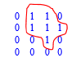
.

Two regions, R_{i} and R_{j} are said to be adjacent if their union forms a connected set. Region that are not adjacent are said to be disjoint.

We consider 4-and 8- adjacency when referring to regions,
EX1 : Below regions are adjacent only if 8-adjacency(connectivity) is used.

1 | 1 | 1
1 | 0 | 1 R_{i}
0 | 1 | 0
0 | 0 | 1
1 | 1 | 1 Rj
1 | 1 | 1

4-path between the two regions does not exist, (so their union is not a connected set).

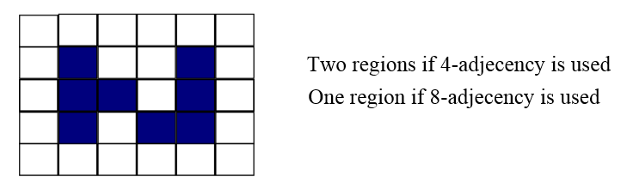
EX2:

3.6. Boundary (border)

Boundary (border or contour) of a region R is the set of points that are adjacent to points in the complement of R (another way: the border of a region is the set of pixels in the region that have at least are background neighbor).

Ex :The circled point is part of the boundary of the 1-valued pixels only if 8-adjacency between the region and background is used

