4. Histogram
The histogram of an image is a plot of the gray _levels values versus the number of pixels at that value.
A histogram appears as a graph with "brightness" on the horizontal axis from 0 to 255 (for an 8-bit) intensity scale) and "number of pixels "on the vertical axis. For each colored image three histogram are computed, one for each component. The histogram gives us a convenient -easy-to-read representation of the concentration of pixels versus brightness of an image, using this graph we able to see immediately:
1.Whether an image is basically dark or light and high or low contrast.
2.Give us our first clues about what contrast enhancement would be appropriately applied to make the image more subjectively pleasing to an observer, or easier to interpret by succeeding image analysis operations.
So the shape of histogram provide us with information about
nature of the image or sub image if we considering an object within the image. For example:
1. Very narrow histogram implies a low-contrast image
2.Histogram skewed ( مائل ) to word the high end implies a bright
Image
3.Histogram with two major peaks , called bimodal, implies an object that is in contrast with the background .
Examples of the different types of histograms are shown in figure
1- الرسم البياني ضيق جدا يعني صورة المنخفضة التباين
تميل في نهاية عالية يعني صورة مشرقة (مائل)الرسم البياني مائل - 2
الرسم البيانني مع اثنين من القمم الكبرى، يعني كائن موجود في تناقض مع الخلفية-3.

One of the principle uses of the histogram is in the selection of threshold parameter .

count | Pixel valus
2  5  3  4  5  2  4 | 0  1  2  3  4  5  6
25 | Total

count

6 | 4 | 4 | 3 | 2
6 | 5 | 4 | 2 | 1
6 | 6 | 5 | 1 | 1
4 | 3 | 3 | 1 | 0
4 | 3 | 2 | 1 | 0

Pixel Value
Image
a) )

Histogram
(b)
Plot of the Histogram
( c)

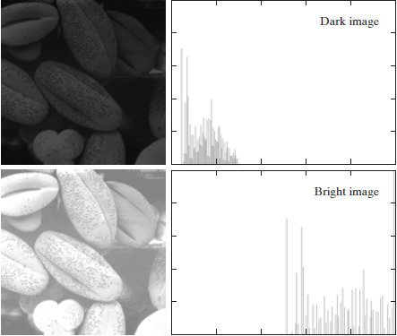
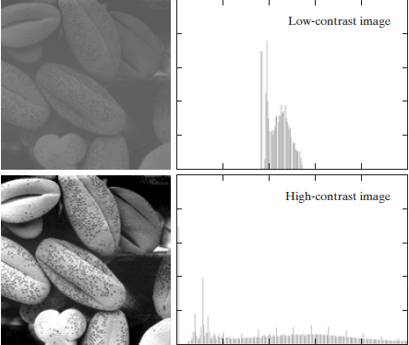
Four basic image type : dark, light, low contrast , high contrast , and their corresponding histogram

We note in the dark Image that the components of the histogram are concentrated on the low (dark) side of the gray scale. Similarly, the components of the histogram of the bright image are biased toward the high side of the gray scale. An image with low contrast has a histogram that will be narrow and will be centered toward the middle of the gray scale. For a monochrome image this implies a dull, washed-out gray look. Finally, we see that the components of the histogram in the high-contrast image cover a broad range of the gray scale and, further, that the distribution of pixels is not too far from uniform, with very few vertical lines being much higher than the others. Intuitively, it is reasonable to conclude that an image whose pixels tend to occupy the entire range of possible gray levels and, in addition, tend to be distributed uniformly, will have an appearance of high contrast and will exhibit a large variety of gray tones.

