8. Image Compression
Image compression involves reducing the size of image data file, while is retaining necessary information, the reduced file is called the compressed file and is used to reconstruct the image, resulting in the decompressed image. The original image, before any compression is performed, is called the uncompressed image file. The ratio of the original, uncompressed image file and the compressed file is referred to as the compression ratio.

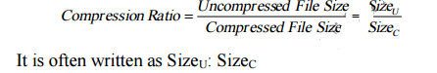
Example: the original image is 256×256 pixel, single band (gray scale), 8- bit per pixel. This file is 65536 bytes (64K). After compression the image file is 6554 byte. The compression ratio is: Siz
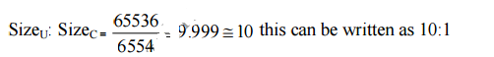
This is called a “10 to 1” compression or a “10 times compression”, or it can be stated as “compressing the image to 1/10 original size. Another way to state the compression is to use the terminology of bits per pixel. For an N×N image
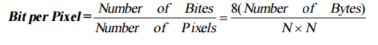
Example: using preceding example, with a compression ratio of 65536/6554 bytes. We want to express this as bits per pixel. This is done by first finding the number of pixels in the image.
256×256 = 65536
We then find the number of bits in the compressed image file
6554× (8 bit/byte) =52432 bits.
Now, we can find the bits per pixel by taking the ration
52432/65536=0.8 bit/ Pixel.
The reduction in file size is necessary to meet
1. The bandwidth ( كمية البيانات) requirements for many transmission systems.
- The storage requirements in computer data base.
The amount of data required for digital images is enormous. For example, a single 512×512, 8-bit image requires 2,097,152 bits for storage. If we wanted to transmission this image over the World Wide Web, it would probably take minutes for transmission –too long for most people to wait.
512 ×512×8= 2,097,152.
Example To transmit a digitized color scanned at 3,000×2,000 pixels, and 24 bits, at 28.8(kilobits/second), it would take about
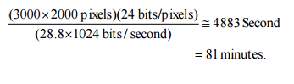

Couple this result with transmitting multiple image or motion images, and the necessity of image compression can be appreciated.
The key to a successful compression schema comes with the second part of the definition –retaining necessary information. To understand this we must differentiate between data and information. For digital images, data refer to pixel gray-level values the correspond to the brightness of a pixel at a point in space. Information is interpretation of the data in a meaningful way. Data are used to convey information, much like the way the alphabet is used to convey information via words. Information is an elusive concept, it can be application specific. For example, in a binary image that contains text only, the necessary information may only involve the text being readable, whereas for a medical image the necessary information may be every minute detail in the original image. There are two primary types of images compression methods and they are:
1. Lossless Compression
2. Lossy Compression.
1. Lossless Compression This compression is called lossless because no data are lost, and the original image can be recreated exactly from the compressed data. For simple image such as text-only images.
2. Lossy Compression. These compression methods are called Lossy because they allow a loss because they allow a loss in actual image data, so original uncompressed image can not be created exactly from the compressed file. For complex images these techniques can achieve compression ratios of 100 0r 200 and still retain in high – quality visual information. For simple image or lower-quality results compression ratios as high as 100 to 200 can be attained.
8.1 Compression System Model The compression system model consists of two parts: Compressor and Decompressor.
Compressor: consists of preprocessing stage and encoding stage.
Decompressor: consists of decoding stage followed by a post processing stage, as following figure:
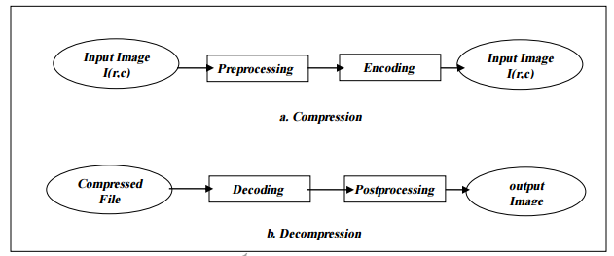
Compression System Model.
Before encoding, preprocessing is performed to prepare the image for the encoding process, and consists of any number of operations that are application specific. After the compressed file has been decoded, post processing can be performed to eliminate some of the undesirable artifacts brought about by the compression process. Often, many practical compression algorithms a

