[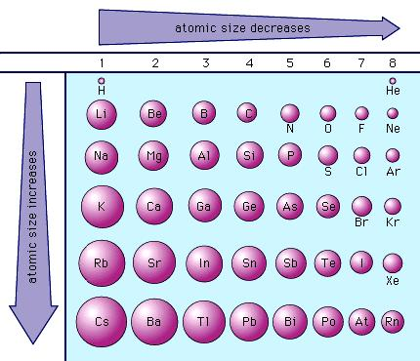](https://www.britannica.com/science/titanium?oasmId=891)