False-Position Method of Solving a Nonlinear Equation

This method attempts to solve an equation of the form f(x)=0. (This is
very common in most numerical analysis applications.) Any equation can be
written in this form.
The algorithm requires a function f(x) and two points a and b for which
f(x) is positive for one of the values and negative for the other. We can write
this condition as f(a)⋅f(b)<0.
If the function f(x) is continuous on the interval [a,b] with f(a)⋅f(b)<0,
the algorithm will eventually converge to a solution.
The idea for the False position method is to connect the points (a,f(a)) and
(b,f(b)) with a straight line.
Since linear equations are the simplest equations to solve for find the regulafalsi
point (C) which is the solution to the linear equation connecting the
endpoints.
Look at the sign of f(C):
If sign (f(C)) = 0 then end algorithm
else If sign(f(C)) = sign(f(a)) then set a = C
else set b = C
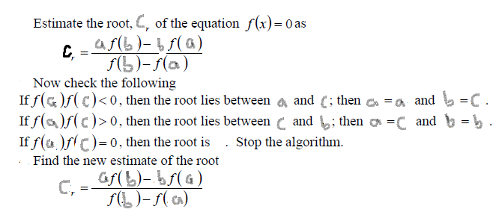

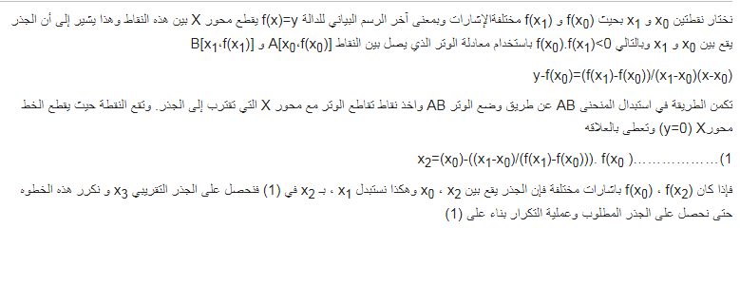
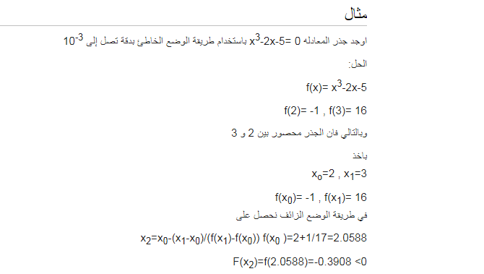
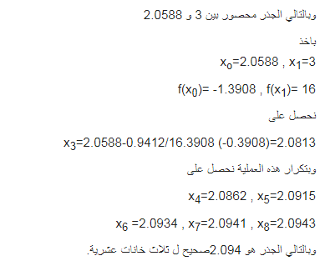

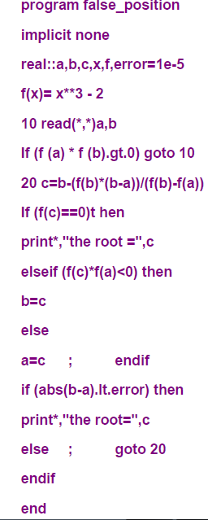

-

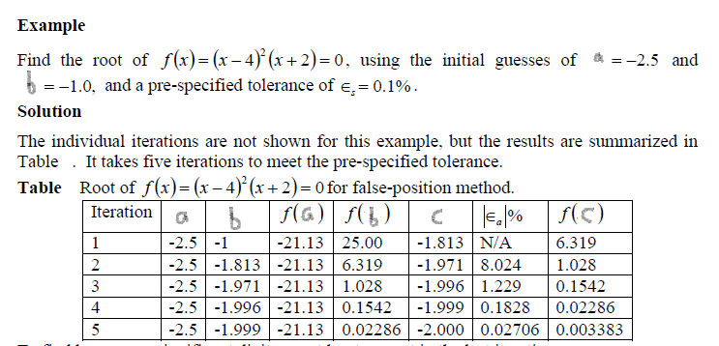

المصادر
- Schwartz, R. K. (2004). Issues in the Origin and Development of Hisab al-Khata’ayn (Calculation by Double False Position). Eighth North African Meeting on the History of Arab Mathematics. Radès, Tunisia. Available online at:http://facstaff.uindy.edu/~oaks/Biblio/COMHISMA8paper.doc and "Archived copy" (PDF). Archived from the original (PDF) on 2014-05-16. Retrieved 2012-06-08.
- Katz, Victor J. (1998), A History of Mathematics (2nd ed.), Addison Wesley Longman, p. 15, ISBN 978-0-321-01618-8

