Trapezoidal rule
In mathematics, and more specifically in numerical analysis, the trapezoidal rule(also known as the trapezoid rule or trapezium rule) is a technique for approximating the definite integral
. 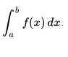
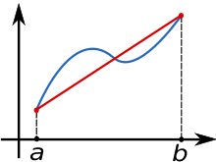
The function f(x) (in blue) is approximated by a linear function (in red).
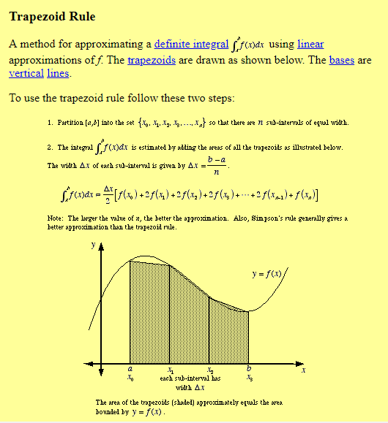
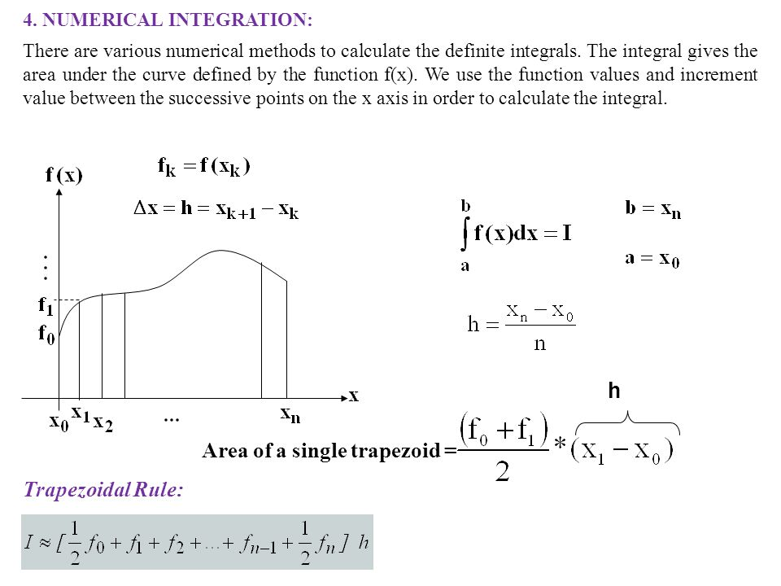

Example 1.
Approximate the integral of f(x) = x³ on the interval [1, 2] with four subintervals.
First, h = (2 - 1)/4 = 0.25, and thus we calculate:
½⋅(f(1) + 2⋅(f(1.25) + f(1.5) + f(1.75)) + f(2))⋅0.25
= ½⋅(1³ + 2⋅(1.25³ + 1.5³ + 1.75³) + 2³)⋅0.25 = 3.796875

If n=8
we set h = (2 - 1)/8 = 0.125, and thus we calculate:
½⋅(f(1)+2⋅(f(1.125)+f(1.25)+f(1.375)+f(1.5)+f(1.625)+f(1.75)+f(1.875))+f(2))⋅0.125
= ½⋅(1³+2⋅(1.125³+1.25³+1.375³+1.5³+1.625³+1.75³+1.875³)+2³)⋅0.25 = 3.76171875
The second approximation is much closer to the correct answer of 3.75.
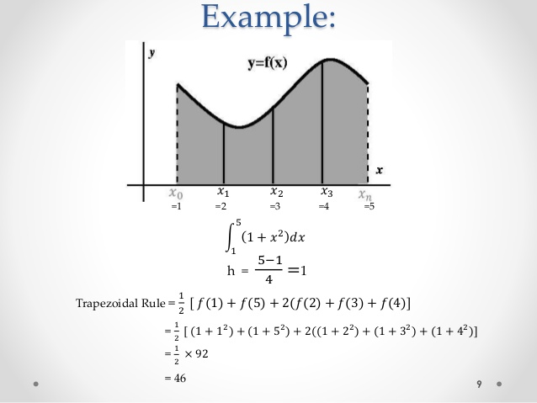

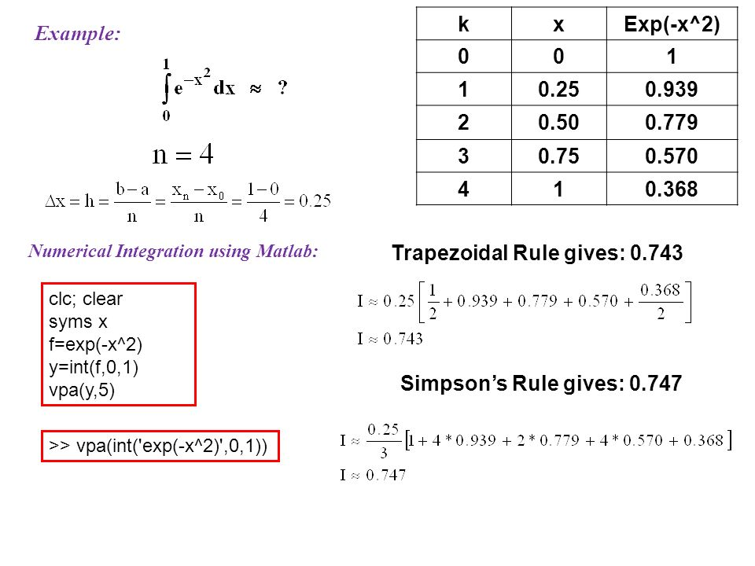

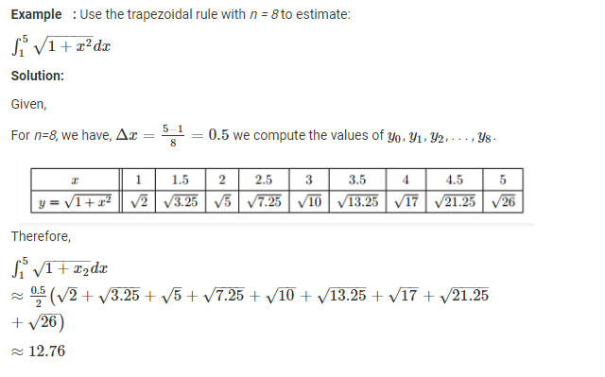

function It=trapezios(f,a,b,N)
h=(b-a)/N;
It=0;
for k=1:(N-1)
x=a+h*k;
It=It+feval(f,x);
end
It=h*(f(a)+f(b))/2+h*It;
End

Example
Evaluate the integral x^4 within limits -3 to 3 using Trapezoidal rule.

Solution
Let y(x)=x^4
here a=-3 and b=3
therefore (b-a)=6
let ‘n’ be the number of intervals. assume n=6 in this case.
also h=(b-a)/n = 6/6 =1
x: -3 -2 -1 0 1 2 3
y: 81 16 1 0 1 16 81
According to trapezoidal rule:
answer= (h/2)*[(y1+y7)+2*(y2+y3+y4+y5+y6)]
answer=(1/2)*[(81+81)+2*(16+1+0+1+16)]
answer=115.
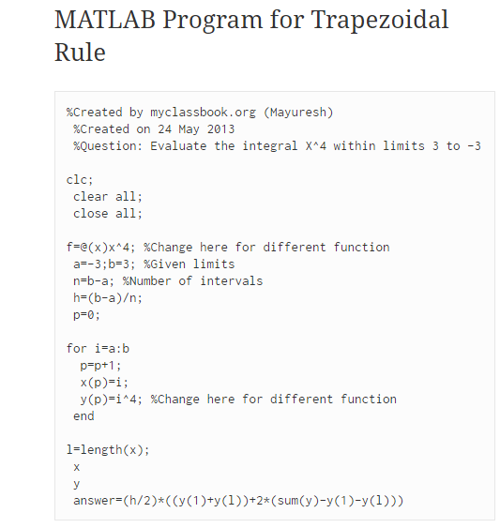

References
- Atkinson, Kendall E. (1989), An Introduction to Numerical Analysis (2nd ed.), New York: John Wiley & Sons, ISBN 978-0-471-50023-0
- Rahman, Qazi I.; Schmeisser, Gerhard (December 1990), "Characterization of the speed of convergence of the trapezoidal rule", Numerische Mathematik, 57 (1): 123–138, doi:10.1007/BF01386402, ISSN 0945-3245
- Burden, Richard L.; Faires, J. Douglas (2000), Numerical Analysis (7th ed.), Brooks/Cole, ISBN 978-0-534-38216-2
- Weideman, J. A. C. (January 2002), "Numerical Integration of Periodic Functions: A Few Examples", The American Mathematical Monthly, 109 (1): 21–36, doi:10.2307/2695765, JSTOR 2695765

