Lecture 17
The Structure of Conversation
Conversation is a form of oral discourse.
Every conversation has a topic development phase which is framed by opening and closing phrase. In between these two phases there are some moves: topic initiation, topic maintenance and topic change.
- The rules of proper conversation vary with the culture
- Comparison of four forms of discourse
Debates:
Topics specified in advance and rules specifying who can speak at a given time and for how long.
Ceremonies:
The topic is specified in advance but not the length of time any given speaker may take.
Meetings:
Meetings are typically less formal than either ceremonies or debates.
Conversations:
Conversations are the least formal of these four types of oral discourse.
Conversation follows a proper structure that consists of participants , opening and closing stages. The roles that participants assume influence the topics that may be discussed as well as the interpretation given to conversational acts.
Opening Conversations
A conversation opener is an introduction used to begin a conversation. Different situations may call for different openers (e.g. approaching a stranger on the street versus meeting them at a more structured gathering of people with like interests).
Only one person speaks at a time
there is considerable individual variation in the number of turns a given speaker will take and the length of each turn.
the number of possibilities for opening conversations is infinite. E.g.
(Hey, Carl ), request information (Do you know what time it is?), offer information (Are you looking for someone?), or use some form of stereotyped expression (Hello) or topic (Strange weather lately, eh?).
Conversation openers serve to get the listener’s attention and often lead to stock replies.
Like all text, conversations have both a beginning and an end. These are also sign-posted by the speaker(s).
Closing Conversations
Conversations do not just end, rather they must be closed, through an elaborate ritual. One must take into account the fact that conversation endings involve inherent face threats.

Albert and Kessler (1978), list ways to end conversations:
- Summarizing the content
- Justifying ending contact
- expressing pleasure
- Making reference to the ongoing relationship
- Planning for future contact
Closing moves form a sequence, with the items occurring in the order indicated earlier.
Use of closing sequences was reciprocal.
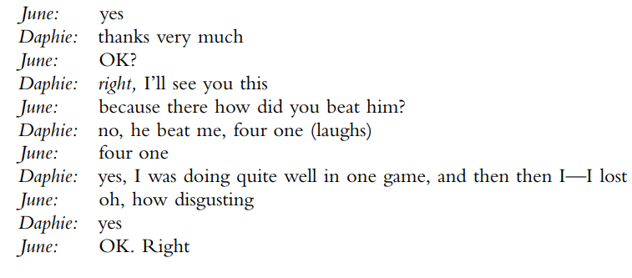 Moving to end a conversation may be interpreted to mean that one does not wish for the conversation to continue. This in turn risks the implication that the company of the other is not being enjoyed, which then could imply that the interlocutor is boring, for example, or annoying.
Taking Turns
Turn-taking is a type of organization in conversation and
Discourse where participants speak one at a time in alternating turns. In practice, it involves processes for constructing contributions, responding to previous comments, and transitioning to a different speaker, using a variety of linguistic and non-linguistic cues.
Sacks and colleagues (1974), turn taking during conversations operates by three implicit rules.
Turn-yielding signal: as the display of one or more of six behavioral cues that appear to indicate a willingness to conclude one’s turn. (1) a drop of pitch (2) a drawl on the final syllable or final stressed syllable of a final clause (3) the termination of hand gestures (4) the use of stereotyped expressions (5) a drop in loudness(6) completion of a grammatical clause.
Attempt-suppressing signal: the continued use of hand gestures in conjunction with one or more of the turn-yielding cues.
Face-to-face encounters enable us to attend to all of these nonverbal behaviors.
Turn-taking has been described as a process which obtain a distribution of talk across two participants. The time gap between one person stopping and the other starting being just a few fractions of a second, yet the co-ordination is achieved with some rapidity and turns are appropriated in orderly fashion.
Negotiating Topics of Conversations
It is not enough, however, merely to take turns with others in conversation. As Grice (1975) has noted, there is a strong social convention to ‘‘be relevant.’’ In conversations, this means sticking to the topic and tying one’s comments to those of the previous speaker.
- Topics in conversation can be defined in terms of the intersection of propositions across sentences (Schank,1977).
Speaker A says, John bought a red car in Baltimore yesterday
- Numerous propositions are being advanced: John bought a car, the car is red, John bought it in Baltimore, and John bought it yesterday.
- Only conversations, not individual sentences or even speaker turns, have topics.
- Noncommittal statements are common when there are lulls in a conversation.
- Any statement provides multiple opportunities for topic shifts
- Polanyi (1989) has analyzed conversational storytelling and has found that it differs in interesting ways from conversational discourse in general.
- Conversations differ from other forms of speech interactions in the number of people and the degree to which topics, turn lengths, and turn orders are specified in advance. Thus, unlike debates, conversations operate without a rigid set of explicit rules.
Identifying Participants and Nonparticipants
During conversations, speakers establish their and others' participant roles (who participates in the conversation and in what capacity)
- We resort to a variety of strategies when dealing with overhearers, including disclosure, concealment, and indifference
- We resort to a variety of strategies in private conversations to conceal our meaning from eavesdroppers, including referring to personal events (for example, the event we talked about yesterday)
Different roles in conversation
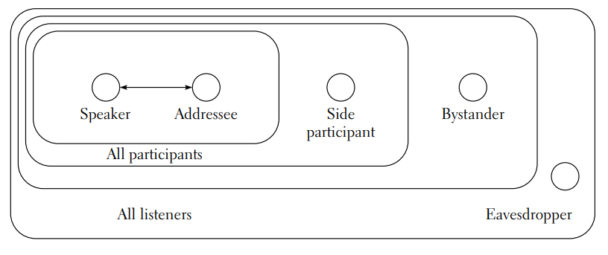 Conversations often take place in a context in which various types of nonparticipants are also present.
The roles of the participants during social interaction are particularly important for understanding spoken discourse .While these roles might be fixed in some social settings (e.g. lectures), most conversational settings allow for shifting of roles.

