Lecture – 3 / cell injury
Dr Hussain Abady
Mechanism of cell injury
The mechanisms responsible for cell injury are complex, however, several principles are relevant to most forms of cell injury;
- The cellular response to injurious stimuli depends upon;
- nature of the injury.
- duration of injury.
- severity of injury.
So mild transient injurious agent may induce reversible cell injury, whereas severe one results in irreversible cell injury or instantaneous cell death.
- The consequences of cell injury depend upon;
- type of injured cells.
- state of injured cells.
- adaptability of the injured cell.
- genetic makeup of injured cells.
- Cell injury is result from different biochemical mechanisms acting on several essential cellular components and simultaneously trigger multiple interconnected mechanisms that damage cells.
- Cellular components that are most frequently damaged by injurious stimuli include;
- Mitochondria.
- Membranes.
- Machinery of protein synthesis and packaging.
- DNA in nuclei.
- The principal mechanisms of cell injury as in figure below and include;

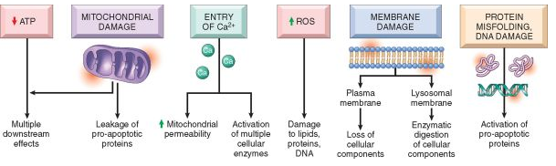
- ATP depletion
ATP depletion and decreased ATP synthesis is frequently the result of both hypoxic and chemical (toxic) injury. ATP is produced in two ways;
- The major pathway is oxidative phosphorylation of adenosine diphosphate in mitochondria in presence of oxygen.
- The second is the glycolytic pathway, which can generate ATP in the absence of oxygen using glucose.
The major causes of ATP depletion are;
- reduced supply of oxygen and nutrients,
- mitochondrial damage,
- actions of some toxins (e.g., cyanide which block oxidative phosphorylation).
Tissues with a greater glycolytic capacity (e.g., the liver) are able to survive loss of oxygen and decreased oxidative phosphorylation better than are tissues with limited capacity for glycolysis (e.g., the brain).

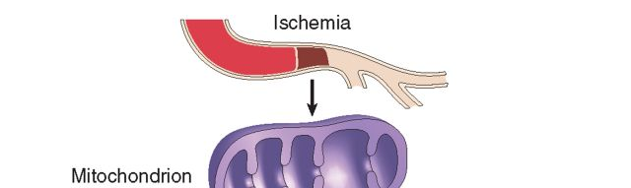
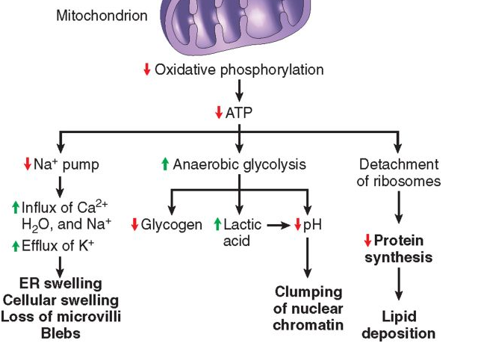
Depletion of ATP to 5% to 10% of normal levels has widespread effects on many critical cellular systems:
- Reduction of activity of the plasma membrane energy-dependent sodium pump (ouabain-sensitive Na⁺, K⁺-ATPase).
- Cellular energy metabolism is altered. decrease in cellular ATP stimulate, leading to an increased rate of anaerobic glycolysis. As a consequence, glycogen stores are rapidly depleted with accumulation of lactic acid. This reduces the intracellular pH (acidosis).
- Failure of the Ca²⁺ pump leads to influx of Ca²⁺, with damaging effects on numerous cellular components (high intracellular Ca+ stimulates enzymes phospholipase, endonucleases, and ATPase).
- With prolonged or worsening depletion of ATP, structural disruption of the protein synthetic apparatus occurs, manifested as detachment of ribosomes from the rough ER and dissociation of polysomes, with a consequent reduction in protein synthesis. proteins may become misfolded, and misfolded proteins trigger a cellular reaction called the unfolded protein response that may culminate in cell injury and even death by apoptosis.

- Mitochondrial damage
Mitochondria are the cell's suppliers of energy in the form of ATP. Mitochondria is sensitive to virtually all types of injurious stimuli can be damaged by;
- increases of cytosolic Ca²⁺.
- reactive oxygen species.
- oxygen deprivation.
- toxins.
- mutations in mitochondrial genes cause of some inherited diseases.
There are two major consequences of mitochondrial damage;
- Mitochondrial damage often results in failure of oxidative phosphorylation and progressive depletion of ATP, culminating in necrosis of the cell.
- The mitochondria also sequester between their outer and inner membranes several proteins that are capable of activating apoptotic pathways; these include cytochrome c and proteins that indirectly activate apoptosis inducing enzymes called caspases.

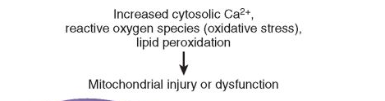
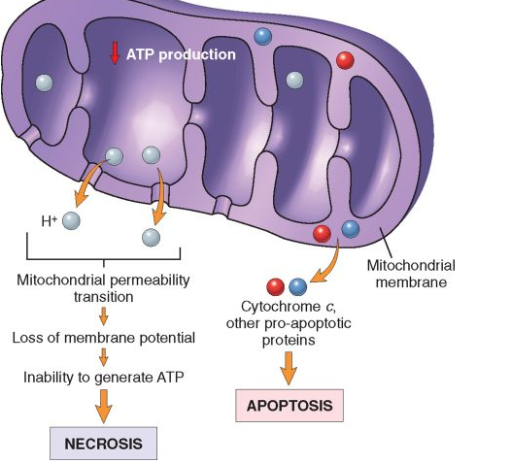

- INFLUX OF CALCIUM AND LOSS OF CALCIUM HOMEOSTASIS;
Ischemia and certain toxins cause an increase in cytosolic calcium concentration. Increased intracellular Ca²⁺ causes cell injury by several mechanisms;
- The accumulation of Ca²⁺ in mitochondria results in opening of the mitochondrial permeability transition pore and failure of ATP generation.
- Increased cytosolic Ca²⁺ activates a number of enzymes;
- phospholipases (which cause membranes damage),
- proteases (which break down both membrane and cytoskeletal proteins).
- endonucleases (which are responsible for DNA and chromatin fragmentation).
- ATPases (thereby hastening ATP depletion).
- Increased intracellular Ca²⁺ levels also result in the induction of apoptosis, by direct activation of caspases and by increasing mitochondrial permeability.

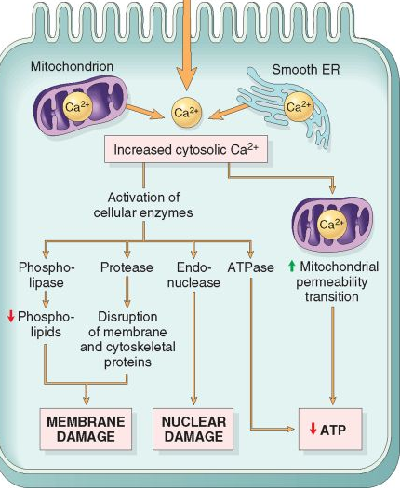

- ACCUMULATION OF OXYGEN-DERIVED FREE RADICALS (OXIDATIVE STRESS);
Cell injury induced by free radicals, particularly reactive oxygen species, is an important mechanism of cell damage in many pathologic conditions, such as
- Chemical injury.
- radiation injury.
- ischemia-reperfusion injury.
- cellular aging.
- microbial killing by phagocytes.
Free radicals are chemical species that have a single unpaired electron in an outer orbit and characterized by;
- Free radicals react with inorganic or organic chemicals—proteins, lipids, carbohydrates, nucleic acids—many of which are key components of cell membranes and nuclei.
- Moreover, free radicals initiate autocatalytic reactions, whereby molecules with which they react are themselves converted into free radicals, thus propagating chain of damage.
- Reactive oxygen species (ROS); are a type of oxygen-derived free radical that are produced normally in cells during mitochondrial respiration and energy generation, but they are degraded and removed by cellular defense systems.
Oxidative stress; Occurs when the production of ROS increases or the scavenging systems are ineffective, the result is an excess of these free radicals. Oxidative stress has been implicated in a wide variety of pathologic processes, including;
- cell injury.
- Cancer.
- Aging.
- some degenerative diseases such as Alzheimer disease.
- ROS are also produced in large amounts by leukocytes, particularly neutrophils and macrophages in inflammatory reactions as mediators for destroying microbes, dead tissue, and other unwanted substances.
Types of ROS are:
- Superoxide (O₂⁻) are produced from oxygen by oxidative enzymes in the endoplasmic reticulum, mitochondria, plasma membrane, peroxisomes, and cytosol.
- Hydrogen peroxide (H₂O_{2),} is produced from (O₂⁻) by dismutation by action of superoxide dismutase (SOD). H₂O₂ is also derived directly from oxidases in peroxisomes.
- Hydroxyl radical (OH⁻) is produced from H2O2 by the Cu²⁺/Fe²⁺ by Fenton reaction. The absorption of radiant energy (e.g., ultraviolet light, x-rays). Ionizing radiation can hydrolyze water into hydroxyl (OH⁻) and hydrogen (H⁻) free radicals.

Mechanisms for removal of free radicals; Free radicals are inherently unstable and decay spontaneously. There are also several non-enzymatic and enzymatic systems that contribute to inactivation of free-radical reactions;
- Superoxide dismutase (SOD) in mitochondria coverts superoxide (O₂⁻) into H2O2.
- Glutathione peroxidase in mitochondria converts hydroxyl radical (OH⁻) into hydrogen peroxide H2O2.
- Catalase in peroxisomes coverts hydrogen peroxide H2O2 into H2O and oxygen
(O2).
- Endogenous or exogenous antioxidants (e.g., vitamins E, A, and C, green tea and
β-carotene) may either block the formation of free radicals or scavenge them once
they have formed.
- Iron and copper can catalyze the formation of ROS. The levels of these reactive
metals are reduced by binding of the ions to storage and transport proteins (e.g.,
transferrin, ferritin, lactoferrin, and ceruloplasmin).

Pathologic effect of ROS
ROS react with following structures causing cell injury and death;
- React with fatty acids causing oxidation with generation of lipid peroxidases leading to disruption of plasma membrane and organelles membranes.
- React with proteins causing oxidation leading to loss of enzymatic activity and abnormal protein folding.
- React with DNA causing oxidation resulting in mutations and breaks.
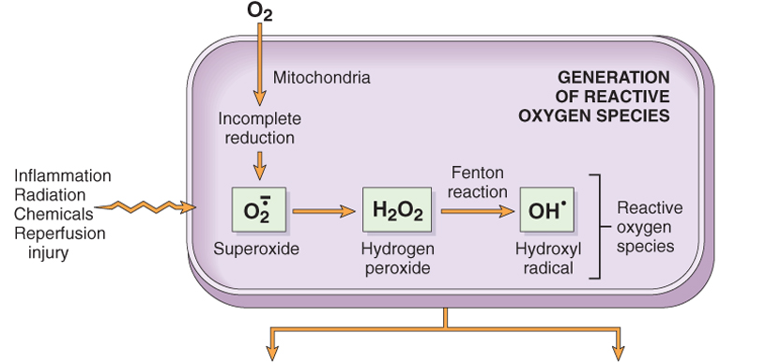
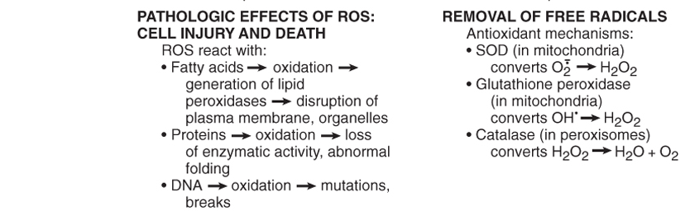
- Enzymatic metabolism of exogenous chemicals or drugs can generate free radicals that are not ROS but have similar effects (e.g., CCl₄ can generate CCl₃, described later in the chapter).
- Transition metals such as iron and copper donate or accept free electrons during intracellular reactions and catalyze free radical formation, as in the Fenton reaction (H₂O₂ + Fe²⁺ ➙ Fe³⁺ + OH + OH-).
- Nitric oxide (NO), an important chemical mediator generated by endothelial cells, macrophages, neurons, and other cell types, can act as a free radical.

- Defects in Membrane Permeability
Early loss of selective membrane permeability leading membrane damage is a consistent feature of most forms of cell injury (except apoptosis).
Biochemical mechanisms that contribute to membrane damage are;
- Decreased phospholipid synthesis; due to fall in ATP levels, leading to decreased energy-dependent enzymatic activities.
- Increased phospholipid breakdown; due to activation of endogenous phospholipases by increased levels of cytosolic Ca²⁺. Oxygen free radicals cause injury to cell membranes by lipid peroxidation.
- Cytoskeletal abnormalities; Cytoskeletal filaments serve as anchors connecting the plasma membrane to the cell interior. Activation of proteases by increased cytosolic Ca²⁺ may cause damage to elements of the cytoskeleton.
- Lipid breakdown products; These include un-esterified free fatty acids, acyl carnitine, and lysophospholipids result of phospholipid degradation by their detergent effect on membranes and by causing changes in permeability and electrophysiologic alterations.
Causes membrane damage are;
- ischemia,
- various microbial toxins,
- lytic complement components,
- variety of physical and chemical agents.
The most important sites of membrane damage during cell injury are;
- Mitochondrial membrane damage; damage to mitochondrial membranes results in decreased production of ATP, culminating in necrosis, and release of proteins that trigger apoptotic death.
- Plasma membrane damage; Plasma membrane damage leads to loss of osmotic balance as well as loss of cellular contents.
- lysosomal membranes; results in leakage of their enzymes into the cytoplasm. Lysosomes contain RNases, DNases, proteases, glucosidases, and other enzymes leading to enzymatic digestion of cell components, and the cells die by necrosis.

- Damage to DNA and Proteins
Cells have mechanisms that repair damage to DNA. P53 (tumor suppressor gene) stops cell cycle of DNA damaged cells and induce DNA repair by DNA repair enzymes, but if this damage is too severe to be corrected, P53 will induces cell death by apoptosis (suicide program). Improperly folded proteins, whether due to inherited mutations or to injury such as by free radicals also trigger apoptosis.
Examples of cell injury and necrosis
- Ischemic and hypoxic injury;
Ischemia (diminished blood flow to a tissue) resulting in diminished supply of oxygen and nutrients to tissues. It is the most common cause of cell injury in clinical medicine, while hypoxia is reduced oxygen delivery to tissues. Ischemia injures tissues faster than does hypoxia. Ischemia and hypoxia results in reduced ATP production with failure of energy dependent essential systems in the cells, if continue results in irreversible cell injury and death by necrosis.
- Ischemia-reperfusion injury;
Usually restoration of blood flow to reversibly injured cells can result in cell recovery. However, under certain circumstances it results, paradoxically, in exacerbated and accelerated injury especially in myocardial and cerebral infarctions.
- Chemical (toxic) injury;
Some chemicals act directly by combining with a critical molecular component or cellular organelle, (e.g.) in mercuric chloride poisoning, mercury binds to the sulfhydryl groups of various cell membrane proteins, causing inhibition of ATP-dependent transport and increased membrane permeability. Metabolites of other drugs and chemicals such as Carbon tetrachloride (CCl₄) and the analgesic acetaminophen cause cell injury directly or by free radical’s formation.

Serum markers for cell necrosis

Leakage of intracellular proteins through the damaged cell membrane and ultimately into the circulation provides a means of detecting tissue-specific cellular injury and necrosis using blood serum samples for example;
- Cardiac muscle enzymes; for example, contains a specific isoform of the enzyme creatine kinase-MB and of the contractile protein troponin, estimation of these protein help in diagnosis of myocardial infarction
- Bile duct epithelium contain an isoform of the enzyme alkaline phosphatase; and hepatocytes contain transaminase enzymes (SGPT & SGOT), estimation of SGPT & SGOT help in diagnosis of hepatocellular diseases, while estimation of Alkaline phosphatase helps in diagnosis of biliary diseases.

