Cell injury/Lecture-5
Dr Hussain Abady

Intracellular accumulations;
- Under some circumstances cells may accumulate abnormal amounts of various substances, which may be harmless or associated with varying degrees of injury.
- The substance may be located in the cytoplasm, within organelles (typically lysosomes), or in the nucleus.
- It may be synthesized by the affected cells or produced elsewhere.
- There are three main pathways of abnormal intracellular accumulation
- A normal substance is produced at a normal or an increased rate, but the metabolic rate is inadequate to remove it. An example of this type of process is fatty change in the liver.
- An abnormal endogenous substance accumulates because of genetic or acquired defects in its folding, packaging, transport, or secretion. (e.g., α1-antitrypsin deficiency).
- An abnormal exogenous substance is deposited and accumulates because the cell has neither the enzymatic machinery to degrade the substance nor the ability to transport it to other sites. Accumulations of carbon or silica particles are examples of this type of alteration.

- Fatty changes (steatosis): abnormal accumulation of triglycerides within parenchymal cells. It is most often seen in the liver, since this is the major organ involved in fat metabolism, but it may also occur in heart, skeletal muscle, kidney, and other organs. Significance of fatty change depends on the cause and severity of the accumulation.
- When mild it may have no effect on cellular function.
- More severe fatty change may transiently impair cellular function,
fatty change is usually reversible.
- In the severe form, fatty change may precede cell death, and may be an early lesion in a serious liver disease called nonalcoholic steatohepatitis.
Steatosis may be caused by;
- Alcohol abuse.
- Diabetes mellitus.
- Obesity.
- Toxins.
- protein malnutrition.
- Anoxia.

Morphology of fatty accumulation
Fatty accumulation appears as clear vacuoles within parenchymal cells. Special staining techniques are required to distinguish fat from intracellular water or glycogen, which are Sudan IV or oil red O (these stain fat orange-red).
Fatty change is most commonly seen in the liver and the heart.
- Mild fatty change in the liver may not affect the gross appearance. protein
- It increases in weigh 3 to 6 kg (1.5-3 times the normal weight) and appear bright yellow, soft, and greasy.
- Early fatty change is seen by light microscopy as small fat vacuoles in the cytoplasm around the nucleus. In later stages, the vacuoles coalesce to create cleared spaces that displace the nucleus to the cell periphery. Occasionally contiguous cells rupture, and the enclosed fat globules unite to produce so-called fatty cysts.
- Cholesterol and Cholesteryl Esters
- Cellular cholesterol metabolism is tightly regulated to ensure normal cell membrane synthesis without significant intracellular accumulation.
- However, phagocytic cells may become overloaded with lipid (triglycerides, cholesterol, and cholesteryl esters) in several different pathologic processes, such foam cells in atherosclerosis and xanthoma of skin in hyperlipidemia.
- Accumulation of protein
- protein accumulations are much less common than lipid accumulations; they may occur because;
- excesses are presented to the cells. In nephrotic syndrome, there is a much larger reabsorption of the protein resulting in the histologic appearance of pink, hyaline cytoplasmic droplets.

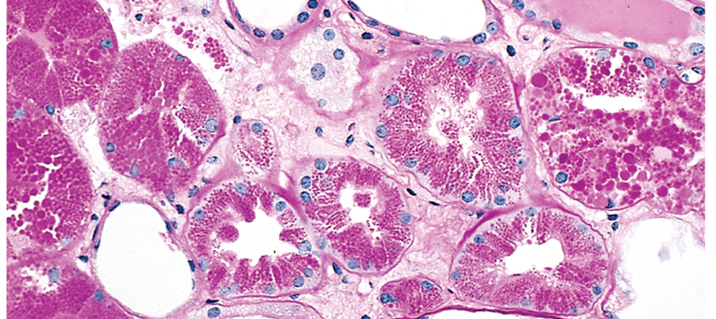

Kidney showing protein accumulation in cytoplasm of renal tubules
- because the cells synthesize excessive amounts. For example, marked accumulation of newly synthesized immunoglobulins in plasma cells forming Russell bodies.

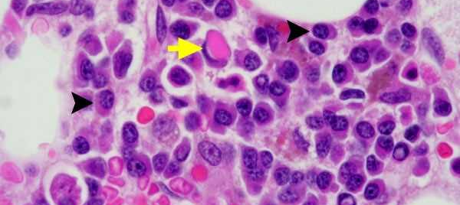

Bone marrow showing plasma cells with Russel bodies (arrows).

- Accumulation of pigments
Pigments are colored substances that are either
- exogenous, coming from outside the body. The most common exogenous pigment is carbon when inhaled, it is phagocytosed by alveolar macrophages. Mild accumulation is called (anthracosis). Heavy accumulations may induce emphysema or a fibroblastic reaction that can result in a serious lung disease called coal workers' pneumoconiosis.
- endogenous, synthesized within the body itself such as, lipofuscin, melanin, and certain derivatives of hemoglobin. Hemosiderin is a hemoglobin-derived granular pigment that accumulates in tissues when there is a local or systemic excess of iron. Iron is normally stored within cells in association with the protein apoferritin, forming ferritin micelles. Hemosiderin pigment represents large aggregates of these ferritin micelles, readily visualized by light and electron microscopy. Prussian blue histochemical reaction stain iron. Causes of Hemosiderosis are;
(1) increased absorption of dietary iron,
(2) impaired utilization of iron,
(3) hemolytic anemias, and
(4) transfusions.
Extensive accumulations of iron are seen in hereditary hemochromatosis with tissue injury including liver fibrosis, heart failure, skin and diabetes mellitus (bronzed diabetes).

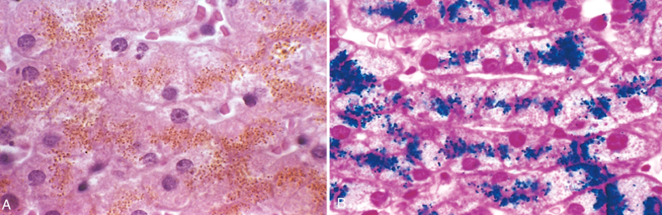

Hemosiderin granules in liver cells. A, H&E section showing golden-brown, finely granular pigment. B, Prussian blue reaction, specific for iron.

Pathological calcification
Pathologic calcification implies the abnormal deposition of calcium salts, together with smaller amounts of iron, magnesium, and other minerals.
- When the deposition occurs in dead or dying tissues, it is called dystrophic calcification. it occurs in the absence of calcium metabolic derangements (i.e., with normal serum levels of calcium).
- In contrast, the deposition of calcium salts in normal tissues is known as metastatic calcification and almost always reflects some derangement in calcium metabolism (hypercalcemia). The causes of hypercalcemia are;
- increased secretion of parathyroid hormone.
- destruction of bone due to (e.g., Paget disease), immobilization, or tumors (increased bone catabolism associated with multiple myeloma, leukemia, or diffuse skeletal metastases).
- vitamin D-related disorders including vitamin D intoxication and sarcoidosis (in which macrophages activate a vitamin D precursor); and
- renal failure, in which phosphate retention leads to secondary hyperparathyroidism.

Cellular aging
Cellular aging is the result of a progressive decline in the proliferative capacity and life span of cells and the effects of continuous exposure to exogenous factors that cause accumulation of cellular and molecular damage. Several mechanisms are known or suspected to be responsible for cellular aging;
DNA damage; Cellular aging is associated with increasing DNA damage, which may happen during normal DNA replication and can be enhanced by free radicals. Although most DNA damage is repaired by DNA repair enzymes, some persists and accumulates as cells age. Some aging syndromes are associated with defects in DNA repair mechanisms. Calorie restriction was associated with prolonged life span because it activates proteins of the Sirtuin family activate DNA repair enzymes.
Decreased cellular replication; All normal cells have a limited capacity for replication. After a fixed number of divisions cells become arrested in a terminally nondividing state, known as replicative senescence.
Telomeres are short repeated sequences of DNA present at the linear ends of chromosomes that are important for ensuring the complete replication of chromosome ends and for protecting the ends from fusion and degradation. When somatic cells replicate, a small section of the telomere is not duplicated, and telomeres become progressively shortened. As the telomeres become shorter, the ends of chromosomes cannot be protected and are seen as broken DNA, which signals cell cycle arrest.
Recent studies suggest that with age, the p16 (CDKN2A) protein accumulates in stem cells, and they progressively lose their capacity to self-renew. p16 is a physiological inhibitor of cell cycle progression.
Accumulation of metabolic damage. Cellular life span is also determined by a balance between damage resulting from metabolic events occurring within the cell and counteracting molecular responses that can repair the damage.

