Labour & its physiology د.شذى سامي
المرحلة الرابعة2016-2017
Labour is defined as the onset of regular painful contractions with progressive cervical effacement and dilatation of the cervix accompanied by descent of the presenting part.and end by delivery of the fetus and placenta,it should be differentiated from faulse labour.
Comparision between true & false labour
True Labor | False Labor
- Contractions are at regular intervals  - Intervals between contractions gradually shorten.  - Contractions increase in duration and intensity  - Discomfort begins in back and radiates around to abdomen  - Intensity usually increases with walking  - Cervical dilatation and effacement are progressive.  - Contractions do not decrease with rest or warm tub bath | Contractions are irregular  Usually no change  Usually no change.  Discomfort is usually in abdomen.  Walking has no effect on or lessens contractions  No change  Rest and warm tub baths lessen contractions.

The criteria of normal labour
1.Spontaneous expulsion
2.a single
3.mature fetus (37 completed weeks – 42 weeks)
- presented by vertex
5.through the birth canal (i.e. vaginal delivery)
6.within a reasonable time (not less than 3 hours or more than 18 hours)
7.without complications to the mother,or the fetus

FACTORS THAT INFLUENCE PROGRESS OF LABOUR

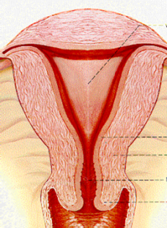power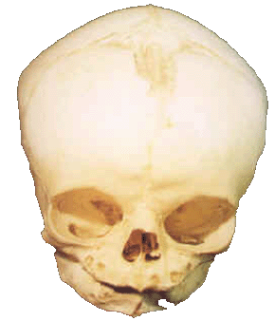passenger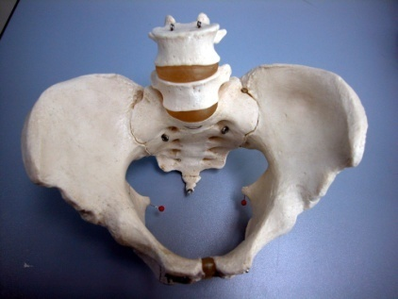pelvis
Causes of Onset of Labour:
It is unknown but the following theories were postulated
A.Hormonal factors
1) Estrogen theory: During pregnancy, most of the oestrogens are present in a binding form. During the last trimester, more free oestrogen appears increasing the excitability of the myometrium and prostaglandins synthesis
2) Progesterone withdrawal theory: Before labour, there is a drop in progesterone synthesis leading to predominance of the excitatory action of oestrogens.
3) Prostaglandins theory: Prostaglandins E2 and F2α are powerful stimulators of uterine muscle activity. PGF2α was found to be increased in maternal and foetal blood as well as the amniotic fluid late in pregnancy and during labour.
4) Oxytocin theory: Although oxytocin is a powerful stimulator of uterine contraction, its natural role in onset of labour is doubtful. The secretion of oxytocinase enzyme from the placenta is decreased near term due to placental ischaemia leading to predominance of oxytocin’s action.
5) Fetal cortisol theory: Increased cortisol production from the foetal adrenal gland before labour may influence its onset by increasing oestrogen production from the placenta.
B.Mechanical factors
1) Uterine distension theory
2) Stretch of the lower uterine segment by the presenting near term

SYMPTOMS AND SIGNS OF LABOUR
Before labour begins, women usually notice one or more premonitory, or warnings, signs that labour is about to begin.
They are:
1.Painful regular uterine contractions – as evidence by contraction at least one in ten minutes
2.Show – as evidence by mucus mixed with blood
3.Rupture of membranes – as evidence by leaking liquor
4.Progressive shortening and dilatation of the cervix

The stages of labour
Labour can be divided into three stages:
First stage This describes the time from the diagnosis of labour to full dilatation of the cervix (10 cm).
The ﬁ rst stage of labour can be divided into two phases:
The ‘latent phase’ is the time between the onset of labour and 3–4 cm dilatation. During this time, the cervix becomes ‘fully effaced.
Effacement is a process by which the cervix shortens in length as it becomes included into the lower segment of the uterus. The process of effacement may begin during the weeks preceding the onset of labour, but will be complete by the end of the latent phase. The cervical os cannot usually begin to dilate until effacement is complete. Effacement and dilatation should be thought of as consecutive events in the nulliparous woman, but may occur simultaneously in the multiparous woman.
Dilatation is expressed in centimetres between 0 and 10. The duration of the latent phase is variable, However, it usually lasts between 3 and 8 hours, being shorter in multiparous women.

The second phase of the ﬁ rst stage of labour is called the ‘active phase’ and describes the time between the end of the latent phase (3–4 cm dilatation) and full dilatation (10 cm). It is also variable in length, usually lasting between 2 and 6 hours. Again, it is usually shorter in multiparous women. Cervical dilatation during the active phase usually occurs at 1 cm/hour or more in a normal labour

Second stage :
This describes the time from full dilatation of the cervix to delivery of the fetus or fetuses. The second stage of labour may also be subdivided into two phases:
The passive phase:
describes the time between full dilatation and the onset of involuntary expulsive contractions. There is no maternal urge to push and the fetal head is still relatively high in the pelvis.
active second stage
There is a maternal urge to push because the fetal head is low (often visible), causing a reﬂ ex need to ‘bear down’. In a normal labour, second stage is often diagnosed at this point. If a, the active second stage is said to begin when she starts making voluntary active efforts. Conventionally, a normal active second stage should last no longer than 2 hours in a primiparous woman and 1 hour in those who have delivered vaginally before, but there is evidence that a second stage of labour lasting more than 3 hours is associated with increased maternal and fetal morbidity. Use of epidural anaesthesia may inﬂ uence the length and the management of the second stage of labour.

Third stage :
This is the time from delivery of the fetus or fetuses until delivery of the placenta(e). The placenta is usually delivered within a few minutes of the birth of the baby,about 15 minute,and there is asigns of sepration of placenta preceding any trial to delivery of it:
1.gush of bleedingfrom site of sepration of placental bed.
2.increased the length of cord.
3.uterus become round globular due to decreasing the size of uterus and starting of countraction.
4.placenta in vagina on PV examination
Fourth stage
a postpartum period of about 4 hours after the third stage, or delivery of the placenta. Some complications, especially hemorrhage, occur at this time, necessitating careful observation of the mother
a.Observation for the patient particularly atony of the uterus and vaginal bleeding
b.Care of The Newborn:
- Clearance of the air passages
- The newborn is placed in supine position with the head lower down. A metal, rubber or better disposable plastic catheter is used to aspirate the mucus from the pharynx and mouth directly by the physician’s mouth or by attach it to an electric suction pump.
- Crying of the baby is usually occurs within seconds, if delayed slapping its soles, flexion and extension of the legs and rubbing the back usually stimulate breathing.
- Congenital anomalies
- The newborn is examined for injuries or congenital anomalies as imperforate anus, hypospadias (not to be circumcised as the cut skin will be used in the repair later on), cyanotic heart diseases.... etc

