Management of labour د.شذى سامي
The AIMS include:
1.To achieve delivery of a normal healthy child
2.To anticipate, recognize and treat potential abnormal conditions before significant hazard develops for the mother or the fetus.

PRINCIPLES IN THE MANAGEMENT OF LABOUR:
These include:

1.Diagnosis of labour
2.Monitoring the progress of labour
3.Ensuring maternal well-being
4.Ensuring fetal well-being

MANAGEMENT of FIRST STAGE OFLABOUR

Maternal
On admission:
a complete history must be taken.
General examination of the mother
a) General conditions – evaluate the mother general health condition. Look for pallor,
edema, abdominal scar (LSCS) and maternal height.
b) Vital signs – Blood pressure, pulse, respiration and temperature are taken and recorded
c) Heart and lungs
d) Urine analysis – for protein, sugar and ketone
- Abdominal examination:
a) A detailed abdominal examination should be carried out and recorded.
b) Determine the presentation and position of the fetus and also the engagement
c) Auscultate the fetal heart
d) Evaluate the uterine contraction

- Vaginal examination – the purpose is to
a) To make a positive diagnosis of labour
b) To make a positive identification of presentation
c) To determine whether the fetal head is engaged in case of doubt
d) To ascertain whether the fore waters have ruptured or to rupture them artificially
e) To exclude cord prolapse after rupture of the fore waters
f) To confirm the degree of cervical dilatation and position of the presenting part
g) To assess progress of labour.
h) To assess the adequacy of the pelvis.
- Bowel preparation:
If there has been no bowel action for 24 hours or the rectum feels loaded on vaginal examination an enema is given.
- Bladder care
A full bladder may initially prevent the fetal head from entering the pelvic brim and later impede descent of the fetal head. It will also inhibit effective uterine action.
The woman should be encouraged to empty her bladder every 1½ - 2 hours during labour.
The quantity of urine passed should be measured and recorded and a specimen obtained for testing.
- Nutrition in early labour
No food is permitted after labour is established – to prevent regurgitation and aspiration
It is important to maintain adequate hydration - via intravenous routes
- Position of labouring mother:
As long as the patient is healthy, the presentation normal, the presenting part engaged, and the fetus in good condition, the patient may walk about or may be in bed, as she wishes
Monitoring the progress of labour
Once labour has become established, all events during labour should be recorded on a partogram.
a) The well-being of the fetus
b) The well-being of the mother
c) The progress of the labour
- Pain relief
When the pains are severe an analgesic preparation may be given.
a) Opiate drugs – e.g. Pethidine given intramuscularly every 4 hour
b) Inhalational analgesia – e.g. Entonox
c) Epidural analagesia
MONITORING FETAL HEART:
Monitoring of fetal heart should be every 15 minute in first stage before & after contraction ,& every 5 minute in the second stage.continuos monitoring required in certin cases.
- Auscultation methods
- Electronic monitoring ~ CTG
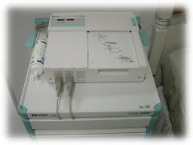

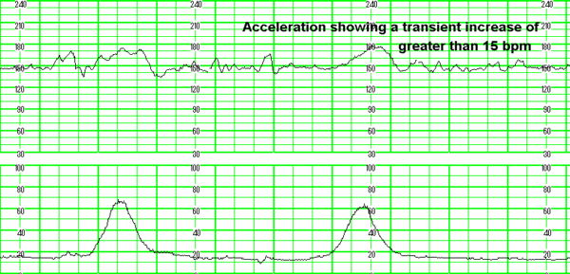

RECORDING THE PROGRESS OFLABOUR
RECORDING THE PROGRESS OF LABOUR - Partogram :this involved:
Patient information: Fill out name, gravida, para, hospital number, date and time of admission and time of ruptured membranes.
Fetal heart rate: Record every half hour.

Amniotic fluid: Record the colour of amniotic fluid at every vaginal examination:
I: membranes intact;
C: membranes ruptured, clear fluid;
M: meconium-stained fluid;
B: blood-stained fluid.
Moulding:
1: sutures apposed;
2: sutures overlapped but reducible;
3: sutures overlapped and not reducible.
Cervical dilatation: Assessed at every vaginal examination and marked with a cross (X). Begin plotting on the partograph at 3 cm.
Station : recorded as a circle (O) at every vaginal examination.
Contractions: Chart every half hour; palpate the number of contractions in 10 minutes and their duration in seconds.
Less than 20 seconds:
Between 20 and 40 seconds:
More than 40 seconds:
Progress of maternal well being
Oxytocin: Record the amount of oxytocin every 30 minutes when used.
Drugs given: Record any additional drugs given – e.g. Pethidine
Pulse: Record every 30 minutes and mark with a dot (●).

Blood pressure: Record every 4 hours and mark with arrows ( )
Temperature: Record every 2 hours.
Protein, acetone and volume: Record every time urine is passed

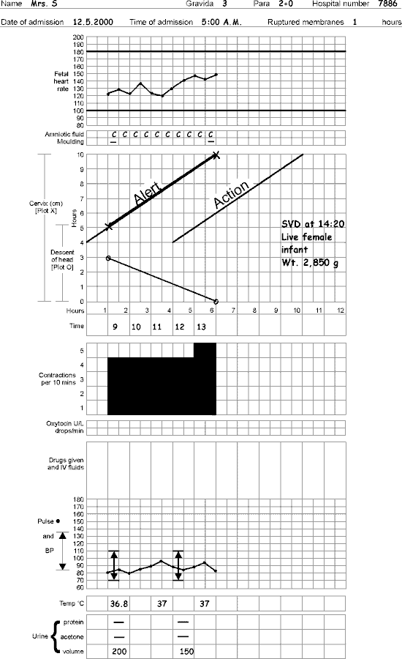
MANAGEMENTSECOND STAGE OF LABOUR
Once the onset of the second stage has been confirmed a woman should not be left without attendance. Accurate observation of progress is vital, for the unexpected can always happen
- Maternal position:
With the exception of avoiding supine position, the mother may assume any comfortable position for effective bearing down.
The semi-recumbent or supported sitting position, with the thighs abducted, is the posture most commonly adopted
- Bearing down
With each contraction, the mother should be encouraged to bear down with expulsive efforts
- Observation during the second stage:
Four factors determine whether the second stage may be safely continued and these must be carefully monitored throughout the second stage of labour.
- Maternal conditions
Observation includes an appraisal of the mother’s ability to cope emotionally as well as an assessment of her physical wellbeing. A maternal pulse rate is usually recorded quarter-hourly and bloods pressure hourly

- Fetal conditions - During the second stage, the fetal heart should be monitored either continuously or after each contraction. stage may be associated with fetal distress.
The liquor amnii is observed for signs of meconium staining.
- Uterine contractions - The strength, length and frequency of contractions should be assessed continuously.
4.The progress of descent - The progress should be recorded approximately every 30 minutes during the second stage

- CONDUCTING THE DELIVERY¹:

When delivery is imminent, the patient is usually placed in the dorsal position, and the skin over the lower abdomen, vulva, anus and upper thigh is cleansed with antiseptic solution and draped.
DELIVERY OF THE HEAD

1) Control the delivery of the head to prevent laceration
2) Performed episiotomy if requires

3) Cleared the airway after delivery of the had
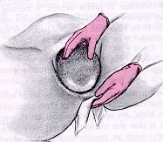
PERFORMING AN EPISIOTOMY:
"..is a surgical incision into the perineum to enlarge the space at the outlet
Episiotomies are not always necessary
Episiotomy should be considered only in the case of:

- Complicated vaginal delivery (breech, shoulder dystocia, forceps,
vacuum);
- Scarring of the perineum;
- Fetal distress.
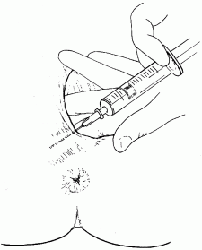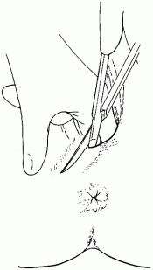
Performing an episiotomy will cause bleeding. It should not, therefore, be done too early.
Wait until:

- the perineum is thinned out
- ; and 3–4 cm of the baby’s head is visible during a contraction.
- CONDUCTING THE DELIVERY²:

DELIVERY OF THE SHOULDERS
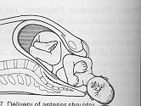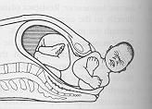
Delivery of the anterior shoulder is aided by gentle downward traction on the head. The posterior shoulder is delivered by elevating the head.
DELIVERY OF THE TRUNK

After the delivery of the shoulders the baby is grasped around the chest to aid the birth of the trunk.Finally, the body is slowly extracted by traction on the shoulders and lifts the baby towards the mother’s abdomen.The time of delivery is noted.
CUTTING THE UMBILICAL CORD
After delivery, it is therefore usual to wait 15 to 20 seconds before clamping and cutting the umbilical cord.After cutting the cord a plastic crushing clamp is placed on the cord 1 to 2 cm from the umbilicus and the cord is cut again 1 cm beyond the clamp

IMMEDIATE CARE OF THE NEW BORN

Once the baby is breathing normally he should be dried and warmly wrapped to prevent cooling and handle to the mother to hold, cuddle and enjoy.If spontaneous respiration is not established soon after birth, resuscitation is the immediate priority.The Apgar’s score of the baby should be noted and recorded.

MANAGEMENT of THIRD STAGE OF LABOUR

- BIRTH OF THE PLACENTA:

Delivery of the placenta occurs in two stages:
(1) separation of the placenta from the wall of the uterus and into the lower uterine segment and/or the vagina.
(2) actual expulsion of the placenta out of the birth canal.

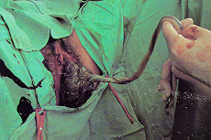

CLINICAL SIGNS OF PLACENTAL SEPARATION
Placental separation takes place within 5 minutes after the delivery of the infant if 30 minute passed and placenta not deliverd it called retained placenta. Signs suggesting that detachment or separation has taken place include:
- The uterus becomes globular and hard. This sign is the earliest to appear.
- There is often a sudden gush of blood

- The uterus rises in the abdomen because the placenta, having separated, passes down into the lower segment and vagina, where its bulk pushes the uterus upward.
- Cord lengthening. This is the most reliable clinical signof placental separation

After the placental separation takes place the placenta can be delivered by the:
- Passive management – wait for spontaneous expulsion of placenta
2.Active management

ACTIVE MANAGEMENT OF THE THIRD STAGE
Active management of the third stage include:
(1) Uterotonic medication administered within one minute after delivery of baby after ruling out presence of another fetus. Oxytocic drugs should be given with the birth of the anterior shoulder.
Syntocinon is the most used oxytocic known to be effective; the addition of ergometrine may reduce blood loss.
SYNTOMETRINE (oxytocin 5 IU + ergometrine 0.5 mg) – widely used

(2) BRANDT’S ANDREW METHOD
controlled umbilical cord traction and counter traction to support the uterus until separation and delivery of the placenta.
(3) uterine massage after delivery of the placenta.

Method of Active Management of the Third Stage
1) After delivery of the anterior shoulder, give oxytocin by rapid IV drip or 10 units IM.
2) After the cord is clamped and cut, delivery of the placenta by controlled cord traction (gentle constant pulling on the umbilical cord) with counter-traction on the fundus. Hold the clamped cord with one hand, and place the other hand just above the woman’s pubic bone and stabilize the uterus by applying counter traction during controlled cord traction. Keep slight tension on the cord and await a strong uterine contraction. When the uterus becomes rounded or the cord lengthens, very gently pull downward on the cord to deliver the placenta.

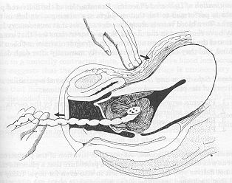
A) Placenta separation B) Controlled cord traction

3) Fundal massage after delivery of the placenta.

