Postpartum hemorrhage
المرحلة الرابعة2016 د.شذى سامي

PPH:is one of the most common obstetric emergencies, in UK hemorrhage was the third most common cause of death. Its defined as:
*primary PPH: loss of ≥ 500 ml blood from genital tract within 24 hours of delivery.
*secondary PPH : loss of ≥ 500 ml blood from genital tract after 24 hours till 12 week post-delivery.
Its can be classify to:
a. Minor PPH if blood loss is between 500 & 1000 ml, the loss of this amount are relatively common, and usually tolerated well by the women.
B.massive PPH loss over 1000 ml this required the application of PPH protocols.
However it should be remember that estimation of blood loss may be inaccurate & if a woman demonstrated evidence of cardiovascular compromise the PPH protocols should be instituted even if estimated loss less than 1000 ml.
PPH can be predicted and preventive measures can be undertaken if risk factors are present :
1.Maternal risk factors:
Antepartum
1.raised maternal age.
2.grand multiparity .
3.primiparity.
4. previous caserean.
5.obesity.
6.uterine fibroid.
7. antepartum hemorraghe.
8.previous PPH.
Intrapartum
1.prolonged labour.
2.caserean section.
3. instrumental delivery.
4. pyrexia in labour.
5. episiotomy.
2.Fetal risk factors:
a.large baby.
b. multiple pregnancy.
3.polyhydraminous.
4. shoulder dystocia.

Aetiology of PPH
The causes of PPH can be remembered as five" T"s
1.Tone:
Uterine atony or a failure of uterus to contract after delivery of placenta it’s the most common cause of PPH.atony occur due to the:
1. uterine over distention: polyhydramnios, multiple gestation, fetal macrosomia
. Rapid or prolonged labor 2.
3. Oxytocin use
4. High parity
5. Chorioamnionitis
6. Myometrial relaxing agents (magnesium sulfate, anesthetic agent.
2.Tissue :retined part of placenta &/or membranes.
3.Truma :almost all types of delivery can cause some degree of genital tract trauma in form of perineal & vaginal tears, but this occur mainly after forceps delivery, cervix may be torn if delivery occurred before the cervix is fully dilated.
4.Thrombin:
Its mean clotting disorder which occur in women with underlying disorder like Von Willebrand disease or platelet disorders .its more commonly arised in women who developed DIC as a result of another obstetric complication such as placental abruption,IUD,amniotic fluid embolism.
5. Traction: uterine inversion
Clinical manfesiation:
Vaginal bleeding tachycardia pallor, hypotension, nausea, vomiting (due to low BP) shock, anemia
Diagnosis:
* Early recognition of blood loss & rapid action is vital in the management of PPH
* A appreciation of risk factors
*accurate estimation of blood loss & recognition of the maternal signs of cardiovascular compromise are vital these include tachycardia, low BP, pallor, slow capillary refill(greater than 2 second).
* The BP does not fall until massive hemorrhage has occurred (often 1200-1500 ml of blood).

Treatment:
In practice, diagnosis and management of PPH occur simultaneously.
1. Team work (senior obstetrician,anaestheatist,senior midwife,porter)
2. Oxygen by mask initially.
3. Two large borecanulae(16-gauge intravenous lines).
4. Rapid fluid resuscitation (crystalloid) should occur at the same time as assessing & treating the cause.
5. Full blood count and clotting studies test for renal function tests and liver function tests.
6. cross-match at least 6 units of blood & transfuse blood as soon as possible or give O negative until the blood of the same group available.
7. Central venous pressure line.
8. Foley catheter & fluid balance chart, vital sign chart.
9. May need fresh frozen plasma, platelets, cryoprecipitate.
10. Treat the cause:
A. Uterine atony which is the most common cause of postpartum hemorrhage. Because hemostasis associated with
placental separation depends on myometrial contraction, atony is treated initially by:
1. Bimanual uterine compression and massage
2.uterotonics drugs that promote uterine contraction.
Bimanual compression if the uterus is soft, massage is performed by placing one hand in the vagina and pushing against the body of the uterus while the other hand compresses the fundus from above through the abdominal wall The posterior aspect ofthe uterus is massaged with the abdominal hand and the anterior aspect with the vaginal hand.

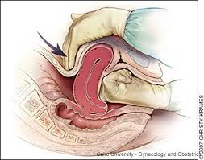

uterotonics drugs: Uterotonic agents include oxytocin, ergot alkaloids, and prostaglandins.
1. Oxytocin stimulates the upper segment of the myometrium to contract rhythmically, which constricts spiral arteries and decreases blood flow through the uterus Oxytocin is an effective firstline treatment for postpartum hemorrhage 10 international units (IU) should be injected intramuscularly, or 20 IU in 1 L of saline may be infused at a rate of 250 mL per hour. 2.Methylergonovine (Methergine) and ergometrine are ergot alkaloids that cause generalized smooth muscle contraction in which the upper and lower segments of the uterus contract tetanically . A typical dose of methylergonovine, 0.2 mg administered intramuscularly, may be repeated as required at intervals of two to four hours. Because ergot alkaloid agents raise blood pressure, they are contrain dicated in women with preclampsia or hypertension. Other adverse effects include nausea and vomiting.
3. Prostaglandins enhance uterine contractility and cause vasoconstriction. The prostaglandin most commonly used is 15-methyl prostaglandin F2a, or carboprost (Hemabate). Carboprost can be administered intramyometrially or intramuscularly in a dose of 0.25 mg; this dose can be repeated every 15 minutes for a total dose of 2 mg. Carboprost has been proven to control hemorrhage in up to 87 percent of patients, but carboprost should be used with caution in patients with asthma or hypertension. Side effects include nausea, vomiting, diarrhea, hypertension, headache, flushing, and pyrexia.
4. Misoprostol is another prostaglandin that increases uterine tone and decreases postpartum bleeding. Misoprostol is effective in the treatment of postpartum hemorrhage, but side effects may limit its use. It can be administered sublingually, orally, vaginally, and rectally. Doses range from 200 to 1,000 mcg Higher peak levels and larger doses are associ ated with more side effects, including shivering, pyrexia, and diarrhea.
2. vaginal examination should be conducted to expel clots & to assess for genital tract truma. Lacerations and hematomas resulting from birth trauma can cause significant blood loss that can be lessened by hemostasis and timely repair. Sutures should be placed if direct pressure does not stop the bleeding. Episi otomy increases blood loss and the risk of anal sphincter tears and this procedure should be avoided unless urgent delivery is necessary and the perineum is thought to be a limiting factor. Hematomas can present as pain or as a change in vital signs disproportionate to the amount of blood loss. Small hematomas can be managed with close observation. Patients with persistent signs of volume loss despite fluid replacement, as well as those with large or enlarging hematomas, require incision and evacuation of the clot. The involved area should be irrigated and the bleeding vessels ligated. In patients with diffuse oozing, a layered closure will help to secure hemostasis and eliminate dead space.if the placenta retained it should be deliverd & inspected.
4.if bleeding contonuies,the patient should be transfferd to theater for examination under anaesthesia..further measure can be used include uterine balloons, radiological occlusion of the uterine vessels,laparotomy for bilateral uterine artery ligation bilateral iliac artery ligation, uterine compression sutures(B-Lynch) which will preserve the uterus and last thing hysterectomy.

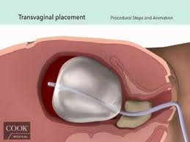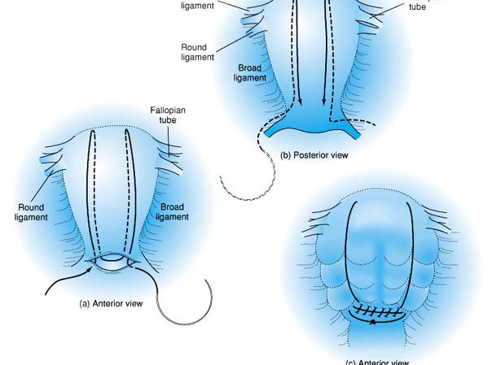
tamponade B-lynch

Secondary pph:
Loss of ≥ 500 ml of blood from genital tract between 24 hours & 12 weeks post delivery.its rare cause of massive bleeding.
Causes of PPH
Main causes:
1.infection mainly(endometritis)
2.retained product of conception

3.blood disorder
4. choriocarcinoma.
Clinical feature:
Bleeding usually slight to moderate,but it may be life threatening,fever subinvoluted uterus may be tender,anaemia,pallor.
Diagnosis
1.CBP & blood film.
2.beta HCG
3. ULS to exclude retained pieces.
Treatment
According to the cause this involved:
- Correction of anaemia
- Antibiotic
- Medical or surgical way to evacuated the uterus.
- If the cause choriocarcinoma chemotherapy may be used.

complications of PPH:
Immediate complications
Anaemia 1.
HypovolemicShock 2.
Acute renal failure 3.
Acute Liver failure (hepato-renal syndrome ) 4.
5. Acute pulmonary oedema, consumption coagulopathy, transfusion reactions, (iatrogenic).

Long term complications:
Infections: puerperal infections 1.
) Sheehan’s syndrome (necrosis of anterior pituitary 2.
Chronic anaemia 3.
4. Chronic renal failure
5. infertility due to
a. sheehans syndrome
b. asherman syndrome
c.infection and tubal blockage

Other disorders of third stage:

Uterine inversion
Its rare complication of the third stage ,incidence 1:2000 -1:6000.the uterine fundus descend through the uterine cavity,or rarely beyond the intoitus,can be occurred after C/S or vaginal delivery.
Causes
1. • mismanagement of the third stage – e.g. premature or excessive cord traction during active
management of the third stage, a combination of fundal pressure and cord traction to deliver
the placenta, or use of fundal pressure when the uterus is atonic during placental delivery

abnormally adherent placenta . 2.
3. spontaneous inversion of unknown etiology

short umbilical cord 4.
sudden emptying of a distended uterus 5.
Diagnosis
The prolaosed uterus stretching the cervix causes vagal stimulation,so the women will have sign of cardiovascular collapse & shock,although bleeding is commonly present,the symptoms will be out of proportion to estimated blood loss. The inverted uterus may be obvious at the intoitus.lack of palpable uterus in the abdomen,feeling of a"dimple" in the uterine fundus on examination.
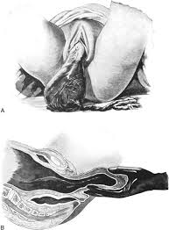

Management:
The inverted uterus usually appears as a bluish-gray mass protruding from the vagina. Vasovagal effects produc ing vital sign changes disproportionate to the amount of bleeding may be an additional clue. The placenta often is still attached, and it should be left in place until after reduction. Every attempt should be made to replace the uterus quickly. The Johnson method of reduction begins with grasping the protruding fundus with the palm of the hand and fingers directed toward the posterior fornix ,The uterus is returned to position by lifting it up through the pelvis and into the abdomen Once the uterus is reverted, uterotonic agents should be given to pro mote uterine tone and to prevent recurrence. If initial attempts to replace the uterus fail or a cervical con- traction ring develops, administration of magnesium sulfate, terbutaline (Brethine), nitroglycerin, or general anesthesia may allow sufficient uterine relaxation for manipulation. If these methods fail, the uterus will need to be replaced surgically
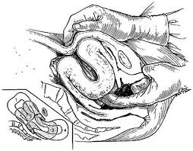

Retained placenta
Failure of placental delivery within 60 minutes after delivery of the fetus, complicates 2% of births
Risk Factors
• Previous retained placenta
• Previous injury or surgery to the uterus
• Preterm delivery
• Induced labor
• Multiparity

Causes
1. Constriction ring-reforming cervix
2. Full bladder
3. Uterine abnormality
4. Morbid adherence of the placenta:
− Placenta Accreta
− Placenta Increta
− Placenta Percreta

Management
If the placenta is undelivered after 30 minutes consider:
1. Emptying bladder
2. Breastfeeding or nipple stimulation
3. Change of position – encourage an upright position
4.using of uterotonics drug by intravenous ,intramuscular,intra umbilical venous route
5.if after20 minute of uteroutonics drug placenta not delivered transferred the patient to the theater for manual removalof placenta under anesthesia.
6.if failed remove it by curettage
7. if placenta was morbid adherent hysterectomy may be done

