د.شذى سامي
FICOG Puberty
Objective
-to define puberty
-explain the normal development and factors affecting it.
-learning student how to diagnose the abnormality in puberty and how to manage it.

Puberty is the process of reproductive & sexual development & maturation which changes a child into an adult.during the transition ,usually between 10 & 16 years of age,avariety of physical,endocrinologic & psychologic changes accompany the increasing levels of sex steroid. There is enormous variation between individuals in the processes involved in puberty but the five major physical changes are growth, breast development, pubic hair development, axillary hair development and, ulti- mately, menstruation. Whilst these changes occur tempo- rally at different rates, there may be changes that occur prematurely or in a delayed fashion which alter this process. Finally, some girls may undergo pubertal change without menstruation and others may fail to enter puberty entirely

Physiology of puberty:
The hypothalamus–pituitary–gonadal axis is active during fetal life and quiescent during childhood. It is the reactivation of this axis that leads to sexual maturation. The arcuate nucleus in the basal hypothalamus is respon- sible for secretion of gonadotrophin-releasing hormone (GnRH) into the hypothalamus–pituitary portal circula- tion. As puberty commences, the arcuate nucleus begins to secrete GnRH in a pulsatile manner, initially solely at night; however, as time progresses GnRH release adopts a low-frequency low-amplitude pulsatile pattern that starts to induce release of luteinizing hormone (LH) from the pituitary. The low-amplitude pulsatile pattern gradu- ally extends to include daytime secretion and gonado- trophin levels themselves start to increase, reflecting higher pulse amplitude and increasing frequency of GnRH production. As the pattern of follicle-stimulating hormone (FSH) and LH release becomes established, so ovarian activity commences and initially this is totally chaotic as it is uncoordinated. This means that there is follicular growth without coordinated ovulation and although oestradiol levels start to rise, there is no evi- dence of ovulation. The ovary may have appearances that are multicystic due to this chaotic gonadotrophin stimula- tion and, over time (about 5–10 years), coordinated pul- satile release of GnRH leads to adult frequency of FSH release (approximately every 90 min). At this stage the ovulatory cycle is established. From age 7, most girls will begin activation of adrenal androgen production, a phenomenon known as adren- arche. As with ovarian oestradiol production, androgen production is initially at extremely low levels and increases over time.
Factors affect the puberty:
The age of onset of puberty in girls ranges from 8.5 to 13.3The exact mechanism determining the onset of puberty is still unknown but its influenced by:
1.race. there are racial differences, with black females showing an earlier age of pubertal onset compared with white
2.Genetics. has a clear and dominant role and there is a clear correlation between age at puberty of a woman and that of her daughter
3.body weight evidence now exists to suggest that a high body mass index (BMI) is linked to earlier age of maturation, and the rela- tionship between body fat and the onset of puberty is proposed to be linked to the release of leptin from adipose
4.exercise.
5. leptin plays apremissive role in the onset of puberty. Leptin and kisspeptin would seem to act as a primary signal to the hypothalamus to allow puberty to commence
6.psychological factors(sever neurotic or psychotic disorder interfere with normal onset of puberty)
7. nutritional status in all ethnic groups seri- ously influences the age of onset of puberty. Children living in areas of malnutrition have significantly delayed onset of puberty and transfer of these girls to a socioeco- nomically superior environment reduces the age of onset of puberty significantly.
Physical(somatic) changes of puberty
The physical changes occurring in puberty are:

Thelarche
onset of breast development-an estrogen induced effect. Average-10.8 yrs in the US. Although the growth spurt is usually the first sign of the onset of puberty, in females it is breast change that is usually used as an indicator of development. The initiation of breast development is known as thelarche and this has been classified by Tanner into five stages .Breast growth is often unequal between the two breasts and Tanner stage 5 represents the mature end- stage of breast development. This takes approximately 5 years.
The growth spurt:
. An increase in vertical growth is the initial physical sign of the onset of puberty. Growth during infancy is rela- tively rapid until age 3–4 and then it rapidly decelerates when the childhood phase begins. Growth velocity during infancy is approximately 15 cm/year but in middle child- hood, until the onset of puberty, slows to 5–6 cm/year. Interestingly, childhood growth rates are usually at their slowest in the 12–18 months immediately preceding puberty and thus if puberty is delayed this effect is exaggerated. At puberty, girls may reach a peak growth velocity of 10 cm/year and girls will gain approximately 25 cm of growth during puberty. Males in contrast have their growth spurt approximately 2 years later than females but eventually gain approximately 28 cm of added height. Once the final stage of growth velocity decreases, epiphyseal fusion occurs which prevents further growth. During the adolescent growth phase, bone density increases rapidly. Control of the growth spurt is primarily through growth hormone and its major secondary messenger insulin-like growth factor (IGF)-1. Oestradiol plays an important role in the increased secre- tion of growth hormone during puberty, particularly in the early stages. As bone growth and height are maxi- mally achieved, oestradiol initiates epiphyseal fusion as it reaches its maximum towards the end of puberty. Thyroid hormone also plays a key role in growth and development as illustrated in severe childhood hypothy- roidism, which results in a dramatic decrease in the veloc- ity of growth.
Pubarche:
onset of pubic hair growth under influence of estrogen or testosterone.age-11 in female. The adolescent development of female pubic hair occurs in conjunction with androgen release and it is the pres- ence of androgen that determines both pubic and axillary hair growth. In approximately 20% of females, pubic hair growth may precede breast development
Menarche:
onset of menstrual flow.average age is 12.8 years in theUS,earlier in black girls. it may take over 3 years before the menstrual cycle establishes a regular pattern, initial cycles are usually an ovulatory and can be unpredictable & irregular.
Adrenarche:
onset of axillary hair growth under the influence of adrenal androgen production.

Marshal & Tanner classify the stages of development into five stages:

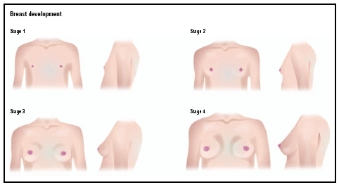
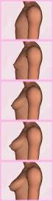
Stage1
stage11
stage111
stage1V
StageV

• Stage I (Preadolescent) - Only the papilla is elevated above the level of chest wall.
Stage II - (Breast Budding) - Elevation of the breasts and
papillae may occur as small mounds along with some
increased diameter of the areolae.
.
Stage III - The breasts and areolae continue to enlarge
although they show no separation of contour..
Stage IV - The areolae and papillae elevate above the level of the breasts & form secondary mounds with further development of the overall breast tissue.
Stage V - Mature female breasts have developed. The
papillae may extend slightly above the contour of the
breasts as the result of the recession of the areolae.

Pubic hair development:
The appearance of pubic hair is depend on the secreation of adrenal androgens & is usually after thelarche.
Pubic hair growth in females is staged as follows
Stage I (Preadolescent) – infantile or preadolescent with no pubic hair.

Stage II - Sparse, long, pigmented, primarily on the labia majora..
Stage III - Considerably darker, coarser, and curlier sexual hair appears. The hair has now spread sparsely over the mons pubes
.
Stage IV - The hair distribution is adult in type but decreased in total quantity. There is no spread to the medial surface of the thighs
.
Stage V - Hair is adult in quantity and type and appears to have an inverse triangleThere is spread to the medial surface of the thighs .
.
Disorder of` puberty:
Precocious puberty:
This is defined as the onset of any sign of secondary sexual characteristic prior to the age of 8 in girl & 9 in a boy.
Classification of p.p.:
a.central precocious puberty:
the aetiology is often unknown ,it’s a gonadotropin-dependent. Although up to 25% are due to central nervous system malformation or brain tumours.
B.peripheral precocious puberty:
Its always pathological & can be caused by estrogen secretion such as exogenous ingestion like pills or a hormone-producing tumor. This is far less common than central precocious puberty and is usually induced by excess production of sex ster- oids. Causes include the following.
• Androgen secretion from a virilizing adrenal tumour.
• Late-onset CAH.
• Oestrogen-secreting tumour causing rapid breast development. If a large ovarian cyst is present, this may be part of McCune–Albright syndrome, with associated classical features of irregular café-au-lait spots and cystic bone lesions called polyostotic fibroid dysplasia.
• Exposure to exogenous hormones, e.g. inadvertent ingestion of birth control pills by children causing excess levels of oestrogens; topical androgen exposure
Precocious puberty may be divided into two major sub groups:hetrosexual p.p(development of secondary sexual characteristic opposite those of anticipated phenotypic sex like virlization in female)
& isosexual p.p.( premature sexual maturation like premature thelarche)

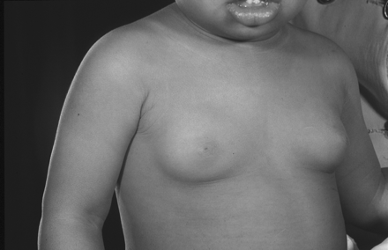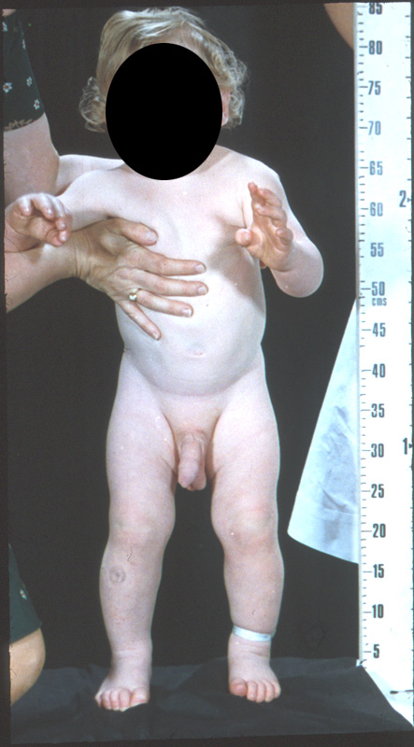

Causes of precocious puberty:

In 75% of cases of precocious puberty in girls the cause is idiopathic;other causes
•organic brain disease (CNS tumors,head trauma,hydrocephalus,infection like meningitis & encephalitis)
•ovarian tumor .eg. granulosa cell tumour which secreate estrogen)
•adrenal neoplasm ,congenital adrenal hyper plasia.
•exogenous estrogen or androgen exposure.
Investigation:
Meticulous history & examination( the girl may present with breast growth ,menarche or pubarche at earlier age) to detect any possible cause:
1.serial bone age(wrist X-ray is done)
2.MRI or CT of the brian with optimal visualization of hypothalamus & sella turcica.
3. MRI, CTor Uls of abdomen. Pelvis or adrenal gland.
4. assay of serum levels of FSH,LH which are high in centrally mediated precocious puberty & low in ovaian tumours.
5. Laparoscopy may be required for abdominal or pelvic tumor.
Treatment
Treatment goals focus on preventing reduced final adult height & limiting the psychological effects of early pubertal epiphyseal fusion is an estrogen dependent process. Accordingly,girl with precocious puberty are at high risk for early growth plate closure & short stature in adulthood.
1.in centrally mediated precocious puberty after exclusion of intracranial tumours,the use of GnRH analogue to suppress the piutary gland is justified(estrogen level drop, often ther is amarked regression of breast & uterine size.if therapy is institude after menses have began,they will cease)until the age of 11.5-12 years when the natural onset of puberty occurs.
2.treatment of ovarian or adrenal tumor.
3.psychological support.

Delayed puberty:
This occurs when are no signs of secondary sexual charaacteristics by the age of 14 years.its due to either acentral defect-hypogonadotrophic hypogonadism or to afaliure of agonadal function –hypergonadotrophic hypogonadism.

Hypogonadotrophic hypogonadism;
this may be constitutional but other causes must be excluded:
1.anoroxia nervosa
2.exessive exercise
3.chronic illness such as diabetes or renal failure
4.rare causes include apitutary tumour & kalmans syndrome.

Hypergonadotrophic hypogonadism:
In this situation the gonad dose not function despite ahigh FSH.
Both turner syndrome andXX gonadal dysgenesis may be the causes ,premature ovarian failure can occur at any age & may be idiopathic ,but can also be apart of autoimmune disorder or following chemo or radiotherapy.

