Dr Manal Madany 4th year

Senior Lecturer 2016-2017
Intra Uterine Growth Restriction

-Intra Uterine Growth Retardation
- Small for gestational age (SGA)
-Fetal growth restriction
-'wasted' and 'stunted

Definition:
Intrauterine growth retardation (IUGR) occurs when the unborn baby is at or below the 10th weight percentile for his or her age (in weeks). The fetus is affected by a pathologic restriction in its ability to grow.
Low birth weight (LBW) means a baby with a birth weight of less than 2500Gms, which could be due to IUGR or Prematurity .

Classification:
1-Symmetrical: the baby's head and body are proportionately small. May occur when the fetus experiences a problem during early development.
2- Asymmetrical : baby's brain is abnormally large when compared to the liver. May occur when the fetus experiences a problem during later development.
In a normal infant, the brain weighs about three times more than the liver. In asymmetrical IUGR, the brain can weigh five or six times more than the liver.

Newer Classification: -
1-Normal small fetuses: have no structural abnormality, normal umbilical artery & liquor but wt., is less. They are not at risk and do not need any special care.
2-Abnormal small fetuses: have chromosomal anomalies or structural malformations. They are lost cases and deserve termination as nothing can be done.
3-Growth restricted fetuses: are due to impaired placental function. Appropriate & timely treatment or termination can improve prospects.

Etiology:
The fetal growth is dependent on multiple factors.
IUGR resulting in SGA babies can result from many factors. Known and unknown either acting alone or in conjunction or in association.
The aetiologic determinants of IUGR have two measures of effect: relative risk and etiologic fraction.
Most of the evidence on aetiologic determinants is based on observational studies and systematic overviews or meta-analyses of such studies.
In a majority of cases (40%) the cause is unknown– probably due to placental insufficiency (idiopathic).
General- Racial / Ethnic origin, Small maternal / paternal height / weight, fetal sex.-1
Maternal causes. -2
Fetal causes.-3
Placental causes.-4
5-Idiopathic- In a majority of cases (40%) the cause is unknown– probably due to placental insufficiency.

Maternal Risk Factors
Has had a previous baby who suffered from IUGR. -1
Extremes of age. -2
Is small in size (Ht & Wt).-3
Has poor weight gain and malnutrition during pregnancy.-4
Is socially deprived.-5
6-Uses substances (like tobacco, narcotics, alcohol) that can cause abnormal development or birth defects.
7-Has a low total blood volume during early pregnancy.
8-Is pregnant with more than one baby.
9-High altitude.
10-Drugs like anticoagulants, anticonvulsants.
11-Has a cardio-vascular disease-preeclampsia, hypertension, cyanotic heart disease, cardiac disease Gr III & IV, diabetic vascular lesions.Chronic kidney disease . Chronic infection- UTI, Malaria, TB, genital infecion
12-Has an antibody problem that can make successful pregnancy difficult (antiphospholipid antibody syndrome, SLE).

Fetal Risk Factors:
1-Exposure to an infection-German measles (rubella), cytomegalovirus, herpes simplex, tuberculosis, syphilis, or toxoplasmosis, TB, Malaria, Parvo virus B19.
A birth defect (cardiovascular, renal, anencephally, limb defect, etc).-2
3-A chromosome defect- trisomy-18 (Edwards’ syndrome),21(Down’s syndrome), 16, 13, xo (turner’s syndrome.
A primary disorder of bone or cartilage. -4
5-A chronic lack of oxygen during development (hypoxia).
Developed outside of the uterus.-6
Placenta or umbilical cord defects.-7

Placental Factors
1-Uteroplacental insufficiency resulting from :
a- Improper / inadequate trophoblastic invasion and placentation in the first trimester
b-Lateral insertion of placenta
Reduced maternal blood flow to the placental bed. -c
Fetoplacetal insufficiency due to:
vascular anomalies of placenta and cord.-1
Decreased placental functioning mass -2
Small placenta, abruptio placenta, placenta previa, post term pregnancy). )

Diagnosis:-
Intrauterine
IUGR can be difficult to diagnose.-1
Presence of risk factors.-2
Inadequate growth detected by serial measurement of Wt., abdominal girth and fundal Ht.-3
Ultrasound to evaluate the fetal growth. -4
Inadequate fetal growth.-5
Reduced AF-6

-Neonatal
Low ponderal index (Wt./Fl).
Decreased subcutaneous fat.
Presence / appearance of Hypoglycemia, Hyperbilirubinemia, Narcotizing enterocolitis, Hyper viscosity syndrome

Neonate and Placenta in IUGR

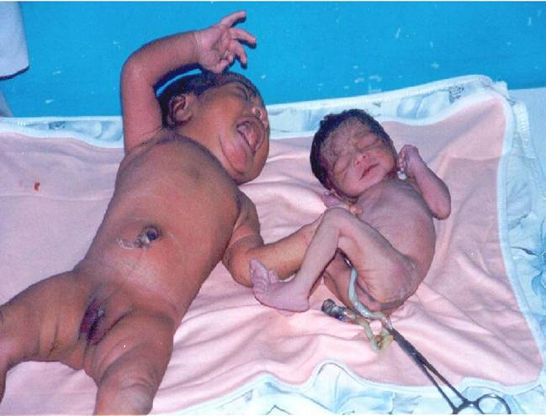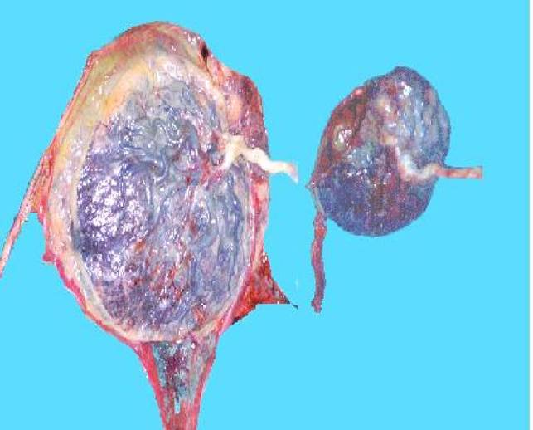

Normal & IUGR Placentas IUGR & Normal newborn babies
Prevention Strategies include:
prenatal care modalities , protein/energy supplementation , treatment of anaemia , vitamin/mineral supplementation , fish oil supplementation , prevention and treatment of hypertensive disorders, Fetal compromise , Infection

Strong evidence of benefit only for the following interventions:
balanced protein/energy supplementation, strategies to reduce maternal smoking, antibiotic administration to prevent urinary tract infections and antimalarial prophylaxis.
Few statistically significant reductions in the risk of IUGR have been demonstrated with other interventions.

Surveillance
Unless delivery occurs, once treatment begins the foetus must undergo surveillance.
The purpose to identify further progression of the disease process that would jeopardize the foetus to a point that it would be better to be delivered than to remain in utero.
There are four testing modalities which are helpful -Non-Stress Test, Amniotic Fluid Index, Doppler of the Umbilical Artery & Biophysical Profile, each of which addresses different aspects of surveillance.
Combination of tests are better than an isolated test.

Non- Stress Test (NST)
This simplest to perform test should b used first in the surveillance of IUGR foetuses. With the help of a heart rate monitor, the changes in the foetal heart rate with foetal movement are to be determined. If the heart rate increases more than 15 beats for more than 15 seconds, this is considered to be a reactive test. If the heart rate does not accelerate, remains flat, or decreases, then this is an abnormal test. The problem with this test is that it changes late in the course of the disease and is not an early predictor of adverse outcome.

Amniotic Fluid Index (AFI)
The vertical depth of four pockets of amniotic fluid are measured by USG, to obtain a total AFI. This method allows for comparison of changes in amniotic fluid with time. In the normal fetus the AFI remains relatively constant. In the fetus with IUGR, it may decrease slowly, or decrease abruptly with time. A decrease in AFI may occur before there are changes in the non-stress test.
The current recommendations are that if the AFI decreases below 8 after 35 weeks, then delivery should
occur.
Amniotic Fluid Index (AFI)
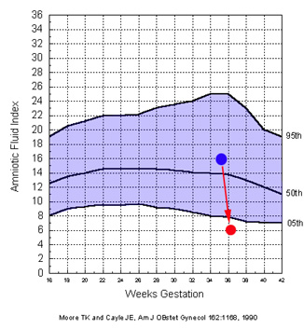

Doppler of the Umbilical Artery

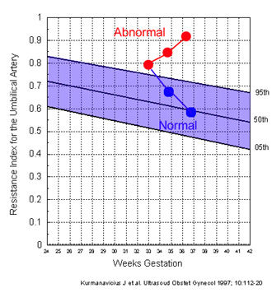
When IUGR is diagnosed, the value of sequential studies of the umbilical artery Doppler waveform is to determine if the Resistance Index is increasing or decreasing. If it is increasing, then this signifies a deteriorating condition.

Biophysical Profile
This test combines the NST and the AFI with foetal movement, breathing, and muscle tone.
If each of the tests are normal they are given a score of 2. If abnormal, a score of 0.
A score of 6 or less suggests the foetus is at risk for adverse outcome.
While the biophysical profile is a useful test, when it becomes abnormal the foetus may have already suffered some damage

Treatment
IUGR has many causes, therefore, there is not one treatment that always works.
Although there are many causes of IUGR, the treatment consists of either delivery or remaining in utero and improving blood flow to the uterus.
When blood flow is improved, the delivery of oxygen and other nutrients to the foetus occurs. If the foetus is lacking in these substances, their increased availability may result in improved growth and development.
If IUGR is caused by a problem with the placenta and the baby is otherwise healthy, early diagnosis and treatment of the problem may reduce the chance of a serious outcome.
There is no treatment that improves foetal growth, but IUGR babies who are at or near term have the best outcome if delivered promptly.
Maternal bed rest
This is the initial approach for the treatment of IUGR. The benefit of bed rest is that it results in increased blood flow to the uterus. Studies have shown, however, that in most cases bed rest at home is just as effective as bed rest in the hospital environment.
Aspirin Therapy
The use of aspirin to treat foetuses with IUGR is still controversial.
If aspirin is used, it may be advantageous if given to patients before 20 weeks of gestation. It is minimal to limited benefit if given at the time of diagnosis (third trimester).
At the present time it is not recommended as a form of prevention for low risk patients.
Other forms of treatment that have been studied are nutritional supplementation, zinc supplementation, fish oil, hormones and oxygen therapy.
Limited studies are available regarding the use of these modalities in the treatment of IUGR.
Judge Optimum Time Of Delivery: RISK OF PREMATURITY , RISK OF IUD ,

Short Term Risks of IUGR
Increased perinatal morbidity and mortality.
Intra uterine / Intrapartum death.
Intrapartuum fetal acidosis characterized by-.
Late deceleration , Severe variable deceleration , Beat to beat variability , Episodes of bradicardia.
Intrapartum fetal acidosis may occur in as many as 40 % of IUGR, leading to a high incidence of LSCS.
IUGR infants are at greater risk of dying because of neonatal complications- asphyxia, acidosis, meconium aspiration syndrome, infection, hypoglycemia, hypothermia, sudden infant death syndrome.
IUGR infants are likely to be susceptible to infections because of impaired immunity.

Labour & Delivery:
IUGR is not a contraindication for induction of labour or vaginal delivery. Continuous electronic fetal monitoring (use of cardiotocography) during labour is necessary. Low-threshold for caesarean section.

Prognosis: depends on the etiology. If treatable then prognosis is generally good

