***Dr.Manal Madany 4th year***

***Senior lecturer 2016-2017***

***Maternal injuries***

**Perineal injury:**

Perineal trauma is common, affecting up to 90% of primigravida.

Definition of perineal injuries:

First degree: involoves skin only.

Second degree: involves perineal muscles, includes episiotomy.

Third degree: second degree with disruption of the anal sphincter, subdivided into:

*3a: less than 50% of external sphincter thickness torn.

*3b: more than 50% of external sphincter thickness torn.

*3c: internal anal sphincter also torn.

Fourth degree: third degree tear with torn anal epithelium.

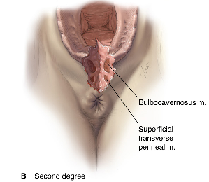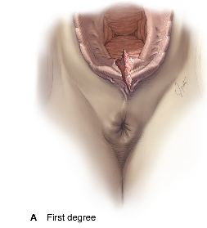

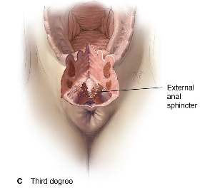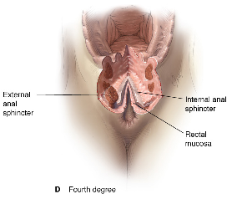

**Risk factors for perineal trauma:**

1. primigravida

2. Second stage of labour more than 60 minutes

3. Instrumental vaginal delivery

4. Midline episiotomy

5. Macrosomia

6. Fetal malposition

7. Epidural anaesthesia

8. Shoulder dystocia

**Repair:**

1. Identification of the extent of damage to the perineum, vagina and rectum with adequate lighting and analgesia.

2. Technique of repair: some first-degree tears that are not bleeding will not require suturing. A loose continuous suture technique to oppose each layer (vaginal epithelium, perineal muscle and skin) is associated with less pain.

Repair of anal sphincter requires adequate muscle relaxation with regional or general anaesthesia.

3. Postoperative precautions:

Prophylactic antibiotics as cephalosporines and metronidazole, analgesics as NSAID, paracetamol and opiod analgesia

stool softening like lactulose for 5-10 days (3rd degree tear)

advise on perineal hygiene and pelvic floor exercise

urethral catheter may be indicated to avoid urinary retention

**Complications:**

1. Infection

2. Bleeding

3. Missing the apex of the tear may cause haematoma

4. Deep sutures into the rectum could lead to fistula formation

5. Improper suturing could lead to later pain and dyspareunia

6.3rd and 4th degree tears could lead to anal incontinence

# Haematoma:

Haematomas are divided into those that lie above and those that lie below the levator muscle.

Infralevator h. includes those of the vulva, perineum, paravaginal and ischiorectal fossa. Supralevator h. spread to the broad ligament and retroperitoneal space

. 

**Incidence**: the incidence of haematomas more than 4 cm in diameter is approximately 1:1000 deliveries.

**Aetiological factors:**

1. Episiotomy (85-90 %)

2. Instrumental vaginal deliveries.

3. Primiparity.

4. Hypertensive disorders.

5. Other factors like: multiple pregnancy, vulval varicosities, macrosomic baby, prolonged second stage of labour.

**Presenting symptoms**:

***Infralevator haematomas***

1. May be asymptomatic until shock develops

2. Vaginal swelling

3. continued vaginal bleeding

4. Severe vaginal / rectal pain

5. Urinary retention

***Supralevator haematomas***

1. Cardiovascular collapse

2. Uterine displacement

3. Abdominal or rectal pain

4. continued vaginal bleeding

**Management:**

1. Resuscitation measures

2. Haematomas less than 5 cm in diameter and not expanding:

Observation using ice-packs and pressure dressings to limit its expansion, analgesia and markings should be made on the skin to establish whether the margins are expanding

3. Haematomas more than 5 cm in diameter and are expanding:

Surgical drainage with ligation of bleeding vessels, leave the wound open with a drain

4. Broad ligament haematomas are usually managed conservatively, if it is not possible to maintain a stable hemodynamic state, surgical exploration is recommended and a hysterectomy may be indicated.

5. Postoperative precautions (as in perineal trauma)

# Injuries to the cervix:

After vaginal delivery, cervical lacerations are extremely common, bleeding that is not from the vagina and continues despite a contracted uterus is an indication to examine the cervix.

**Management**: Resuscitation measures , recognition of the injury and repair it.

Repair: good visibility using right-angle retractors is essential. Using two pairs of ring forceps applied to the cervix to inspect the whole circumference accurately. Identify the apex of the tear and suture it.

# Caesarean hysterectomy:

The risk is increased with caesarean delivery, previous caesarean section, placenta previa, placenta accreta and uterine atony when the conservative medical and surgical measures have been unsuccessful. The maternal mortality and morbidity is high with this surgery.

***RUPTURE OF THE UTERUS***

**a potential obstetric catastrophe**

**a major cause of maternal death.**

**The incidence of uterine rupture is approximately 1/ 1500 deliveries.**

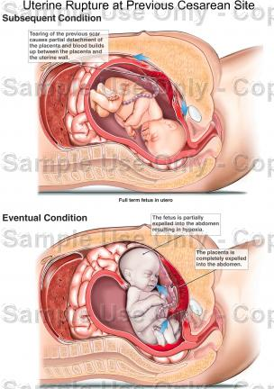

***ETIOLOGY***

**A.Before current pregnancy**

1. surgery involving the myometrium

* cesarean section or hysterotomy

* previously repaired uterine rupture

* myomectomy, cornual resection, metroplasty

2. uterine trauma

* abortion with instrumentation

* sharp or blunt trauma (accidents, bullets, knives)

* silent rupture in previous pregnancy

3. congenital anomaly

* pregnancy in undeveloped uterine horn

**B. During current pregnancy**

**1.Before delivery**

external trauma-1

labor stimulations (oxytocin or PG)-2

external version-3

uterine overdistention (multiple pregnancy, hydramnios) -4

**2. During delivery**

fetal anomaly distending lower segment (hydrocephalus)-1

internal version, breech extraction-2

difficult forceps delivery -3

difficult manual removal of placenta -4

5-abnormal presentations

contracted pelvis -6

tumors of the birth canal -7

multiparity -8

***CLASIFICATION***

Incomplete rupture → a laceration separated by the visceral peritoneum. -1

2-“Occult” (“incomplete rupture”) → dehiscence of an uterine incision from previous surgery.

Complete rupture -3

* Vertical uterine incision through the uterine body - probability of rupture is several times greater than that of a lower segment scar.
* Dehiscence of a lower segment cesarean section scar is more frequent than actual rupture.

**CLINICAL FINDINGS. DIAGNOSIS**

Impending uterine rupture → the sudden appearance of gross hematuria is suggestive.

Prior to the onset of labor, a beginning rupture may produce local pain and tenderness associated with increased uterine irritability and, in some cases, a small amount of vaginal bleeding.

If the fetus is partly or totally extrauterine, abdominal palpation or vaginal examination → the presenting part **has** moved away from the pelvic inlet (loss of station).

**The Classic SIGN & SYMPTOMS of spontaneous rupture during labor**

cessation of uterine contractions -1

suprapubic pain and tenderness-2

disappearance of fetal heart tones -3

recession of the presenting part -4

5-vaginal hemorrhage → signs and symptoms of hypovolemic shock and hemoperitoneum.

**PREVENTION**

good prenatal care-1

correct trial of labor-2

correct supervised administration of oxytocin during labor.-3

correct closure of a cesarean section incision -4

correct estimation of fetal weight-5

**TREATMENT**

Whenever uterine rupture is diagnosed –

**EMERGENCY SURGERY**

two effective, large-bore **intravenous infusion** -1

type-specific **whole blood** in large quantities is rapidly infused;-2

a **surgical team**, including anesthesia personnel;-3

**pediatric personnel** skilled in neonatal resuscitation. -4

Immediate laparotomy -5

Suture or Total hysterectomy

If a large hematoma in the broad ligament, identification and ligation of the internal iliac arteries (reduces the hemorrhage appreciably).

Prompt diagnosis, immediate operation, the availability of large amounts of blood and antimicrobial therapy have greatly improved the maternal prognosis.

**PROGNOSIS**

**Maternal Prognosis**

the maternal mortality rate is 10- 40%.-

if the patient survives: pituitary failure (Sheehan syndrome), infertility/sterility-

vesico-vaginal fistula.

**Fetal prognosis**

If the fetus is alive at the time of the rupture, the only chance of continued survival is afforded by immediate delivery, most often by laparotomy. Otherwise, hypoxia and death from both, placental separation and maternal hypovolemia, is inevitable.