Gross structural abnormalities in the chromosomes

The chromosomes are made up of DNA and other protein complexes and contain most of the genetic information that passed from one generation to the next. They are visualized normally through the microscope only when they are in a contracted state as they go through cell division.
Chromosomes are arranged by size in pairs, the largest being chromosome 1 and the smallest is chromosome 22 and then sex chromosomes X & Y. the position of centromere in regard to the chromosome arms is anther distinguishing feature of each chromosome. The short arm of the chromosome is referred to as p (from petit) and the long arm as q.
Karyotyping: refers to systemic arrangement from photograph or by a computer of previously stained and banded chromosomes of a single cell by pairs. The cells are cultured, arrested in mitosis during metaphase and then fixed and stained. If finer details are necessary prophase chromosomes are longer and less condensed. They show 600-1200 bands compared with metaphase chromosomes 400-600 bands. Typsin-Giemsa staining gives G banding – Quinacrine give the Q ( fluorescent ) banding. Special stains are used to demonstrate centromers. The banding pattern is unique for individual chromosomes and is (almost) identical in all individuals
Chromosomes have polymorphisms that differ among individuals without affecting phenotypic like: arm of the Y chromosome and Regions of the short arms satellites on 13, 14, 15, 21, and 22.
FISH (fluorescent in situ hybridization) uses a fluorescent probe to anneal to specific areas of the chromosomes.
- Chromosome analysis can be done on any tissue you can grow (most common are the peripheral blood and bone marrow)

Nomenclature of chromosomes: # chromosomes, sex chromosomes, + any abnormalities
- Normal female: 46, XX
- Normal male: 46, XY
- Changes in chr. #:
o Trisomy: 47, XY, +21
o Monosomy: 45, XO – Turner’s (monosomy is generally only seen for the X chromosomes because a monosomy in the autosomes usually is a lethal disorder)
- Deletions and additions:
o 46, XX, 18p- (deletion of short arm of chr. 18)
o 46, XY, 3q+ (addition of extra material to long arm of chr. 3)
- Translocations:
o 46, XX, t(3;4)(p13; q20) (female with translocation of chr. 3 and 4 with breakpoints in short and long arms respectively)
o 46, XX, t(3;4) (translocation without breakpoints specified)

o 45, XX, t(13q/14q) (indicating a female carrier of translocation between the long arms of chro. 13 and 14)
So translocation may be balanced (person with normal amounts of genetic material and a normal phenotype) or unbalanced (person with missing or additional material and an abnormal phenotype)
- Mosaics: (any combination of the above where there is more than one cell line)
o 45, XO/46, XY
o 46, XX/47, XX, +21

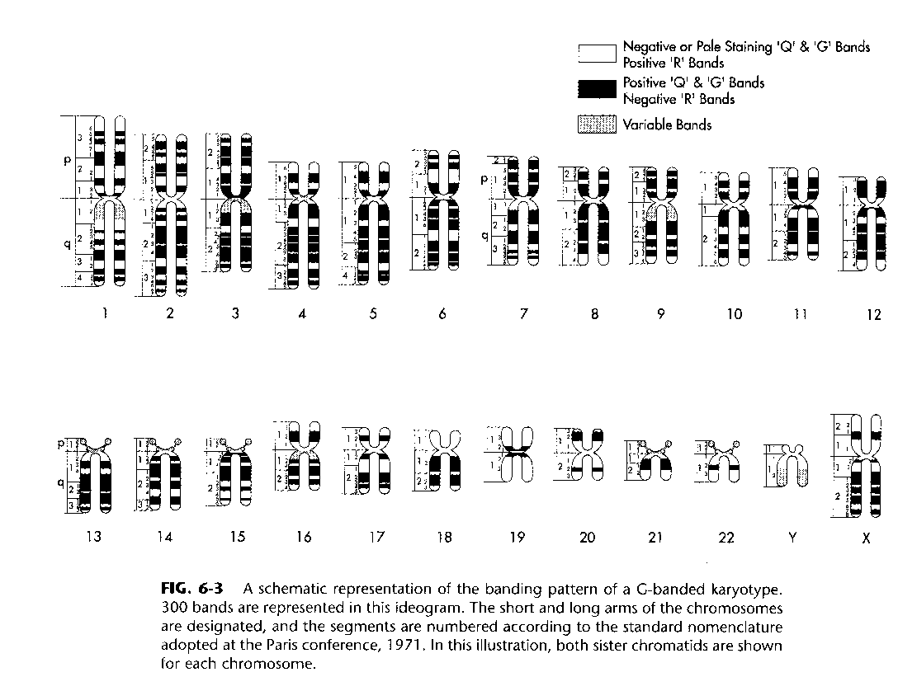

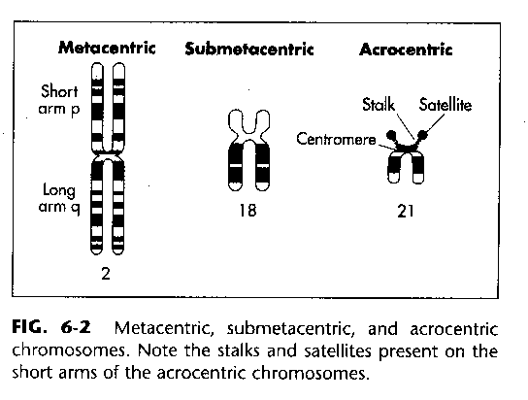

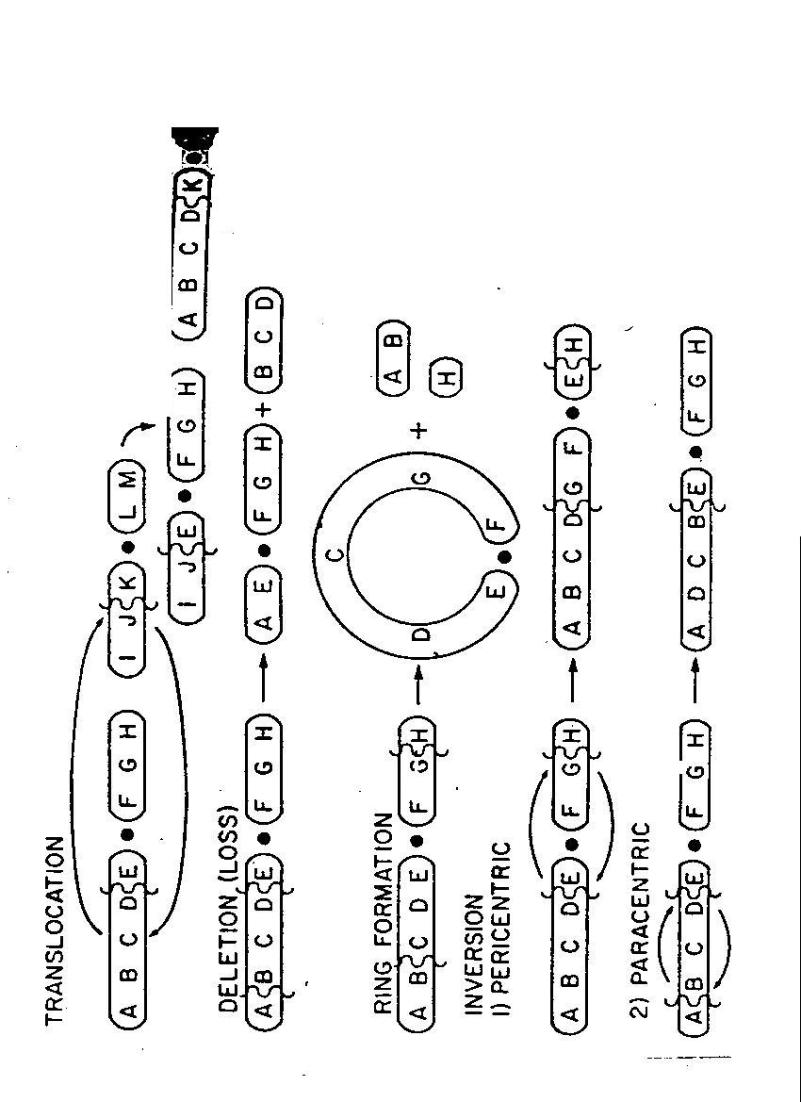

Types of structural abnormalites

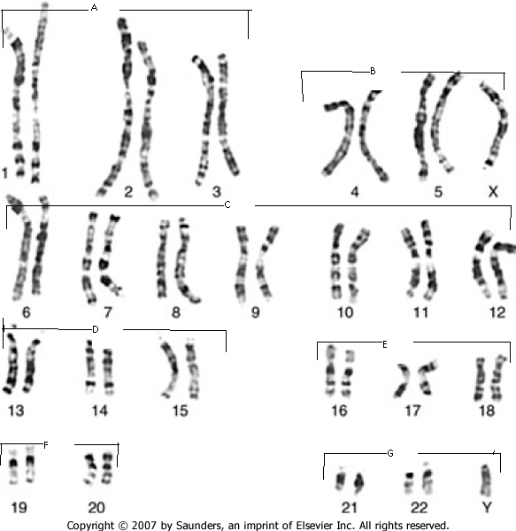

Incidence of Chromosome Disorders in each group:
  - Spontaneous Abortion 50% (The single most common chromosomal abnormality among abortuses is Turner’s syndrome - 18% abortuses, 0.6% live births)
  - Neonatal deaths - 50%
  - Birth defects - 70%

Genetic Diagnosis:
- Features of disorder
- Family history
- Thinking and research

- Tests

Indications for cytogenetic analysis:
1. Confirmation of a suspected classical chromosomal syndrome
2. Multiple congenital anomalies/mental retardation syndromes
3. Couples with 2+ spontaneous abortions/undetermined infertility
4. All abortuses and malformed stillborns/all phenotypically normal stillborns of undetermined etiology
5. Females with proportionally short stature of unknown etiology (specifically, checking for Turner’s syndrome)
6. Primary amenorrhea/secondary amenorrhea of unknown etiology
7. Pubertal failure in either sex
8. Ambiguous genitalia
9. Suspected Fragile X syndrome

Cytogenetic disorders cause three types of problems and they may all occur in the affected person:
1) Growth abnormalities
2) Mental retardation
3) Birth defects and dysmorphic features
o Hands and ears are often dysmorphic in genetic abnormalities
o Always compare suspected abnormalities with parents’ features - It may just be a normal variant in that family

Trisomies
Down syndrome (DS)
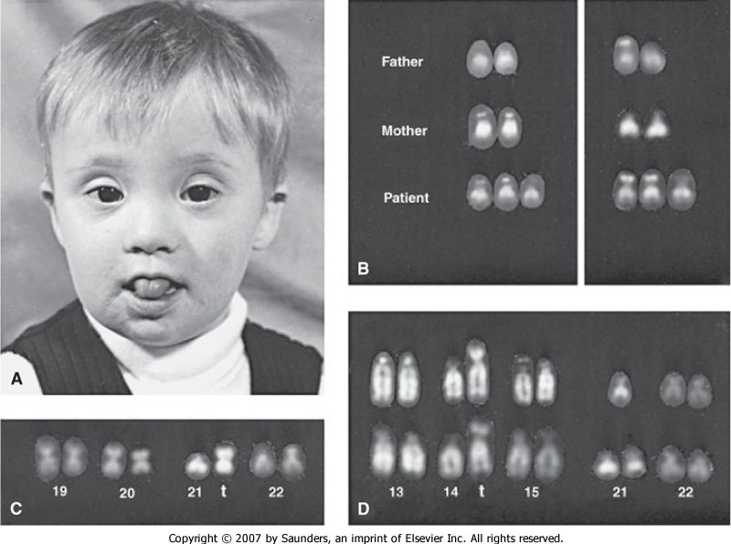
- Affects 1 in every 600-800 live births
- Females with Downs have early menopause, but can have children
- Males are usually sterile.
- The percentage of pregnancies resulting in DS grows exponentially when the mother is over the age of 35. (However, most Downs syndrome children are born to women under the age of 35, since a vast majority of pregnancies occur under that age.)
- Classical features include: Mental retardation (100%), congenital heart defect (50%)
Others are:
- Brachycephaly
- Microcephaly
- Flat facial profile
- Short neck with excess skin at nape
- Small facial features
- Short folded over ears
- Wispy hair
- Short nose
- Brushfield spots
- Short 5th finger with clinodactyly
- Single transverse palmar crease
- Wide gap between 1st and 2nd toes hypotonicity
- Short palpebral fissures that slant up (or down if child has large jaw)
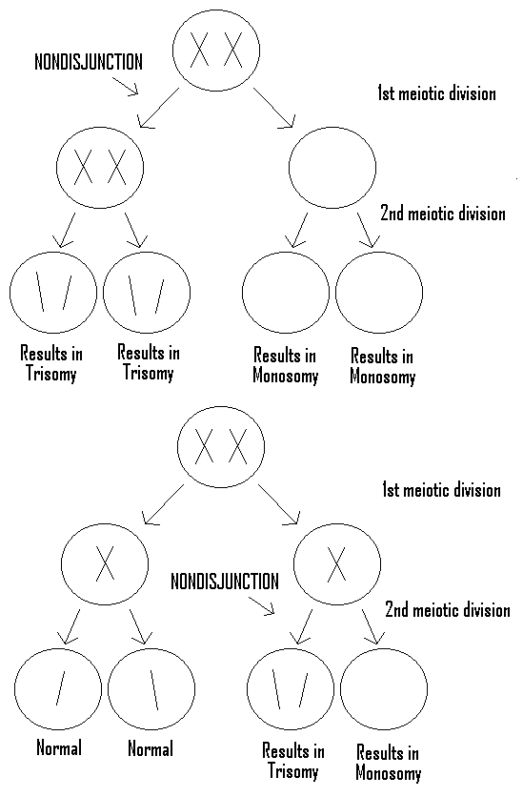
- Causes of DS
- Trisomy 21 – accounts for 95% of individuals with DS
- Due to nondisjunction in the ova
- Incidence increases with maternal age
  - Age 35 - 1 in 200 live births
  - Age 40 - 1 in 40 live births
  - Age 45 - 1 in 15 live births
- Nondisjunction can occur in either Meiosis I or II (see picture)
- Translocation: chromosome 21 translocated on another chromosome especially another acrocentric chromosomes e.g. 13, 14, 15, 21, 22.
- Accounts for 2-4% of individuals with DS
- Prognosis is the same for Trisomy 21 patients
- These individuals have one 14/21 translocation and two normal chr. 21's and thus they express the same phenotypic characteristics as individuals with trisomy 21
- De novo translocation occurs about 50% of the time (this is due to breakage and recombination of the chromosomes – test the parents, they will be normal)
- The other 50% is inherited - one of the parents carries a translocated chr. 21 and a normal chr. 21
  - A father’s risk of producing a child with an unbalanced karyotype is 5%, but mother’s risk is 10-15%
  - Ex. Father Mother
14 14/21 21 14 14 21 21
(Balanced translocation) (Normal) Normal offspring 14 14 21 21 (2 14’s, 2 21’s)
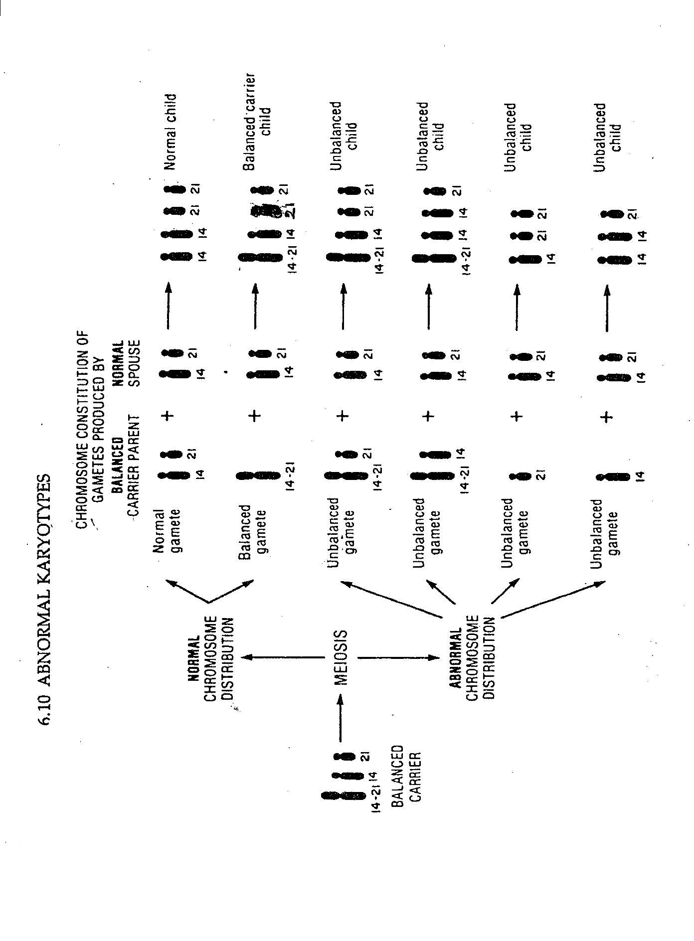
Balanced translocation
(Normal phenotype) 14 14/21 21 (2 14’s, 2 21’s)
Unbalanced translocation
(Down syndrome) 14 14/21 21 21 (2 14’s, 3 21’s)

- Mosaicism
- Nondisjunction occurs after fertilization in somatic cells very early in embryonic development
- Individuals have normal chromosomes in a certain % of the their cells and DS in the remaining cells
- Tend to have slightly higher IQs and are somewhat higher functioning than trisomy 21 DS patients

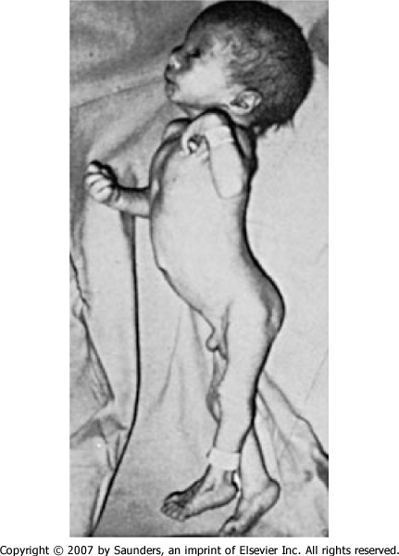
Trisomy 18 - the next most common trisomy, affects 1 in 6,000 live births
- Results in spontaneous abortion about 95% of the time
- Individuals who are born with trisomy 18 usually die at about 4 months of life( 90% die in first year of live)
- Problems are much more severe than trisomy 21
- Clinical features include:

- Small for gestation age (SGA)
- Post-term birth
- Dolichocephalic
- Small physical features (“delicate”)
- Short sternum
- Short dorsiflexed feet
- Rocker bottom heels
- Short first toes
- Over folded hands - hands stay in a locked position
- Lack of creases at the interphalangeal joint
- Flat arches on all their fingertip prints
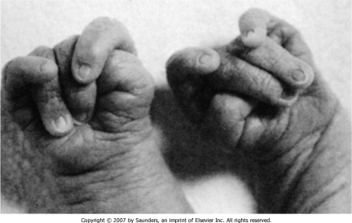
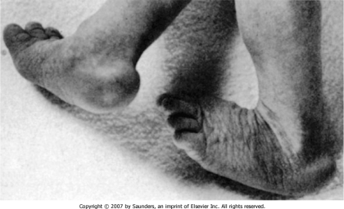

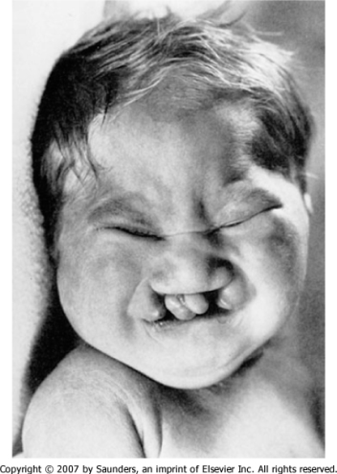
Trisomy 13 - the next most common trisomy, affects 1 in 10,000 live births .
- Prognosis is similar to that of Trisomy 18.
- Clinical features include:

- Large size
- Severe facial cleft
- Over folded hands
- Large facial features (esp. nose)
- Dorsiflexed, rocker-bottom feet
- All have heart and kidney defects

Deletions

occur when chromosomes break and divide. Deletion in the heterochromatic band ( no active genes) result in minimal abnormal features. Deletion in the euchromatic band ( active genes) results in major problems.

Cri du Chat Syndrome - due to a deletion at the end of the short arm of chr. 5
- Either the entire end or only a small piece of the end of the chr. may be deleted.
- The severity of the disorder correlates with the size of the deletion.
- Clinical features include:

- Microcephaly
- Wide, round eyes w/ major epicanthal folds
- A flat nasal bridge
- Round face
- Low-set ears with preauricular tags
- Unusually small jaws
- Severe mental retardation
- A distinct cat-like cry (“like a Siamese cat”)

Sex Chromosome Disorders

Turner’s Syndrome - affects 1 in 5000 live births,
- Females missing an X chromosome
- The most frequent karyotype is 45,XO
- 50% of cases have other karyotypes
- Mosaics (25%) - 46,XX/45,XO
- Ring chromosome - the end of each chromosome is deleted and broken arms reunite in a ring
- Clinical features include:
- Short stature (that begins early and becomes more pronounced)
- Gonadal malformations and infertility
- Puffy feet, hands, and swollen neck at birth (due to abnormal lymphatic drainage - lymphademia)
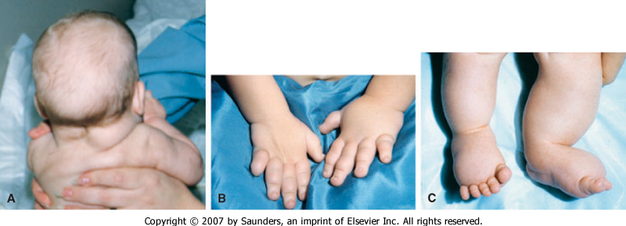
- Low posterior hair line
- Broad chest with widely spaced nipples
- Elevated risk of cardiovascular (esp. coartication of aorta) and renal anomalies.
- Secondary sex characteristics and genitalia may be developed with external hormone therapy
- Turner’s syndrome is most commonly diagnosed in infants (puffy hands/feet and thick neck), 8 year olds (shortest in class), 18 year olds (has not undergone puberty), and older young adults (infertility). Early detection will allow treatment with growth hormone, estrogen, etc. that might produce a more normal development.
- Patient’s usually have normal IQ - no mental retardation
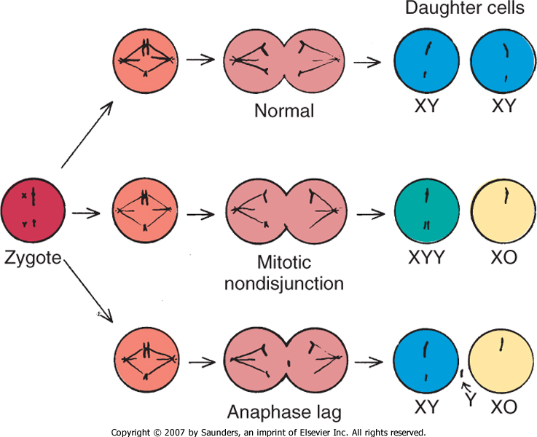

Klinefelter Syndrome
- This syndrome is suspected when males fail to undergo puberty - very hard to pick up in prepubertal boys
- Males have one or more extra X chromosomes (XXY is most common).
Karyotype Incidence
47,XXY 1/1000 males
48,XXXY 1/25,000 males
Others (48,XXYY,49,XXXYY, mosaics) 1/10,000 males
- Mosaic karyotypes account for 15% of the affected
- 50% of the affected are thought to be as the result of nondisjunction in the male.
- Clinical features include:

- Tall, slim build
- Arachnodactyly (long fingers)
- Gynecomastia
- Female fat distribution

- Hypogenitalism
- Skeletal dysplasia with scoliosis
- Elbow dysplasia
- Fifth finger clinodactaly
- Many of these problems occur due to lack of production of testosterone by the gonads.
- Affected males are likely to be of lower than average intelligence, and have an abnormal personality profile.
- Typical psychological characteristics: shy, passive, dependent, apprehensive, impulsive, distractible, and aggressive.
- Often affected males have adaptive problems, such as chronic school failure, separation from family and poor peer relations. Males with this disorder are much better able to develop in a stable, nurturing home than a disruptive one.
- Each additional X (as in XXXY or XXXXY) results in more severe MR and other symptoms.

Fragile X Syndrome - the second most common cause of mental retardation (after T21).
- More males than females are mentally retarded. 80% of males with the gene are mentally retarded
- The # of CGG expansions & the degree of methylation are directly correlated to the severity of mental retardation.
- The size of the insertion is amplified in each successive generation, resulting in anticipation.
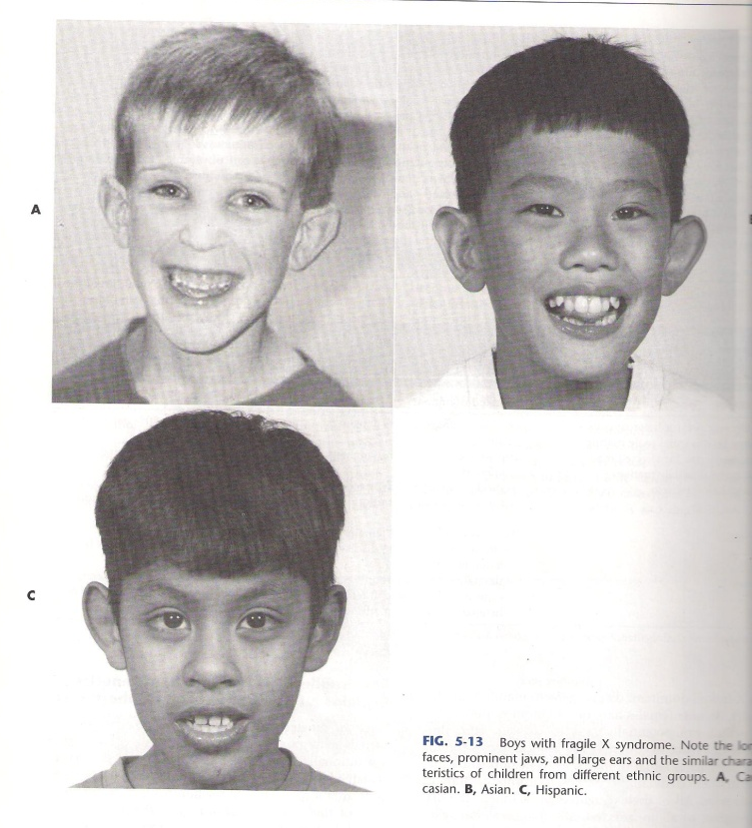
- Normal persons have between 2-50 repeats, while carriers with 50-230 repeats are phenotypically normal or near normal (premutation). Affected persons have more than 250 repeats (full mutation).
- Fragile X Syndrome is an X-linked trait carried by mildly affected or unaffected mothers and passed on to their sons and daughters. Normal transmitting males can pass it on to their daughters who will all be carriers and most likely normal (the gene doesn't undergo expansion as much in the male).
- IQ often decreases with age.
- Facial Features: long narrow face with a large mandible, long everted ears, prominent chin and forehead, high palate
- Neurologic: seizures (20%), strabismus and amblyopia(40%), and motor tics
- Hypermobile joints and macroorchidism (increased testicular volume) in postpubertal males.
- The term fragile X is related to the fact that cells from affected individual , when cultured in folic acid deficient media , sometimes exhibit beaks and gaps near the tip of the long arm
