Inborn Error Of Metabolism

Many childhood conditions are caused by single gene mutations that encode specific proteins. These mutations can result in the alteration of primary protein structure or the amount of protein synthesized. The function of a protein, whether it is an enzyme, receptor, transport vehicle, membrane, or structural element, may be relatively or seriously compromised. These hereditary biochemical disorders are also termed inborn errors of metabolism or inherited metabolic
So inborn error of metabolism are a large group of hereditary biochemical diseases in which specific gene mutation cause abnormal or missing proteins that lead to alter function
Although individually rare, inborn errors of metabolism are an important cause of pediatric morbidity and mortality.
Single gene defects result in abnormalities in the synthesis or catabolism of proteins, carbohydrates, or fats.
Most are due to a defect in an enzyme or transport protein, which results in a block in a metabolic pathway.
Effects are due to toxic accumulations of substrates before the block and by a deficiency of products beyond the block, or a combination of these metabolic deviations.

Common Characteristics of Genetic Disorders of Metabolism

Although the manifestations of genetic metabolic disorders are quite variable, the following features are shared among most of these conditions:
 |  | 1 | The affected infant is normal at birth and becomes symptomatic later on in life. This differentiates these infants from those who appear sick at birth due to birth trauma, intrauterine insults, chromosomal abnormalities or other genetic diseases.
 |  | 2 | The nature of the mutation that causes the dysfunction of the gene usually varies from family to family. This results in variation in severity of the phenotype in different families.
 |  | 3 | Mutations causing severe malfunction of the gene or its product result in clinical manifestations shortly after birth. In general, the earlier the appearance of clinical symptoms the more severe is the disease.
 |  | 4 | The majority of conditions are inherited as autosomal recessive traits. Therefore, a history of consanguinity in the parents or of an unexplained death in the neonatal period may raise the question of an inherited metabolic disease in the sick infant.
 |  | 5 | Most of the genetic metabolic conditions can be controlled successfully by some form of therapy, and a few can be potentially cured by the use of bone marrow or liver transplants. These patients can have a normal life if diagnosed and treated early, before irreversible damage to organs, especially to the brain, occurs. This underlines the importance of early diagnosis, which can be achieved through screening of all newborn infants.  presentation
 | An inborn error of metabolism may be suspected before birth from a positive family history or previous unexplained deaths in the family.

After birth, inborn errors of metabolism usually, but not invariably, present in one of five ways:
- As a result of newborn screening, e.g. phenylketonuria (PKU), or family screening, e.g. familial hypercholesterolaemia
- After a short period of apparent normality, with a severe neonatal illness with poor feeding, vomiting, encephalopathy, acidosis, coma and death, e.g. organic acid or urea cycle disorders
- As an infant or older child with an illness similar to that described above but with hypoglycaemia as a prominent feature or as an ALTE (acute life-threatening episode) or near-miss 'cot death',
- In older children it should be considered in any child with one or more of the following manifestations:
a. unexplained mental retardation, developmental delay, motor deficits or convulsions.
b. unusual odor particularly during an acute illness
c. intermittent episodes of unexplained vomiting, acidosis, mental retardation or coma.
d. hepatomegaly.
e. renal stones.
- In a subacute way, after a period of normal development, with regression, organomegaly and coarse facies, or As a dysmorphic syndrome.
Mass Screening of Newborn Infants

Common characteristics of genetic metabolic conditions make a strong argument for screening all newborn infants for the presence of these conditions. During the past half-century, methods have been developed to screen all infants inexpensively with accurate and fast-yielding results. Tandem mass spectrometry (MS/MS) is the latest technical advance in the field. These tests are done on a spot of blood from a heel-prick collected onto a filter paper and mailed to a central laboratory for assay

Treatment
The majority of patients with genetic disorders of metabolism respond to one or all of the following treatments:
 | 1 | Special diets play an important role in the treatment of affected children. Dietary changes should be tailored to the pathophysiology of the condition and vary greatly among disorders.
 | 2 | Peritoneal dialysis or hemodialysis for expeditious removal of accumulated noxious compounds. This is a very effective modality for treatment of the acute phase of the condition.
 | 3 | Administration of the deficient metabolite.
 | 4 | Administration of the deficient enzyme.
 | 5 | Administration of the cofactor or coenzyme to maximize the residual enzyme activity.
 | 6 | Activation of alternate pathways to reduce the noxious compounds accumulated because of the genetic mutation.
 | 7 | Bone marrow transplantation.
 | 8 | Liver transplantation.

The last two modalities have the potential to cure the metabolic abnormalities. Replacement of the mutant gene with a normal one (gene therapy) is still in the experimental phase.
Treatment of genetic disorders of metabolism is complex and requires medical and technical expertise. The therapeutic regimen often needs to be tailored to the individual patient because of large phenotypic variations in the severity of the disease, even within a single family. Providing education and support for the family is the key to successful long range therapy. Effective treatment is best achieved by a team of specialists (physician specialist, nutritionist, geneticist, neurologist, and psychologist) in a major medical center.

Defects in Metabolism of Amino Acids
Phenylketonuria

This occurs in 1 in 10 000-15 000 live births in the UK. It is either due to a deficiency of the enzyme phenylalanine hydroxylase (classical PKU) or in the synthesis or recycling of the biopterin cofactor for this enzyme.

Homocystinuria

This is due to cystathionine synthetase deficiency. Presentation is with developmental delay and eventually subluxation of the ocular lens (ectopia lentis). There is progressive learning difficulty, psychiatric disorders and convulsions. Skeletal manifestations resemble Marfan syndrome. The complexion is usually fair with brittle hair. Thromboembolic episodes may occur at any age. Almost half respond to large doses of the coenzyme pyridoxine. Those who do not respond are treated with a low-methionine diet supplemented with cysteine and with the addition of the re-methylating agent betaine.

Defects in Metabolism of Carbohydrates
Galactosaemia
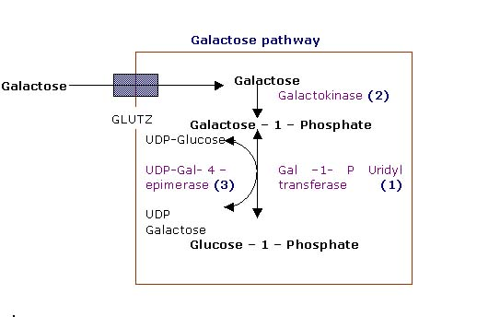
This rare, recessively inherited disorder results from deficiency of the enzyme galactose-1-phosphate uridyltransferase, which is essential for galactose metabolism. When lactose-containing milk feeds such as breast or infant formula are introduced, affected infants feed poorly, vomit and develop jaundice, hypoglycemia and hepatomegaly and hepatic failure there is increase risk of sepsis by E.coli. Chronic liver disease, cataracts and developmental delay are inevitable if the condition is untreated. Even if treated early, there are usually moderate learning difficulties (adult IQ 60-80).
Diagnosis:
- positive reducing substance in urine (galactose)
- elevated level of galactose in the blood (during neonatal screening)
- enzyme assay in blood sample
Management is with a lactose- and galactose-free diet for life.
Glycogen storage disorders
These mostly recessively inherited disorders have specific enzyme defects which prevent mobilisation of glucose from glycogen, resulting in an abnormal storage of glycogen in liver and/or muscle. There are eleven main enzyme defects.
Type I (von Gierke)
In this type the enzyme deficient is Glucose-6-phosphatase the disease started at infancy and the liver is the main organ of storage, and hepatomegaly and hypoglycaemia are prominent. There is also an enlarged kidneys and growth failure, Long-term complications of type I include hyperlipidaemia, hyperuricaemia, the development of hepatic adenomas and cardiovascular disease
Management is to maintain blood glucose by frequent feeds or by carbohydrate infusion via a gastrostomy or nasogastric tube in infancy. In older children, glucose levels can be maintained using slow-release oligosaccharides (corn starch).
Prognosis is good

Type II (Pompe disease)
In this type the enzyme deficient is Lysosomal α-glucosidase and the disease started at infancy there is generalised intralysosomal storage of glycogen (liver and muscles) . The disorder may predominantly affect muscle leading to skeletal muscle weakness. The heart is severely affected, leading to death from cardiomyopathy. Treatment with enzyme replacement therapy (Myozyme) is now available

Lysosomal storage disorders
e.g. lipid storage disorders and mucopolysaccharidoses, in which absence of an enzyme leads to accumulation of a harmful metabolite
In lipid storage disorders, which are sphingolipidoses, there is an accumulation of sphingolipids, essential components of CNS membranes. They are diagnosed on testing white cell enzymes.
Tay-Sachs disease
This disease results from the deficiency of β-hexosaminidase activity and the lysosomal accumulation of GM₂ gangliosides, particularly in the central nervous system. It is an Autosomal recessive disorder, Most common among Ashkenazi Jews,
Clinical features Developmental regression in late infancy, exaggerated startle response to noise, visual inattention and social unresponsivenessSevere hypotonia, enlarging head, Cherry red spot at the macula, Death by 2-5 years
Diagnosis - measurement of the specific enzyme activity
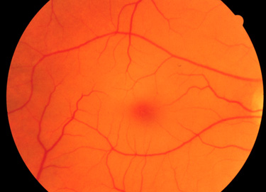
Carrier detection of high-risk couples is practised
Prenatal detection is possible

Gaucher disease
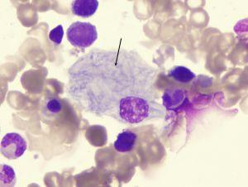
Gaucher disease results from the deficient activity of the lysosomal hydrolase, acid β-glucosidase, The enzymatic defect results in the accumulation glucosylceramide, in cells of the reticuloendothelial system. Chronic childhood form Occurs in 1 in 500 Ashkenazi Jews presented by splenomegaly, bone marrow suppression, bone involvement, normal IQ
DIAGNOSIS by asses the enzyme level in the WBC. Splenectomy may alleviate hypersplenism Enzyme replacement therapy is available, but is expensive Acute infantile form - splenomegaly, neurological degeneration with seizures Carrier detection and prenatal diagnosis are possible

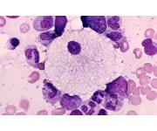
Niemann-Pick disease
result from the deficient activity of acid sphingomyelinase, a lysosomal enzyme The enzymatic defect results in the pathologic accumulation of sphingomyelin, in the monocyte-macrophage system usually presented at 3-4 months with feeding difficulties and failure to thrive, hepatosplenomegaly, developmental delay, hypotonia Cherry red spot in macula affects 50%-and deterioration of hearing and vision Death by 4 years

mucopolysaccharidoses

Hurler syndrome:(MPS1)
- AR disorder caused by deficiency of α-iduronidase.
- Signs and symptoms occur due to accumulation of heparan and dermatan sulphate.

- Clinical features: usually normal at birth.
Short stature
Short neck , low hair line
Mental retardation
Hepatosplenomegaly
Stiff joint.
Inguinal and umbilical hernia
Coarse facial features:
( depressed nasal bridge,large prominent
Tounge ,corneal opacity, copious nasal secreation).
.recurrent chest and ear infection
Developmental delay mainly by end of 1st Year. .
.Cardiomyopathy and aortic valve regurgitation

Diagnosis:
1.clinical examiation
2.heparan and dermatan sulphate in urine.
3.enzyme assay in the WBC or fibroblast.
4.radiological changes in ribs (oar-rod), in vertebrae ( hook or beaked vertebra mainly in lumbar region), in fingers (bullet shape).,
Skull( j shape sella turcica,thick calvarium).

Treament:
1.BMT: it is cureative treatment.
2.enzyme replacement is under study

Prognosis:
Most of cases die by the age of 10 year because of recurrent chest infection and heart failure, and airway obstruction due to accumulation of MPS IN the trachea.

Hunter syndrome :it is the only x. linked MPS.
It occurs exclusively in ♂.
It is due to deficiency in iduronate 2-sulphatase.
It resemble Hurler syndrome clinically and radiologically but there is no corneal clouding (hunter need normal eye).
It is milder and with slower progression than Hurler syndrome and life expectancy is near 20 years or more.
Diagnosis is by radiological changes and enzyme assay in WBC.

