4th year
2016-2017
Dr. Alaa Ibrahim
Development of placenta

The placenta is a materno-fetal organ which begins developing at implantation of the blastocyst and is delivered with the fetus at birth.
Development of the Placenta
- -Soon after ovulation, the endometrium develops its typical secretory pattern under the influence of progesterone from the corpus luteum.
- -Pregnancy occurs when healthy spermatozoa in adequate numbers penetrate receptive cervical mucus, ascend through a patent uterotubal tract, and fertilize a healthy ovum within about 24 hours following ovulation. The cellular union between the sperm and the egg is referred to as syngamy.
- -The first cleavage occurs during the next 36 hours. As the conceptus continues to divide and grow, the peristaltic activity of the uterine tube slowly transports it to the uterus, a journey that requires 6–7 days. Concomitantly, a series of divisions creates a hollow ball, the blastocyst, which then implants within the endometrium. Most cells in the wall of the blastocyst are trophoblastic; only a few are destined to become the embryo.
- Macroscopic features of the term placenta
- Measures
The placenta at term displays a round disc-like appearance with the insertion of the umbilical cord in a slightly eccentric position on the fetal side of the placenta. The average measures of a delivered placenta at term are a diameter of 22 cm, a central thickness of 2.5 cm, and a weight of 450–500 g. One has to keep in mind, though, that these data may vary considerably due to the mode of delivery, especially content versus loss of maternal and/or fetal blood.

- Tissue arrangements

- -On the fetal side of the placenta, the avascular amnion covers the chorionic plate. Underneath the amnion, chorionic vessels continue with those of the umbilical cord and are arranged in a star-like pattern. At the other end, these vessels continue with those of the villous the human placenta is classified to be a discoidal placenta, confining interactions to a more or less circular area fuse with each other, thereby closing the intervillous space and generating the fetal membranes or chorion laeve.

- -On the maternal side of the placenta, the basal plate is located. It is an artificial surface generated by separation of the placenta from the uterine wall during delivery

- -The functional unit of the placenta is the fetal cotyledon. The mature
human placenta has about 120 fetal cotyledons grouped into visible lobes (frequently and somewhat confusingly termed ‘maternal cotyledons’). Each cotyledon contains a primary villus stem arising from the chorionic plate and supplied by primary branches of fetal vessels. The primary stems divide to form secondary and tertiary stems from which arise the
terminal villi, where maternal–fetal exchange takes place. The fetal cotyledons appear to develop around the entries of the maternal spiral arteries from the decidual plate. The centre of each cotyledon is hollow
and during maternal systole, blood spurts from the spiral arteries and enters the intercotyledon space.
- Placental circulation
- In preparation for implantation of the blastocyst, the uterine endometrium undergoes "decidualisation". Spiral arteries in decidua are remodeled so that they become less convoluted and their diameter is increased. The increased diameter and straighter flow path both act to increase maternal blood flow to the placenta. The relatively high pressure as the maternal blood fills intervillous space through these spiral arteries bathes the fetal villi in blood, allowing an exchange of gases to take place. In humans and other hemochorial placentals, the maternal blood comes into direct contact with the fetal chorion, though no fluid is exchanged. As the pressure decreases between pulses, the deoxygenated blood flows back through the endometrial veins.
- -Blood rises high to the chorionic plate then disperses laterally between and over the surface of the terminal villi, becoming increasingly desaturated of oxygen and nutrients and picking up carbon dioxide and waste products. The blood then filters into narrow venous channels between the cotyledons, before falling back to the maternal decidual plate, where the maternal veins return the desaturated blood to the maternal circulation.

- Maternal and fetal blood is separated by three microscopic tissue layers:
-Trophoblastic tissue.
-connective tissue .
-The endothelium of the fetal capillaries.
-However, microscopic examination of the terminal villi surrounding the intracotyledon space shows numerous vasculosyncytial membranes where the fetal capillaries and trophoblast fuse to form a very thin membrane, where most of the transfer of nutrients and blood gases takes place, this what we call it the placental barrier. This type of placentation is termed haemomonochorial since on the maternal side there is only blood and no longer blood vessels (haemo) and on the fetal side there is only one layer of trophoblast (monochorial) between maternal blood and the fetal capillaries.
-The maternal blood flow to the placenta increases throughout pregnancy from 50 mL/min in the first trimester to 500–750 mL/min at terms. This increase in perfusion is accomplished by anatomical conversion of the maternal spiral arteries by trophoblast.
Trophoblast cells invade the spiral arterioles within the first 12 weeks of pregnancy and replace the smooth muscle of the wall of the vessels, thus converting them to wide bore, low resistance, large capacitance vessels
This process is normally complete by 20 weeks gestation.
- Onset of maternal blood flow
At the end of the first trimester the trophoblastic plugs become pervious and maternal blood cells enter the maternal blood floating in the intervillous space and the fetal vessels within the mesenchymal villous core.

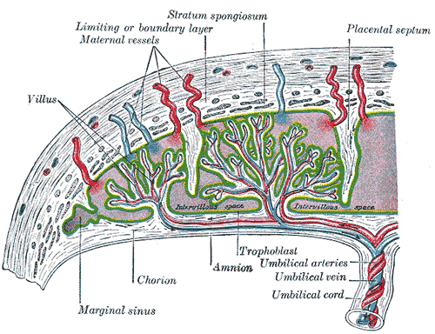

- Trophoblast lineage

At the transition between morula and blastocyst, the trophoblast lineage is the first to differentiate from the inner cell mass, the embryoblast . Only after attachment of the blastocyst to the endometrial epithelium, further differentiation of the trophoblast occurs. Exact knowledgeThe development of the lacunar system leads to the subdivision of the placenta into its three compartments.
1 the embryonically oriented part of the trophoblast will
develop into the chorionic plate,
2 the lacunae will become the intervillous space,
3 while the trabeculae will become the anchoring villi,
4 with the growing branches developing into floating villi,
5 finally, the maternally oriented part of the trophoblast will develop into the basal plate.
At the end of this stage, at day 12 postconception, the process of implantation is completed. The developing embryo with its surrounding extraembryonic tissues is totallyembeddedin the endometrium and the syncytiotrophoblast surrounds the whole surface of the conceptus. Mesenchymal cells derived from the embryo spread over
the inner surface of the trophoblast, thus generating a new combination of trophoblast and mesoderm, termed chorion.
- The Decidua
The decidua is a specialized, highly modified endometrium of pregnancy and is a function of hemochorial placentation. The latter has in common the process of trophoblast invasion, and considerable research has focused on the interaction between decidual cells and invading trophoblasts. Decidualization—transformation of secretory endometrium to decidua—is dependent on estrogen and progesterone and factors secreted by the implanting blastocyst.
- Decidual Structure
- The decidua is classified into three parts based on anatomical location. Decidua directly beneath blastocyst implantation is modified by trophoblast invasion and becomes the decidua basalis. The decidua capsularis overlies the enlarging blastocyst, and initially separates it from the rest of the uterine cavity . This portion is most prominent during the second month of pregnancy, consisting of decidual cells covered by a single layer of flattened epithelial cells. Internally, it contacts the avascular, extraembryonic fetal membrane—the chorion laeve. The remainder of the uterus is lined by decidua parietalis—sometimes called decidua vera when decidua capsularis and parietalis are joined
- During early pregnancy, there is a space between the decidua capsularis and parietalis because the gestational sac does not fill the entire uterine cavity. By 14 to 16 weeks, the expanding sac has enlarged to completely fill the uterine cavity. With fusion of the decidua capsularis and parietalis, the uterine cavity is functionally obliterated. In early pregnancy, the decidua begins to thicken, eventually attaining a depth of 5 to 10 mm. With magnification, furrows and numerous small openings, representing the mouths of uterine glands, can be detected. Later in pregnancy, the decidua becomes thinner, presumably because of pressure exerted by the expanding uterine contents.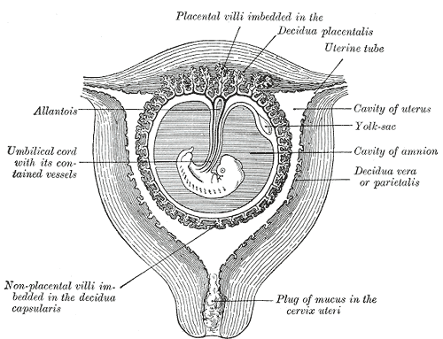
- Fetal membranes :
- Fluid accumulation within the amnionic cavity, that is,between embryo and chorionic sac leads to a complete separation of embryo and surrounding extraembryonic tissues, only leaving the developing umbilical cord as the connection between placenta and embryo. The amnionic mesenchyme comes into direct contact with the chorionic mesoderm lining the inner surface of the chorionic sac. Both tissue layers do not fuse, and it remains that amnion and chorion can easily slide againsteach other. As described above, it is only at the implantation pole that the definitive placenta develops. Due to regression of villi, most of the surface of the chorionic sac (about 70%) develops in such a way that the early chorionic plate, together with the amnion, remnants of villi and the early basal plate fuse and form a multilayered compact structure termed the chorion laeve or fetal membranes.

- Function

1.Nutrition
The perfusion of the intervillous spaces of the placenta with maternal blood allows the transfer of nutrients and oxygen from the mother to the fetus and the transfer of waste products and carbon dioxide back from the fetus to the maternal blood supply.

2. Excretion
Waste products excreted from the fetus such as urea, uric acid, and creatinine are transferred to the maternal blood bydiffusion across the placenta.

3. Immunity
IgG antibodies can pass through the human placenta, thereby providing protection to the fetus in utero.
4. endocrine function:
The first hormone released by the placenta is called the human chorionic gonadotropin hormone. This is responsible for stopping the process at the end of menses when the Corpus luteum ceases activity and atrophies.
Progesterone helps the embryo implant by assisting passage through the fallopian tubes.
Estrogen is a crucial hormone in the process of proliferation. This involves the enlargement of the breasts and uterus, allowing for growth of the fetus and production of milk.

