Breech presentation
ا.م.د.علي مراد

Breech presentation occurs when the fetal buttocks or lower extremities present into the maternal pelvis . The incidence of beech presentation is 4% of all deliveries .prior to 28 weeks approximately25% of fetuses are in a breech presentation.
Etiology :
1-The magor factors predisposing to breech presentation is prematurity .
2-structural anomalies e.g hydrocephlus .
3- uterine anomalies e.g bicornoate uterus .
4- multiple gestation .
5- placenta previa .
6- contracted maternal pelvis .
7 –pelvic tumour that obstruct birth canal .fibroid
Classification :
- 1.Frank breech occurs when both fetal thighs are flexed and both lower extremities are extended at the knees
- 2.Complete breech has both thighs flexed and one or both knees flexed (sitting in a squat position ).
- 3.An incomplete or footling breech has one or both thighs extended and one or both knees or feet lying bellow the buttocks
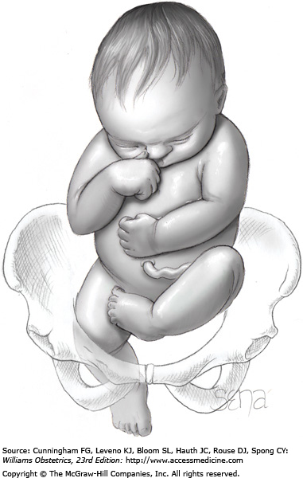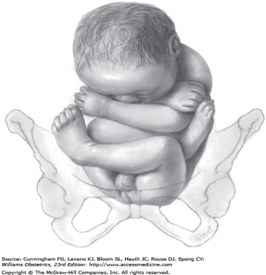
Diagnosis :
The diagnosis of breech presentation can often be made by obstetrical examination in which the fetal head is palpated in the fundal region and the softer smaller breech occupies the lower uterine segment above the symphysis pelvis . In a frank breech in labor , the fetus buttocks ,anus ,sacrum and ischial tuberosities can be palpated on vaginal examination ,with complete breech the feet ,ankles and often the buttocks are palpable through dilated cervix .
Pregnancy management
- Exclude fetal and uterine anomalies like fetal structural anomaly , uterine myoma.
- External cephalic version is aprocedure in which the obstetrician is manually converts the breech fetus to a vertex presentation via external uterine manipulation under ultrasound guidnace .ECV may be considered in a breech presentation at term before the onset of labor .Version is not carried out prior to 36 to 37 weeks gestation because tendency for the pre mature fetus to revert spontaniously to a breech presentation .
- The procedure must be carried out in a hospital that is equiped to perform an emergency caesarean section because the small risk of placental abruption or cord compression . The patient should have nothing by mouth for 8 hours prior to the version a attempt in case emergency delivery is necessary. Evidence of utro placental insufficiency , hypertension ,intra uterine growth restriction ,oligohydramnia or previous uterine surgery is contra indication to external cephalic version.
- Risks of ECV
- 1-placental abruption
- 2- premature rupture of the membranes
- 3-cord accident
- 4-transplacental haemorhage so you have to give ante Din Rh –ve patients
- 5-fetal bradicardia

- Caesarean section is better than planned vaginal birth ,however when a women presents in advanced labour and delivery is imminent , there is no choice but to perform a vaginal delivery .
- Prerequisities for vaginal breech delivery:
- 1-The presentation should be either extended (hip flexed , knees extended) or flexed (hips flexed , knees flexed but feet not below the fetal buttocks).
- 2- There should be no evidence of feto pelvic disproportion with a pelvis clinically adequate and an estimated fetal weight of less than 3500 g (ultrasound or clinical measurement).
- 3- there should be no evidence of hyperextention of the fetal head.
- Fetal well being and progress should be carefully monitored

- Technique :
- Breech delivery needs the position of masterly inactivity (hands off).Problems are more likely to arise when the obstetrician tries to speed up the process(by pulling on the baby).
- Delivery of the buttocks :
- In most circumstances , full dilatation and descent of the breech will have occurred naturally once the anterior butock is delivered and the anus is seen over the forchette an episiotomy
- Delivery of the legs and lower body .If the legs are flexed , they will deliver spontanously . If extended they may need to be delivered using Pinards manoeuvere this by using a finger to flex the legs at the knee and then extend at the hip , first anteriorly then posteriorly.With contraction and maternal effort the lower body delivered.
- Delivery of the shoulders :Lovset s manover help to deliver the shoulders
- Delivery of the head
- The head is delivered using the Mauriceau –Smellie Veit manoeuvere the baby lies on the obstetricians arm with downward traction being levelled on the head via afinger in the mouth and one each maxilla. Delivery occurs with first downward and then upward movement if this manoeuvre proves difficults forceps need to be applied
- Breech extraction is rarely performed but may be done in
- 1- delivery of second twin
- 2- cord prolapse

- Complications
- 1- maternal 2- fetal a- intracranial haemorhage
- A- trauma to genital tract b-birth asphyxia
- B-operative vaginal delivery c-birth injuries
- C-Caesarean section
- D-sepsis

