Subfertility

D.Hind 2016 C.A.B.O.G, Lecturer
Objectives
•Define Infertility
•Identify the various causes of infertility
•Understand the evaluation for infertility
Definition:
Failure to conceive within 1 year of unprotected regular intercourse.
classification:
Primary subfertility: couples who had no previous conception.
Secondary subfertility: couples who had previous conception
Epidemiology:
- 50% of couples will conceive spontaneously after receiving advice & simple treatment.
- The remainder require more complex assisted conception techniques.
- 4% of couples will remain involuntarily childless
Factors that reduce the chance of spontaneous conception:
- The age of female partner, the fertility reduced rapidly in woman over 35 years old.
- Duration of infertility <2 years
- Low coital frequency & inappropriate timing of intercourse to ovulation
- No previous pregnancy in current relationship
- Smoking
- Body mass index outside the range 20-30(weight\Kg).
Etiology of infertility
20-40% of couples will have multiple causes
Female - about 60%
Tubal - 35%
Ovulatory - 15%
Cervical - 5%
Other - 5%
Causes of female subfertility:
Ovulation problems:
Can be classified according to the clinical findings when the level of disruption between the hypothalamus , pituitary axis & the ovary is assessed.
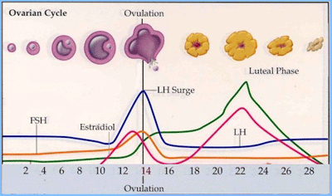

Hypergonadotrophic hypogonadism
- this occur as a result of failure of ovary to responds to gonadotrophic stimulation by the pituitary gland
- The absence of negative feedback mechanism by oestradiol &inhibin B from a developing follicle results in excessive secretion of FSH (follicular stimulating hormone )&LH(luteinizing hormone).
- Causes of Hypergonadotrophic hypogonadism : premature ovarian failure ,resistant ovarian syndrome.
- Neither premature ovarian failure ,resistant ovarian syndrome is treated by injection of FSH.
Hypogonadotraphic hypogonadsim
- Due to hypothalamic disorders ,when the pulsatile secretion of the GnRH is slowed or stops.
Causes:
Excessive exercise ,psychological stress & anorexia nervosa.

Failure of the pituitary gland to produce gonadotrophins
Causes:
- Destruction of the anterior pituitary gland by tumor(craniopharangioma ,benign non –functioning adenoma).
- Pituitary inflammatory reaction as in tuberculoses, sarcoidosis.
- Ischemic changes as in Sheehan syndrome.
- Congenital abnormality as in Kallman syndrome.
- Surgical causes at the time of hypophysectomy for pituitary tumor.
- Damage during cranial irradiation.
Ovarian disfunction:
The commonest cause of anovulatory subfertility is PCOS(polycystic ovarian sundrome),the diagnosis is based on the biochemical abnormalities (low sex hormone binding globulin concentration& high androgen concentration) ,with U\S appearance of the ovaries (an enlarged ovaries, multiple subcapsular follicles & dense stroma)
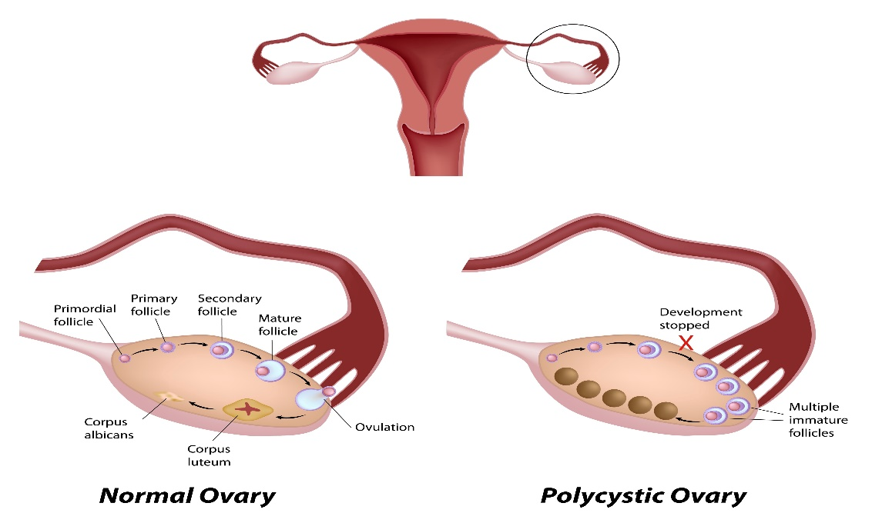

Other causes:
Endocrine disorder, e,g: hyperprolactineamia ,both hypothyrodism &hyperthyroidism
Tuba l infertility:
Tubal damage may be caused by:
1: Pelvic infection which is caused by:
- Sexual transmitted disease caused by Chlymedia trachomatis, gonococci &other microorganism can lead to tubal damage .
- Pelvic sepsis following appendicitis or peritonitis.

2:Endometriosis ,this lead to mechanical damage of the tube because of adhesions formed.
3: Pelvic surgery.
Disorder of implantation:
- Endometrial polyp
- Submuocosal fibroid
- Asherman syndrome(intrauterine adhesion)
- Congenital abnormal uterine cavity.
Unexplained infertility:
Completion of routine investigation of infertility fails to reveal a cause in 15-30% of cases.

Management:
History:
- Personal & social history:
The couples Age, Occupation of the male, exposure to high temperature, chemicals, ionizing radiation may affect the production of the sperm.
Smoking, alcohol, drugs.

- Menstrual history, age of menarche, regularity, duration, of the cycle, any associated pain (dysmenorrheal).
- Obstetric history: include history about the previous pregnancy from current & previous relationship, the pregnancy outcome ,any difficulties in getting pregnant & ask about the breast feeding.
- Contraception history: the use of oral contraception pills & long acting progesterone may associate with a period of amenorrhea. The use of intrauterine contraceptive device increases the risk of pelvic infection.
- Past medical history: any medical problem should be discussed prior to pregnancy ,use of antidepressant drugs increase prolactin secretion & NSAID may affect the ovulation.
- Sexual history: Frequency of intercourse around the period of ovulation. any pain during intercourse(dysparunia).
Examination:
- An examination of both partner is essential to ensure normal reproductive organs.
- Assessment of body mass index.
- General & pelvic examination
Investigation:
Assessment of ovulation:
- An early follicular phase ( day 2-5) measurement of (FSH&LH) assesses the reserve of oocyte.
- Basal body temperature.
- Measure of mid luteal progesterone level.
- Serial U\S to assess the size of the follicle. Transvaginal preferred than transabdominal.
- Look for endocrine abnormality by measuring thyoid hormons level, androgen & prolactin level.
Assessment of tubal patency:
- Hystrosalpingography: is the radiographic demonstration of the female reproductive tract with a contrast medium. The radiographic procedure best demonstrates the uterine cavity and the patency of the uterine tubes by injection of radio- obaque contrast medium through the cervix into the uterus & take abdominal X-ray at intervals during & after injection.
Contraindications
Hysterosalpingography is contraindicated with
* Pregnancy, to avoid the possibility that the patient may be pregnant, the examination typically is performed 7 to 10 days after the onset of
menstruation
.* acute pelvic inflammatory disease
*active uterine bleeding.
*allergic to dye.
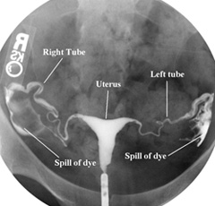
It is consider to be safe procedure but it may be associated with pelvic infection.so antibiotic and analgesic drug given for few days .

2: Hystro contrast sonography(HyCoSy):
Ultrasonographic contrast medium is slowly injected through the cervix ,visualization done by U\S, this method does not required X-ray. 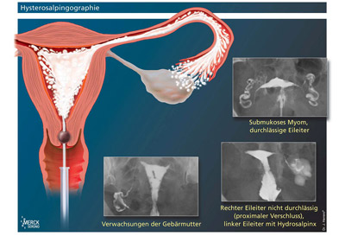
3:laproscopy : the principle of this procedure is to visualize the passage of methylene blue dye through the tubes ,direct visualization of the fimbrial ends & pelvic structures.

Assessment of the uterine cavity:
By hystrosalpingography & hysteroscopy
Before any uterine instrumentation, consideration should be given either to screening women for Chlamydia trachomatis, using an appropriately sensitive technique, or using appropriate antibiotic prophylaxis
Hysteroscopy :it is advisable to assess the uterine cavity pathology as submucosal fibroid, polyp, uterine malformations.

Post coital test:
Has limited prognostic value & is rarely used today it involves the assessment of the periovulatry cervical mucus & sperm in sample obtained from female partner 6-10 hours after coitus.

Trearment:
Ovulation problems:
- Those with hypothalamic disorder from excessive weight gain or low body weight should optimize their weight.
- Those with stress should modify their life style.
- Patient with hyper prolactineamia should do full investigation to exclude medical & physiological causes.
- With PCOS ,insulin sensitizing drugs like metformin may lead to resumption of normal ovarian activity.
- Ovulation induction can be made by anti oestrogen medication including clomiphene citrate , tamoxifin or exogenous gonadotrophen to stimulate the development of one or more mature follicle.
- Clomiphen citrate is administrated during the follicular phase of the menstrual cycle. For not more than 5 days it is effective in inducing ovulation in 85 % of cases.clomiphene side effects may include: hot flashes; headache; breast pain or tenderness mild stomach discomfort.
- Ovulation induction can be induced by exogenous gonadotrophin by daily injection from the beginning of the cycle ,the dose is titrated against the individual response . Laparoscopic ovarian drilling with either diathermy or laser is an effective treatment for anovulation in women with clomiphene-resistant PCOS.
Tubal disease:
The aim is to restore the normal anatomy of the tubes.
The success rate depends on the severity, location of the damage as well as the skills of the surgeon.
Treatment:
- surgery to restore patency by laprotomy
- laproscopic adhesiolysis
- IVF-ET
UNEXPLAINED INFERTILITY
- Unexplained infertility is a diagnosis of exclusion
- Spontaneous pregnancy rate are high in first three years of trying
- Clomiphene encourages multi follicular ovulation and increases the chances of pregnancy in couple’s with unexplained infertility
Thank you

