Family and Community Medicine

EPIDEMIOLOGICAL STUDY DESIGN

Dr. Alaa A.Salih -FICMS (FM) (LEC 1&2) -2016
Types of the epidemiological studies
1. Descriptive studies: Examine patterns of disease
2. Analytical studies: Studies of suspected causes of diseases
3. Interventional studies: Compare treatment modalities.

DESCRIPTIVE STUDY DESIGNS
Types of Descriptive Studies
(1) Correlational studies
(2) Case reports and case series
(3) Cross-sectional studies

Correlational Studies
Typically, an ecologic measure of exposure and an aggregate measure of disease or mortality are compared.
– Examples
• Correlation of rate of a given disease and average amount of caloric intake, proportion of smokers, or median income.
• Death rates from coronary artery disease correlate with per capita cigarette sales.

Uses of Correlational Studies:
• To suggest disease causation.
• To describe broad social and cultural attributes affecting health.
• Surveillance.
• To evaluate disease control measures.

Case Reports and Case Series
• Describe the experience of a single patient or a group of patients with similar diagnosis
– Recall: Correlational studies consider whole populations
• Typically, an observant clinician reports an unusual feature of a disease, a patient’s exposure history, or unusual medical event
– May lead to formulation of new hypotheses
– A series of unusual cases may prompt further investigations with more rigorous study designs.

Case Series
Collections of individual case reports
- May occur in a relatively short time period
(1) Can indicate the beginning or presence of an epidemic
(2) Hypothesis formulation - through investigation of the experiences of the affected individuals
(3) Identification of possible causal factors – analytic study to compare experiences of the case series with a group of individuals who did not develop the disease.

Case Report and Case Series Summary
Advantages
• Useful in the formulation of research hypotheses – suggestive of risk factors
• Important step in recognizing new diseases or risk factors.
Disadvantages
• Case report is based on the experience of one individual; the presence of any “risk factor” may be coincidental.
• Can’t use to test for valid statistical association (No comparison group).
• Can merely raise the question of an association.

Cross-Sectional Studies
• General design:
– Define a population and determine presence or absence of exposure, and presence or absence of disease for each individual.
• Exposure and disease outcome are determined simultaneously for each subject.
– Identify prevalent cases (the cases existed at the time of the study, but do not know their duration).
– Measure prevalence, not incidence (no new cases).
– Also called a “prevalence study”
– Measures of association based on prevalent cases reflect both
• The exposure’s effect on incidence
• The exposure’s effect on duration or survival.
In a cross-sectional study, we identify prevalent (existing) cases rather than incident (new) cases.
– Prevalent cases may not be representative of all cases in this population
– If an association is observed, it may be with survival, or may be a result of the disease, rather than with risk of development of disease.
– Incidence-prevalence bias
• Prevalent cases include long-term survivors, who have a better average survival than that of incident cases (represent the full spectrum of disease severity).

Descriptive Studies Summary
Advantages
• Often uses routinely collected, readily available data
• Less expensive and time-consuming as compared to analytic studies
• Good for assessing prevalence and patterns of disease occurrence
• Useful in the formulation of research hypotheses – suggestive of risk factors.
Disadvantages
• Usually cannot test epidemiologic hypotheses.
• Lacks comparison group.
• Cannot usually discern a temporal relationship between an exposure and disease.
• Not useful for rare events.
• May be subject to selection bias due to refusal, death, etc.

ANALYTIC STUDY DESIGNS

2×2 table
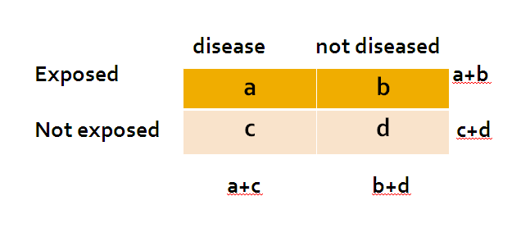

CASE-CONTROL STUDIES:

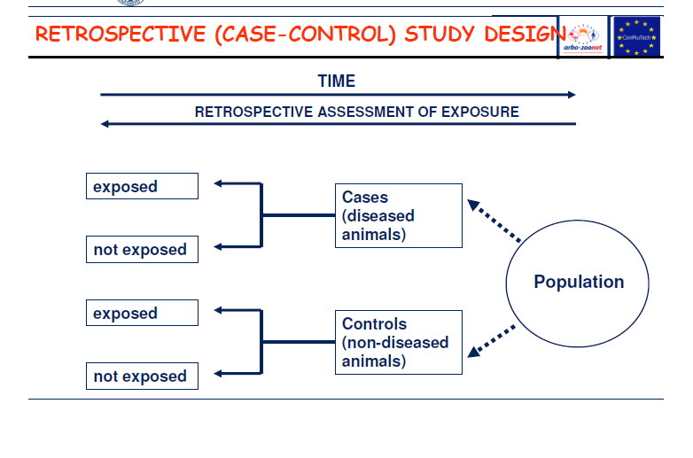
Step-by-step guide
- Select a group of diseased (cases) and group of non-diseased (controls). Matched pairs are recommended.
- Investigate the past exposure status and establish the number of exposed cases and controls,
3. Enter the data into a 2x2 table.

Case-control studies are "retrospective" because they start after the onset of disease and assess the history of postulated exposure.
• In a case-control study the inference is from effect to cause, not from cause to effect as it would be in a cohort study.

Measure of Association in Case-control Study by:
Odds ratio= Odds of exposure among cases/Odds of exposure among controls = ad/bc.

Parameters to be estimated from case-control studies include
- Prevalence of exposure:
= (a + b) / (a + b + c + d)
- Prevalence of exposure given disease:
= a / (a + c)
- Prevalence of exposure given no disease:
= b / (b + d)
- Odds ratio for exposure: Odds of exposure among cases/Odds of exposure among controls.
=a.d/b.c

Bias in Case-control Studies
1. Selection bias: Systematic error due to differences in characteristics between those selected for a study and those not selected Example: Hospitalized cases.
2. Recall bias: Systematic error due to differences in accuracy or completeness of reporting of past events or experiences Example: Mothers of children with birth defects.

• Advantages
– Useful for rare diseases.
– Relatively smaller sample sizes.
– Cost/time effective.
• Disadvantages
– Can’t directly calculate incidence
– Control selection is challenging
– Subject to bias (recall and selection).

COHORT STUDIES
Types:
1. Prospective
2. Retrospective

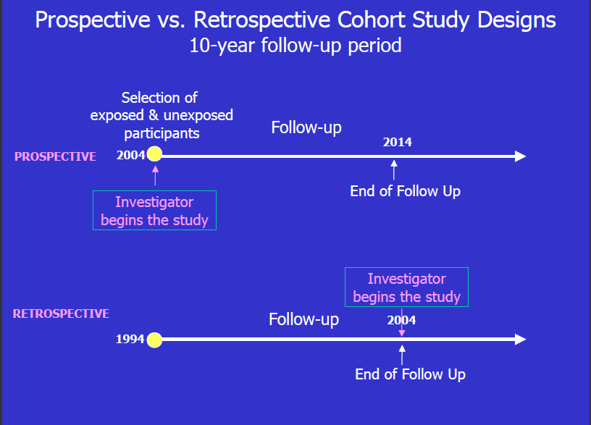

General Design:
1. Subjects are defined on the basis of exposure status.
2. Subjects are followed over time to assess disease development (Prospective).

Parameters to be estimated include:
Cumulative incidence in the exposed cohort = a / (a + b)
Cumulative incidence in the unexposed cohort, = c / (c + d)
Relative risk (cumulative incidence ratio, risk ratio):
RR = a / (a + b) / c / (c + d)
The numerical value of RR is interpreted in a similar way as OR.

Group Selection
Exposed:
• Select a sample of the population: Good for relatively common exposures, such as cigarette smoking or coffee drinking.
• Select based on special exposure e.g.:
– Individuals in certain occupations
– Individuals who have undergone a particular medical process
– Individuals living near a suspected environmental hazard
Unexposed:
• Should be similar to the exposed group with respect to all factors that
May be related to the disease except the exposure under investigation.

Main Threats to Validity
1. Differential loss to follow-up
– Example: Some participants given a new antibiotic
might have such poor outcomes that they are unable
to complete questionnaires or return for examination. Their disappearance would make the new antibiotic look better than it is.
2. Biased assessment of exposure and/or outcome
– Example: If the exposed group in an occupational
setting has periodic health examinations, and rate of
disease is compared with that of the general
population, a biased estimated could result because
of greater opportunity to have the disease diagnosed
among the exposed.

Advantage
- Study new or rare exposures
- Maintain temporal sequence between exposure & outcome.
- Directly calculate measures of risk, incidence rate, survival.
- Assess the various outcome of a single exposure.
- Avoid bias in the exposure measurement
- Better for studying natural history of disease following exposure
Disadvantage
- Likely to be large and expensive
- Inefficient for studying rare diseases
- Potentially long duration of follow-up for some outcomes
- Loss to follow up of subjects
- Exposures can change through study
- Difficult to measure confounding variables

