Lecture-1(Dr Hussain Abady Aljebori)
Introduction to pathology
Pathology; is a word meaning the study of disease and composed of (logos) means study and (pathos) means disease. More specifically, it is devoted to the study of the structural, biochemical, and functional changes in cells, tissues, and organs that underlie disease. It includes the gross, microscopic, biochemical, genetic and molecular changes in cells and tissues. It thus serves as the bridge between the basic sciences and clinical medicine, and is the scientific foundation for all of medicine. Pathology is divided into general and systemic pathology.
Etiology or Cause; there are two major classes of etiologic factors:
- genetic (e.g., inherited mutations and disease-associated gene variants, or polymorphisms).
- acquired (e.g., infectious, nutritional, chemical, physical).
- Multifactorial, In fact, most of the common diseases, such as atherosclerosis, hypertension, diabetes, cancer and others, arise from the effects of various external triggers (environmental factors) on a genetically susceptible individual.
Pathogenesis: refers to the sequence of events in cells and tissues in response to the etiologic agent.

Overview of cellular responses to stress and noxious stimuli
Cells constantly adjusting their structure and function to accommodate changing in demands and extracellular stresses by a mechanism which is called adaptation in order to remain in a state of homeostasis and avoid cell injury. If the adaptive capability is exceeded or if the external stress is inherently harmful, cell injury develops. Within certain limits injury is reversible, however, severe or persistent stress results in irreversible injury and death of the affected cells. Cell death results from diverse causes, including ischemia (lack of blood flow), infections, toxins, and immune reactions. Cell death is also a normal and essential process in embryogenesis, the development of organs, and the maintenance of homeostasis.
Cellular adaptation to stress
Adaptations; are reversible changes in the number, size, phenotype, metabolic activities, or function of cells in response to changes in their environment.
Irreversible
cell injury
- Physiologic adaptations; usually represent responses of cells to normal
stimulations by hormones or endogenous chemical mediators (e.g., the hormone-
induced enlargement of uterus during pregnancy).
- Pathologic adaptations; are responses to stress that allow cells to modulate their
structure and function and thus escape injury.
Types of adaptations are: 1. Atrophy, 2. Hypertrophy, 3. Hyperplasia, and
Cell injury
4. Metaplasia.
Atrophy; Shrinkage in the size of the cell by the loss of cell substance. When a sufficient number of cells are involved by atrophy, the entire tissue or organ diminishes in size, becoming atrophic as in figures below. It should be emphasized that although atrophic cells may have diminished function, they are not dead. Causes of atrophy include;
- Decreased workload (e.g., immobilization of a limb to permit healing of a
fracture).
- Loss of enervation.
- Diminished blood supply.
- Inadequate nutrition as Kwashiorkor.
- Loss of endocrine stimulation, as in hypopituitarism.
- Aging (senile atrophy).
Although some of causes of atrophy are physiologic (e.g., the loss of hormone stimulation in menopause) and others pathologic (e.g., denervation of a skeletal muscle).The fundamental cellular changes in both types of atrophy are identical. The aim of this type of adaptation (atrophy) is to maintain cell survival in the face of reduction in (blood supply, hormonal stimulation, nutrition etc). Atrophy is the result of decreased protein synthesis and increased protein degradation in cells. In many situations, atrophy is also accompanied by increased autophagy ("self-eating"), with resulting increases in the number of autophagic vacuoles. Autophagy is the process by which the starved cell eats its own structural components (mitochondria, myofilaments, endoplasmic reticulum etc), in an attempt to find nutrients and survive. The reduction in cell size is due to reduction in number of its structural components. Some intracellular materials resist digestion by intracellular enzymes and become enclosed by a membrane (residual bodies) such as lipofuscin granules that imparts a brown discoloration to the affected tissue or organ as in (brown atrophy of the heart).
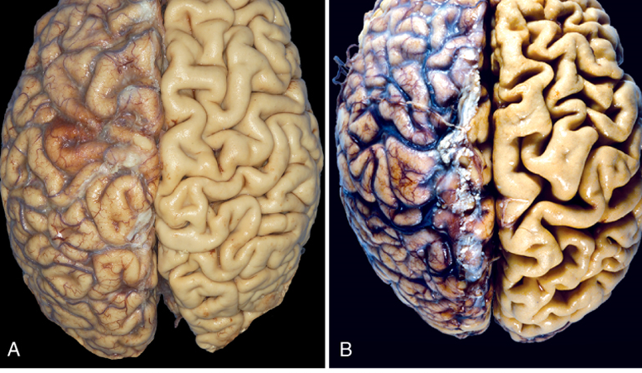
A-Normal brain of young adult. B- Atrophic brain of 82-year old man with atherosclerosis, note small
brain size with narrow gyri and widened sulci.

Hypertrophy: is an increase in the size of cells resulting in increase in the size of the organ or tissue. In contrast to atrophy, hypertrophy is due to synthesis of more structural components within the cell (more enzymes, more mitochondria and more myofilaments etc.).
Hypertrophy can be;
- Physiologic; Enlarged muscles of athletes, enlarged gravid uterus and enlarged lactating breast.
- Pathologic; hypertrophied left ventricle in hypertensive patients.
Hypertrophy is caused either by increased functional demand or by specific hormonal stimulation. Hypertrophy and hyperplasia usually occur together. Massive physiologic enlargement of the uterus during pregnancy occurs as a consequence of estrogen-stimulated smooth muscle hypertrophy and smooth muscle hyperplasia. Left ventricle hypertrophy in systemic hypertension or aortic valve diseases is an example of pathological hypertrophy. The aim of hypertrophy is to achieve equilibrium between the demand and the cell's functional capacity. If the burden persists the hypertrophy reaches a limit beyond which the enlarged muscle is no longer able to compensate for the increased work and cardiac failure happened.

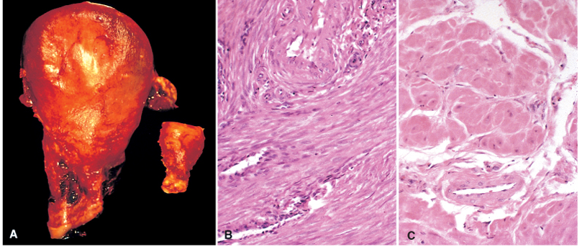
- Gross right normal uterus and gravid hypertrophied uterus on left. B-Section of normal smooth muscle fibers of uterus. C-Sections from hypertrophied smooth muscle fibers of gravid uterus, notice difference in sizes of smooth muscle in B&C.

Hyperplasia: refers to an increase in the number of cells in an organ or tissue leading to an increase in size of that organ or tissue. Hyperplasia and hypertrophy are closely related and often occur together (e.g. in estrogen induced enlargement of the uterus during pregnancy; there is both hyperplasia and hypertrophy of the myometrium). Hyperplasia occurs only in cells capable of replication.
Types of hyperplasia:
1. Physiological hyperplasia is due to either;
- Hormonal stimulation (e.g. proliferation of the breast glandular epithelium in females at puberty and during pregnancy, and also uterine smooth muscle hyperplasia during pregnancy.
- Compensatory hyperplasia (as in liver cells after partial hepatectomy).
2. Pathological hyperplasia is mostly either due to;
- Excessive hormonal stimulation (e.g. endometrial hyperplasia).
- The effect of growth factors on target cells such as in warts in human papilloma virus infection (HPV infection).
Not all adult cell types are capable of hyperplasia. Only cells capable of self-replication (division) undergo hyperplasia, accordingly cells are divided into;
- Labile cells, are the cell that are continuously in a state of cell division, such as those of the epidermis, mucosal surfaces, fibroblasts and bone marrow cells.
- Stable cells, are those cells which are capable of cell division when needed, e.g. the hepocytes.
- Permanent cells, are the cells which are incapable of cell division, like nerve cells, muscles of the heart (myocardial cells) and skeletal muscle fibers.
Metaplasia; is a reversible change in which one differentiated (adult) cell type (epithelial or mesenchymal) is replaced by another differentiated (adult) cell type. It represents an adaptive substitution of cells that are sensitive to stress by another cell type better able to withstand the adverse environment.
Metaplasia is thought to arise by genetic "reprogramming" of stem cells rather than transdifferentiation of already differentiated cells. Examples of metaplasia are: -
- Metaplasia of respiratory epithelium in the bronchi into squamous epithelium in habitual smokers as in figures below.
- Squamous metaplasia of the urothelium in the urinary bladder into squamous epithelium due to Bilharziasis or vesical stones.
- Columnar metaplasia of lower esophageal squamous epithelium into columnar epithelium as a result of prolonged reflux of acidic gastric juice into the esophagus in Barrett’s esophagus.
- In the mesenchymal cells metaplasia as in the formation of bone in long-standing fibrosis of soft tissue as a result of injury.
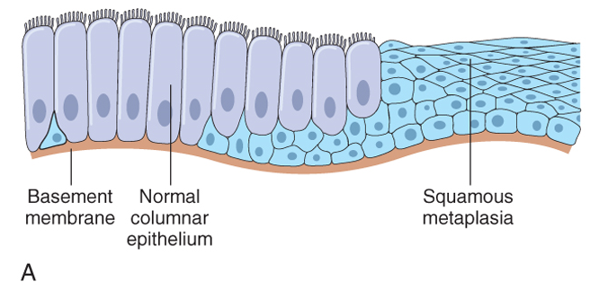
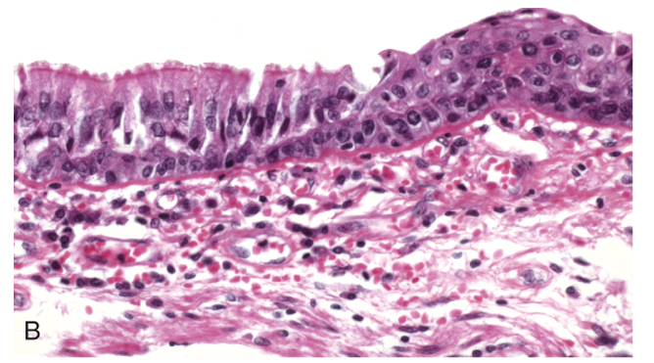

Columnar ciliated (normal respiratory Metaplastic epithelium (stratified squamous
epithelium). epithelium).

