**Haemopoiesis**

**Objectives:**

**1-Define haemopoiesis and main site of haemopoiesis**

**2-Define exteamedulary haemopoiesis**

**4-Define the surface markers of haemopoietic stem cell**

**5-Define haemopoietic growth factors**

**6-Know the function of erythropoietin and stimulants for its production**

**7-Know haemoglobin types in normal subjects and the red cell indicies**

**Haemopoiesis**

It is the process of blood cells formation (red blood cells,white blood cells and platelets).

**Site of haemopoiesis**:

-In the **first few weeks of gestation** the **yolk sac** is the main site of haemopoiesis.

-From **6 weeks until 6-7 months of fetal life** the **liver and spleen are the major haemopoietic organs** and continue to produce blood cells until about 2 weeks after birth.

-The **bone marrow** is the **most important** site from **6 to 7 months of fetal life.**

-**During normal childhood and adult life the marrow is the only source of new blood cells.**

**-In infancy all the bone marrow is haemopoietic** but during **childhood there is progressive fatty replacement of marrow throughout the long bones** so that in **adult life haemopoietic marrow is confined to the central skeleton and proximal ends of the femurs and humeri .**

Even in these haemopoietic areas, approximately 50% of the marrow consists of fat . The remaining fatty marrow is capable of reversion to haemopoiesis and in many diseases there is also expansion of haemopoiesis down the long bones.

Moreover, the liver and spleen can resume their fetal haemopoietic role **('extramedullary haemopoiesis').**

All the blood cells are derived ,in the bone marrow ,from a **pluripotent haemopoietic stem cell** that is capable of giving rise to both lymphoid and myeloid progeny via a common lymphoid progenitor cell and a common myeloid progenitor cell respectively.

This *haemopoietic stem cell* is rare, perhaps **1 in every 20 million nucleated cells in bone marrow.** Although its exact phenotype is unknown, on immunological testing it is CD34+ CD38- and has the appearance of a small or medium-sized lymphocyte.



##**The haemopoietic growth factors**: are glycoprotein hormones that regulate the proliferation and differentiation of haemopoietic progenitor cells and the function of mature blood cells e..g. erythropoietin , thrombopoietin, and Interleukin 3

( IL-3).

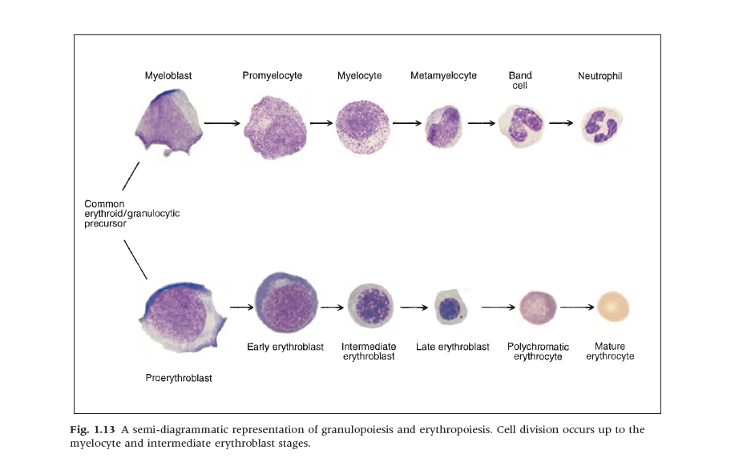

**Erythropoiesis and Red Blood Cells**

We each make approximately 1012 new erythrocytes (red cells) each day by the complex and finely regulated process of **erythropoiesis.**

**The first recognizable erythrocyte precursor in the bone marrow , is**

**the *pronormoblast.***



- Erythropoiesis is regulated by the hormone erythropoietin.. Normally, 90% of the hormone is produced in the peritubular interstitial cells of the kidney and 10% in the liver and elsewhere.

**There are no preformed stores** and **the stimulus to erythropoietin production is the oxygen (02) tension in the tissues of the kidney.**

**Erythropoietin production therefore increases** in:

- anaemia,

- haemoglobin for some metabolic or structural reason is unable to give

up 02 normally.

- when atmospheric 02 is low

- when defective cardiac or pulmonary function

- damage to the renal circulation affects 02 delivery to the kidney.

The marrow requires many other precursors for effective erythropoiesis. These include metals such as iron or cobalt, vitamins (especially vitamin B12, folate, vitamin C, vitamin E, vitamin B6, thiamine and riboflavin) and hormones such as androgens and thyroxine.

Deficiency in any of these may be associated with anaemia..

**Haemoglobin synthesis**

Normal adult blood contains three types of haemoglobin:

1.Adult haemoglobin (Hb A) 96-98 % : Hb A :**α2β2** ,The major component

2. Fetal Hb (Hb F) 0.5-0.8 % : Hb F **α2γ2****The minor haemoglobins**

3. Hb A2 1.5-3.2 % : **α2δ2**

At birth Hb F is the dominant haemoglobin in the blood. The major switch from fetal to adult haemoglobin occurs 3-6 months after birth .

**Red blood cell indicies:**

**1.Red blood cell count (RBC).**

**2. The Hb concentration (Hb).**

* 13.5 – 17.5 g/dL ♂
* 11.5 – 15.5 g/dL ♀

**3.The haematocrit (Hct) or packed cell volume PCV.**

PCV 0.39-0.50 male, 0.36-0.46 female.

**4.The mean cell volume (MCV):** PCV/RBC.

MCV 80-95 fimtoliter( fl**) .**

**5.The mean cell haemoglobin (MCH):** the average amount of

haemoglobin in an individual red cell.

MCH 27-32(pigogram) pg **.**

**6.The** **maen cell haemoglobin concentration(MCHC):** is the average

concentration of haemoglobin ,rather than the absolute amount,in an

individual red cell.

MCHC 32-36 gm/dl