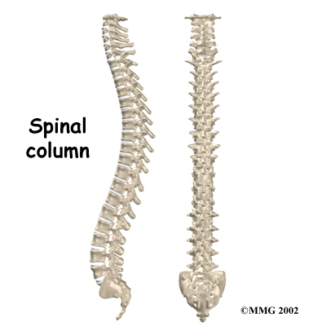***Lecture: Date: Dr. Saad Mubarak***

***Intervertebral disc prolapse***

***ACUTE INTERVERTEBRAL DISC PROLAPSE***

*Acute disc herniation (prolapse, rupture)* is much less common than chronic degeneration. Physical stress (a combination of flexion and compression) is the proximate cause.

Pathology:

A (*protrusion*)is a posteriorly bulging disc with some outer annulus intact. When *rupture* does occur, fibro-cartilaginous disc material is extruded posteriorly (*extrusion*) and usually bulges to one or other side of the posterior longitudinal ligament. With a complete rupture, part of the nucleus may sequestrate and lie free in the spinal canal (*sequestration*).

A large central rupture may cause compression of the cauda equina. A posterolateral rupture presses on the nerve root proximal to its point of exit through the intervertebral foramen. Sometimes a local inflammatory response with oedema aggravates the symptoms.

Clinical features:

*Acute disc prolapse* may occur at any age, but more common in adults 20–45 years severe back pain and is unable to straighten up. If the pain is felt in the buttock and lower limb, this is called sciatica. Both backache and sciatica are worse by coughing or straining. Later there is paresthesia or numbness in the leg or foot. Cauda equina compression is rare but may cause urinary retention and perineal numbness.

The patient has a list to one side (sciatic scoliosis). All back movements are restricted, and during forward flexion the list may increase.

There is often tenderness in the midline of the low back, and para-vertebral muscle spasm. Straight leg rising is restricted and painful on the affected side; dorsiflexion of the foot may accentuate the pain. Sometimes raising the unaffected leg causes acute sciatic tension on the painful side (crossed sciatic tension).

Neurological examination may show muscle weakness (and, later, wasting), diminished reflexes and sensory loss related to the affected level. Cauda equina compression causes urinary retention and sensory loss over the sacrum.

Imaging:

*1. X-rays* are helpful to show an abnormal narrowed disc space and to exclude bone diseases. After several attacks the disc space may be narrowed and small osteophytes appear.

*3. CT* and *MRI* are more reliable than myelography.

Differential diagnosis:

*1. Inflammatory disorders* such as infection or ankylosing spondylitis, cause severe stiffness, a raised ESR and erosive changes on x-ray.

*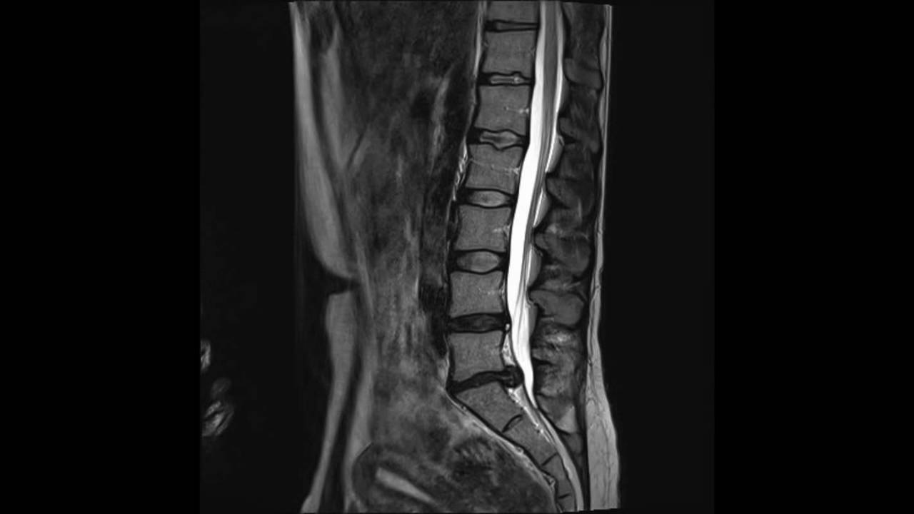2. Vertebral tumours* cause severe pain, marked muscle spasm and pain through the night. With metastases the patient is ill, the ESR is raised and the x-rays show bone destruction or sclerosis.

*3. Nerve tumours* such as a neurofibroma of the cauda equina May cause sciatica but pain is continuous. Advanced imaging will confirm the diagnosis.

FEATURES OF CAUDA EQUINA SYNDROME:

1. Bladder and bowel incontinence

2. Perineal numbness (saddle paresthesia).

3. Bilateral sciatica

4. Lower limb weakness

5. Crossed straight-leg raising sign

Treatment**:**

3 Rs: *Rest, Removal,* and *Rehabilitation*:

*Rest:* With an acute attack the patient should be kept in bed. A non-steroidal anti-inflammatory drug and heat is useful. If the symptoms and signs do not improve, an epidural injection of corticosteroid and local anesthetic may help.

*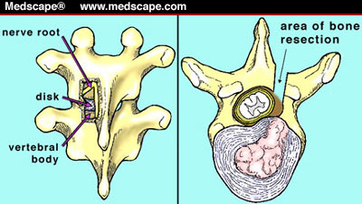Removal:* The indications for operative removal of a prolapse are: (1) a cauda equina compression syndrome (emergency); (2) neurological deterioration while under conservative treatment; (3) persistent pain and signs of sciatic tension (especially crossed sciatic tension) after 2–3 weeks of conservative treatment. The two operations most widely performed are *laminotomy* and *micro-discectomy.* *Laminotomy:* Ligamentum flavum on the relevant side and at the relevant level is removed, if necessary with some margin of the bordering laminae and medial third of the facet joint. The dura and nerve root are then gently retracted towards the midline and disc is excised.

*Micro-discectomy* is essentially similar to the standard posterior operation, except that the exposure is very limited and the procedure is carried out with the aid of an operating microscope. The major postoperative complication is disc space infection (disciitis). Recurrent prolapse with sciatica is more common and may require revision decompression surgery.

*Rehabilitation:* After recovery from an acute disc rupture, or disc removal, isometric exercises and physiotherapy are started.

***PERSISTENT POSTOPERATIVE BACKACHE AND SCIATICA***

Persistent symptoms after operation may be due to:

(1) Residual disc material in the spinal canal.

(2) Disc prolapse at another level.

(3) Nerve root pressure by a hypertrophic facet joint or a narrow lateral recess (root canal stenosis). After careful investigation, any of these may call for re-operation.

***CHRONIC INTERVERTEBRAL DISC DEGENERATION***

This is an age related phenomenon that occurs in over 80 per cent of people who live for more than 50 years and in most cases it is asymptomatic.

Pathology:

With normal ageing the disc gradually dehydrated. The annulus fibrosus develops fissures, and small herniations of nuclear material squeeze through the annulus. This process begins early in life and increases gradually with age. The discs flatten down and bulge slightly beyond the margins of the vertebral bodies. Where they protrude against the ligaments, reactive new bone formation produces bony ridges osteophytic projections which may lead to spinal stenosis. In the adjacent vertebrae the end plates ossify and become sclerotic. The picture as a whole is referred to as *spondylosis*.Then displacement of the facet jointsand this lead to segmental spinal instability and spondylolisthesis.

Clinical features:

Disc degeneration of itself is usually asymptomatic. Sometimes chronic backache or low-back pain on activity may appear.

X-Rays:

Flattening of the disc space and marginal osteophyte formation appear later.

MRI:

Bulging of the annulus fibrosus in both sagittal and axial projections and diminished thickness and reduced signal intensity (dehydration) of the degenerating disc.

Treatment:

Asymptomatic lumbar disc degeneration does not need any treatment. Secondary features of disc degeneration, such as spinal stenosis, spinal instability, or spondylolisthesis may needs management, usually operative treatment.

***SPINAL STENOSIS***

Abnormal narrowing of the central canal, the lateral recesses, or the intervertebral foramina to the point where the neural elements are compromised and the patient develops neurological symptoms and signs in the lower limbs.

The causes of spinal stenosis are: (1) congenital vertebral dysplasia (achondroplasia); (2) chronic disc degeneration; (3) displacement of facet joints; (4) hypertrophy of ligamentum flavum; (5) bone thickening due to Paget's disease; (6) spondylolisthesis.

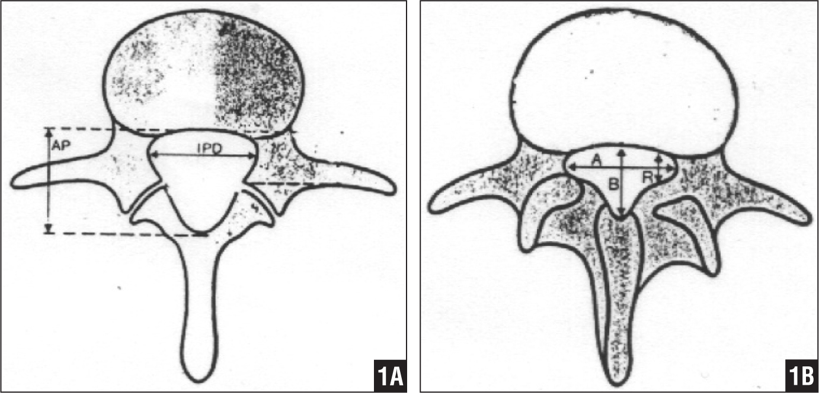Unilateral narrowing of the intervertebral foramen (*root canal stenosis*) may result from an unresolved lateral disc herniation.

Two measurements are used: the mid-sagittal (anteroposterior) diameter and the inter-pedicular (transverse) diameter of the spinal canal. Normally, the diameters are 15 mm for the anteroposterior and 20 mmfor the transverse.Anything less than 11 mmfor the anteroposterior diameter and 16 mm for thetransverse diameter is considered abnormal.

Clinical features:

The patient, usually over 50 years, complains of aching, heaviness, numbness and paresthesia in the thighs and legs; it comes on after standing upright or walking for 5–10 minutes, and is relieved by sitting, squatting or leaning to flex the spine (spinal claudication) and should be differentiated form arterial claudication which occur in atherosclerosis. The patient sometimes has a previous history of disc prolapse, chronic backache or spinal operation.

Imaging:

X-rays will show features of disc degeneration or spondylolisthesis. Measurement of the spinal canal can be carried out on CT and MRI.

Treatment:

Conservative measures, including instruction in spinal posture, may enough. Operative decompression is almost always successful (laminectomy with spinal fusion).

***SPONDYLOLISTHESIS***

Spondylolisthesis means forward translation of one segment of the spine upon another. The shift is nearly always between L4 and L5, or between L5 and the sacrum. Backward translation is called retrolisthesis.

Normal discs, laminae and facets constitute a locking mechanism that prevents each vertebra from moving forwards on the one below. Forward shift (or slip) occurs only when this mechanism has failed.

Classification:

Basically there are six types of spondylolisthesis:

1. Dysplastic (20%): The superior sacral facets are congenitally defective. Associated anomalies (usually spina bifida occulta) are common.

2. Lytic or isthmic (50%): In this, there is a defect in the pars interarticularis (spondylolysis). It may be a genetic factor.

3. Degenerative (25%): Degenerative changes in the facet joints and the discs permit forward slip (always at L4/5).

4. Post-traumatic: Unusual fractures may result in destabilization of the lumbar spine.

5. Pathological: Bone destruction (e.g. due to tuberculosis or neoplasm) may lead to vertebral slipping.

6. Postoperative (iatrogenic): Occasionally, excessive operative removal of bone like in laminectomy.

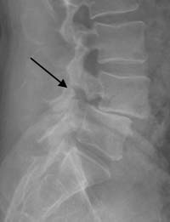Pathology:

In the common lytic type of spondylolisthesis the pars interarticularis on both sides is disrupted (spondylolysis), leaving the posterior neural arch separated from the vertebral body anteriorly; the gap is occupied by fibrous tissue. With stress, spondylolisthesis developed.

The degree of slip is measured by the amount of overlap of adjacent vertebral bodies and is usually expressed as a percentage. With slipping there will be spinal stenosis.

Clinical features:

Spondylolysis, and even spondylolisthesis, may be discovered incidentally during routine x-ray examination which is usually asymptomatic.

In *children:* the condition is usually painless but there is protruding abdomen and peculiar gait.

In *adolescents* and *adults:* intermittent backache is the usual presenting symptom.

*Patients over 50:* are usually women with degenerative spondylolisthesis. They always have backache; some have claudication due to spinal stenosis.

On examination the buttocks look flat, a step can often be felt when the fingers are run down the spine.

X-ray:

Lateral views show the forward shift of the vertebra above on the vertebra below.

The gap in the pars interarticularis is best seen in the oblique views. CT-scan and MRI are helpful.

Treatment:

Conservative treatment*,* similar to that for disc prolapse, is helpful.

Operative treatment is indicated: (1) if the symptoms are interfere significantly with work; (2) if the slip is more than 50 % and progressing; (3) if neurological signs are significant.

The surgery is posterior or anterior intervertebral body fusion.

***APPROACH TO DIAGNOSIS IN PATIENTS WITH LOW BACK PAIN***

Careful history taking and examination will uncover one of five pain patterns:

*1. Transient backache following muscular activity:*

This suggests a simple back strain that will respond to a short period of rest followed by gradually increasing exercise.

*2. Sudden, acute pain and sciatica:*

--- In young people (those under the age of 20) it is important to exclude *infection* and *spondylolisthesis*; both produce recognizable x-ray changes.

--- Patients aged 20–40 years are more likely to have an acute disc prolapse: diagnostic features are: (1) a history of a lifting strain, (2) sciatica; (3) neurological symptoms and signs.

--- Elderly patients may have osteoporotic *compression fractures*, but *metastatic* *disease* and *myeloma* must be excluded.

*3. Intermittent low back pain after exertion:*

Patients of almost any age may complain of recurrent backache following exertion or lifting activities and this is relieved by rest. Features of disc prolapse are absent but there may be a history of acute sciatica in the past. In early cases x-rays usually show no abnormality; later there may be signs of lumbar spondylosisin those over 50 years and osteoarthritisof the facet joints is common, disorders such as ankylosing spondylitis, chronic infection (TB or Brucellosis), myelomatosisand other *bone diseases* must be excluded by appropriate imaging and blood investigations.

*4. Back pain + claudication with walking:*

These patients are usually aged over 50 and may give a history of previous, longstanding back problem. The diagnosis of spinal stenosisshould be confirmed by CT and/or MRI.

*5. Severe and constant pain localized to a particular site:*

This suggests local bone pathology, such as acompression fracture, Paget's disease, a tumour orinfection.