Transplantation
Transplantation: is the process of taking cells, tissues, or organs (a graft) from one individual (the donor) and implanting them into another individual or another site in the same individual (the recipient). Transfusion is the mostcommon one.
Types of transplantation:
- Autograft (autologous graft): transfer of an individual’s own tissue to another site in the body. This graft is always permanently accepted, e.g. skin transplant after burn.
- Syngeneic graft (isograft): is a transfer of tissue between genetically identical twins (monozygotic twins).
- Xenograft (zenogeneic or heterograft): is a transfer of tissue between different species, it is always rejected, e.g. from animal to human, as baboon heart into human child.
- Allograft (allogeneic or homograft): is a graft between genetically different members of the same species, e.g. from one human to another, as kidney transplant. It is usually rejected unless the recipient is given immunosuppressive drugs.

Mechanisms of graft rejection:
The recognition of transplanted cells as self or foreign is determined by the extremely polymorphic genes of the major HLA complex, which are expressed in a codominant fashion. So all grafts except autografts are ultimately identified as foreign invading proteins and destroyed by the process of graft rejection. Even syngeneic grafts between identical twins can express recognizable antigenic differences due to somatic mutations that occur during development of the individual. For this reason, all grafts must be followed by some degree of lifelong immunosuppression of the host to attempt to avoid rejection reactions.

Recognition of Alloantigens by T Cells
Allogeneic MHC molecules of a graft can be presented for recognition by the recipient’s T cells in two fundamentally different ways, called the direct and indirect pathways.

Direct Recognition of MHC Alloantigens on Donor Cells
In the case of direct recognition, intact MHC molecules displayed by cells in the graft are recognized by recipient T cells without a need for processing by host APCs. T cell responses to directly presented allogeneic MHC molecules .
Donor APCs migrate to regional lymph nodes and present, on their surface, unprocessed allogeneic MHC molecules to the recipient’s T cells (the direct pathway of allorecognition).

Indirect Recognition of Alloantigens
In the indirect pathway, donor (allogeneic) MHC molecules are captured and processed by recipient APCs, and peptides derived from the allogeneic MHC molecules are presented in association with self MHC molecules.
Host dendritic cells from the recipient migrate into the graft, pick up graft alloantigens, and transport these back to the draining lymph nodes, where they are displayed (the indirect pathway). 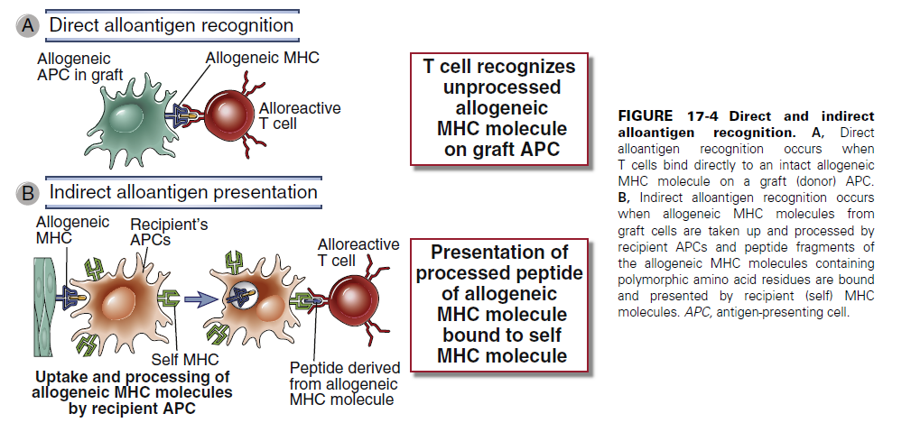

Activation and Effector Functions of Alloreactive T Lymphocytes
- Activation of Alloreactive T Lymphocytes
The T cell response to an organ graft may be initiated in the lymph nodes that drain the graft . Naive lymphocytes that normally traffic through the lymph node encounter these alloantigens and are induced to proliferate and differentiate into effector cells. This process
is sometimes called sensitization to alloantigens. Effector T cells migrate back into the graft and mediate rejection. Direct allorecognition can generate both CD4+ and CD8+ T cells that recognize graft antigens and contribute to rejection.
- Effector Functions of Alloreactive T Cells
The CD4+ helper T cells differentiate into cytokine-producing effector cells that damage grafts by cytokine-mediated inflammation, similar to a delayed type hypersensitivity (DTH) reaction. Alloreactive CD8+ T cells differentiate into cytotoxic T lymphocytes (CTLs), which kill cells in the graft that express the allogeneic class I MHC molecules. CTLs also
secrete inflammatory cytokines, which can contribute to graft damage.
Only CTLs that are generated by direct allorecognition can kill graft cells, whereas both CTLs and helper T cells generated by either direct or indirect alloantigen recognition can cause cytokine-mediated damage to grafts.
CD8+ CTLs that are generated by direct allorecognition of donor MHC molecules on donor APCs can recognize the same MHC molecules on parenchymal cells in the graft and kill those cells. In contrast, any CD8+ CTLs that are generated by the indirect pathway are self MHC restricted, and they will not be able to kill the foreign graft cells because these cells do not express self MHC alleles displaying allogeneic peptides. Therefore, when alloreactive T cells are stimulated by the indirect pathway, the principal mechanism of rejection is not CTL-mediated killing of graft cells but inflammation caused by the cytokines produced by the effector T cells. Presumably, these effector cells infiltrate the graft and recognize graft alloantigens being displayed by host APCs that have also entered the graft.

Activation of Alloreactive B Cells and Production and Functions of Alloantibodies
Antibodies against graft antigens also contribute to rejection. Most high-affinity alloantibodies are produced by helper T cell–dependent activation of alloreactive B cells, much like antibodies against other protein antigens . The antigens most frequently recognized by alloantibodies are donor HLA molecules, including both class I and class II MHC proteins. Naive B lymphocytes recognize foreign MHC molecules, internalize and process these proteins, and present peptides derived from them to helper T cells that were previously activated by the same peptides presented by dendritic cells. Thus, activation of alloreactive B cells is an example of indirect presentation of alloantigens.
The alloreactive antibodies produced in graft recipients activate complement, target the activation of neutrophils, macrophages, and NK cells through Fc receptor binding.
Because HLA antigens are expressed on endothelial cells, much of the alloantibody-mediated damage is targeted at the graft vasculature.

The acceptance or rejection of a transplant is determined by:
*1. Class I & II MHC proteins on the donor cells, with class II playing the major role, especially DR locus. These allo Ag activate T-cells (both helper & cytotoxic). The activated T-cell proliferates & then reacts against the allo Ag on the donor cells. CD8 +ve cytotoxic cells do the most of the killing of the allograft cells. Foreign MHC proteins activate more T-cells.
*2. Both CD4 & CD8 T-cells have involved in allograft rejection, of which removal of them by using monoclonal Ab (antiCD4 & antiCD8) result in long-term survival of allograft.
*3. Dendritic cells play a role in rejection as well, of which, it can present Ag in the context of class I MHC molecules, giving CD8 +ve T-cell the opportunity to recognize alloAg.
*4. Difference in minor histocompatibility loci.
*5. ABO blood group.
Note: difference in blood group and major histocompatibility Ags are responsible for the most intense graft rejection reaction.

PATTERNS AND MECHANISMS OF ALLOGRAFT REJECTION
Graft rejection is classified on the basis of histopathologic features and the time course of
rejection after transplantation rather than on the basis of immune effector mechanisms. Based on the experience of renal transplantation, the histopathologic patterns are called
hyperacute, acute, and chronic
- Hyperacute Rejection
Hyperacute rejection is characterized by thrombotic occlusion of the graft vasculature that begins within minutes to hours after host blood vessels are anastomosed to graft
vessels and is mediated by preexisting antibodies in the host circulation that bind to donor endothelial antigens
Binding of antibody to endothelium activates complement, and antibody and complement products together induce a number of changes in the graft endothelium that promote intravascular thrombosis. Complement activation leads to endothelial cell injury and exposure of sub endothelial basement membrane proteins that activate platelets.
In the early days of transplantation, hyperacute rejection was often mediated by preexisting IgM alloantibodies, which are present at high titer before transplantation.
The best known examples of such alloantibodies are those directed against the ABO blood group antigens expressed on red blood cells.
- Acute Rejection
Acute rejection is a process of injury to the graft parenchyma and blood vessels mediated by alloreactive T cells and antibodies.
acute rejection begin several days to a few weeks after transplantation. The time of onset of acute rejection reflects the time needed to generate alloreactive effector T cells and antibodies in response to the graft. The patterns of acute rejection are divided into cellular (mediated by T cells) and humoral (mediated by antibodies), both typically coexist in an organ undergoing acute rejection.
Acute Cellular Rejection
The principal mechanisms of acute cellular rejection are inflammation caused by cytokines produced by helper T cells and CTL-mediated killing of graft parenchymal
cells and endothelial cells.
The cellular infiltrates present in grafts undergoing acute cellular rejection include both CD4+ helper T cells and CD8+ CTLs specific for graft alloantigens, and both types of T cells may contribute to parenchymal cell and endothelial injury. The helper T cells include IFNγ- and TNF-secreting TH1 cells and IL-17–secreting TH17 cells, both of which contribute to macrophage and endothelial activation and inflammatory damage to the organ.
Acute Antibody-Mediated Rejection
Alloantibodies cause acute rejection by binding to alloantigens, mainly HLA molecules, on vascular endothelial cells, causing endothelial injury and intravascular thrombosis
that results in graft destruction. The binding of the alloantibodies to the endothelial cell surface triggers (1) local complement activation, which leads to lysis of the cells, recruitment and activation of neutrophils, and thrombus formation. (2) Alloantibodies may also engage Fc receptors on neutrophils and NK cells, which then kill the endothelial cells. (3) In addition, alloantibody binding to the endothelial surface may directly alter endothelial function by inducing intracellular signals that enhance surface expression of proinflammatory and procoagulant molecules.
- Chronic Rejection and Graft Vasculopathy
Chronic rejection develops insidiously during months or years and may or may not be preceded by clinically recognized episodes of acute rejection. Chronic rejection of different
transplanted organs is associated with distinct pathologic changes. A dominant lesion of chronic rejection in vascularized grafts is arterial occlusion as a result of the proliferation of intimal smooth muscle cells, and the grafts eventually fail mainly because of the resulting ischemic damage.
The arterial changes are called graft vasculopathy or accelerated graft arteriosclerosis. The likely mechanisms underlying the occlusive vascular lesions of chronic rejection are activation of alloreactive T cells and secretion of cytokines that stimulate proliferation of vascular smooth muscle cells.
[The relative importance of direct and indirect allorecognition in graft rejection is a matter of continuing debate. It is often stated that acute graft rejection is mediated mostly by direct recognition of alloantigens, primarily by CD8+ T cells that directly destroy the graft, whereas chronic graft rejection has a larger component of indirect recognition, resulting in activation of CD4+ T cells that induce rejection mainly by triggering cytokine-mediated inflammation, and by helping B cells to make antibodies against alloantigens.]
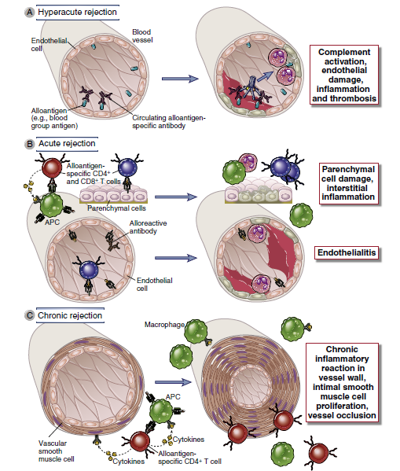
Graft-Versus-Host Disease
Graft-versus-host disease (GVHD) is caused by the reaction of grafted mature T cells in the hematopoietic stem cells (HSC) inoculum with alloantigens of the host. It occurs when the host is immunocompromised and therefore unable to reject the allogeneic cells in the graft. In most cases, the reaction is directed against minor histocompatibility antigens of the host because bone marrow transplantation is not performed when the donor and recipient have differences in MHC molecules.
Because B.M. is a source of some mature T lymphocytes, it is necessary to remove these cells before transplantation to avoid the appearance of graft-versus-host disease in the recipient. In this special case of rejection, any mature T cells remaining in the B.M. inoculums can attack allogeneic MHC-bearing cells of the recipient & cause widespread epithelial cell death accompanied by rash, jaundice, diarrhea, & gastrointestinal hemorrhage.
Allograft may be accepted without immunosuppressive agents in these cases:
1. tissue that lack allo Ag as cartilage, heart valve.
2. Tissue grafted in privilege site as cornea, anterior chamber of the eye, testes.
3. Exposure to allo Ag early in life, that leads to tolerance.
The fetus is an allograft that is not rejected: to start with, the reason that the mother fail to reject the fetus is unclear. The mother forms Ab against the foreign paternal MHC proteins; therefore, the reason is not that the mother is not exposed to fetal Ag. One possible explanation is that the trophoblast layer of the placenta does not allow maternal T-cell to enter the fetus.
Prevention of rejection:
Most of the treatments currently in use suffer from lack of specificity, so it leave the host with generalize immunosuppression & then increased risk of infection.
- General immunosuppressive therapy as,
- Mitotic inhibitors that inhibit T-cell proliferation.
- Anti-inflammatory agents as corticosteroid.
- Fungal metabolite that act as immunosuppressive agents.
- Total lymphoid irradiation, for all organs except bone marrow.
The goal of immunosuppression is to block cell proliferation.
2. Specific treatment:
- Monoclonal Ab as
* anti CD3, so ↓mature T-cell.
* Ab to surface adhesion molecule, so no signal.
* Ab to cytokine as anti IL-2.
B. Block co-stimulatory signal so result in cell anergy. For e.g. to CD40L so block binding of CD40-CD40L.

