Anatomy
The side of the neck

It is the region of the body that lies between the lower margin of the mandible and the superior nuchal line superiorly , the suprasternal notch and the upper border of the clavicle inferiorly, midline of the neck anteriorly ,and anterior border of the trapezius posteriorly.

Cutaneous nerves of the neck
1. The skin overlying the trapezius muscle on the back of the neck is supplied by the medial branches of the posterior rami of 2,3and 4 cervical nerves:
The greater occipital nerve is the medial branch of the posterior ramus of the second cervical nerve.
Third occipital nerve is the medial branch of the posterior ramus of the third cervical nerve.

2. The skin of the front and the sides of the neck is supplied by the anterior rami of the 2, 3, and 4 cervical nerves through cutaneous branches of the cervical plexus [these branches emerge beneath the posterior border of sternocleidomastoid.]

Cutaneous branches of the cervical plexus:

Lesser occipital nerve [C2]: it hooks around the accessory nerve and ascends along the posterior border of the sternocleidomastoid to supply the skin over the lateral part of the occipital region and the medial surface of auricle

Great auricular nerve [C2, C3]: it ascends across the sternocleidomastoid, toward the parotid gland and divides into anterior and posterior branches. The anterior branch supplies the skin over the angle of the mandible and the parotid gland. The posterior branch supplies the skin on the mastoid process and skin on both surface of the auricle.

Transverse cutaneous nerve [C2, C3]: it emerges from behind the middle of the posterior border of the sternocleidomastoid then passes forward across that muscle and divides into branches that supply the skin on the anterior and lateral surfaces of the neck.

Supraclavicular nerves [C3, C4]: the medial, intermediate, and lateral supraclavicular nerves emerge from beneath the posterior border of the sternocleidomastoid as a single trunk. Then, they Diverge, descend across the side of the neck, and pass to the anterior chest wall by crossing above the clavicle. They supply the anterior chest wall and shoulder region, down to the level of the second rib.
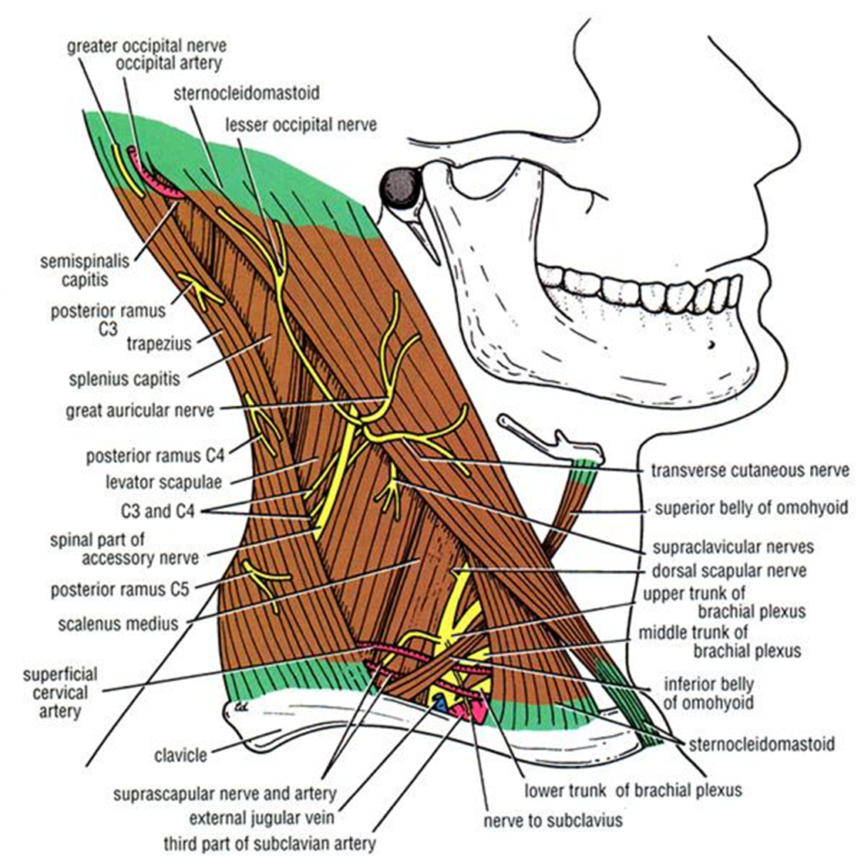

Superficial fascia of the side of the neck
It is thin layer that loosely attached to the skin and deep fascia.
The following structures are embedded in the superficial fascia:
Platysma, superficial veins, superficial lymph nodes, cutaneous nerves of the neck, and the cervical branch of the facial nerve.

Platysma
Thin sheet of muscle in the superficial fascia. It lies superficial to the cutaneous nerves of the cervical plexus and the external jugular vein.
Origin: skin and deep fascia that cover the upper part of the pectoralis major and deltoid muscles
Insertion: it passes into the neck and the anterior fibers are inserted into the lower margin of the anterior part of the mandible. The posterior fibers curve upward over the mandible to insert to the skin of lower face and the muscles at the angle of the mouth.
Nerve supply: cervical branch of the facial nerve
Action: it depresses the mandible and pulls down the angle of mouth. Also it tenses the skin of the neck and elevates the skin over the upper part of the chest

Superficial veins of the side of the neck :External jugular vein.
Superficial lymph nodes
1. The superficial cervical lymph nodes: lie along the external jugular vein
2. submental lymph nodes : lie below the chin.

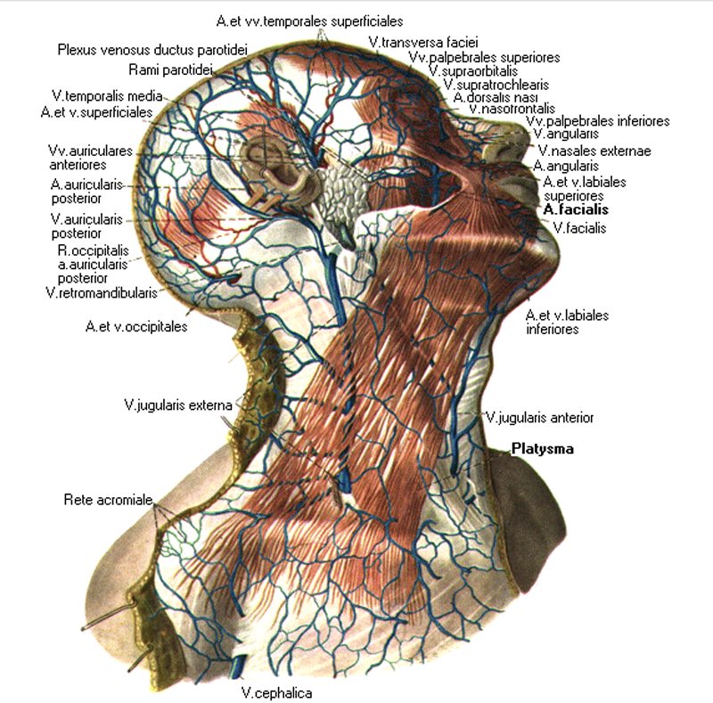

Deep cervical fascia
It is areolar tissue that supports the muscles, vessels, and the viscera of the neck. In certain areas it is condensed to form fibrous sheets called the investing layer, the pretracheal layer, the prevertebral layer, and the carotid sheath.
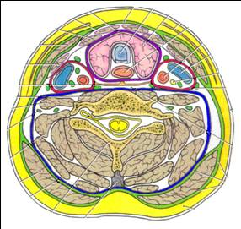

A. Investing layer of deep cervical fascia
1. It is completely surrounds the neck, like a collar.
2. It lies deep to the platysma and splitting to enclose the sternocleidomastoidand the trapezius muscles.
3. It forms the roof of the anterior and posterior triangle.
4. Attached posteriorly to the ligamentum nuchae.
5. Attached anteriorly to the symphysis menti and the hyoid bone.
6. Superiorly, it is attached to the superior nuchal line, mastoid process, and the inferior border of the body of the mandible.
7. Inferiorly, it is attached to the acromion process, the clavicle and the manibrium sterni.
8. It is thickened between the angle of the mandible and the styloid process of the temporal bone to form the stylomandibular ligament.
9. Between the mastoid and the angle of the mandible it splits to enclose the parotid gland.
10. Between the hyoid bone and the mandible it splits to enclose the submandibular gland.

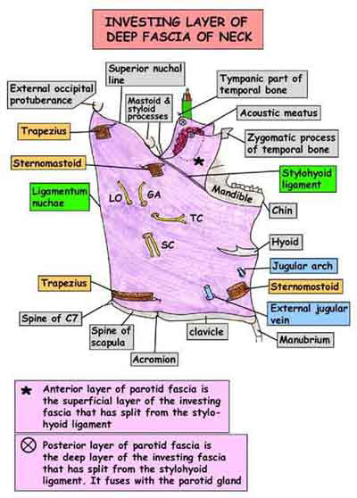

B. Pretracheal layer deep cervical fascia
- It completely surrounds the thyroid gland, forming a sheath for it, and binds the gland to the larynx.
- Covers the sides and front of the trachea.
- Superiorly, it is attached to the hyoid bone and the oblique line of the thyroid cartilage.
- Inferiorly, the pretracheal fascia fuses with the pericardium.
- On either sides fascia fuses with front of the carotid sheath.

C. prevertebral layer of deep cervical fascia
- It covers the prevertebral muscles and the vertebral column.
- It forms the facial floor of the posterior triangle.
- Anteriorly it is separated from the pharynx and esophagus by retropharyngeal space [contain loose areolar tissue], which permits these tube to be distended.
- posteriorly ,it attached to the ligamentum nuchae
- Superiorly, it is attached to the base of the skull.
- As the trunks of brachial plexus and the subclavian artery emerge between the scalenus anterior and scalensmedius, they carry covering of the fascia, known as the axillary sheath.
- The cervical sympathetic trunk is embedded in the prevertebral fascia.

D. Carotid sheath
1. It is condensation of deep fascia in which are embedded the carotid arteries, internal jugular vein, the vagus nerve, and the deep cervical group of lymph nodes [form a chain along the internal jugular vein].
2. The ansa cervicalis lies embedded in the anterior wall of the carotid fascia.
3. Superiorly, the sheath is attached to the base of the skull at the margins of the carotid canal & the jugular fossa. Here it contains the internal carotid artery, the internal jugular vein & the last 4 cranial nerves.
4. Inferiorly, it fuses with the fibrous pericardium.
5. Cervical sympathetic trunk lies behind the carotid sheath.
6. It is fused to all three layers of the deep cervical fascia.

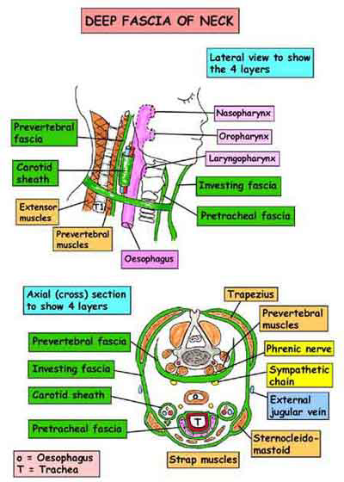

Triangles of the neck
The side of the neck is divided into anterior and posterior triangles by the sternocleidomastoid muscle.
Anterior triangle of the neck
It is a large triangular space on each side of the neck, bounded anteriorly by the midline of the neck, posteriorly by the anterior border of the sternocleidomastoid, superiorly by lower margin of the body of the mandible.
The roof of the anterior triangle
Skin, superficial fascia, platysma, and investing layer of deep fascia. Running across the triangle are the cervical branch of the facial nerve and the transverse cutaneous nerve.

Subdivision
The anterior triangle is subdivided by the anterior and posterior bellies of the digastric and the superior belly of the omohyoid muscle into:
Submental, digastric, carotid, and muscular triangles

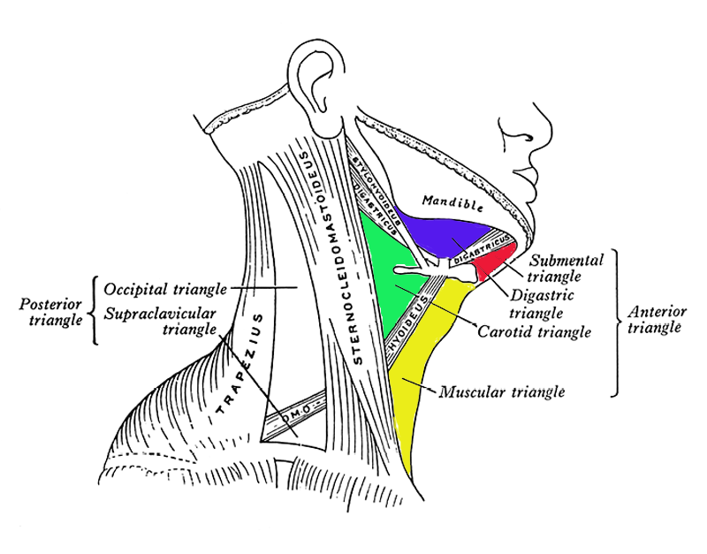
Submental triangle
It lies below the chin
Boundaries:
Medial: midline of the neck.
Lateral: anterior belly of the digastric.
Inferior: body of the hyoid bone.
Floor:
It is formed by the mylohyoid muscle.
Contents:
submental lymph nodes.
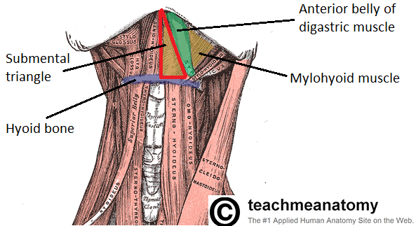

Digastric triangle
It lies below the body of the mandible.
Boundaries:
Anterior: anterior belly of the digastric.
Posterior: posterior belly of the digastric.
Superior: lower border of the body of the mandible.
Floor:
It is formed by mylohyoid muscle anteriorly and the hyoglossus muscle posteriorly.
Contents:
- Structures superficial to mylohyoid:
  - Superficial part of the submandibular gland, with facial vein and submandibular lymph nodes superficial to it and the facial artery deep to it.
  - Submental artery and mylohyoid nerve and vessels.

- Structures superficial to hyoglossus:
- Submandibular salivary gland.
- Intermediate tendon of the digastric and stylohyoid muscles.
- Hypoglossal nerve.

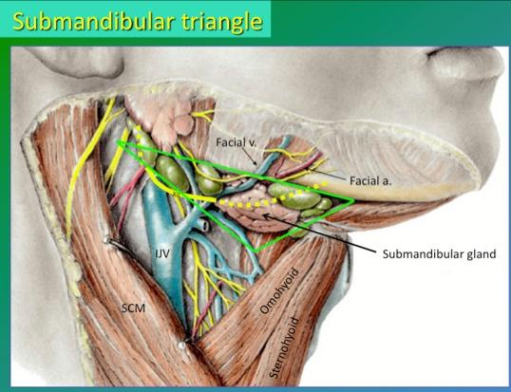
Carotid triangle
It lies behind the hyoid bone.
Boundaries:
Superior: posterior belly of digastric and the stylohyoid.
Inferior: superior belly of omohyoid.
Posterior: anterior border of the sternocleidomastoid.
Floor:
It is formed by thyrohyoid, middle constrictor and inferior constrictor of the pharynx.
Contents:
- Arteries:
  - Common carotid artery.
  - Internal carotid artery.
  - External carotid artery with its branches.
- Veins:
- Internal jugular vein and its tributaries.

- Nerves:
- Vagus nerve.
- Superior laryngeal nerve: branch of vagus dividing into the external and internal laryngeal nerves.
- Spinal accessory nerve.
- Hypoglossal nerve with its descending branch [superior root of ansacervicalis] and the nerve to the thyrohyoid.
- Sympathetic chain.
- Inferior root of ansacervicalis.

- Lymph nodes: deep cervical lymph nodes.
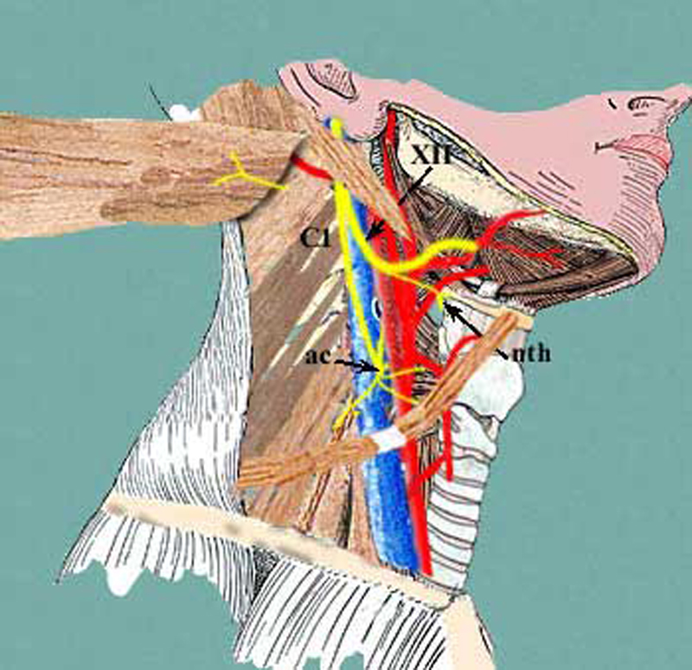

Muscular triangle:
It lies below the hyoid bone.
Boundaries:
Anterior: midline of the neck.
Superior: superior belly of the omohyoid.
Inferior: anterior border of the sternocleidomastoid.
Floor;
Sternohyoid and sternothyroid.
Contents:
1.Superficial structures are the infrahyoid muscles [sternohyoid, sternothyroid, thyrohyoid, and the omohyoid].
2. The deeper structures: thyroid gland, the trachea, and the esophagus.

Clinical anatomy
Spread of Infections in Neck
The investing layer of deep cervical fascia helps prevent the spread of abscesses (purulent infections)caused by tissue destruction. If an infection occurs between the investing layer of deep cervical fascia and the muscular part of the pretracheal fascia surrounding the infrahyoid muscles, the infection will usually not spread beyond the superior edge of the manubrium of the sternum. If, however, the infection occurs between the investing fascia and the visceral part of pretracheal fascia, it can spread into the thoracic cavity anterior to the pericardium.

