***Pelvic organ prolapse***

***Dr Ban Hadi F.I.C.O.G. 2018***



**Objectives:** by the end of this lecture, the 5th year student should be able to:

1. Define genital prolapse
2. Summarize the types and grades of prolapse
3. Differentiate between its types by history taking
4. Demonstrate on menniquene the examination of a case with genital prolapse
5. Predict the management option for different case presentations

**Definition**

Pelvic organ prolapse (POP) is defined as the downward displacement of pelvic organs from their original position into or beyond the vagina

**Classification**:

Genital prolapse is classified according to its location and the organs contained within it into:

1. **Anterior vaginal wall prolapse**

**•** Urethrocele: urethral descent (lower 1\3 of the vagina)

**•** Cystocele: bladder descent (upper 2\3 of the vagina)

**•** Cystourethrocele: descent of bladder and urethra

1. **Posterior vaginal wall prolapse**

**•** Rectocele: rectal descent (lower 2\3 of the vagina)

**•** Enterocele: small bowel descent (upper 1\3 of the vagina)

1. **Apical vaginal prolapse**

**•** Uterovaginal: uterine descent with inversion of vaginal apex

**•** Vault: post-hysterectomy inversion of vaginal apex

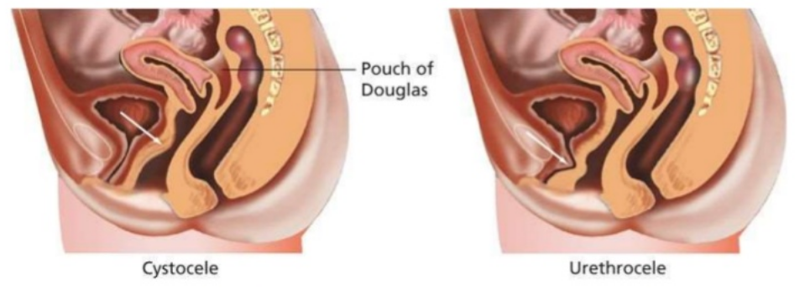

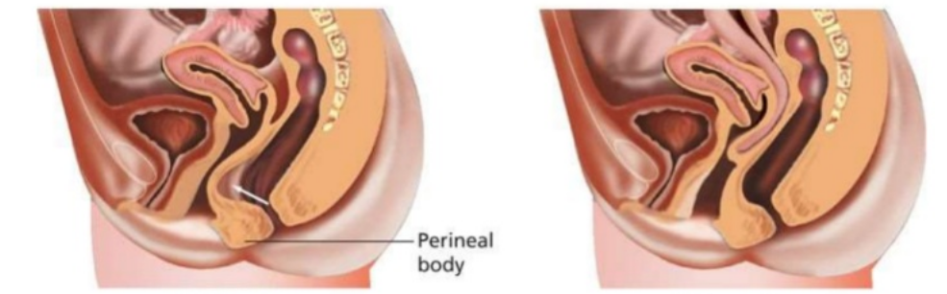

Rectocele Enterocele

**Prevalence**: Pelvic organ prolapse is a very common problem with a prevalence of 40–50 per cent of women over the age of 40 years

The most common form of prolapse is that of the anterior wall of the vagina (cystocele). Prolapse of the posterior wall (rectocele) is far less frequent and apical

prolapse (descent of the uterus or vaginal vault if the patient has had a hysterectomy) the least common

**Grading**

Three degrees of prolapse are described and the lowest or most dependent portion of the prolapse is assessed while the patient is straining:

• 1st: descent within the vagina

• 2nd: descent to the introitus

• 3rd: descent outside the introitus.

In the case of uterovaginal prolapse, the most dependent portion of the prolapse is the cervix. Third-degree uterine prolapse is termed ‘procidentia’ and is usually

accompanied by cystourethrocele and rectocele

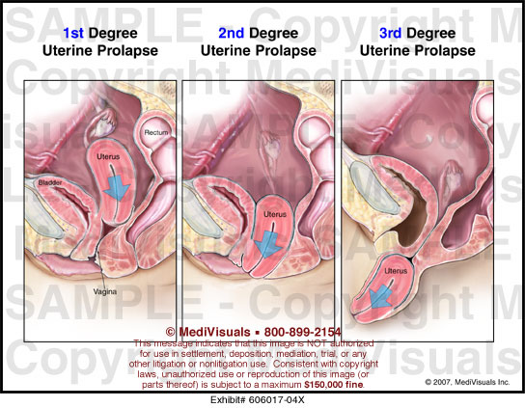

***Pathophysiology:***

There are three components that are responsible for supporting the position of the uterus and vagina:

**•** ligaments and fascia, by suspension from the pelvic side walls;

**•** levator ani muscles, by constricting and thereby maintaining organ position;

**•** posterior angulation of the vagina, which is enhanced by rises in abdominal pressure causing closure of the ‘flap valve’.



*Damage to any of these mechanisms will contribute to prolapse*.

Endopelvic fascia is a continuous sheet that attaches laterally to the arcus tendineus fascia pelvis and levator ani muscles and extends from the symphysis pubis to the ischial spines. This network of tissue lies immediately beneath the peritoneum, surrounds the viscera and fills the space between the peritoneum above and

the levators below; in parts it thickens to form ligaments, e.g.the uterosacral and **cardinal complex. This complex is probably the most important component of the support**. The segment of fascia that supports the bladder and lies between the bladder and vagina is known as the pubocervical fascia, and that which prevents anterior rectal protrusion and lies between the rectum and posterior vagina is termed the rectovaginal fascia.

The levator ani muscles (puborectalis, pubococcygeus and iliococcygeus) support the pelvic organs and relieve excessive pressure from the ligaments and fascia.

• The uterosacral ligaments provide essential apical support (level 1 support).

• Vaginal fascia supports the vagina (level 2 support).

• The perineal body is very important in supporting the lower vagina (level 3 support).

**Aetiology**

The connective tissue, levator ani and intact nerve supply are vital for the maintenance of position of the pelvic structures, and are influenced by pregnancy

childbirth and ageing. Whether congenital or acquired, connective tissue defects appear to be important in the aetiology of prolapse and urinary stress incontinence.

1. ***Congenital***

2% of symptomatic prolapse occurs in nulliparous women, implying that there may be a congenital weakness of connective tissue. An ethnic influence is seen more in white than black women.

1. ***Childbirth and raised intra-abdominal pressure***

The single major factor leading to the development of genital prolapse appears to be vaginal delivery.

chronic cough and constipation are also risk factors.

1. ***Ageing and menopause***

The process of ageing can result in loss of collagen and weakness of fascia and connective tissue. These effects are noted particularly during the post-menopause as

a consequence of oestrogen deficiency.

1. ***Postoperative***

Poor attention to vaginal vault support at the time of hysterectomy leads to vault prolapse

1. ***Obesity and smoking***
2. ***Occupation such as lifting heavy weights***

**Diagnosis:**

***History***:

Most pelvic organ prolapse is asymptomaticand women usually present with non-specific symptoms.

Evaluation of risk factors such as vaginal deliveries, chronic cough and constipation. **Understanding the pathophysiology**

**• Non-specific**: lump in the introitus, local discomfort, backache, bleeding/infection if ulcerated, dyspareunia or apareunia. Dragging and deterioration with activity.

Symptoms relieved by rest.

Rarely, in extremely severe cystourethrocele, uterovaginal or vault prolapse, renal failure may occur as a result of ureteric kinking.

**• Specific:**

**•** cystourethrocele – urinary frequency and urgency, voiding difficulty, urinary tract infection, stress incontinence;

**•** rectocele: incomplete bowel emptying, digitations and splinting (digital support for the perineum to defecate), passive anal incontinence

***Examination:***

Abdominal examination: masses, hernia and scars.

Vaginal examination:

* Prolapse may be obvious when examining the patient in the dorsal position if it protrudes beyond the introitus; ulceration and/or atrophy may be apparent***.***
* The anterior and posterior vaginal walls and cervical descent should be assessed with the patient straining in the left lateral position, using a Sims speculum.
* Assess the uterus and cervix for masses***,*** Pelvic floor toneassessment
* Cough test for stress incontinence

***Investigations:***

The condition is diagnosed clinically and there are no essential investigations.

1. If urinary symptoms are present, Urinalysis, Flow study and measurement of residuals are essentials. Urodynamics can be done.

2. If renal failure suspected, serum urea, creatinine and renal ultrasound are performed.

3. There is little place for radiological investigations such as dynamic MRI and transperitoneal ultrasound (TPUS)

**Prevention**

***Prevent and limit injury to pelvic support during childbirth by****:*

Avoid: prolonged labour, bearing down before full cervical dilatation and difficult instrumental delivery

Encouragement of postnatal pelvic floor exercises.

Family planning and smaller family size.

***Avoid and treat factors which increase the intra-abdominal pressure***such as obesity , smoking, chronic cough and chronic constipation

***Prevention of postmenopausal atrophy of pelvic support*** by balanced diet, exercise, calcium & by the use of HRT

**Treatment**

***A.General measures***:

Correct obesity, treat chronic cough or constipation. If the prolapse is ulcerated (decubitus ulcer) keep it reduced with packing and a 7 days course of topical oestrogen should be administered.

***B.Conservative***:

1. Pelvic floor physiotherapy (Kegel exercise) in cases with mild prolapse by contracting the pelvic floor muscles

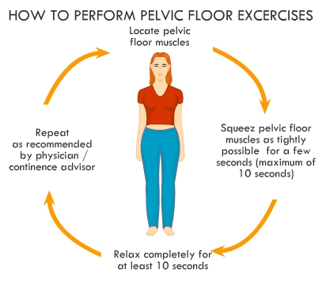

.

2. Vaginal rings: Silicon rubber-based ring pessaries are the most popular form of conservative therapy. They are inserted into the vagina in much the same way as a contraceptive diaphragm and need replacement at annual intervals

Shelf pessaries are rarely used but may be useful inwomen who cannot retain a ring pessary.

***Indications for pessary treatment are***:

• patient’s wish;

• as a therapeutic test;

• childbearing not complete;

• medically unfit;

• during and after pregnancy (awaiting involution);

• while awaiting surgery.



**Complications with Pessary Use**

Serious complications such as erosions into adjacent organs are rare with proper use and usually result only after years of neglect. At each return visit (6 monthly), the pessary is removed and the vagina is inspected for erosions, abrasions, ulcerations, or granulation tissue. Vaginal bleeding is usually an early sign and should not be ignored. ***Pessary ulcers*** or abrasions are treated by changing the pessary type or size to alleviate pressure points or by removing the pessary completely until healing occurs. Water-based lubricants applied to the pessary may help prevent these complications

***C.Surgery***

The aim of surgical repair is to restore anatomy and function. There are vaginal and abdominal operations designed to correct prolapse, Choice of operation depends on :

1. Type of prolapse

2. Age and parity of the patient

3. Coital function

The abdominal supporting procedures should be reserved for the younger, fitter and more active patients while the vaginal procedures should be reserved for

older and frailer patients.

***Cystourethrocele***

Anterior repair (colporrhaphy) is the most commonly performed surgical procedure but should be avoided if there is concurrent stress incontinence. An anterior

vaginal wall incision is made and the fascial defect allowing the bladder to herniate through is identified and closed. With the bladder position restored, any redundant vaginal epithelium is excised and the incision closed.

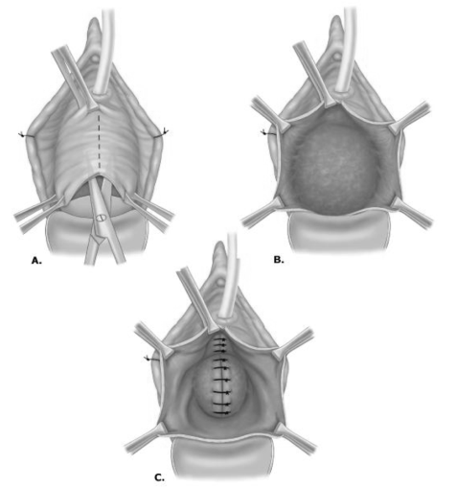

***Rectocele***

Posterior repair (colporrhaphy) is the most commonly performed procedure. A posterior vaginal wall incision is made and the fascial defect allowing the

rectum to herniate through is identified and closed.

With the rectal position restored, any redundant vaginal epithelium is excised and the incision closed.

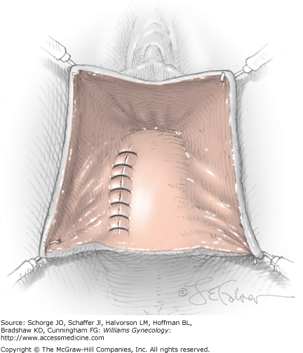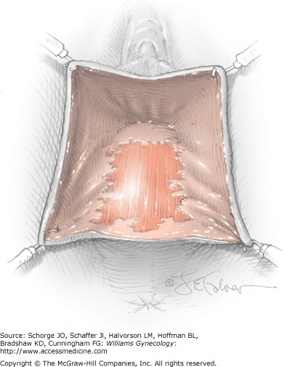

***Enterocele***

The surgical principles are similar to those of anterior and posterior repair, but the peritoneal sac containing the small bowel should be excised. In addition, the

pouch of Douglas is closed by approximating the peritoneum and/or the uterosacral ligaments

***Surgery for uterovaginal prolapse***

***a.Uterine preserving surgery***

Uterine preserving surgery is used largely when a woman still wants to have further children and therefore the uterus has to be preserved.

1• **Hysterosacropexy:** This may be performed by an open route or a laparoscopic route and a mesh is attached to the isthmus of the cervix and the uterus is suspended by attaching the other part of the mesh to the anterior longitudinal ligament on

the sacrum.

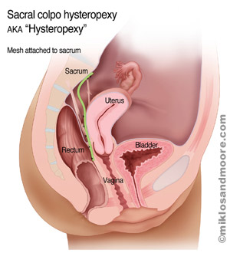

2• **The Manchester repair:** This involves accessing the uterus vaginally, amputating the cervix and using the uterosacral cardinal ligament complex to support the uterus. The operation is rarely used now because of problems with complications to the cervix resulting in either cervical stenosis or cervical incompetence and a risk of miscarriage.

3• **Le Fort colpocleisis:** This operation is used in very frail patients who are unfit for major surgery and are not sexually active. It involves partial closure of the vagina while preserving the uterus.



***b.Procedures involving hysterectomy***

These procedures involve removal of the uterus:

• **Vaginal hysterectomy:** The operation involves making an incision around the

cervix and entering the peritoneal cavity from the vaginal side ligating all the major blood vessels and delivering the uterus through the vagina and suturing the vault of the vagina. If there is concomitant anterior prolapse at the time of vaginal hysterectomy an anterior repair may be performed

.

• **Total abdominal hysterectomy and sacrocolpopexy:** This involves complete removal of the uterus through an abdominal incision, followed by repair of the vault of the vagina and then attaching a mesh to the vault of the vagina and suspending it to the anterior longitudinal ligament on the sacrum.

• **Subtotal abdominal hysterectomy and sacrocervicopexy:** This operation involves either an abdominal or laparoscopic approach. A subtotal hysterectomy is performed leaving the cervix intact. The cervix is then used as an attachment point for the mesh

.

***Vault prolapse***

***1.Sacrocolpopexy*** is similar to sacrohysteropexy but the inverted vaginal vault is

attached to the sacrum using a mesh and the pouch of Douglas is closed.



***2.Sacrospinous ligament fixation***

is a vaginal procedure in which the vault is sutured to one or other sacrospinous ligament

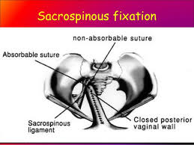

**Surgical options**

1. *Restorative*

Vaginal

●● Anterior colporrhaphy.

●● Posterior colporrhaphy.

●● Vaginal hysterectomy.

●● Sacrospinous fixation.

●● Sacrospinous hysteropexy.

●● Uterosacral plication.

Abdominal

●● Sacrocolpopexy (open/laparoscopic/robotic).

●● Sacrohysteropexy (open/laparoscopic/robotic).

1. *Obliterative*

●● Colpocleisis.

Treatment of prolapse (summery)



End of lecture