Hypertensive disorders of pregnancy
Dr. Fadia J Alizzi

Objectives
At the end of this lecture, the 4th year student will be able to:
- Define hypertensive disorders during pregnancy (HTD).
- Describe hypertensive disorders classification during pregnancy
- Distinguish preeclampsia from other hypertensive disorders during pregnancy
- Show preeclampsia clinical presentation (s&s)
- List preeclampsia maternal & fetal complications
- Explain preeclampsia etiology.
- Interpret clinical and biochemical investigation in preeclampsia.
- Assess the severity of HTD during pregnancy
- Diagnose preeclampsia and other types of hypertensive disorders during pregnancy.
- Summarize managements of HTD during pregnancy.

Definition:
Hypertension is defined as changes of BP recorded on at least 2 occasions of either:
- Diastolic BP >90 mmHg, or
- Systolic BP >140 mmHg, or
- A rise (compared to booking) in diastolic BP of at least 15 mmHg, or
- A rise (compare to booking) in systolic BP of at least 30 mmHg.

Classification:
- Pregnancy-induced hypertension (Non-proteinuric pregnancy-induced hypertension or Gestational hypertension alone): hypertension arising for the first time in the second half of pregnancy &in the absence of proteinuria or any other features of pre-eclampsia.It is not associated with adverse pregnancy outcome and mild and moderate increases in blood pressure in this setting do not require treatment. However, up to one-third of women who present with gestational hypertension will progress to pre-eclampsia
- Chronic hypertension: pre-existing hypertension may be diagnosed before gestation or assumed when a women is found to be hypertensive in early pregnancy. It can predispose to the later development of superimposed pre-eclampsia. Even in the absence of superimposed preeclampsia, chronic hypertension is associated with increased maternal and fetal
morbidity and pregnancies complicated by chronic hypertension should therefore be regarded as high risk.
- Pre-eclampsia: defined as hypertension of at least 140/90 mmHg recorded on 2 separate occasions at least 4 hours apart & in the presence of at least 300 mg protein in a 24-hour collection of urine, arising de nova after the 20th week of gestation in a previously normotensive women & resolving completely by the sixth postpartum week
- Eclampsia: is a serious & life-threatening complication of pre-eclampsia.It is defined as convulsions occurring in a woman with established pre-eclampsia, in the absence of any other neurological or metabolic cause. It is an obstetric emergency.
- It may occur:
  - Antepartum 40%.
  - Intrapartum 20%.
  - Postpartum 40%.
- Imminent eclampsia (fulminating pre-eclampsia): is the transitional condition characterized by increasing symptoms & signs, it’s the sever form of pre-eclampsia.

Degrees of hypertension
1. Mild: diastolic blood pressure 90–99 mmHg, systolic blood pressure 140–149
mmHg.
2. Moderate: diastolic blood pressure 100–109 mmHg, systolic blood pressure
150–159 mmHg.
3. Severe: diastolic blood pressure ≥110 mmHg, systolic blood pressure ≥160
mmHg

Pre-eclampsia:
Incidence&Epidmiology:
- It complicates approximately 2-3% of pregnancies.
- It is more common in primigravida (effect of fetal and hence paternal genome).
- Maternal genetic predispositions (3-4 folds increase in the first-degree relatives of affected women).
- Risk factors for pre-eclampsia(predisposing factors)generally divided into :
1. Conditions in which the placenta:-
*multiple gestation.
*diabetes.
*hydrops.
2. Pre-existing hypertension or renal disease.
3. Pre-existing vascular disease (such as in diabetes or autoimmune vacuities).

Risk factors for pre-eclampsia:
- First pregnancy.
- Multiparous with a previous history of pre-eclampsia.
- Pre-eclampsia in any previous pregnancy.
- 10 years or more since last baby.
- Age 40 years or more.
- Body mass index (BMI) of 35 or more.
- Family history of pre-eclampsia (in mother or sister).
- Booking diastolic blood pressure of 80 mmHg or more.
- Booking proteinuria ( of ≥1+ on more than one occasion or quantified at ≥0.3 g/24 h).
- Multiple pregnancies.
- Certain underlying medical conditions:
- pre-existing hypertension;
- pre-existing renal disease;
- pre-existing diabetes;
- antiphospholipid antibodies

Clinical presentation:-
- May be asymptomatic.
- Headache.
- Visual disturbances.
- Epigastria & right upper abdominal pain.
Signs of pre-eclampsia:
- Elevation of BP.
- Fluid retention (non-dependent oedema).
- Brisk reflexes.
- Ankle clonus (more than 3 beats).
- Uterus & fetus may feel small for gestational age.

Etiology:
- Trophoblastic tissue provides the stimulus for the disorder, so it's only occurs in pregnancy, but it has been described in pregnancy lacking a fetus (molar pregnancy)& in the absence of the uterus ( abdominal pregnancy) .
- General thinking suggests that the development of pre-eclampsia is a two-stage process:
1. In early pregnancy Trophoblastic invasion is patchy& the spiral arteries retain their muscular walls which interne prevent the development of a high flow, low-impedance uteroplacental circulation, the reason for that is unknown.
2. Uteroplacental ischemia results in oxidative and inflammatory stress, with the involvement of secondary mediators leading to endothelial dysfunction, vasospasm and activation of the coagulation system.

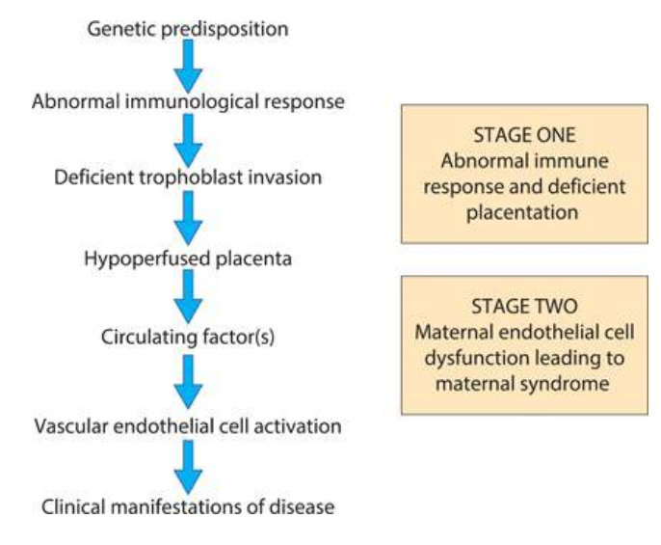

Organ-specific changes associated with pre-eclampsia:
- Central nervous system
- Cerebral oedema.
- Cerebral hemorrhages.
- Retinal haemorrhage, exudates & papillodema are characteristic of hypertensive encephalopathy and are rare in PE.

- Cardiovascular
- Generalized vasospasm.
- Increased peripheral resistance.
- Reduced central Venus/pulmonary wedge pressures.

- Haematological
- Platelet activation & depletion.
- Coagulopathy.
- Decreased plasma volume.
- Increased blood viscosity.

- Renal
- Proteinuria
- Decreased GFR(oliguria)
- Decreased urate excretion (increase serum uric acid).

- Important note: In the kidney, a highly characteristic lesion called glomeruloendotheliosis is seen. This is relatively specific for pre-eclampsia (it is not seen with other hypertensive disorders) and is associated with impaired glomerular filtration and selective loss of intermediate weight proteins, such as albumin and transferrin, leading to proteinuria. This is turn causes a reduction in plasma oncotic pressure and exacerbates the development of oedema.

- Hepatic
- Periportal necrosis
- Sub- capsular haematoma.
- Elevation of liver enzymes.

- HELLP syndrome: it is sever form of pre-eclampsia, occur in 2-4% of women with pre-eclampsia. Women with HELLP syndrome typically present with epigastric pain, nausea and vomiting. Hypertension may be mild or even absent. Associated complications include:
- is associated with fetal loss rate of up to 60% if occur antenatally.
- maternal mortality of up to 24%.
- It may be associated with DIC, acute renal failure & placental abruption.

- HELLP syndrome is an acronym for:
- H=Haemolysis.
- EL=Elevated Liver enzymes.
- LP=Low Platelet count.

- The management of HELLP syndrome involves stabilizing the mother, correcting any coagulation deficits and assessing the fetus for delivery

DIAGNOSIS:
A diagnosis of pre-eclampsia usually requires admission of the patient for more intensive investigations & monitoring of her condition.
1.) Mild form:
- BP mildly elevated i.e. diastolic BP of 90-95 mmHg.
- Minimal proteinuria.
- Normal haematological &biochemical parameters.
- Patient can be monitored as an outpatient, attending for regular fetal & maternal assessment.

2.) Moderate (95-105mmHg), it requires admission to the hospital for investigation &follow up.

3.) Sever pre-eclampsia is identified by
- symptoms of sever pre-eclampsia:-

- Frontal headache
- Visual disturbance
- Epigastric pain
- General malaise & nausea
- Restlessness
- Signs of sever pre-eclampsia:

- Agitation
- Hyper- reflexia(clonus)
- Facial &peripheral odema
- Right upper quadrant tenderness
- Poor urine output

Diagnosis & Investigation for pre-eclampsia:
- A diagnosis of pre-eclampsia usually requires admission:
- Patients with mild hypertension, minimal protein and normal haematological and biochemical parameters may be monitored as outpatients, but will require frequent attendance for fetal and maternal assessment.
- Women with moderate or severe hypertension, significant proteinuria or abnormal hematological or biochemical parameters require admission and inpatient management.

- The investigations will be repeated at interval depending on the overall clinical picture.

- To monitor maternal complications:
- Urinalysis by dipstick (quantitatively inaccurate).
- 24-hour urine collection for total protein & creatinine clearance).
- Full blood count (platelets &haematocrit). If platelet values are normal, additional clotting studies are not indicated
- Blood chemistry (renal function, protein concentration).
- Plasma urate concentration.
- Liver function.
- Coagulation profile.
- To monitor fetal complications:

- Ultrasound assessment :
  - Fetal size.
  - Amniotic fluid volume.
  - Doppler.
- Antenatal cardiotocography, used in conjunction with ultrasound surveillance, provides a useful but by no means infallible indication of fetal wellbeing. A loss of baseline variability or decelerations may indicate fetal hypoxia.

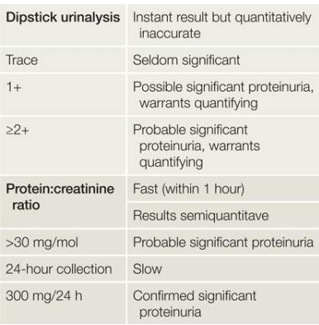

Complications:
MATERNAL COMPLICATIONS
Increase maternal morbidity &mortality because of:
- Cerebral oedema, cerebral haemorrhage& retinal haemorrhage.
- Heart failure & pulmonary oedema.
- Sub-capsular haematoma, Periportal necrosis& elevated liver enzymes.
- Hematological complications:
  - Decrease platelets count.
  - Haemolysis.
  - Coagulopathy & DIC.
- Renal failure.
- HELLP syndrome.
- Increase risk of thrombosis (DVT, pulmonary embolism).
- Increase risk of APH & PPH.
- Increase risk of surgical interventions(c/s, instrumental delivery).
- Eclampsia.
- Adult Respiratory Distress Syndrome (ARDS).
Fetal complications:
- Increase perinatal morbidity & mortality.
- Preterm delivery (iatrogenic).
- IUGR.
- IUD.
- Birth asphyxia.

Treatment:
- The mainstay of treatment is ending the pregnancy by delivering the fetus & placenta; this can be significant problem at 24-32 weeks.
- The principles of management of pre-eclampsia are:
- Early recognition of the symptomless syndrome
- Awareness of the serious nature of the condition in its severest form
- Adherence to agreed guidelines for admission to hospital, investigation and the
- Use of antihypertensive and anticonvulsant therapy.
- Well-timed delivery to pre-empt serious maternal or fetal complications.
- Postnatal follow-up and counseling for future pregnancies.

- The aim of antihypertensive therapy is to lower the BP & reduce the risk of maternal cerebrovascular accident without reducing uterine blood flow & compromising the fetus.
- Antihypertensive drugs are:

- Methyldopa: centrally acting antihypertensive agent, safe, can only giving orally ,need at least 24 hours to work and has a range of unpleasant side-effects including sedation and depression. These properties limit its usefulness
- Labetalol: is an alpha & beta- blocking agent, it can be given orally or IV, safe, can be given antenatally intrapartum to control BP in sever pre-eclampsia.
- Nifedipine : calcium-channel blocker with a rapid onset of action. It can, however , cause severe headache that mimic worsening disease.
- Hydralazine : arterial vasodilator , used IV in sever pre-eclampsia.
- So sever form of pre-eclampsia , IV infusion of hydralazine/labetolol can be titrated rapidly against changes in the BP.

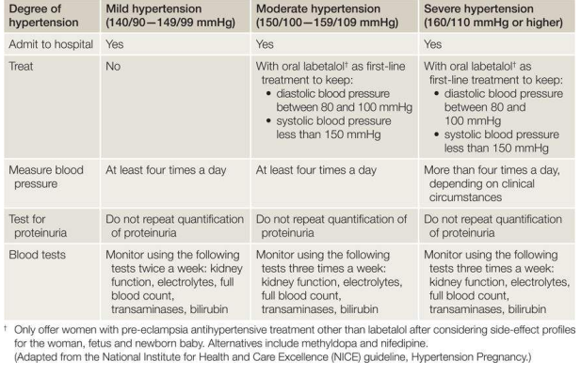

- Management of eclampsia :
- Maintain an open air way by mouth piece & oxygen.
- maintain an 2 IV line & take blood samples for :
  - Blood group &Rh.
  - CBC & Blood film.
  - LFT
  - RFT
  - Serum uric acid.
  - Coagulation profile.
- Control fit by giving magnesium sulphate which is given IV as bolus dose directly & maintenance dose over 24 hours after last fit.
- Control BP by hydralazine / labetalol IV.
- Close observation of vital sign (PR,BP,Temp.), urine output ,patellar reflex & clonus.
- Assessment of fetal condition & immediate delivery.

Magnesium sulphate (MgSO4)
*Centrally acting anticonvulsant drug.
* act as membrane stabilizing agent.
* can be given iv or im but preferable iv
* Is the drug of choice (1st drug of choice) in the acute phase treatment of eclamptic fit.
*4-6 g given iv slowly over at least 10 min to arrest fit, then maintain on 1g / hr iv in drip for at least 24 hr from the last fit.
*should be monitored carefully while giving it because of its toxicity by:
1.measuring its level in the blood
2.monitering the following
a) respiratory rate.
b) urine output.
c) patellar reflexes (1st sign to disappear in MgSO4 toxicity).
* Antidote of MgSO4 toxicity is calcium gluconate10%, 10 ml over 10 min given iv.
Screening and prevention
- there is currently no screening test for pre-eclampsia
- Doppler ultrasound uterine artery waveform analysis to identify women at risk of pre-eclampsia (a characteristic ‘notch’ can often be seen in the waveform pattern that frequently also demonstrates high resistance).
- Established preventive interventions include
- low-dose aspirin (typically 75 mg daily), which modestly reduces the risk of pre-eclampsia in high-risk women;
- Calcium supplementation may also reduce risk, but only in women with low dietary intake.

Additional points in management
Management of sever PE that necessity delivery in ˂ 34 week pregnancies:
- the mother should be transferred to a center with adequate facilities to care for her baby
- Steroids should be given intramuscularly to the mother to reduce the chance of neonatal RDS.
- Delivery before term is often by
caesarean section.
- Such patients are at particularly high risk for thromboembolism
and should be given prophylactic subcutaneous heparin and issued with
antithromboembolic stockings.
- In the case of spontaneous or induced labour and if
clotting studies are normal, epidural anaesthesia is indicated as it helps control blood pressure.
- Ergometrine is avoided in the management of the third stage as it
can significantly increase blood pressure.

KEY POINTS

- Pre-eclampsia is a multisystem disorder that likely originates in the placenta
and is a significant cause of maternal and perinatal morbidity and mortality.

- There is no cure other than delivery; the aim of management is to stabilize the maternal blood pressure and prevent seizures and cerebral bleeding.

Chronic Hypertension :

- Essential hypertension is the underlying cause in 90% of cases.
- Before a diagnosis of essential hypertension is made, other causes of chronic hypertension should be excluded which are :
- Renal disease:
  - Glomerulonephritis.
  - Polycystic disease.
  - Diabetic nephropathy.
  - Renal artery stenosis.
- Collagen vascular disease :

-SLE
- Scleroderma.
- Coarctation of the aorta.

- Endocrine causes:
- phaeochromocytoma.
- conn s syndrome.
- Irrespective of the underlying cause, the principal concern is that these women may develop superimposed pre-eclampsia (1/3).

Treatment:
- 1.mild (BP<150/100): no need for immediate treatment, however , the pregnancy should be monitored carefully to detect any rise in BP or features of pre-eclampsia or IUGR.
- 2. BP>150/100:antihypertensive medication is recommended which includes:
- Methyldopa
- Labetalol
- Nifedipine.
- Aim of treatment is to maintain the BP < 160 mmHg &100-110 mmHg diastolic.
- In women requiring antihypertensive medication, delivery is usually offered around 39 weeks, but may need to be earlier if complications have developed. It is reasonable to await spontaneous labour or attempt vaginal delivery by induction at 39 weeks.

Risk factors for developing superimposed preeclampsia
- Renal disease.
- Maternal age >40 years.
- Pre-existing diabetes.
- Multiple pregnancies.
- Connective tissue disease (e.g. antiphospholipid syndrome).
- Coarctation of the aorta.
- Blood pressure ≥160/100 mmHg in early pregnancy.
- Prepregnancy BMI >35.
- Previous pre-eclampsia.
- Antiphospholipid syndrome.

………….thank you

