Community &family medicine
MNT kidney diseaseS &Gout
Dr. Mayasah A. Sadiq FIBMS-FM
Functions of the Kidney
- Excretory
- Acid-base balance
- Endocrine
- Fluid and electrolyte balance
Causes of Chronic Kidney Disease
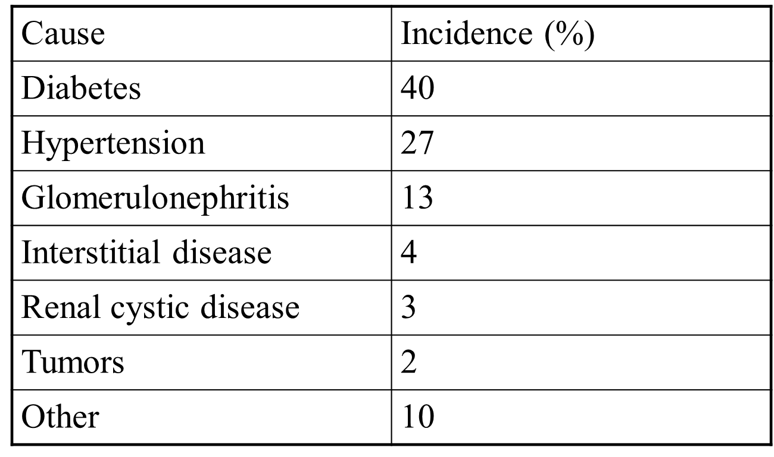
Medical nutritional therapy
MNT is recommended for all stages of Kidney disease.
Prevents and treats protein-energy malnutrition and mineral and electrolyte disorders.
Improves patient outcome
Minimizes the impact of other comorbidities on the progression of kidney disease

The renal diet
 Sufficient in protein
 Adequate in calories
 Restricted in sodium, potassium, phosphorus, and fluids(Dialysis).

Nutrition needS in CKD
 Protein needs: 0.6-0.8 grams/Kg.
 Caloric needs: 25-35Cal/Kg
 Sodium: ≤ 2.4 grams/day.
 Potassium: Not restricted unless serum K is high. (2-4 grams daily).
 Phosphorous: 10-12mg/gram of protein or 800-1000mg/day
 Calcium: ≤ 2000mg/day
 Fluids: unrestricted

Nutrition needs on haemodialysis
 Protein needs: 1.2-1.5 grams/Kg.
 Caloric needs: 30-35Cal/Kg.
 Sodium: 2-3 grams/day.
 Potassium: 40 mg/Kg.
 Phosphorous: 10-12mg/gram of protein or 800-1000mg/day
 Calcium: ≤ 2000mg/day
 Fluids: 500-1000ml/day plus urine output

Protein

 Help to build and repair body tissues.
 Rich sources : Dairy products, meat, poultry, fish, eggs, legumes and soya.
 Low protein food items: Bread, rice, pasta, potatoes, cornflakes, oats and other grains.

Sodium restriction
 Canned and processed food: mortadella, bastourma, readymade & frozen meals, canned & dehydrated soups and chicken stock, canned vegetables and tomato juice.
 Seasonings and dressings like salt, soy sauce, barbeque sauce, ketchup, mustard.
 potato chips, processed cheese, pickles, olives, roasted nuts and most fast food items.

Potassium restriction
 Avoid nuts and seeds, chocolate, vegetable juices.
 Milk and yogurt can be taken in limited amount.
 Limit coffee to 1 cup daily and tea to 2 cups daily.

Nephrotic syndrome
- Not a specific disease—kidney disorders that result in urinary protein losses in excess of 3 grams/day
- Occurs most often in children between 1 ½-4 years old
- Damage to glomeruli increases permeability to plasma proteins, allowing protein to escape into the urine
- Can progress to renal failure
Causes
Infection
Chemical damage
Immunological & hereditary disorders
Diabetes mellitus
Other disorders involving glomerulus
Clinical findings
Proteinuria
Low serum albumin levels
Edema
Elevated blood lipids
Blood coagulation disorders

Nutrition of Nephrotic syndrome

- Meet protein (0.8-1g/Kg)& energy (35 kcal/Kg)needs to minimize muscle tissue loss
- Low sat fats, cholesterol
- Low refined sugars
- Sodium restriction(1-2g/d) Potassium-rich foods (if potassium-wasting diuretics are used)
- Vitamin & mineral supplements

Kidney Stones
- Crystalline mass that forms within urinary tract
- May be asymptomatic or may cause severe pain or blockage of urinary tract as the stone passes
- Tend to recur, but can be prevented with diet & medical treatment

Formation of kidney stones
Develop when stone constituents become concentrated in urine
Formation promoted by factors that:
- Reduce urine volume
- Block urine flow
Types of Stones
Calcium oxalate stones
- Most common
- Reduce intake of oxalate
- Avoid vitamin C supplements

Uric acid stones
- Abnormally acidic urine
- Associated with gout
- Low-purine diet
Cystine stones
Inherited disorder cystinuria

Struvite stones
Form in alkaline urine

MNT of renal stones
Drink 12-16 cups of fluids/day
- Tea, coffee, beer
- No apple or grapefruit juices
- Other Dietary Measures
- Consume enough calcium to control oxalate absorption
- Restrict dietary oxalate & purine
- Moderate protein intake
- Sodium restriction

Gout
- Hereditary abnormal metabolism of purines.
- Cause a form of acute arthritis, with inflamed joints (usually knees& feet).
- Hyperuricemia results with deposition of urate& s.t. sodium.

Pathophysiology

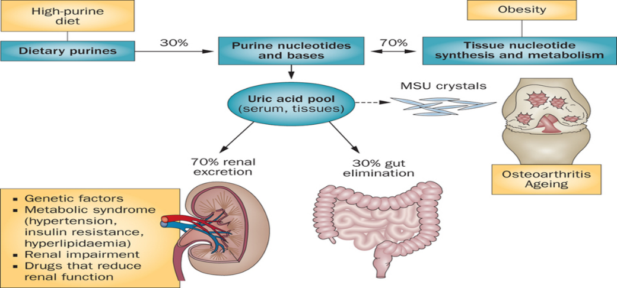

Risk factors
- M:F = 20:1(>after menopause)
- Age >40
- Alcohol
- Genetics
- Diseases: DM,Psoriasis ,Myeloproliferative
- Drugs :Diuretics,B3(Niacin)
- Obesity:(waist hip circumference)

MNT goals of Gout:
-Weight loss for obese patient.
-Increase urates excretion.
-Force fluid intake to prevent uric acid stones.
-Correct any existing hyperlipidemia.
Dietary recommendations (MNT):
1-High CHO diet& low fat intake
increase excretion of urates.
2- In acute case; avoid excessive intake of purines( shellfish, smoked meat, sardines & meat extracts).
3-Exclude alcohol beverages.
4-Calorie controlled diet for obese.
5-Ensure high fluid intake.

Foods high in purines
High: content 150-825mg/100g
*Shellfish, seafood, sardines.
*Meat, brain, kidney, liver.

Moderate: content 50-150mg/g
*Vegetables; cauliflower, green peas, mushrooms, spinach
*Grains& legumes; peas, lentils, beans,
*Oatmeal, wheat bran, whole grain
breads & cereals.
*Fish; all kind, .
*Meat; beef, lamb
*Poultry; chicken, duck, turkey.
Low: content 0-50mg/100g
*Beverages; carbonated beverages, coffee, tea.
*Grains; bread& cereals (refined white flour)
*Dairy; cheese, milk (all fat levels)
*Miscellaneous; eggs, fat, fruits,nut&vegetables.

