Shoulder dystocia:
Dr Ban Hadi \ F.I.C.O.G. 2019

Objectives:
by the end of this lecture ,the 4th year student should be able to
1. Define shoulder dystocia
2.List the risk factors for shoulder dystocia
3.Describe the possible maternal and fetal complications of such a condition
4.Recognize the prediction and prevention of shoulder dystocia
5.Implement the steps of shoulder dystocia drill on the menniquene

Definition:
Difficulty with delivery of the fetal shoulders, after delivery of fetal head.
The incidence varies from 0.2 to 1.2%
Risk factors:
1. Large baby
2. Small mother
3. Maternal obesity
4. Diabetes mellitus
5. Postmaturity
6. Previous shoulder dystocia
7. Prolonged first and second stage of labour
8. Assisted vaginal delivery.

Complications:

A –Fetal:
1. Hypoxia and cerebral damage: due to occlusion of the vessels in the fetal neck after 5 minutes, if the baby is already compromised, this may occur earlier.
2. Nerve and brachial plexus damage (Erb's palsy): due to inappropriate traction on the head causing lateral flexion of the head on the neck.
3.Fetal death
4.Bone fractures: like humerus and clavicular fracture.

B –Maternal:
Postpartum hemorrhage is the major maternal risk from shoulder dystocia, usually from uterine atony, but also from vaginal and cervical lacerations, trauma to the genital tract, uterine rupture and puerperal sepsis.

Management:
Prevention: Shoulder dystocia can only be completely avoided by caesarean section
Prophylactic caesarean section is indicated when:
Estimated fetal weight > 5 kg in women without DM.
Estimated fetal weight > 4.5 kg in women with DM.
Diagnosis: the head recoils against the perineum after delivery (turtle's sign) with failure of restitution
Shoulder dystocia drill:
1. Call for help, senior Obstetrician, anesthesiologist and pediatrician, empty the bladder and generous episiotomy is indicated to facilitate the maneuvers
2. Avoid: fundal pressure, turning the patient into left lateral position and inappropriate traction on the fetal head at all times as this may cause fetal trauma.
3. Hyperflex and abduct the hips (Mc Robert's position)
4. Apply suprapubic pressure

These will be successful in most of the cases, if failed then:

5. Rotate the shoulders by internal manipulation (Wood's screw)
6. Deliver the posterior arm, posterior arm sling can be done by NG tube
7. Turn the patient into all four position
8. More dramatic techniques as fracture of the fetal clavicle, symphysiotomy, replacement of the fetal head and delivery by caesarean section (Zavanelli maneuver) are traumatic and rarely necessary

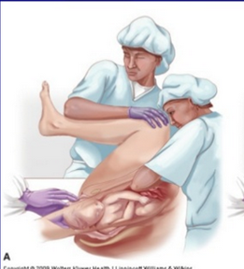
Mc Robert's position
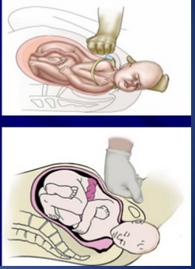
Apply suprapubic pressure
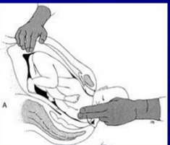
Wood's screw
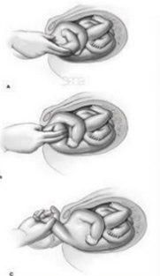 Deliver the posterior arm

End of lecture

