**DECARBOXYLATION REACTION AND BIOGENIC AMINES**

**Decarboxylation**

Decarboxylation is the reaction by which CO2 is removed from the COOH group of an amino acid as a result ***an*** ***amine is formed.*** The reaction is catalysed by the enzyme ***decarboxylase*,** which requires pyridoxal-P (B6-PO4) as coenzyme. Tissues like liver, kidney, brain possess the enzyme *decarboxylase* and also by microorganisms of intestinal tract. The enzyme removes CO2 from COOH and converts the amino acid to corresponding amine.



**SOME OF THE IMPORTANT BIOGENIC AMINES**

**1. Tyramine**

Decarboxylation of tyrosine forms tyramine. This occurs in the gut as a result of bacterial action. Also this reaction takes place in kidney. The ***reaction is*** ***favoured by O2-deficiency.*** In the presence of sufficient O2, tissue deaminates tyrosine. Tyramine elevates blood pressure.



**2. Tryptamine**

Mammalian kidney, liver and bacteria of gut can decarboxylate the amino acid, tryptophan to form the amine ***tryptamine***. Tryptamine also elevates blood pressure. Hydroxylation at 5-position produces 5-OHtryptamine- 5-HT (Serotonin).



**Histamine**

Histamine is formed by decarboxylation of amino acid “Histidine” by the enzyme ***Histidine decarboxylase*** or aromatic L-amino acid decarboxylase in presence of B6-PO4.



**Metabolism of Individual Amino Acids**

**A-Metabolism of Aromatic amino acids**

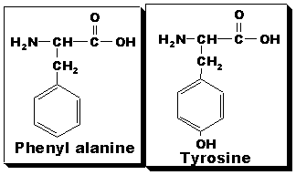

**Points to remember**

• Phenyl alanine is nutritionally an essential amino acid. It cannot be synthesized in humans, hence must be provided in diet.

•Tyrosine is not essential, as it can be formed in the body from phenyl alanine.

• Tyrosine possesses an additional –OH group at para position of benzene ring

• Phenyl alanine is readily converted to tyrosine, but the reaction is NOT reversible.

• The feeding of tyrosine decreases the need of phenyl alanine in the diet ("sparing action").

• In phenyl ketonuria patient, where phenyl alanine cannot be converted to tyrosine in the body due to inherited deficiency of the enzyme, tyrosine becomes essential amino acid to the patient.

• Both amino acids are 'glucogenic' and 'ketogenic'.

• Both can participate in transamination reaction.

**Note:**

-Amino acids which give rise to pyruvic acid or one of the intermediates of Krebs cycle are **glucogenic.**

-Amino acids which give acetyl CoA are **Ketogenic** amino acids. Leucine and lysine are the only pure ketogenic amino acids.



**A- Metabolic Fate:**

**(1) Conversion of phenyl alanine to tyrosine.**

The reaction involves hydroxylation of phenyl alanine at p-position in benzene ring by phenyl alanine hydroxylase which present in the liver. The enzyme requires coenzymes and cofactors for its activity: Molecular oxygen, NADPH, Fe++ and Ptreidine (folic acid) coenzyme: Tetrahydrobiopterin- FH4].

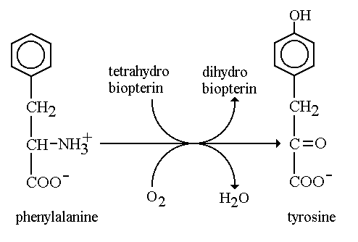

**(2) Metabolic Fate of Tyrosine.**

1-Tyrosine is degraded to produce as end products Fumarate and acetoacetate.

2-Fumarate is glucogenic, whereas acetoacetate is ketogenic.

3-Phenyl alanine is catabolized via tyrosine. Hence both phenyl alanine and tyrosine are glucogenic and ketogenic.

**B-Metabolic Role of Tyrosine:**

Tyrosine though it is non- essential, but it is of great importance in human body. Many biological compounds of importance are synthesized from tyrosine like:

1 -Synthesis of thyroid hormones: Thyroxine (T4) and tri-iodo thyroxine (T3)

2 -Synthesis of catecholamine’s: epinephrine ( adrenaline), nor epinephrine (nor-adrenaline) and dopamine. All three are synthesized from tyrosine and acts as "neurotransmitters"

*Steps of synthesis:*

a- Conversion of tyrosine to DOPA (3,4-di-hydroxy phenyl alanine)( in mitochondrion ).

b- Conversion of DOPA to dopamine ( in cytoplasm ).

c- Conversion of dopamine to nor-epinephrine ( in granules / vesicles ).

d- Conversion of nor-epinephrine to epinephrine ( in cytosol ).

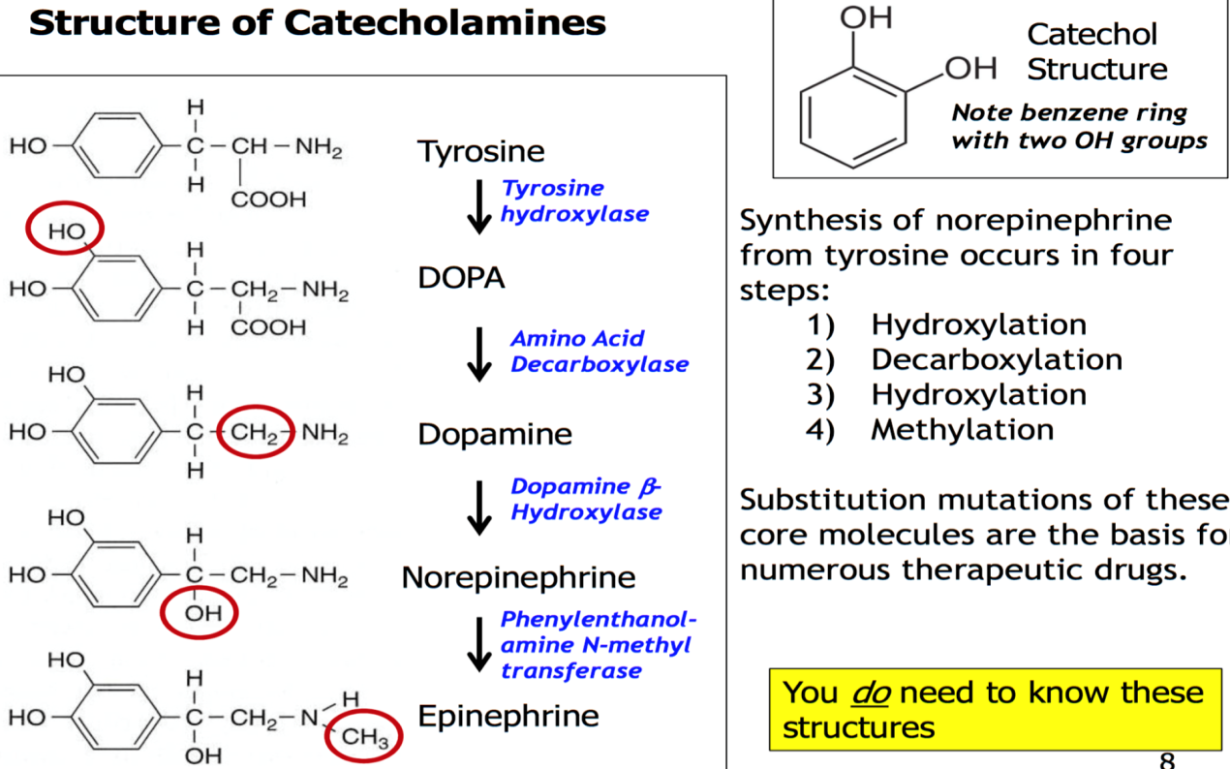

**3- Synthesis of melanin pigment:**

Melanins are synthesized from tyrosine in " melanosomes", membrane bound particles within melanocytes in skin which are cells of neural crest origin.

Melanins function is to protect underlying cells from the harmful effects of sunlight.

**Types of melanins:**

a- Eumelanins:are insoluble, hetrogenous, high M.W, black to brown (hetropolymers) .

b-Pheomelanins:are yellow to reddish-brown polymers, high M.W, soluble in dilute alkali. They contain sulphur.

c- Trichochromes:low M.W compounds, contains sulphur and are related to pheomelanins.

**4 - Formation of tyramine**: (refer to biogenic amines)

**5- Formation of phenol and cresol**: phenylalanine (through tyrosine) and tyrosine are acted upon by intestinal bacteria in the gut to form p-cresol and phenol.These are absorbed from the gut and conjugated in liver with H2SO4 and D- Glucuronic acids and are excreted in urine.

**6 - Formation of tyrosine-O-sulphate**: this is present in fibrinogen molecule.

**Clinical aspect: Inherited Disorders**

Following disorders are associated with phenylalanine and tyrosine metabolism.

1-Phenyl Ketonuria

2- Albinism

3- Tyrosinaemia Type I

4-Tyrosinaemia Type II

5- Neonatal Tyrosinaemia

6-Hereditary Tyrosinaemia

7- Alkaptonuria

1. **Phenyl Ketonuria:**

Six types of hyper phenylalaninaemia have been described

**Classical type of phenyl Ketonuria (PKU):**

An inherited disorder with incidence of 1 in 10,000 live births.

Enzyme deficiency: phenyl alanine hydroxylase is absent.

Metabolic changes: phenyl alanine cannot be converted to tyrosine, as a result alternative catabolites are produced, phenyl alanine accumulates in the blood; phenyl alanine undergoes transamination to form phenyl pyruvic acid and its products as phenyl lactic acid and phenyl acetic acid are produced.

Phenyl acetic acid is conjugated with glutamine and excreted as phenyl acetyl glutamine in urine (responsible for “mousy odour “of urine).

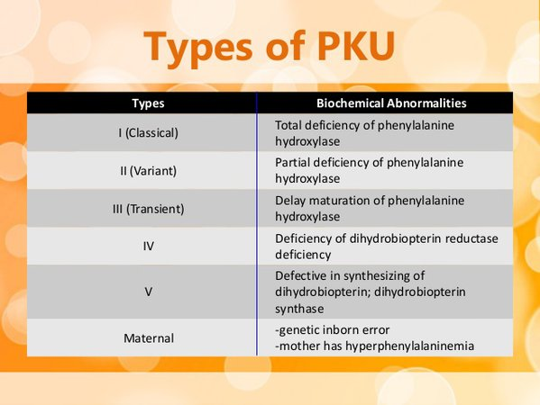

**Accumulation of phenylalanine leads to:**

- Defective "serotonin " formation.

- Also impairs melanin synthesis, children with the defect tend to have flair skin and fair hair.

-Excess of phenyl alanine in blood leads to excretion of this amino acid into the intestine. Here it competes with tryptophan for absorption. Tryptophan becomes subject to action of intestinal bacteria resulting in formation of indole derivatives which are absorbed and excreted in urine.

**Clinical Features**:

Child is mentally retarded, other features include seizures, psychoses, eczema, failure to walk or talk, hyperactivity, tremor, and failure to grow.

-untreated PKU shows symptoms of mental retardation by age of one year.

Blood: increased levels of phenyl alanine. Normal level in blood is 1-2 mg%. It increases to 15-65 mg%.

Urine: - excretion of phenyl alanine, and its catabolites: phenyl pyruvic acid, and phenyl acetic acid.

-phenyl acetic acid excreted as phenyl acetyl glutamine which produces "mousy odour".

- also abnormal O-hydroxy derivative is formed, whose metabolites may also be found in urine.

**2-Alkaptonuria:**

A rare inborn error or hereditary defect in metabolism of phenyl alanine and tyrosine. This is based on the observation that the **urine becomes black** on standing when it becomes alkaline**.** Enzyme deficiency: lack of the enzyme homogentisate oxidase resulting in the accumulation of homogentisic acid (one of many derivatives of tyrosine).

**Diagnosis of Alkaptonuria**

**1. Urine becomes black on standing** when it becomes alkaline. Blackening is accelerated on exposure to sunlight and oxygen. The urine when kept in a test tube will start to blacken from the top layer.

**2. Ferric chloride test** will be positive for urine.

**3. Benedict's test** is strongly positive. Therefore, alkaptonuria comes under the differential diagnosis of reducing substances in urine

**3-Albinism**

Albinism refers to a group of conditions in which a defect in tyrosine metabolism results in a deficiency in the production of melanin( hypomelanosis).

These defects result in partial or full absence of pigment from skin, hair and eyes.

**4- Tyrosinosis**

A rare inherited disorder.Tyrosinosis is characterised by accumulation of metabolites that adversely affect the activities of several enzymes and transport systems. Pathophysiology of this disorder is complex.

**Enzyme deficiency:** There is lack of the enzyme Fumaryl acetoacetate hydrolase and possibly also Maleyl acetoacetate isomerase.

**Types:** Both acute and chronic forms are known.

**1. In acute tyrosinosis:** Infants exhibit diarrhoea, vomiting, a “cabbage”-like odour. They do not thrive well, and there is usually associated Liver damage. **Infants die from liver failure.** Untreated acute tyrosinosis cases do not survive

and death occurs within 6 to 8 months.

**2. In chronic tyrosinosis:** Clinical features are similar but milder symptoms and course. Children survive and in untreated cases leads to death by the age of 10 years. In both types plasma tyrosine levels are elevated: 6 to 12 mg/dl. There also occurs increase in plasma methionine level.

