Gynecological disorders in pregnancy and breast disease In gynecology
د.شذى سامي
FICOG/CABCOG
2019-2020

Many gynecological problems may coincide with pregnancy some had no effect ,others may cause major adverse effect and may need interference,the following are problems may occur in pregnancy
Vaginal Infections During Pregnancy
Bacterial Vaginosis (BV)
Approximately 1 in 5 pregnant women will develop this itchy, irritating infection,hormonal changes during pregnancy may lead to change in distirbuation of common flora lead to development of this disease its may lead to preterm labor,IUGR,PROM
Symptoms
Thin grayish-white discharge
dysuria
itching

Treatment
May passed asymptomatic need no treatment , A course of antibiotics, usually Metronidazole or Clindamycin may be enough
Fungal infection
An overgrowth of Candida occur in pregnancy due to increased levels of estrogen and progesterone
Symptoms:
Pain and itching in the vagina; Redness and swelling of the vagina and labia , Thick, curdled whitish-yellow discharge; may or may not have an odor Pain or discomfort during sex , Burning while urination
Treatment by antifungal drugs
FIBROID WITH PREGNANCY
- EFFECTS ON PREGNANCY
- May be none
- Pressure symptoms
- Abortion
- Malpresentation
- Non engagement of presenting part
- Preterm labour and prematurity
- EFFECTS ON LABOUR
- May be unaffected
- Uterine inertia
- Dystocia
- PPH
- EFFECTS ON PUERPERIUM
- Subinvolution
- Sepsis
- Secondary PPH
- Lochiometra
- Pyometra
- EFFECTS OF PREGNANCY ON FIBROID
- Increase in size
- Changes in position
- Changes inn shape – becomes flattened
- Red degeneration
- Torsion of pedunculated subserous fibroid
- Infection
Ovarian cyst
Ovarian cysts are sometimes discovered during pregnancy. In most cases, they are an incidental finding at the time of routine prenatal ultrasound screening. The majority of ovarian cysts found during pregnancy are benign conditions that do not require surgical intervention. However, surgery may be indicated if there is a suspicion of malignancy, if an acute complication such as rupture or torsion (twisting of the cyst, disrupting the blood supply) develops, or if the size of the cyst is likely to present problems with the pregnancy.

CA CERVIX WITH PREGNANCY
- DIAGNOSIS
May be Asymptomatic cases or may be Symptomatic cases
- EFFECTS OF PREGNANCY ON CA CERVIX
- Malignant process remain unaffected
- Rapid spread following vaginal delivery or induced abortion
- EFFECTS OF CA ON PREGNANCY
- Abortion
- Premature labour
- Secondary cervical dystocia
- Missed labour
- Injury to cervix and lower segment
- PPH
- Lochiometra and pyometra
- Uterine sepsis
- TREATMENT
- Surgery or radiotherapy
- First trimester
- Radical surgery with fetus in situ
- Radiotherapy – external pelvic radiation
- Second trimester
- Uterus is to be evacuated
- Prophylactic antibiotic
- Radical surgery after 10 -14 days
- External pelvic radiation followed by intracavity radiation
- In operable stage – Palliative radiotherapy
- Labour – Vaginal delivery not allowed

Common breast disease
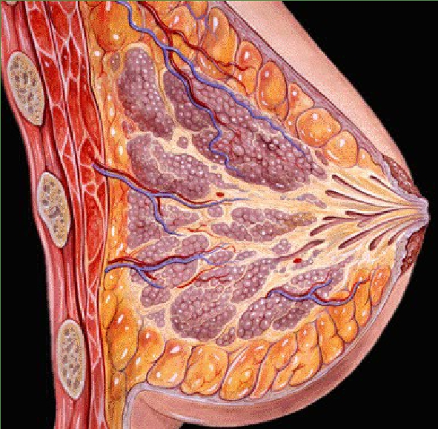
BREAST PATHOLOGY
Congenital
Aplasia : turners / Juvenile hypertrophy
Accessory/ectopic breasts –along milk line
Inflammatory
Acute: lactational* / Chronic Mastitis
Trauma –Traumatic Fat necrosis
Duct ectasia–chronic, discharge, sinus,
Galactocele

Proliferative Conditions
Fibrocystic disease –common cause of lumps
Cysts, Adenosis, Metaplasia & mixed.

Neoplastic
Benign –Fibroadenoma, duct papilloma
Malignant –DuctalCarcinoma & DCIS–several types

Acute Mastitis:
There are two types
1.NonLactational(central,periductal,rare) 2.Lactational(periphery, common)
Usually occur in the First few weeks after delivery.due to Crack in the nipple –entry pointcommon microorganism was Staph. aureus, Strep. pyogenes. Patient present with Localized inflammation, Swelling erythema& pus.
Chronic Mastitis:causes
1.Granulomatous due to (TB, Fungal, Silicone etc.)
2.Traumatic fat necrosis: Chronic granuloma, foam macrophages, radial scar –ddCa.
3.Diabetic mastopathy: DM1, rubbery lymphocytic.

Duct Ectasia:
Usually occur in age more than 50years, multiparous.presented with Periareolarmass with white, cheesy nipple discharge.this is due to Duct obstruction/destruction, inflammation, dilation, fibrosis with fat globules & foamy macrophages in lumen. May lead to Recurrent abscess fistula. And lead to Scarring with nipple inversion may mimic Ca.

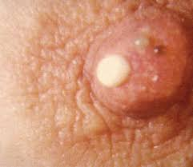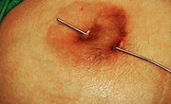

Fibroadenoma

A fibroadenoma is a benign (not cancerous) breast lump that occurs mainly in women under 35. This is the most common lump found in teenagers and in women in their early 20’s. Unlike cysts, which are fluid-filled, fibroadenomas are solid lumps made up of fibrous tissue and gland cells that have multiplied faster than normal.

Common features of a fibroadenoma:
It is usually a painless, firm lump that may increase in size over time, but it does not tend to change with the menstrual cycle. Some women find the lump becomes tender before their period. Fibroadenomas are often found alone, but about 15% of women have them in groups or in both breasts. The cause of fibroadenomas is not known
Diagnosis of a Fibroadenoma:
1.examination Fibroadenomas usually feel like a slippery, smooth, hard marble that moves freely within the breast.
2. Mammography and /or ultrasound : Radiologists recognize fibroadenomas on a mammogram as an ovalshaped, smooth surfaced, well-defined lump,
3. Fine Needle Aspiration
4. Surgical Biopsy
Treatment
Because the malignant potential of fibroadenomas is extremely low, treatment is not required on an oncologic basis, A significant minority of fibroadenomas will disappear without treatment; with the remaining lesions either increasing in size or remaining unchanged, Traditional open excisional biopsy is effective treatment, Two newer approaches, percutaneous excision and in situ cryoablation

