Lecture One 2021-2022. / Organic Chemistry. First Year Students.

Organic Chemistry

Hydrocarbons and Stereochemistry of organic

Compounds
The aim of the study is to learn about the nature, types, properties of hydrocarbons, and study the configuration effect on organic molecules reactivity for medical applications.

Chemical bond
The chemical bond is a type of attraction force between atoms, ions or molecules leading to form chemical compound that have new properties differ from that for its constituents (atoms, ions or molecules). Sometimes neutral atom shares other atom by accepting electrons (called Anion), or loosing electrons (called Cation) Figure 1, and forming Ionic Bonds, Covalent Bonds, Hydrogen Bonds, and van der Waals interactions.

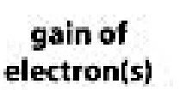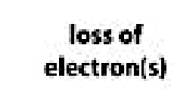
Figure 1:
Chemical bond.

Covalent bond indicates the sharing of electrons between atoms, for example compounds that contain carbon called organic compounds are commonly consist of covalent bonds Methane CH₄. Figure 2.
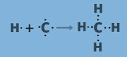

4
Figure 2: Covalent bond and Molecular geometry of Methane CH₄.

Organic compound

Organic compound, are a large class of chemical compounds in which one or more atoms of carbon are covalently linked to atoms of other elements commonly hydrogen, oxygen, or nitrogen. Forming simple linear chains or rings molecules as an important basis for example: human texture, plastics, drugs, petrochemicals, foods. Universe consist of organic and inorganic molecules the inorganic molecules are consist of elements but not the style as in organic molecules.

Organic chemistry
The study of carbon containing compounds (organic compounds) reactions and properties. In Animals, plants, and other forms of life is called Organic chemistry. Organic compound consist of Nucleic acids, proteins, fats, carbohydrates, enzymes, vitamins, and hormones are all organic compounds. The branch of organic chemistry is named Biochemistry include the study of chemical compounds, and its reactions in living cells.

Hydrocarbons
Hydrocarbons are a class of organic chemical compounds composed only of the elements carbon I and hydrogen (H) in its structures. The molecular structure of hydrocarbon Carbon atoms can form four bonds in its molecular structures, while hydrogen has one bond, Figure 3

Hydrocarbons occur in nature
Carbon atoms join together with the hydrogen atoms attachment in different configurations to form the framework of the organic chemical compounds, Hydrocarbons are the principal constituents in Human being, Viruses, Bacteria, Fungus, plants, earth petroleum and natural gases, they serve as raw materials for the production of natural and industrial chemicals. These may contain single bond, or double bond or triple carbon-to-carbon bonds.
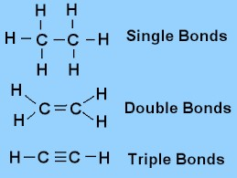
Figure 3: Carbon-to-carbon bonds

Types of Hydrocarbons
There are two types:
1. The Saturated hydrocarbon. 2. The Un saturated hydrocarbon.

1. Saturated hydrocarbon
For a saturated hydrocarbon molecule there is no double or triple carbonto-carbon bonds and will have a maximum number of hydrogen atoms by the chemical formula CnH2n+2, where is the C symbol indicates Carbone atom, n indicates nombers of Carbon atoms present, this equation applied for all saturated hydrocarbons.

2. The Un saturated hydrocarbon
The unsaturated molecule has double or triple bond in its structure, their types are:
- Alkene compounds which having double carbon-to-carbon bond. Its chemical formula CnH2n.
- The Alkyne unsaturated molecules have triple carbon-to-carbon bond with the chemical formula CnH2n-2 respectively.
- Also, Aromatic hydrocarbons are compounds containing Benzene ring in its structure, the benzene ring contains double carbon-to-carbon bond.

Hydrocarbon derivatives
Hydrocarbon derivatives are a type of organic compound commonly contain carbon, hydrogen beside other elements nonmetals (referred to as heteroatoms) such as oxygen, nitrogen, halogens, Sulphur, and phosphorus.

Functional group
Organic compounds are characterized by their type of bonds. In hydrocarbons Functional groups include the double (> C = C <) present in alkenes, or triple bond (- C C -) of alkynes, or double bond of carbon-tocarbon atoms of aromatic hydrocarbons, the hydroxyl group of alcohols, or carbonyl group of aldehydes and ketones, or Cl ^{-,} F ^{-,} Br ^{-,} I – ions of halides, and / or heteroatom groups (such as amino, phosphate, and sulfhydryl, Table1.
Table1: Functional group.
Hydrocarbon Chemical Formula Functional group of Hydrocarbon Alcohol (R- CH2 – OH) Hydroxyl group (-OH)
Aldehyde RCHO Carbonyl group (-C H =O)
Alkene (R2 C = C R2) Double Bond (> C = C <)
Carboxylic acid RCOOH Carboxyl group(-COOH).
Ketone R₂CO Carbonyl group (>C=O)

Hydrocarbons Naming
The names of the straight chain saturated hydrocarbons is differ from the other types start with mono, di and so on, so for straight-chain hydrocarbon molecules that contain only singl bond of carbone – carbons are called alkanes.
Straight-chain hydrocarbon molecules that contain carbone – carbons at least one double -bond carbon are called alkenes. When naming these molecules, start with pointing to the presence of functional group (doublebond).bond, and the final syllable in their name is “ene”,
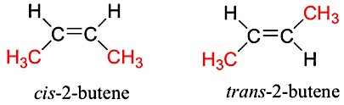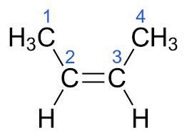

=
Figure 4: Hydrocarbons Naming

Classification of Hydrocarbons
Division of the Hydrocarbons Family depending on the activity of functional group, for that hydrocarbon are divided into two main groups:
- Aliphatic Hydrocarbons. (Saturated and Unsaturated Hydrocarbons).
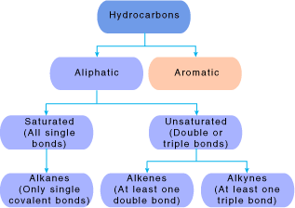
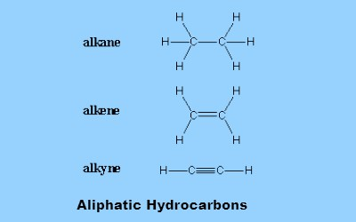
- Aromatic Hydrocarbons.

Figure 5: Aliphatic hydrocarbons.

1. Aliphatic hydrocarbons
The aliphatic hydrocarbons saturated and unsaturated hydrocarbons may be present as saturated or unsaturated compounds. a. Aliphatic Saturated Hydrocarbons
The saturated aliphatic hydrocarbons are:
- known as alkanes or paraffins.
- The alkane molecules have no double bonds in their structure are called saturated hydrocarbons.
- This simply means that there are many hydrogen atoms, and no more can be added in the molecule.
- Chemical formula is CnH2n+2.
- Alkane show only covalent single bonds, its strong as a single bond. b- Aliphatic Unsaturated Hydrocarbons:
- Unsaturated hydrocarbons are classified as alkenes contain double bond and alkyne contain triple bond are less than twice as strong as a single bond. making it easier to break one part of the unsaturated bond apart than to break a single bond.
- They have at least one carbon-carbon double bond, or one carboncarbon triple bond respectively in its structure.
- Unsaturated hydrocarbons are more reactive than saturated hydrocarbons, and they usually have fewer hydrogen atoms can be seen in bond with carbon atoms.
- Chemical formula is CnH2n, for alkenes.
- Chemical formula is CnH2n-2, for alkynes. Figure 5

Visualization of an Alkane’s Structure in Space
Ethan conformation is indicated by first Structural formula CH₃₋CH₃ as a graphical representation of the way hydrogen atoms are connected, This structural formula helps to save time /space, and the other model indicates convenient Ball-and-Stick model – 3Dimentional models as shown below.
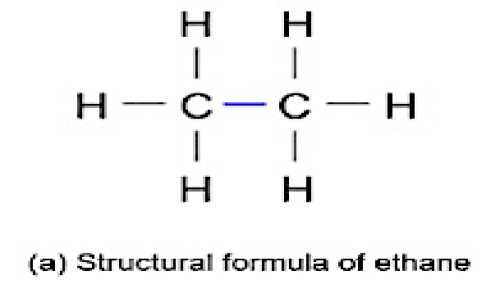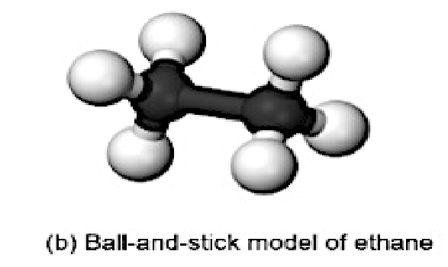

STEREOCHEMISTRY
The Hydrocarbon Molecules Stereochemistry

Stereochemistry Definition
Stereochemistry is the branch of chemistry which deals with threedimensional structure 3D of molecule and their effect on physical and chemical properties, for example the bonds in a methane (CH₄) molecule are formed by four separate bonds. Carbon-12 is composed of 6 protons, 6 neutrons, and 6 electrons, also the equivalent orbitals; a single 2s and three 2p orbitals of the carbon hybridize into four sp³ orbitals, giving Tetrahedral Carbon bellow as three-dimensional shape. Figure 6.
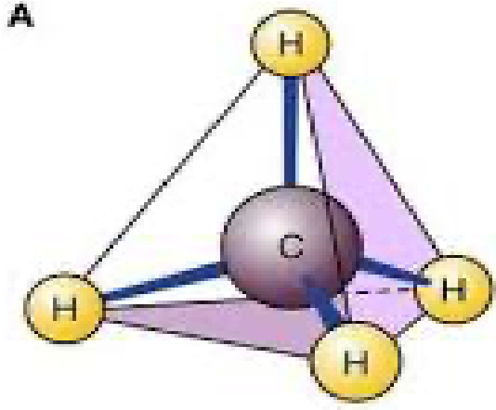

Figure 6: Tetrahedral Carbon shape of Methane (CH4)

Stereochemistry of Tetrahedral Carbon compounds must contain sp³ hybridized, at least for representing molecules as 3Dimention objects.
To represent a molecule as three dimensional object we need at least one carbon sp3- hybridized.
Stereochemistry is the studying of different spatial arrangements of carbone atoms in space. The stereo carbone center is refer to the carbone atom bounded to 4 different atoms or group of atoms named Chiral molecules. The stereo chemical configuration of any stereo center is the using of naming 'R ' from the Latin rectus, meaning the direction of stereo center is right-handed, or ' S ' from the Latin sinister, meaning the direction of stereo center is left-handed. The two structures are not identical Figure 7.
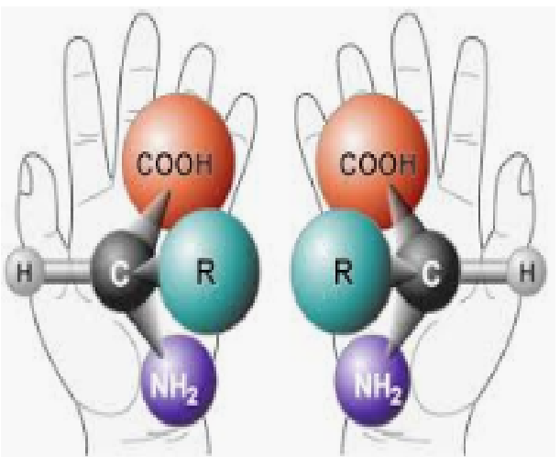
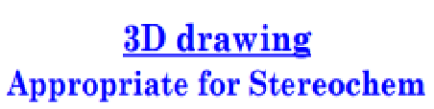

Sinister Rectus left-hand direction right-hand direction
Figure 7: Rectus and Sinister configurations in stereochemistry.
The following structures in Figure bellow indicate that designations, of the direction of Br – group, to bound carbon atom, once the direction below the page gives (R) Rictus structure, while, in this case of (S) Sinister structure Br ⁻ group direction to bound carbon atom is above the page. The positions, of the Br ⁻ group are reversed, for each structure, and gives two compounds Rictus (R) -2- bromo butane, and (S) Sinister (S) -2- bromo butane respectively. Figure 8.

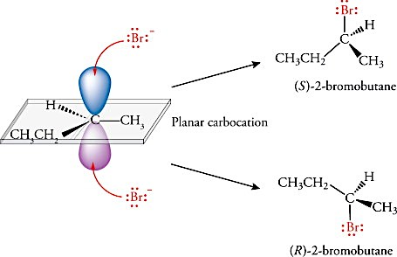
First optional direction of Br
-

ion bonding

forming (S)
-
2
-

bromo butane

Second optional direction of Br
-

ion bonding

forming (R)
-
2
-

bromo butane

Figure 8: The design of Hydrocarbon Stereochemistry.

Isomers of Hydrocarbons
Isomerism is the branch of chemistry that deals with the special arrangement of atoms in molecules, and the effects of such arrangements, on the chemical and physical properties of the molecules, especially where asymmetric centers, of substitution lead, to optical rotation. Isomers are compounds with identical chemical formulae, but different configuration structures in space. These compounds are containing exactly the same chemical formula, but differ from each other, by the way in which the atoms are arranged in space. Figure (9).
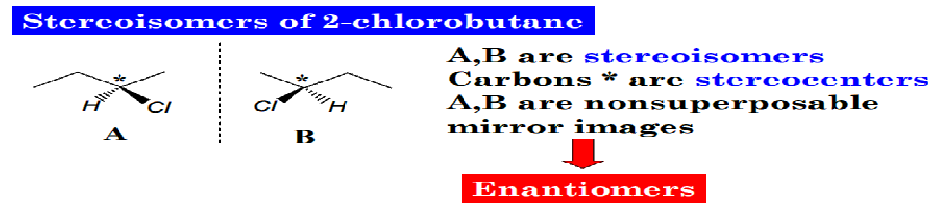
Figure (9): The two structures (A and B) differ only in the way; that the four groups bonded to the carbon are oriented in space. Consequently, they are stereoisomers.
Isomers Classification

Cis and Trans Isomers
For example, of isomers: the compound named 2- Butene with chemical formula C₄H₈ this compound can be named cis 2- butene (cis isomer) and trans 2 butene (trance isomer), so there are two compounds with the same molecular weight buy differ, in their configuration, in space.
The important center group of isomers is the carbone - carbone double bond C=C of 2- butene, since the methyl groups bound to carbon atoms, by the same direction giving cis - 2 butene, while if methyl groups bound to carbon atom by the opposite direction giving trans - 2 butene as shown in Figure 10.

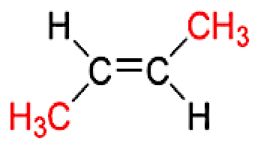
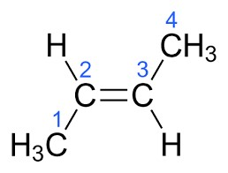
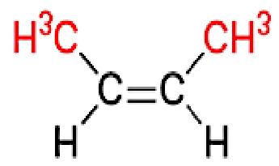
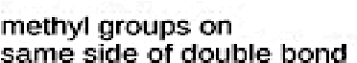
Figure 10: Cis and trans are two isomers with identical chemical formula. Cis and Trans Isomers.
This difference in structure lead to significant differences in chemical and physical properties, the boiling points of cis 2- butene (cis isomer) has a higher boiling point than the trans 2 butene (trance isomer) which differ only by the arrangement at one carbon atom respectively.

D and L Isomers
The other Classification type of isomers is D or L isomers, amino acids are consisted of the general formula R₂CNH₂COOH form optical isomers, and exist as D or L isomers named enantiomers. Sometimes D or L isomer compounds present in one container in different ratios as 30% of D isomer and 70% of L isomer enantiomers the resulting solution is optically active. Racemic mixture means the presence of 50% D isomer enantiomers, and 50% of L isomer enantiomers the resulting solution is equal to zero, or optically inactive.
Amino acids are the building unit, of proteins, and enzymes. Human proteins and enzymes consist of L isomers only, but the D amino acid isomers present in bacteria. The D amino acid isomers D-Alanine (D-Ala), and D-glutamate (D-Glu) are the vital components of bacterial peptidoglycan.
They are necessary components of the peptidoglycan layer of the cell wall, to preserve the cell structure and resistance to various environmental threats. Peptidoglycan makes up the cell wall in bacteria and consists of polymers of the two amino compounds, N-acetylglucosamine and Nacetylmuramic acid, together named glycan.
The polymers are cross-linked by short peptides, made from D isomers D-Alanine (D-Ala), and D-glutamate (D-Glu) amino acids in bacteria, and therefore these isomers have been used as markers or tracers of bacteria helping in examination of life on this or discovered space planets. Figure 11 below:
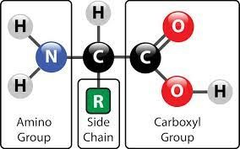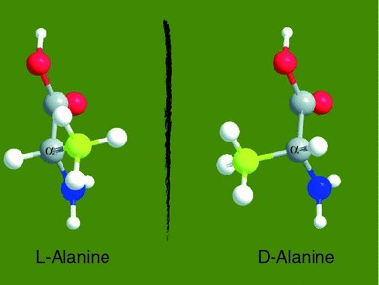 Figure 11: The D or L isomers Classification.

Emerging knowledge of regulatory roles of d-amino acids in bacteria | SpringerLink
Superposable and non-superposable Hydrocarbons
Every Hydrocarbon has a mirror image, if this mirror image is nonsuperposed described as chiral compounds, but if this mirror image is superposed described as Achiral compounds.
Chiral hydrocarbons are described as chiral if their reflected image in a mirror cannot be superimposed on the original, by this we mean chiral compounds are hydrocarbon image, and its mirror image are not identical, so that the hydrocarbon and its mirror image are not superposable one on the other.
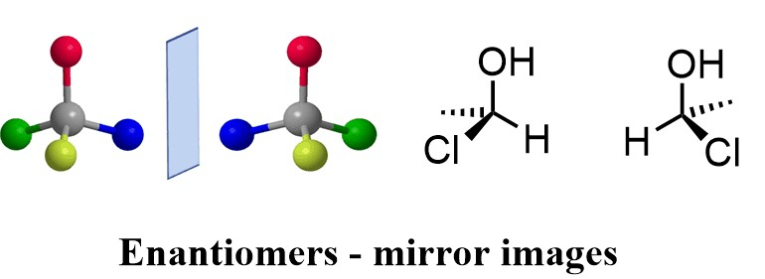

The isomers D or L are enantiomers of amino acids (Enantiomers or optical isomers are chiral molecules which are non-superimposable mirror images of each other.). The L enantiomers amino acids clearly predominate in nature while D enantiomers have been thought to have relatively minor functions in biological processes.
Superposable means that one can, place one object on the other so that all parts of each match, or coincide. But Chiral object is one that cannot be superposable on its mirror image Figure 12.

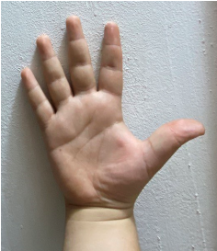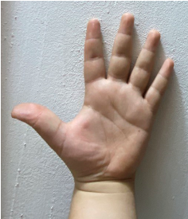

Chiral
compound

Left
hand

R
ight hand

The mirror images of each other The non-superimposable image.

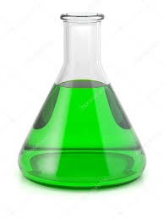

Flask A

Flask B

The two are Flasks (
Superposable
image
)

Achiral

compound

Figure 12: Optical isomers (Enantiomers) are Chiral molecules non-superimposable mirror images of each other.

Chiral Sample
Chiral from Greek word meaning hand. A sample have Chiral or an asymmetric carbon atom in its structures, and chiral if it contains one or more central atom bounded with 4 different groups of atoms called chiral compound, its optically active, and non-superposable with its mirror image.
Figure 13.
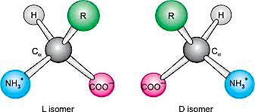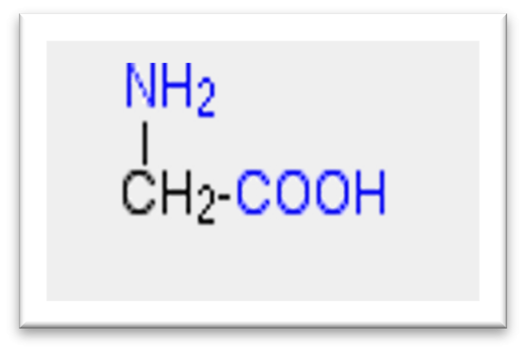

Glycine

Chiral compounds Achiral compound
Central ⍶ (alpha) carbon atom bounded to 4 different groups.
Figure (13): Central atom bounded 4 different groups, in Chiral optically active enantiomer, and the Achiral Glycine, is a kind of Achiral compound due to absence of central carbon atom bounded to four different atoms.

The Biochemical Importance of Chirality
The human body is structurally chiral, with the heart lying to the left of center and the liver to the right. Chirality in molecules, Carbohydrates, nucleotides, phospholipids and proteins have chirality. Protein building unit is amino acid. All but one (except Glycine) of the 20, L - amino acids that make up naturally occurring proteins are chiral, and all of these are classified as being left - handed.

Application of Enantiomers and Chirality in Pharmacology
The importance of stereochemistry of enantiomers in drug action is gaining greater attention in medical practice, and a basic knowledge of the subject will be necessary for clinicians to make informed decisions regarding the use of single-enantiomer drugs.
For some therapeutics, single-enantiomer formulations can provide greater selectivities for their biological targets, and improved therapeutic better than a mixture of enantiomers.
The activity of drugs containing chirality centers can similarly vary between enantiomers. For several years the drug Thalidomide was used to alleviate the symptoms of morning sickness in pregnant women. But it was discovered that thalidomide was the cause of horrible birth defects in many children born subsequent to the use of the drug.
Most pharmaceuticals are chiral. Usually only one mirror-image form of a drug provides the desired effect. The other mirror image form is often inactive or, at best, less active. In some cases, the other mirror-image form of a drug actually has severe side effects or toxicity. Moreover, selecting one enantiomer by physical separation as effective drug.
To form an enzyme-substrate complex, all three sites on the enzyme must bind with the corresponding groups or atoms of the substrate.
For Epinephrine only the (-) L- enantiomer can bind to enzyme receptor binding sites on the cell surface with all three groups. While, the (+) DEnantiomer can bind only two of a maximum of three sites. In this way the enzyme can distinguish between the two enantiomers in response to cell metabolism Figure14.
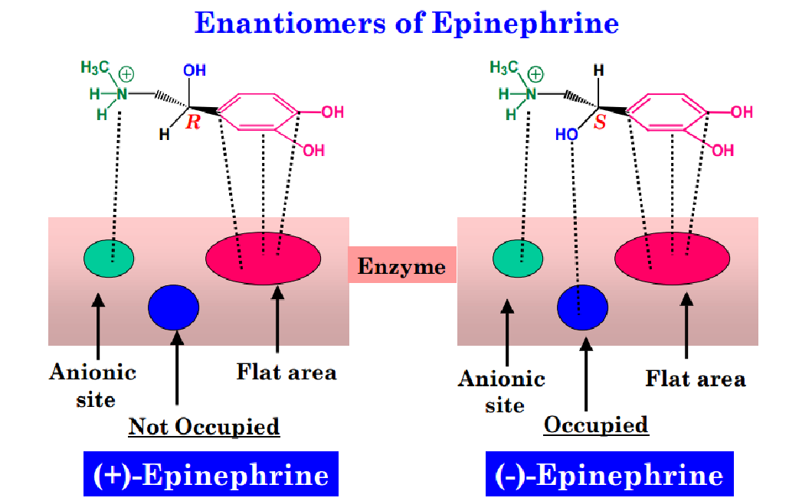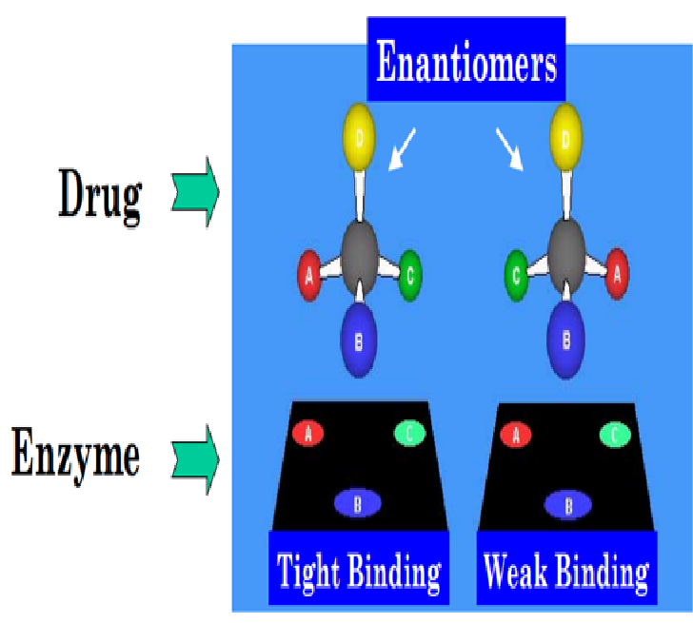

Figure 14: (-) L- Epinephrine Enantiomer drug more efficient than (+) D- Epinephrine Enantiomer.

Diastereomers
Diastereomers are defined as stereoisomers compounds that have the same molecular formula and sequence of bonded elements, but they are non-superimposable, or non-mirror images.
Enantiomers and diastereomers commonly called stereoisomers the difference between an enantiomer, and a diastereomer are two types, of stereoisomers. Enantiomers include mirror images, and nonsuperimposable chiral centers.
Diastereomers contain non-superimposable chiral centers, but are not mirror images. Figure 15.
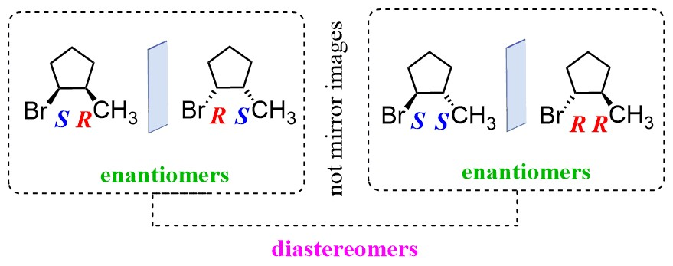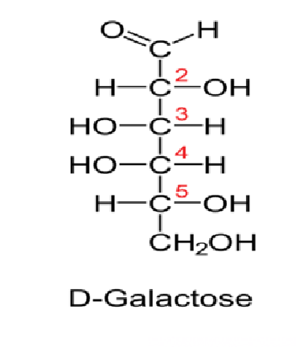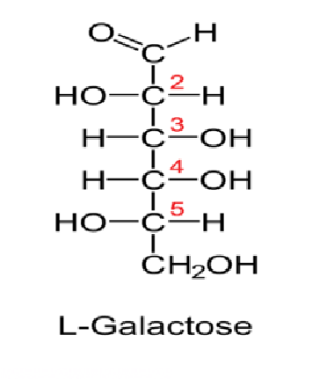
Diastereomers Enantiomer Isomers
Figure 15: The difference between Diastereomers and Enantiomer Isomers of Galactose.

Optical Activity
Optical Activity is the ability of some substances to rotate plane polarized light, rotates plane-polarized light to the right is called Dextrorotatory (+), while to lift is called Levorotatory (-).
When ordinary light is passed through a polarizing filter, all planes of oscillation are filtered out except one, resulting in plane-polarized light. A beam of plane-polarized light passed through a sample solution of a chiral enantiomer compounds, interacts with the chiral enantiomer compound in such a way that the angle of oscillation will rotate polarized light.
This property is called optical activity. Racemic mixture: its 1:1 [{equimolar of Dextrorotatory (+), & Levorotatory (-)}] mixture of two enantiomers, its optical activity is zero. Optical activity is useful in choosing the appropriate drugs or choosing the effective enantiomer. Figure 15.

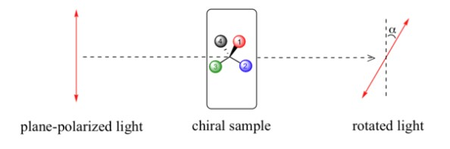
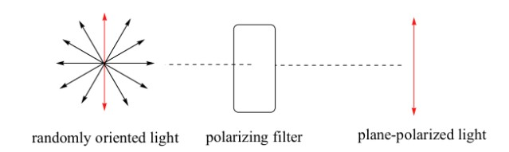
Figure 15: Measurement of optical activity.

