5th stage
Assistant prof. Dina Akeel
2022-2023
Hormonal replacement therapy
HRT has been the mainstay of the treatment of menopausal symptoms for decades. Its use has always attracted controversy, initially in its promotion as a drug with restoring abilities, and then during a period where long-term benefits on osteoporosis and CVD prevention from large cohort studies were appearing. In 2002 a large randomized trial highlighted a series of potential risks from HRT use.
Types of hormones contained in HRT
Oestrogens
There is a group of hormones with oestrogenic activity. If oestrogen is given without progestogenic opposition, there is a risk that in time endometrial hyperplasia and cancer may develop. Systemic oestrogen-only HRT is suitable for women who no longer have a uterus following a hysterectomy
Oestrogen with progestogen
The administration of progestogen is necessary to protect the endometrium in women who have not had a hysterectomy. It is normally given cyclically in preparations over a 28-day cycle, of which 16–18 days will provide oestrogen alone and 10–12 days will provide oestrogen and progesterone combined
(cyclical HRT). This results in regular monthly menstruation and is suitable for women during the perimenopause or early postmenopausal years.
Oestrogen and progesterone may be given continuously (continuous combined HRT) to women who are known to be postmenopausal or over the age of 54 years. These are usually preparations with the same dose of daily oestrogen combined with a smaller dose of progestogen taken every day. These regimes normally result in about 90% of women not experiencing vaginal bleeding.
Testosterone
Testosterone has traditionally been given to women with disorders of sexual desire and energy levels who have failed to respond to normal HRT. These beneficial effects of testosterone are well documented; however, few long-term studies into the adverse effects of testosterone exist. Over the past years manufacturers have stopped making testosterone drugs for women to the point that the only available preparations available now are those licensed for use in men.

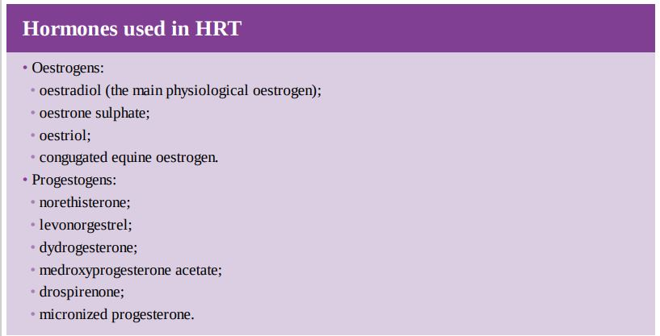
Routes of hormone therapy administration
The two main routes of HRT delivery are oral and transdermal.
- The oral route is normally a daily tablet that contains the appropriate mix of oestrogen and progestogen, depending on the preparation. The oral route is convenient and cheap but does influence lipid metabolism and the coagulation system through its effects on the liver during first-pass metabolism.

- The transdermal route, either given as patches applied to the skin on the trunk or as measured amounts of gel, is also effective, with the advantage of delivery of oestradiol directly into the circulation, avoiding the above potentially adverse effects on the liver and the coagulation system. Oestradiol is also available as small vaginal tablets and a vaginal ring, and oestriol as measured dose vaginal creams that are important in the management of lower genital tract symptoms.

Beneficial effects of hormone therapy

Vasomotor symptoms
The principal reason for taking HRT is vasomotor symptom improvement. Well over 90% of women note a significant improvement within 6 weeks, with reductions in frequency and severity of hot flushes and night sweats and consequent improvements in sleep and daytime energy levels as well as concentration.

The skeleton
The protective effects of HRT on the skeleton include prevention of bone loss and the prevention of osteoporotic fractures of the hip and spine. The use of HRT is strongly recommended for women after POF as they are at a much greater risk of osteoporosis.

The lower genital tract

Both systemic and locally administered HRT have significant beneficial effects on the lower genital tract. There is good evidence that its administration improves vulvovaginal dryness, irritation, soreness and dyspareunia. There is also an improvement in symptoms of cystitis and occasionally dysuria. They can often be reassured that were they to use the form of local hormone therapy as a 10 µg twice weekly dose vaginal tablet, they would only be administering approximately the equivalent of a 1 mg oral tablet over a whole year.

The cardiovascular system

The cardiovascular benefits of HRT were first demonstrated in large observational cohort studies. The principal benefits were reduction in ischaemic heart disease and overall mortality. However the large randomized Women’s Health Initiative (WHI) study demonstrated reductions in survival from CVD in women taking HRT.

Risks of hormone therapy

Cancer

1. Breast cancer is without doubt the cancer that attracts most concern from patients and most attention from the world’s media. The studies performed still do not fully inform patients of the additional risks they expose themselves to by using HRT.
It is important to be aware that recent data with oestradiol HRT suggest that mortality from breast cancer is not increased and that certain types of HRT may promote the growth of pre-existing malignant cells rather than initiate tumours.

2.Endometrial cancer and ovarian cancer are not considered significant risks with HRT use. Endometrial malignancy risk is largely eliminated if women are given progestogens. Incidence of ovarian cancer has not been shown to significantly increase with HRT use.

Cardiovascular disease and stroke
a most of the effects of HRT on the cardiovascular system when given to younger women are beneficial. However, when given to older women the effects may become deleterious.

Venous thromboembolism
The influence of HRT on the clotting system is similar to that of the oral contraceptive. The background incidence of all VTE in women over 50 is low (approximately 15–20 per 10,000) and HRT doubles this risk. There is evidence to suggest that transdermal HRT, through its avoidance of effects on the liver, may not have such a great effect on VTE incidence.

