Anatomy
The Skull & the Cranial Vault

SKULL Bones

The skull has 22 bones, excluding the ossicles of the ear. Except for the mandible, which forms the lower jaw, the bones of the skull are attached to each other by sutures, are immobile, and form the cranium.

The cranium can be subdivided into:

  - an upper part (the calvaria), which surrounds the cranial cavity containing the brain; (The cranial vault: or the cranial bones)
  - a lower anterior part-the facial skeleton (viscerocranium).

The bones forming the calvaria (Upper part) are the:

- Paired temporal and parietal bones.
- Unpaired frontal, sphenoid, ethmoid, and occipital bones.

The bones forming the facial skeleton are the:

- Paired nasal bones, palatine bones, lacrimal bones, zygomatic bones, maxillae, inferior nasal conchae.
- Unpaired vomer.

Note: (Anatomically) the mandible is neither part of the cranium nor part of the facial skeleton.

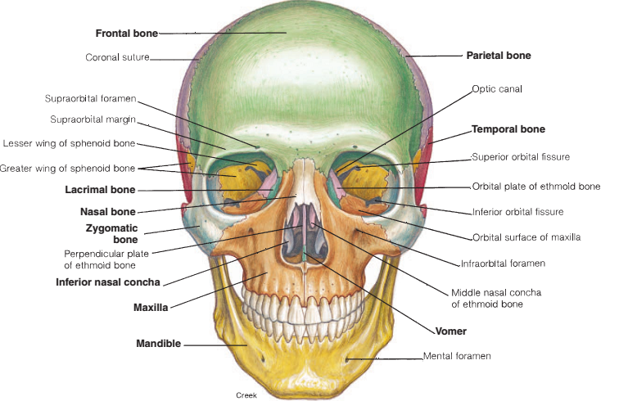
Anterior view
The anterior view of the skull includes the forehead (frontal bone) superiorly, and, inferiorly, the orbits, the nasal region, the part of the face between the orbit and the upper jaw, the upper jaw, and the lower jaw

Cranial bones
The cranial bones enclose and protect the brain and associated sensory organs. They consist of one frontal, two parietals, two temporals, one occipital, one sphenoid, and one ethmoid.
Most of the vault bones are flat, and consist of two tables or plates of compact bone enclosing a narrow layer of relatively dense cancellous marrow (diploic bone). The marrow within the skull bones is a site of haemopoiesis, at least in the young individual.
The majority of bones in the skull articulate via fibrous joints termed sutures, which facilitate growth rather than movement in the developing skull.
The term synostosis refers to the fusion of 2 bones; in the skull vault the sutures between bones will start synostosis i.e. fusion of skull bones usually at about 30 years of age and th fusion between bones will increase while the person is aging.

Parts of the Skull

The skull is made up of 22 bones plus 6 ear ossicles. It can be studied in two parts namely:
1. Neurocranium (calvaria/brain-box)
2. Facial skeleton.
Neurocranium:It is also known as calvaria. It is made up of 8 bones, 2 paired and 4 single bones. These are:
1. Paired bones: Parietal and temporal.
2. Unpaired bones: Frontal, occipital, sphenoid and ethmoid.
Facial skeleton: It consists of 14 bones, 6 paired and 2 unpaired bones.
1. Paired bones: Maxilla, zygomatic, nasal, lacrimal, palatine and inferior nasal concha.
2. Unpaired bones: Mandible and vomer.
Bones forming the skull (except ear ossicles) are flat bones made up of two flat plates of compact bone with a central marrow cavity lined by a thin strip of cancellous bone. The two plates may be fused, as in vomer and pterygoid bones.

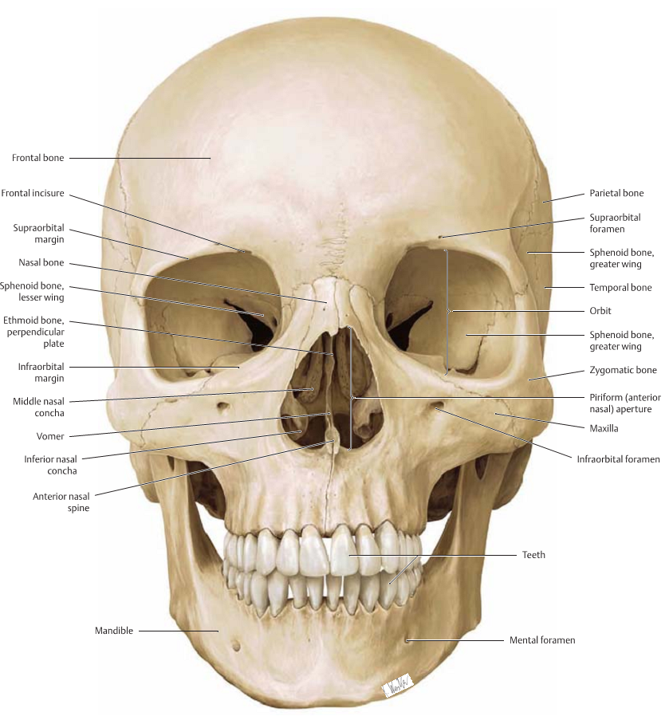
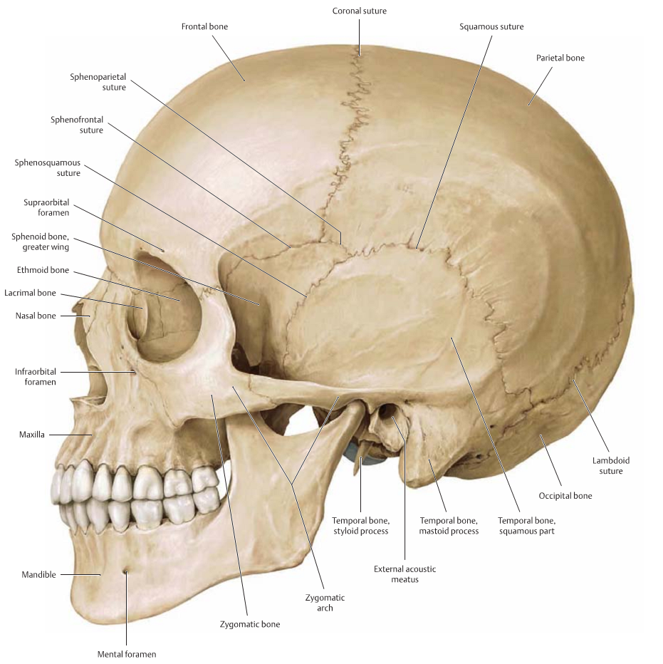

- Frontal bone

The frontal bone forms the anterior roof of the cranium, the forehead, the roof of the nasal cavity, and the superior arches of the orbits, which contain the eyeballs.
The frontal bone develops in two halves that grow together.
Generally, they are completely fused by age 5 or 6. A suture sometimes persists between these two portions beyond age 6 and is referred to as a metopic suture.

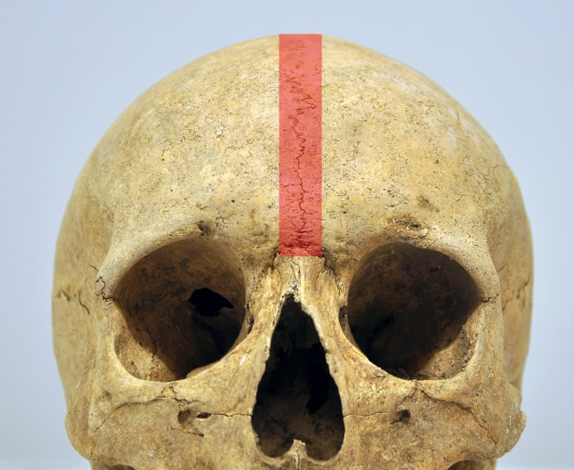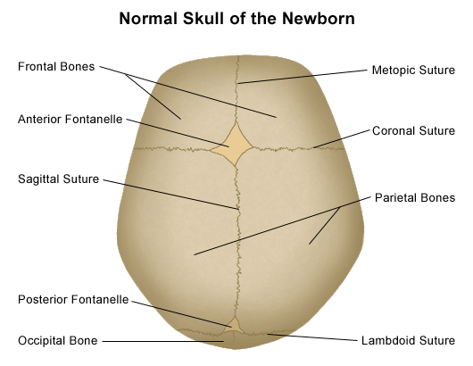
These pictures represents the metopic suture which usually only found in neonates and disappear at the age of 6 years.

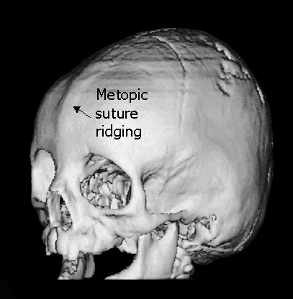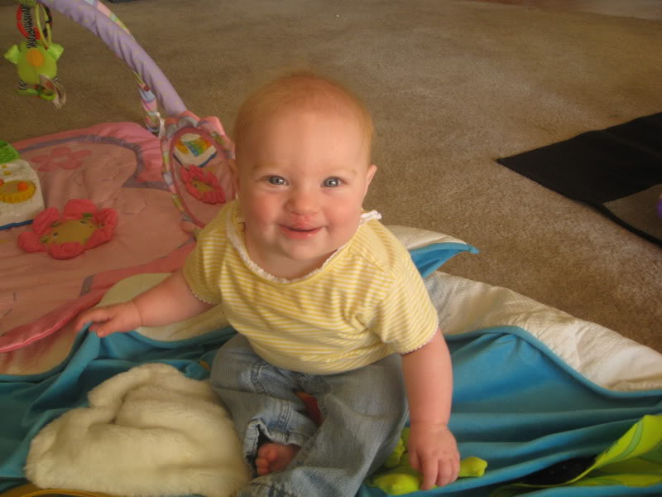
Some people will have a ridge like in the midline of the forehead represent the site of the metopic suture.

The forehead consists of the frontal bone, which also forms the superior part of the rim of each orbit.
Just superior to the rim (Supra-orbital ridge: is just below the supercilliary arches the ridge is the outer portion of the orbit that enclosed the eyes) of the orbit on each side are the raised superciliary arches. These are more pronounced in men than in women. Between these arches is a small elevation (the glabella).

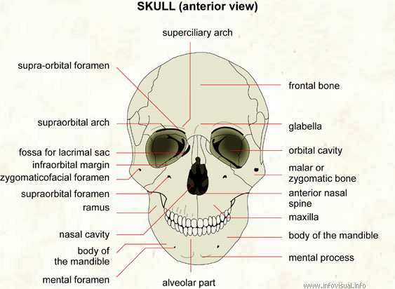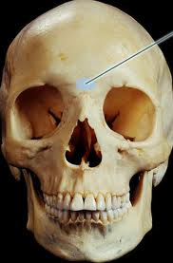
The portion pointed by the arrow in the picture to your right is the glabella

The supraorbital margin is a prominent bony ridge over the orbit. Slightly medial to its midpoint is an opening called the supraorbital foramen, which provides passage for the supraorbital nerve, artery, and veins.
Clearly visible in the medial part of the superior rim of each orbit is the supra-orbital foramen (supra-orbital notch).
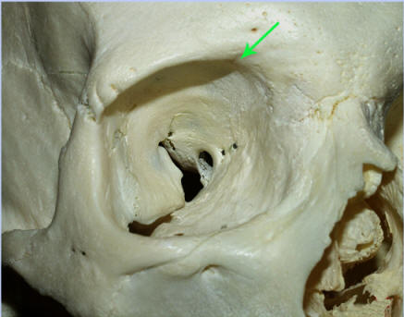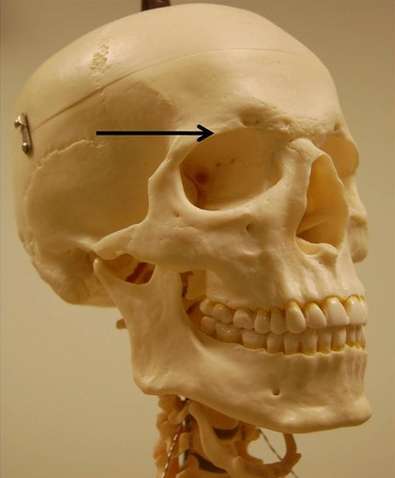
The figures above: the figure on your left showing the position of the supra-orbital notch. While the right figure the arrow is pointing toward the supra-orbital ridge.

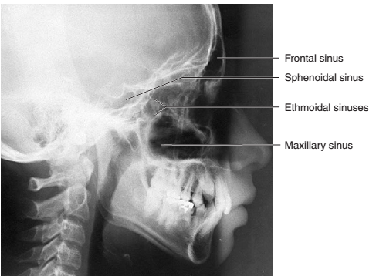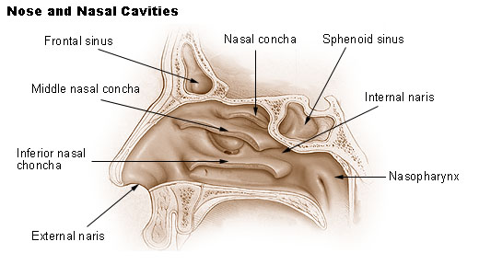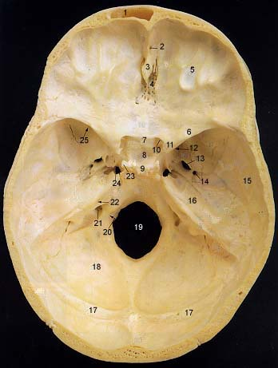
The 3 figures: (x-ray, transverse section of the skull base and the nasal diagram) showing the position of the frontal sinus. The frontal bone also contains frontal sinuses, which are connected to the nasal cavity.

Function of These sinuses, along with the other paranasal sinuses, lessen the weight of the skull and act as resonance chambers for voice production.

Medially, the frontal bone projects inferiorly forming a part of the medial rim of the orbit.
Laterally, the zygomatic process of the frontal bone projects inferiorly forming the upper lateral rim of the orbit. This process articulates with the frontal process of the zygomatic bone.

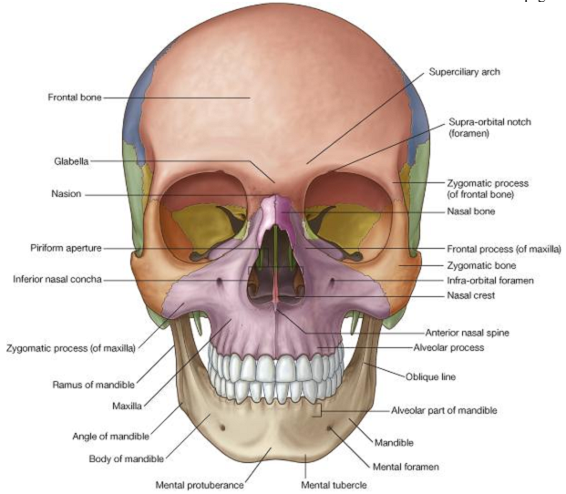

- Parietal bones: The two parietal bones form the upper sides and roof of the cranium. The coronal suture separates the frontal bone from the parietal bones, and the sagittal suture along the superior midline separates the right and left parietals from each other. The inner concave surface of each parietal bone, as well as the inner concave surfaces of other cranial bones, is marked by shallow impressions from convolutions of the brain and vessels serving the brain.
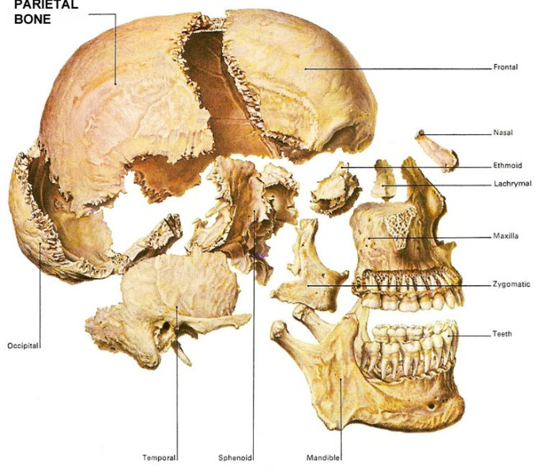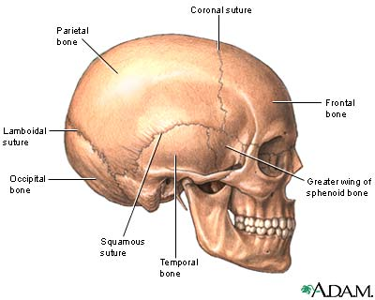

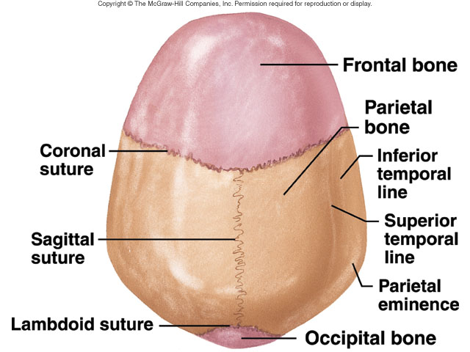
The figures above; showing the relation between the cranium vault bones especially the parietal bones and its relation to the surrounding bones and sutures.

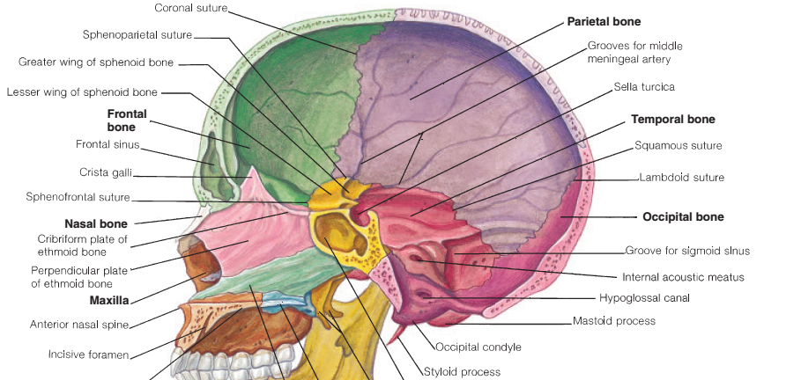
- Temporal bones: The two temporal bones form the lower sides of the cranium each temporal bone is joined to its adjacent parietal bone by the squamous suture. Structurally, each temporal bone has four parts.
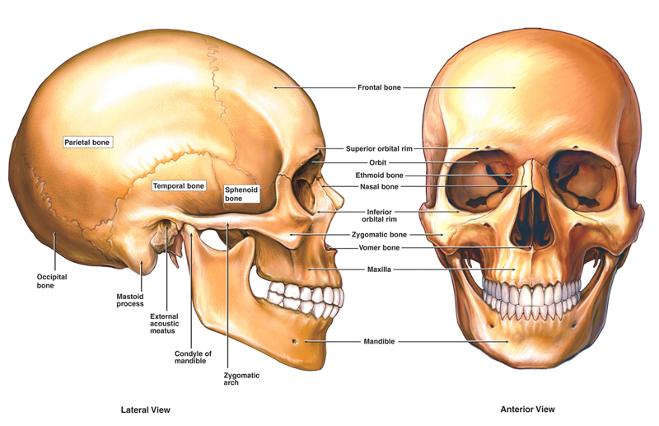
  - Squamous part. The squamous part is the flattened plate of bone at the sides of the skull. Projecting forward is a zygomatic process that forms the posterior portion of the zygomatic arch. On the inferior surface of the squamous part is the cuplike mandibular fossa (glenoid fossa), which forms a joint with the condyle of the mandible. This articulation is the temporomandibular joint (TMJ).
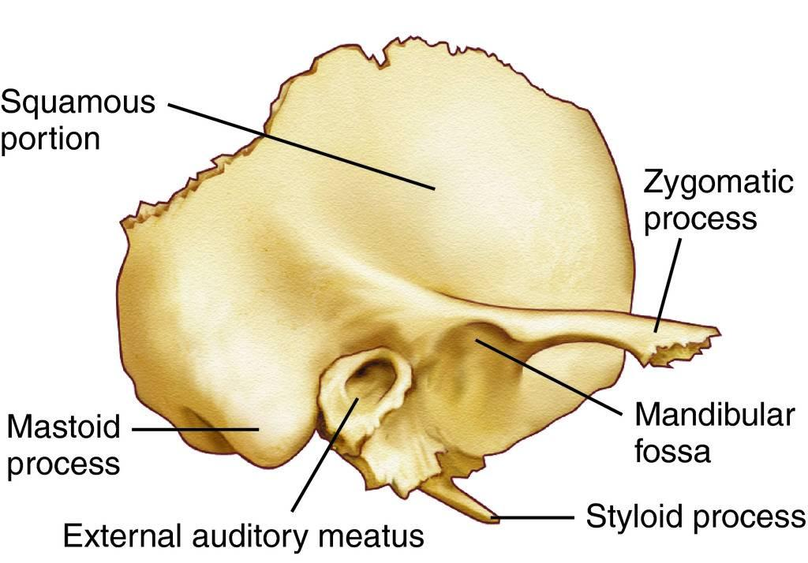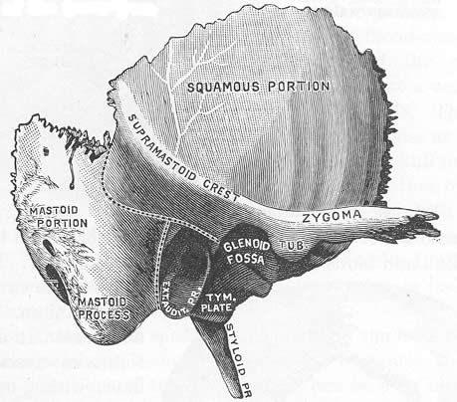

  - Tympanic part. The tympanic part of the temporal bone contains the external acoustic meatus (me-a'tus),or ear canal, which is posterior to the mandibular fossa. A thin, pointed styloid process projects inferiorly from the tympanic part.

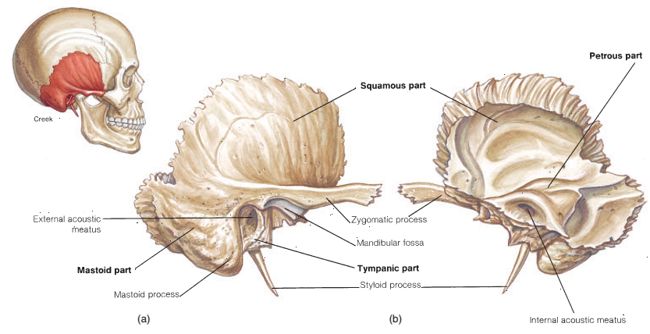
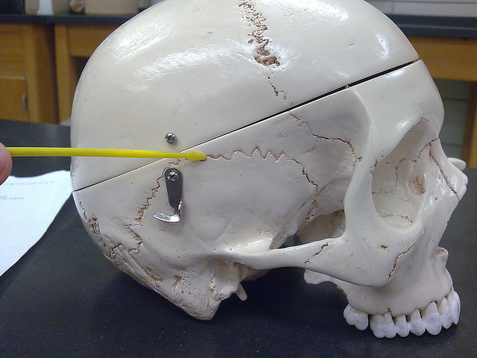
Squamosal suture; connect the temporal bone to the parietal bone
  - Mastoid part. The mastoid process, a rounded projection posterior to the external acoustic meatus, accounts for the mass of the mastoid part. The mastoid foramen is directly posterior to the mastoid process. The stylomastoid foramen, located between the mastoid and styloid processes, provides the passage for part of the facial nerve.
  - Petrous part. The petrous (pet'rus) part can be seen in the floor of the cranium. The structures of the middle ear and inner ear are housed in this dense part of the temporal bone. The carotid (ka˘-rot'id) canal and the jugular foramen border on the medial side of the petrous part at the junction of the temporal and occipital bones. The carotid canal allows blood into the brain via the internal carotid artery, and the jugular foramen lets blood drain from the brain via the internal jugular vein. Three cranial nerves also pass through the jugular foramen.

*Clinical note: The mastoid process of the temporal bone can be easily palpated as a bony knob immediately behind the earlobe. This process contains a number of small air-filled spaces called mastoid air cells that can become infected in mastoiditis, as a result, for example, of a prolonged middle-ear infection.
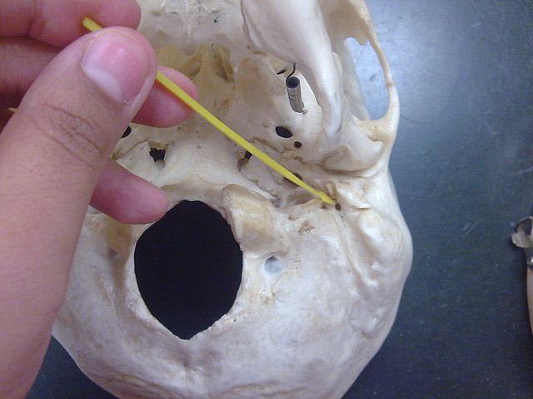
Foramina related to the temporal bone:
Pictures from up to below:

Pic(1) (stylomastoid formaen): the exit point for the facial nerve.

Pic (2) Jugular foramen: It is located behind the carotid canal and is formed in front by the petrous portion of the temporal, and behind by the occipital; it is generally larger on the right than on the left side
The jugular foramen may be subdivided into three compartments, each with their own contents:
- The anterior compartment transmits the inferior petrosal sinus. [مهم: the blood sinuses are for collecting the blood from the brain they resemble the venous drainage of the brain (Don’t get confused with air sinuses)]

- The intermediate transmits the glossopharyngeal, vagus, and accessory nerves (aka cranial nerves number IX, X, and XI respectively).[مهم: the human body have 12 cranial nerves the emerges directly from the brain to supply many parts of the body mainly the head and neck region, the rest of the body is supplied by the spinal nerves].
Vernet's syndrome (متلازمة) [مجموعة من الأعراض المرضية والعلامات المتزامنة ذات المصدر الواحد] Vernet’s syndrome is: characterized by the paresis of 9th–11th (with or without 12th) cranial nerves together.

- The posterior transmits the sigmoid sinus (becoming the internal jugular vein) and some meningeal branches from the occipital and ascending pharyngeal arteries.

Pic (3) Carotid Canal: is the passage way in the temporal bone through which the internal carotid artery enters the middle cranial fossa from the neck. In the living human this picture cannot seen because it will be covered by fibrous tissue.
The carotid artery is main blood supply source for the head and neck region. It is divided in the middle of the neck into external carotid artery (supply the face) and internal carotid artery (supply the brain)
Pic(1) stylomastoid foramen
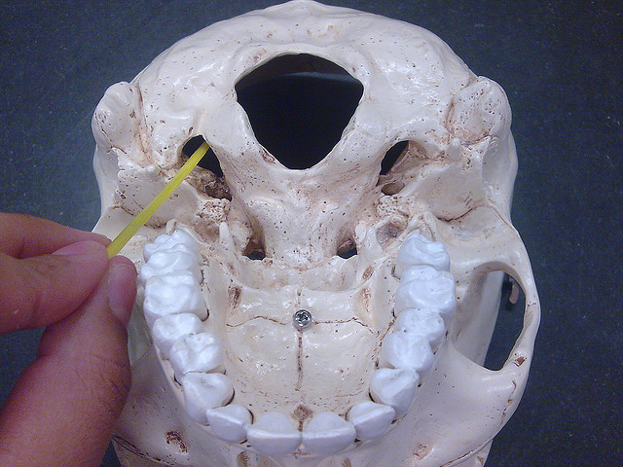
Pic (2) Jugular foramen
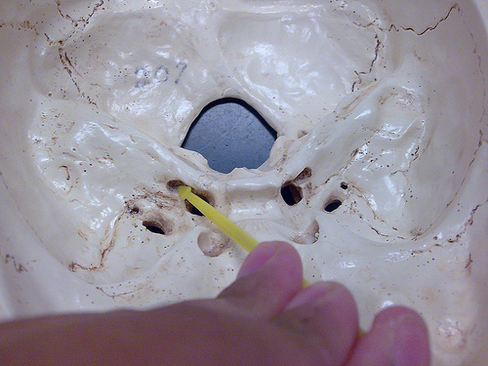
Pic (3) Carotid canal
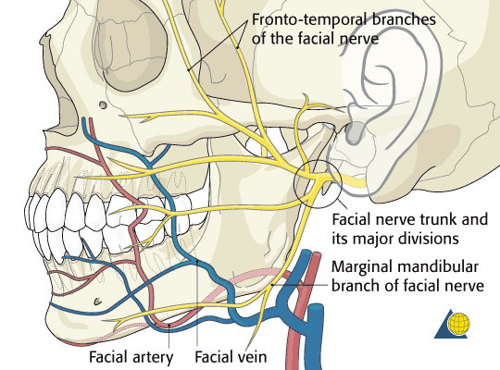
The arrow is pointing at the emergence point of the facial nerve (VII, the seventh cranial nerve) from the stylomastoid foramen.
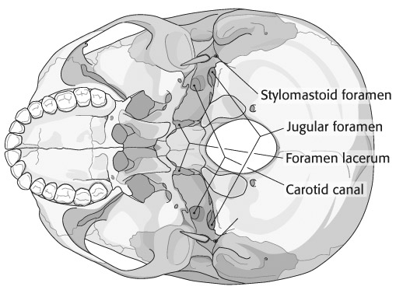
Inferior view of the skull showing the relation between the stylomastoid foramen, Jugular foramen and the carotid canal

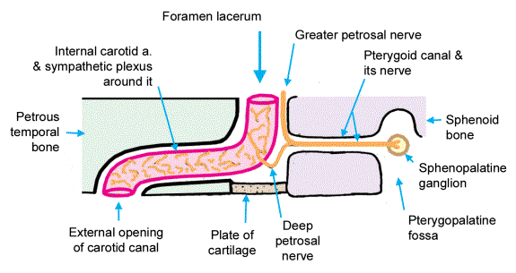
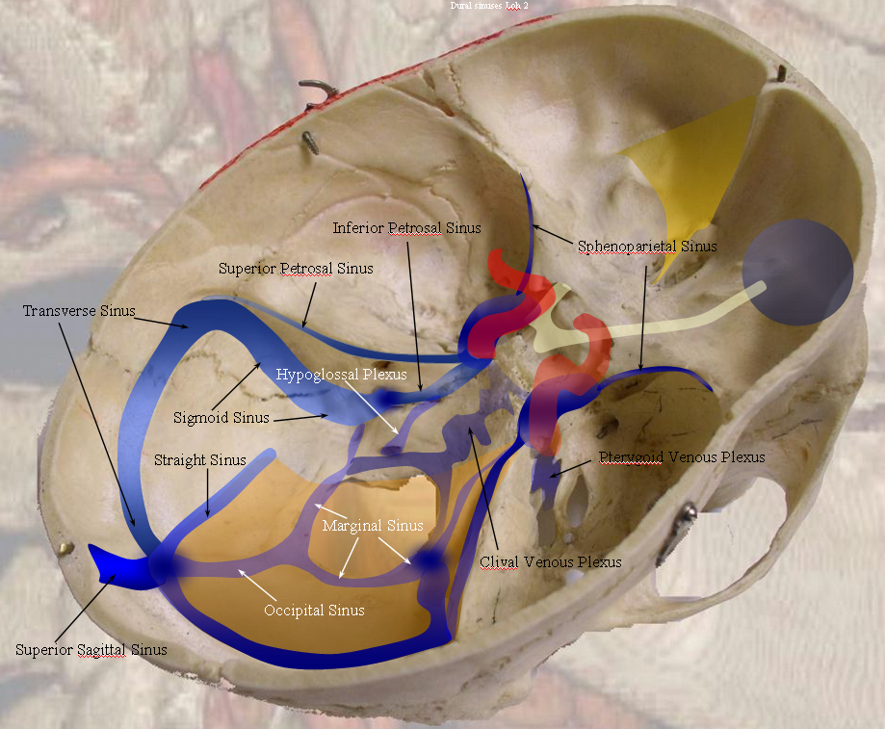
Base of the skull showing the main blood sinuses that drain the blood into the internal Jugular vein which is the main vein that collect blood from the head and neck region

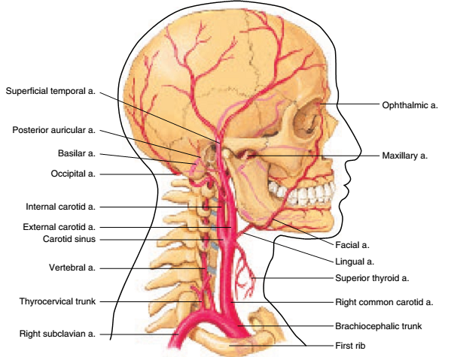
Internal carotid artery supply the brain
External carotid artery supply the face and superficial parts of the head and neck region
The common carotid artery the main source of supplying the head and neck region
The arterial supply of the head neck. The arrows are pointing towards the branches of carotid artery, the main arterial supply of the head and neck region
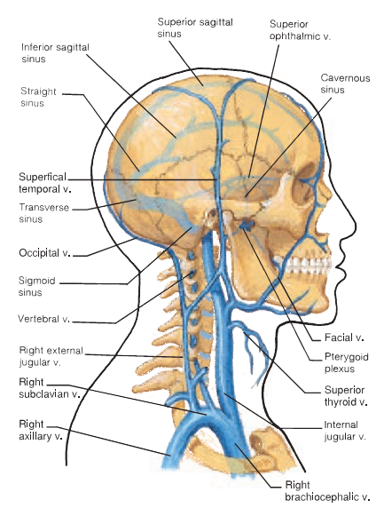
Internal Jugular vein, the main venous drainage of the head and neck region
- Occipital bone: The occipital bone forms the posterior and most of the base of the skull. It articulates with the parietal bones at the lambdoid suture. The foramen magnum is the large hole in the occipital bone through which the spinal cord passes to attach to the brain stem. On each side of the foramen magnum are the occipital condyles, which articulate with the first vertebra (the atlas) of the vertebral column. At the anterolateral edge of the occipital condyle is the hypoglossal canal, through which the hypoglossal nerve passes. The external occipital protuberance is a prominent posterior projection on the occipital bone that can be felt as a definite bump just under the skin. The superior nuchal(noo'kal) line is a ridge of bone extending laterally from the occipital protuberance to the mastoid part of the temporal bone. Sutural bones are small clusters of irregularly shaped bones that frequently occur along the lambdoid suture.
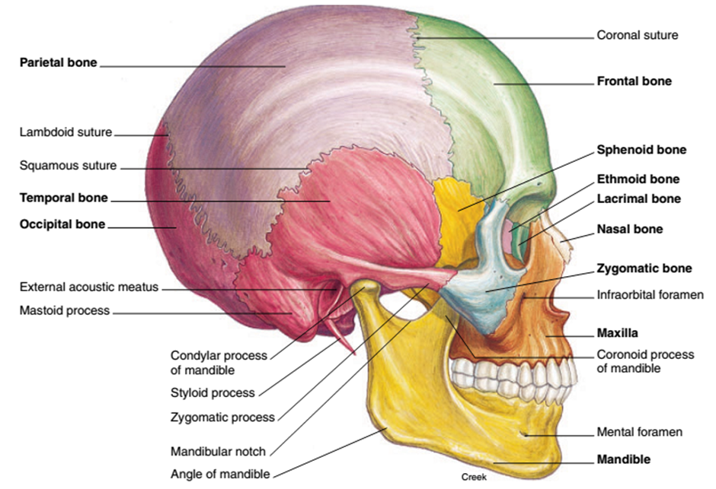

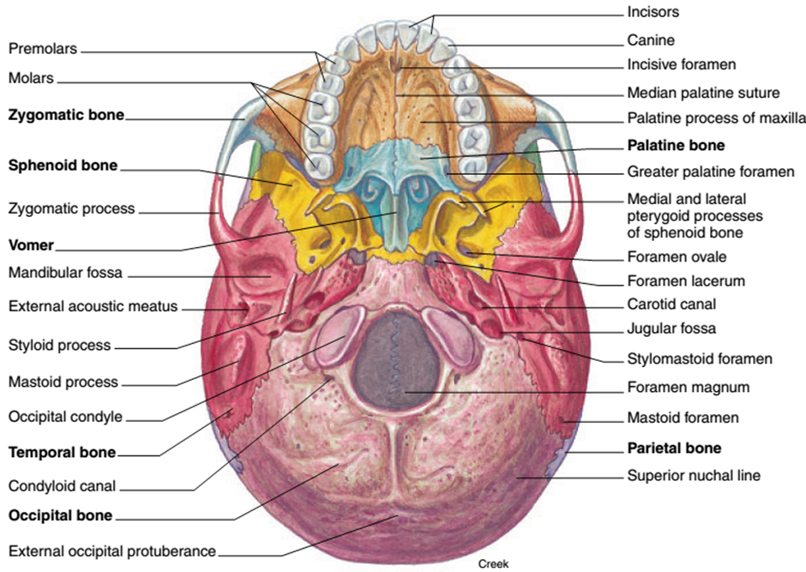

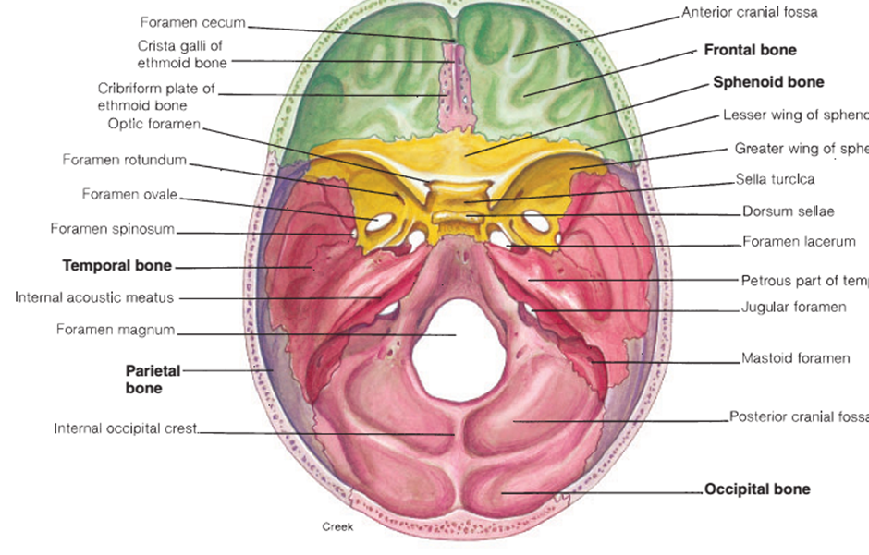

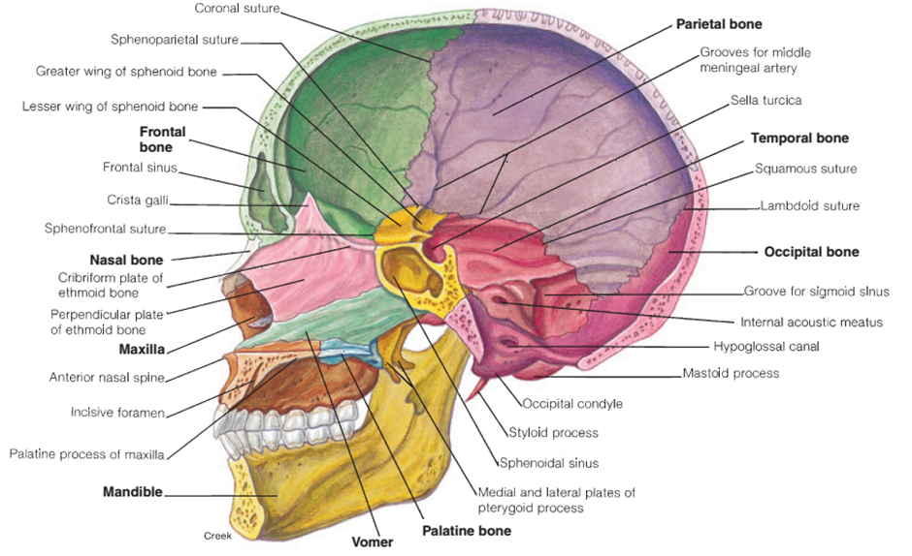

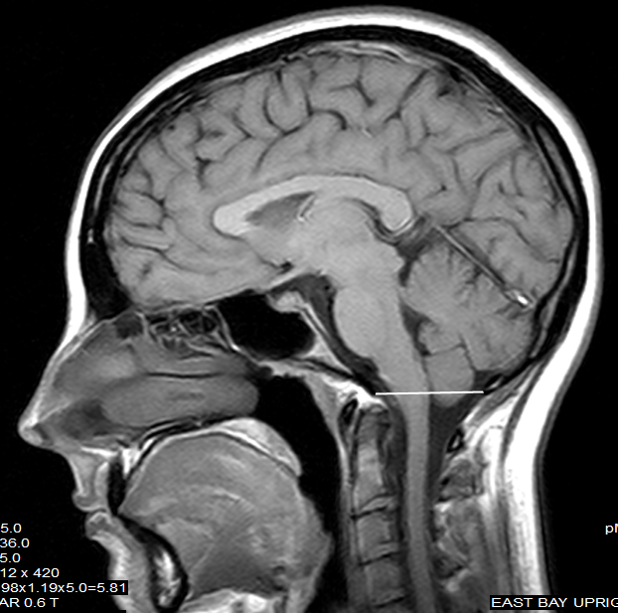
The level of foramen magnum at the base of the skull.
MRI : Magnetic Resonance Image (الرنين المغناطيسي) of the brain. The arrow is pointing towards the spinal corad (الحبل الشوكي) emergence from foramen magnum in the base of the skull within the occipital bone
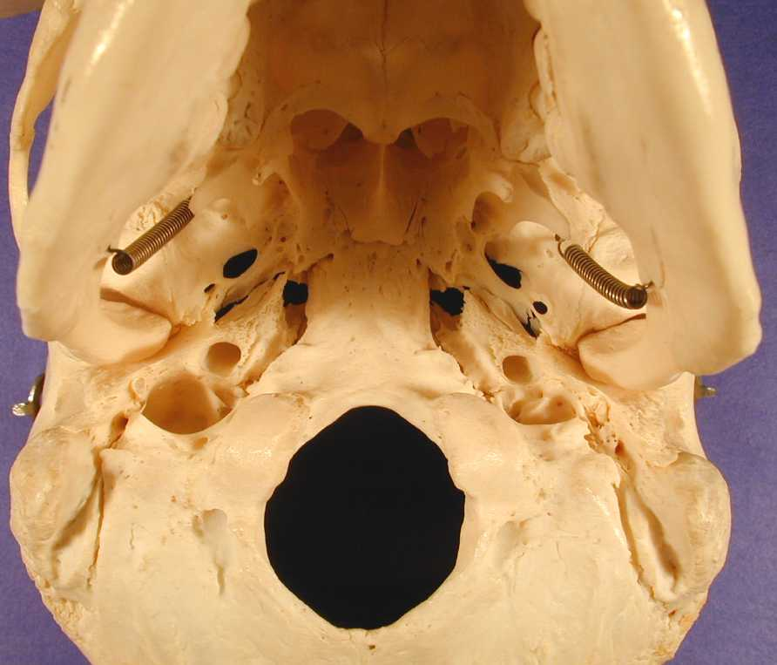
Foramen magnum
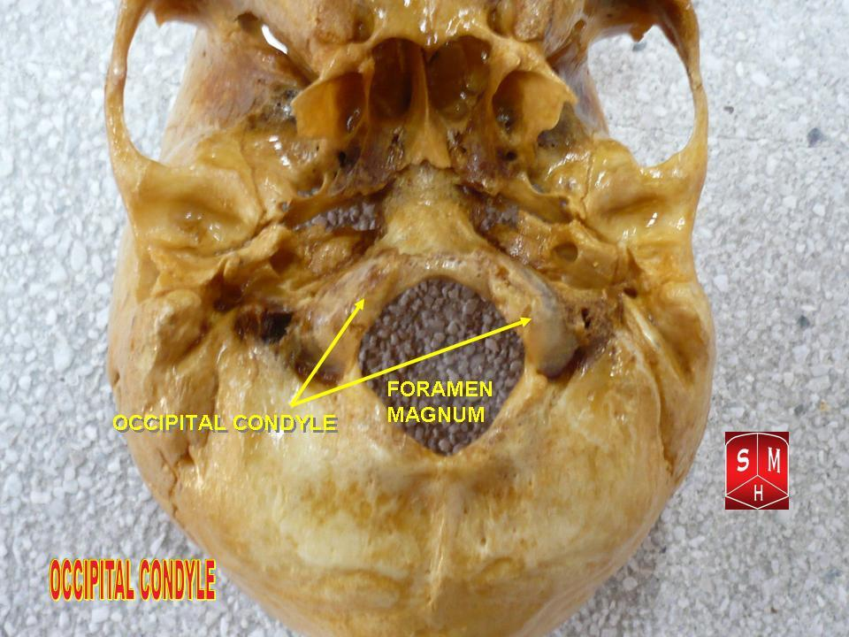

This part superior articulating surface will articulate with the occipital condyle
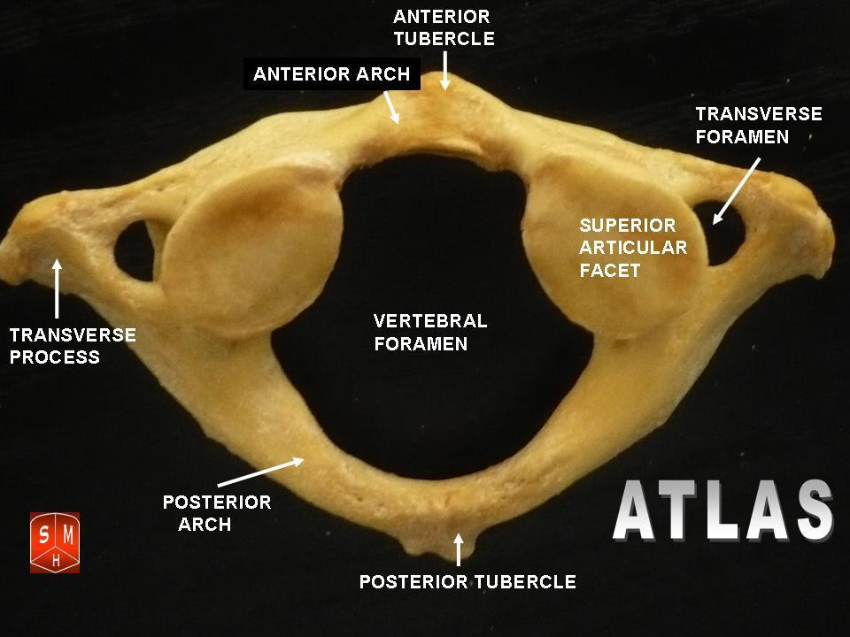
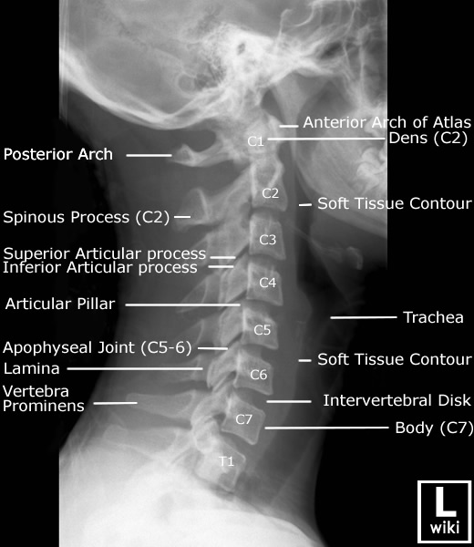

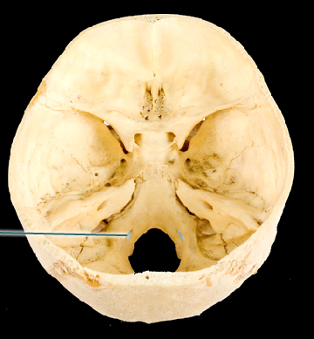
Hypoglossal canal is the emergence point of the hypoglossal nerve; which is the 12th cranial nerve (XII). Leading to muscles of the tongue, It is called hypoglossal nerve because it is below the tongue. It controls tongue movements of speech, food manipulation, and swallowing.
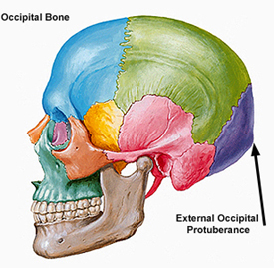

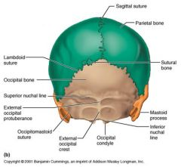

- Sphenoid bone: The sphenoid (sfe'noid) bone forms part of the anterior base of the cranium and can be viewed laterally and inferiorly. This bone has a butterfly appearance. It consists of a body and laterally projecting greater and lesser wings that form part of the orbit. The wedge like body contains the sphenoidal sinuses and a prominent saddle like depression, the sella turcica (sel'a ˘ tur'sı˘-ka ˘) [this is a depression for the pituitary gland (الغدة النخامية)]
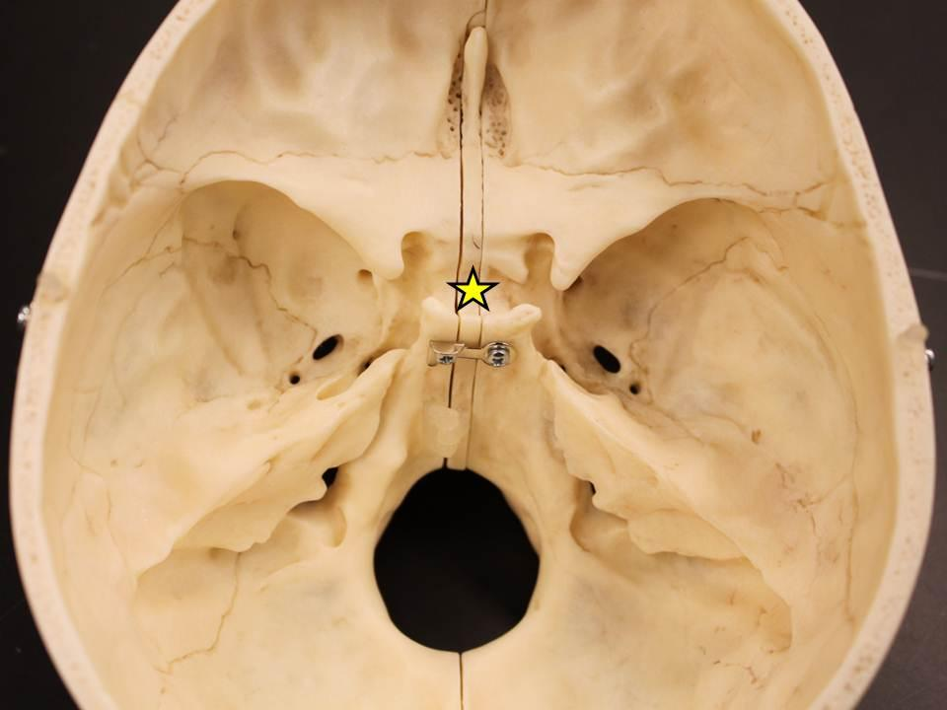
The star is exactly where the sella turcica is, at this site is where the pituitary gland found

Several Foramina associated with the sphenoid bone:
- The optic canal is a large opening through the lesser wing into the back of the orbit that provides passage for the optic nerve (Is the 2nd cranial nerve (II) responsible for providing us with ability to see (vision)) and the ophthalmic artery.

- The superior orbital fissure is a triangular opening between the wings of the sphenoid bone that provides passage for the ophthalmic nerve, a branch of the trigeminal nerve (Is the 5th cranial nerve (VII ) responsible for providing our face the ability to sense and it is responsible for providing our tongue with the ability to taste), and for the oculomotor (3rd cranial nerve III) , trochlear (4th cranial nerve IV) , and abducens nerves (6th cranial nerve) [the 3rd, 4th , and 6th cranial nerves provide out eyes with the ability to move by supplying the muscles controlling our eyes].

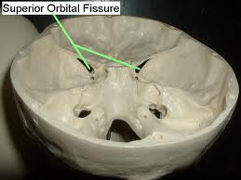

- The foramen ovale is an opening at the base of the lateral pterygoid plate, through which the mandibular nerve passes (3rd division of the trigeminal nerve, this division provide sensation to our lower teeth).
4. The foramen spinosum is a small opening at the posterior angle of the sphenoid bone that provides passage for the middle meningeal vessels.
5. The foramen lacerum (las'er-um) is an opening between the sphenoid and the petrous part of the temporal bone, through which the internal carotid artery and the meningeal branch of the ascending pharyngeal artery pass.
6. The foramen rotundum is an opening just posterior to the superior orbital fissure, at the junction of the anterior and medial portions of the sphenoid bone. The maxillary nerve (2nd branch of the trigeminal nerve pass through this foramen give sensation to our maxillary teeth) passes through this foramen.

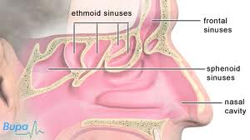
Sphenoid air sinuses, with the ethmoid bone sinuses and the frontal air sinus

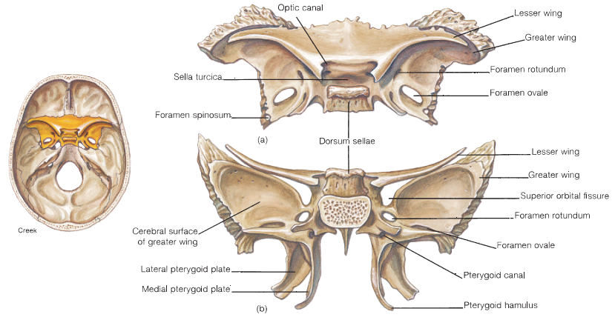

- The Ethmoid bone: The ethmoid bone is located in the anterior portion of the floor
of the cranium between the orbits, where it forms the roof of the nasal cavity. An inferior projection of the ethmoid bone, called the perpendicular plate, forms the superior part of the nasal septum that separates the nasal cavity into two chambers. Each chamber of the nasal cavity is referred to as a nasal fossa. Flanking the perpendicular plate on each side is a large but delicate mass of bone riddled with ethmoidal air cells, collectively constituting the ethmoid sinus. A spine of the perpendicular plate, the crista galli (kris'ta˘ gal'e), projects superiorly into the cranial cavity and serves as an attachment for the meninges covering the brain. On both lateral walls of the nasal cavity are two scroll-shaped plates of the ethmoid bone, the superiorand middle nasal conchae(kong'ke— singular, concha), also known as turbinates. At right angles to the perpendicular plate, within the floor of the cranium, is the cribriform(krib'rı˘-form) plate, which has numerous cribriform foramina for the passage of olfactory nerves (The 1st cranial nerve, provide us with the ability to smell), from the epithelial lining of the nasal cavity.
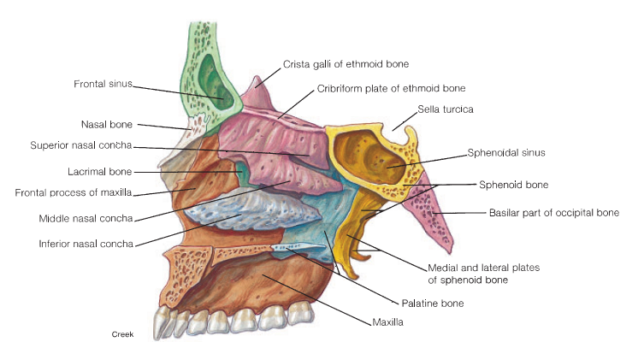

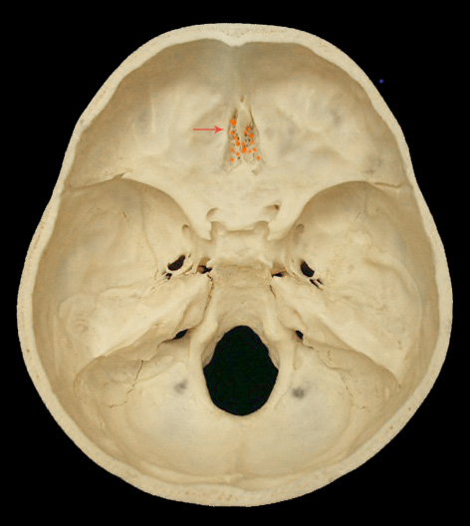

Skull Sutures

- coronal suture divides the frontal from the parietal bones,
- sagittal suture separates the parietal bones in the midline
- lambdoid suture marks off the occipital from the parietal and temporal bones
- squamosal suture separates the squamous temporal bone from the parietal bone and greater wing of sphenoid.

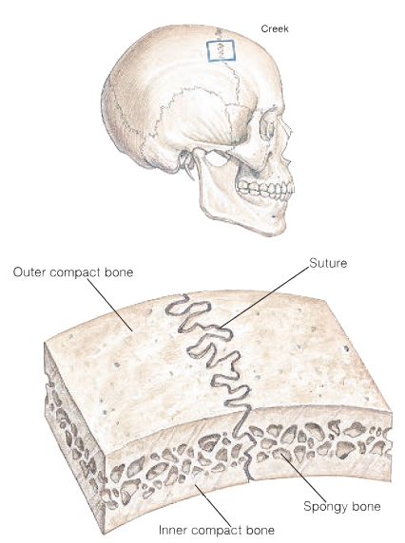
Notice that the skull bone composed of 2 tables (outer table and inner table enclosing a spongy bone and bone marrow in the middle)

THANK YOU

