The Face & the Orbital Region

The human face formed by combination of skin, muscles, nerves, and bones; this combination will provide our face with protection, movement, sensation, and the support.
To understand the anatomical relations between all the parts of the face we need to study the area in what is called the regional anatomy. In this lecture we will discuss all the related systems that are forming the face.

Skin of the Face:
The skin of the face contains numerous sweat glands and sebaceous glands (secrete oily/watery substances to protect the skin). The skin attached to the underlying bone in between there is a layer of connective tissue where the muscles of the facial skeleton, the nerves, and the vessels are embedded. The skin of the face varies in thickness for example it is very thin on the eyelids compared to other parts of the face.

Section 1: Sensory Nerves of the Face
The skin of the face is supplied by branches of the three divisions of the trigeminal nerve, except for the small area over the angle of the mandible and the parotid gland which is supplied by the great auricular nerve. There is an overlapping between the nerves that supply the face but generally the nerves are:
Ophthalmic (V1) supply the upper 3rd of the face.
Maxillary (V2) Supply the middle 3rd of the face.
Mandibular (V3) supply the lower 3rd of the face.

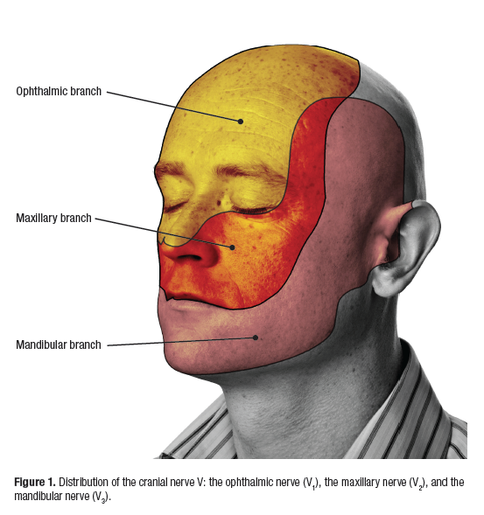

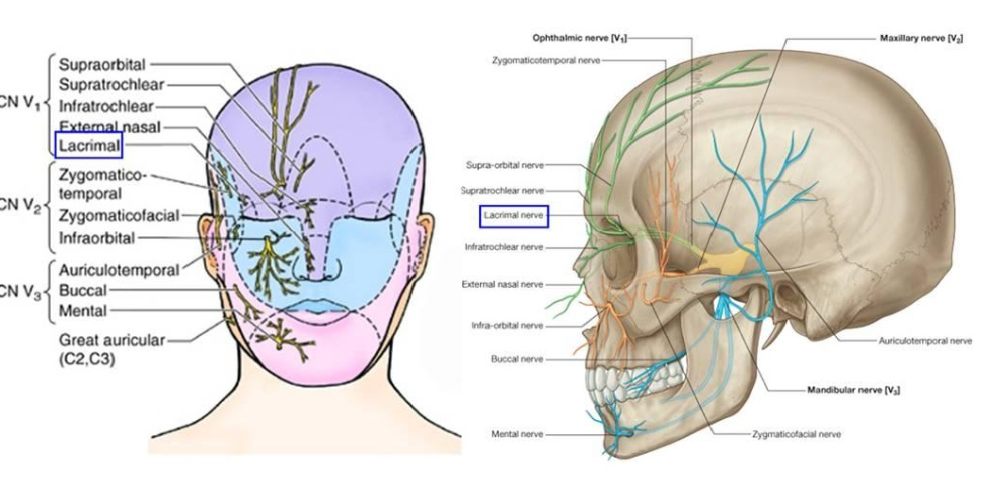
The nerves that supply the face and provide sensation:
The 3 branches of the trigeminal nerve & the Great auricular nerve which is from the (C2 & C3 [ cervical nerves not cranial nerves])

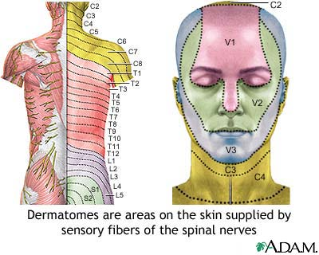

The Ophthalmic Nerve

The ophthalmic nerve supplies the skin of the forehead, the upper eyelid, the conjunctiva (The conjunctiva lines the inside of the eyelids and covers the sclera (white part of the eye)), and the side of the nose down to and including the tip. Five branches of the nerve pass to the skin.

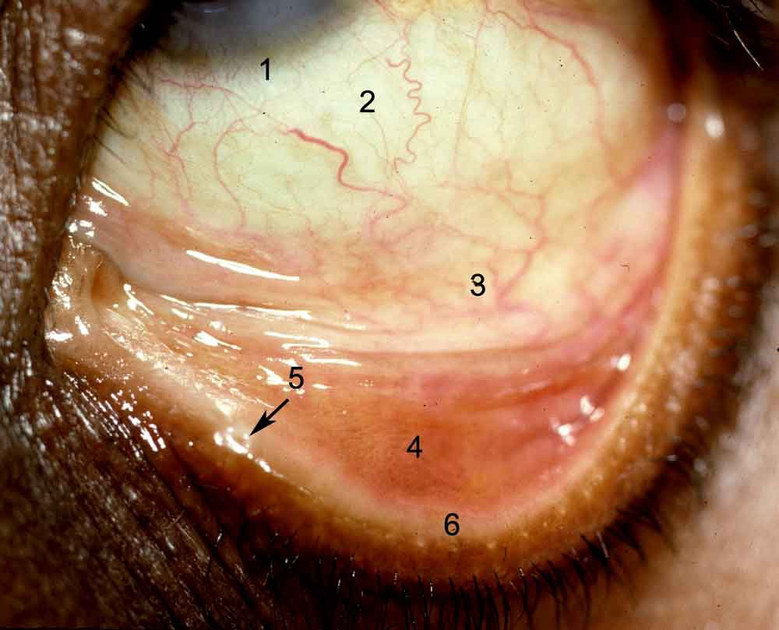
All this region is called the conjunctiva (1,2,3,4,5,6) all part of the conjunctiva. This photo doesn’t show the cornea and the patient is looking up

The branches of the ophthalmic Nerve:

- Lacrimal Nerve: supplies the skin and conjunctiva of the lateral part of the upper eyelid & and the lacrimal gland (الغدة الدمعية).
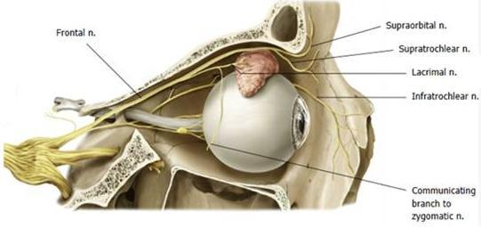
- The supraorbital nerve emerges around the upper margin of the orbit at the supraorbital notch. It divides into branches that supply the skin and conjunctiva on the central part of the upper eyelid; it also supplies the skin of the forehead.

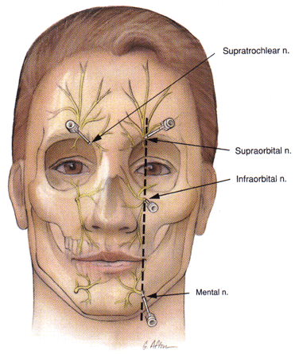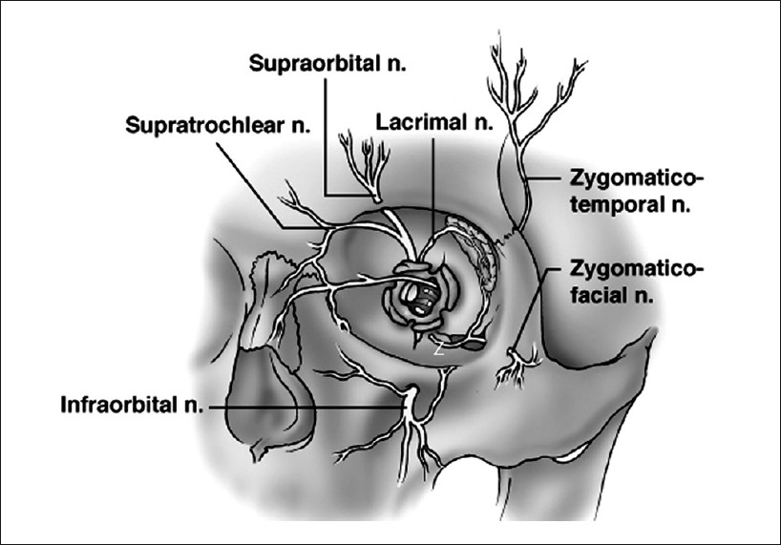

- The supratrochlear nerve winds around the upper margin of the orbit medial to the supraorbital nerve. It divides into branches that supply the skin and conjunctiva on the medial part of the upper eyelid and the skin over the lower part of the forehead, close to the median plane.

- The infratrochlear nerve leaves the orbit below the pulley of the superior oblique muscle. It supplies the skin and conjunctiva on the medial part of the upper eyelid and the adjoining part of the side of the nose.

- External Nasal Nerve: The external nasal branches (or external nasal nerve) are terminal branches of the anterior ethmoidal nerves (from the ophthalmic division of the trigeminal nerve, CN V), leaves the nose by emerging between the nasal bone and the upper nasal cartilage. It supplies the skin on the side of the nose down as far as the tip.

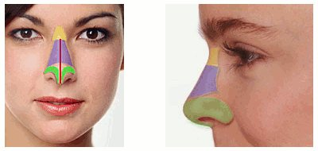
The point the external nasal nerve emerge from into the skin

The Maxillary Nerve (V2) [the second branch of the trigeminal nerve]

The maxillary nerve supplies the skin on the posterior part of the side of the nose, the lower eyelid, the cheek, the upper lip, and the lateral side of the orbital opening. Three branches of the nerve pass to the skin (Note: the following branches are the branches that supply the skin; the nerve has other branches we are not going to mention it now).

- The infra-orbital nerve is a direct continuation of the maxillary nerve. It enters the orbit and appears on the face through the infraorbital foramen. It immediately
divides into numerous small branches, which radiate out from the foramen and supply the skin of the lower eyelid and cheek, the side of the nose, and the upper lip.
Medical Note: This nerve will give branches to the anterior teeth of the maxilla through its terminal branch ‘anterior superior nerve’, so sometimes we can give local anaesthetic injection to this nerve to provide anaesthesia for the anterior teeth.

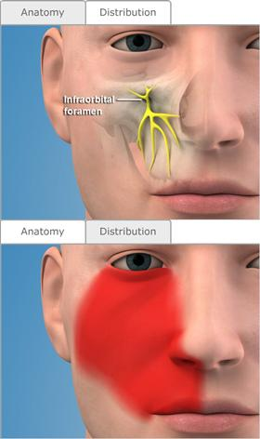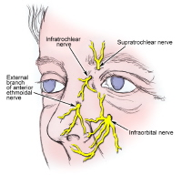
The anatomical emergence from the infra-orbital foramen and the distribution of the nerve branches on the skin.

- The zygomaticofacial nerve passes onto the face through a small foramen on the lateral side of the zygomatic bone. It supplies the skin over the prominence of the cheek.

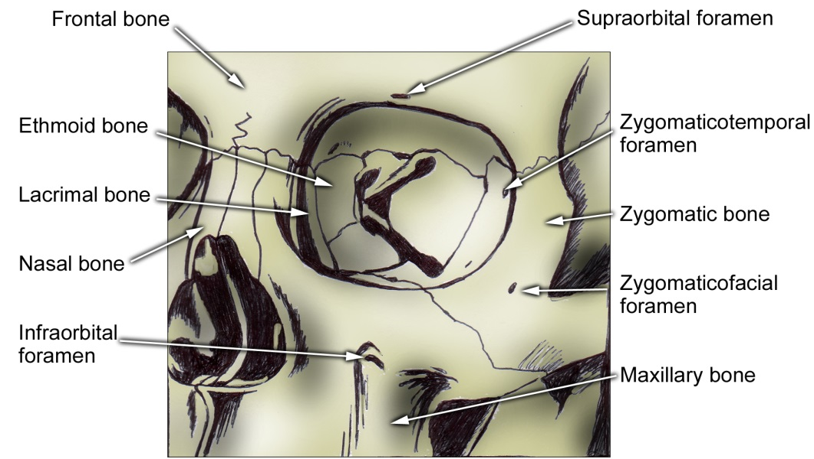

- The zygomaticotemporal nerve merges in the temporal fossa through a small foramen on the posterior surface of the zygomatic bone. It supplies the skin over the
Temple.

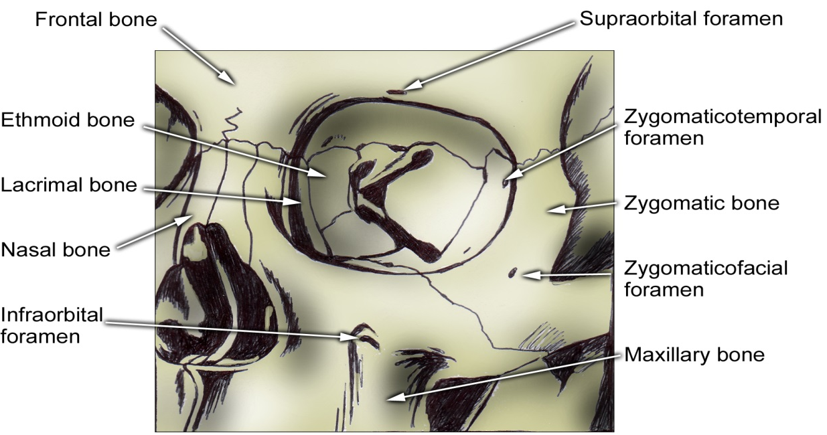

The Mandibular Nerve
The mandibular nerve supplies the skin of the lower lip, the lower part of the face, the temporal region, and part of the auricle. It then passes upward to the side of the scalp (skin of the cranial vault). Three branches of the nerve pass to the skin. (Note: the nerve has other branches but these are the nerves that supply the skin).

- The mental nerve emerges from the mental foramen of the mandible and supplies the skin of the lower lip and chin. This nerve supplies the anterior teeth as well.

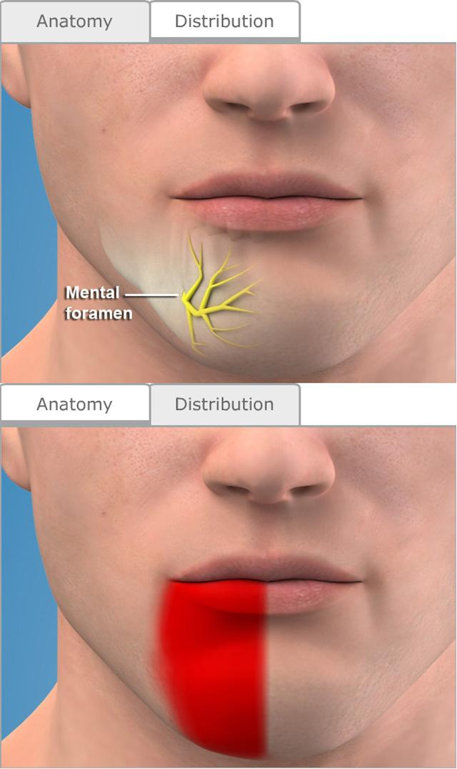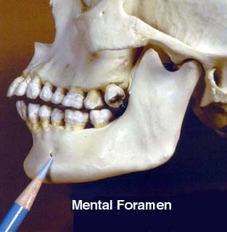
The mental nerve emerges from the mental foramen of the mandible
The foramen located at the end of the mandibular canal (or the inferior dental canal).
The nerve is the end branch of the inferior dental nerve.
The inferior dental nerve supplies the teeth of the mandible and it is a branch from the mandibular nerve V3.

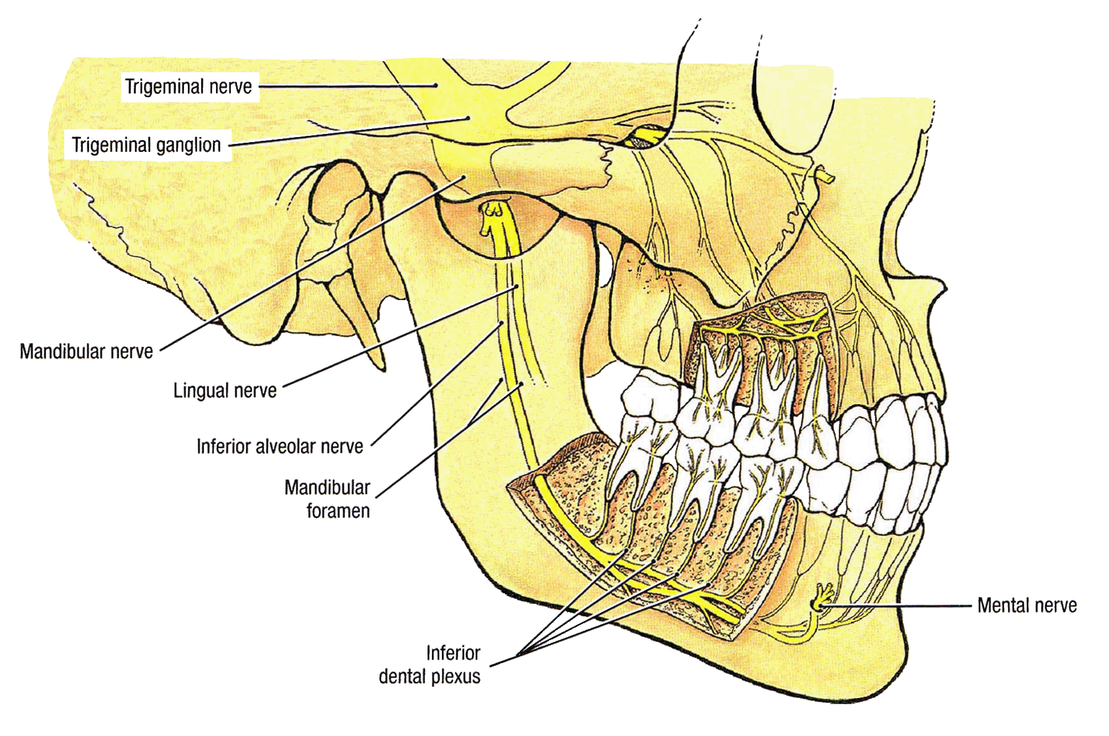

- The buccal nerve emerges from beneath the anterior border of the masseter muscle and supplies the skin over a small area of the cheek.

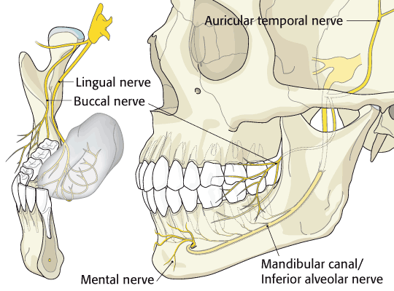
Mental Nerve
Mental Foramen
Inferior Dental Nerve, branch of V3
Buccal Nerve, branch of V3
Auriculo-temporal nerve, Branch of V3

- The auriculotemporal nerve ascends from the upper border of the parotid gland between the superficial temporal vessels and the auricle. It supplies the skin of the auricle, the external auditory meatus, the outer surface of the tympanic membrane, and the skin of the scalp above the auricle.

Note The previous innervation demonstrated the sensory innervation of the face. The motor innervation (nerves that give the ability to move the muscles of facial expressions) is supplied by the Facial nerve and its branches.

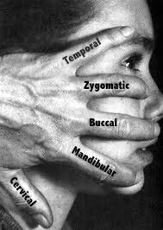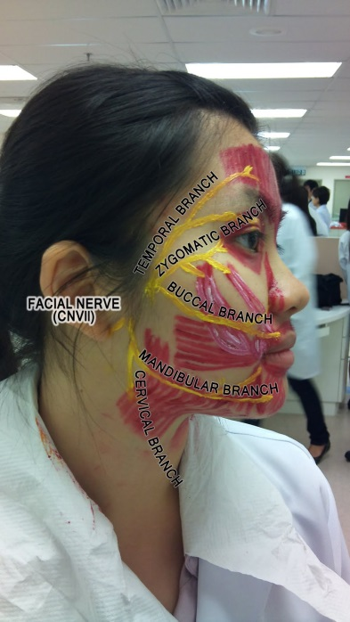
The Facial Nerve will give 5 branches That will innervate the muscles of the facial expressions which will provide us the ability to express our feelings, such as angry, happy, fear, …etc.

- Temporal branch.
- Zygomatic
- Buccal.
- Mandibular.
- Cervical.

Section 2: The Arterial supply of the Face
The arteries which supply the head and neck come mainly from the carotid arteries in addition to the subclavian arteries.

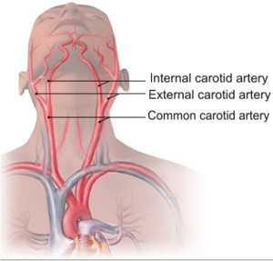

The common carotid will subdivide into the internal carotid artery and the external carotid artery. Generally speaking the internal artery will supply many parts of the brain with the vertebral arteries while the external carotid will supply the face and the related structures.

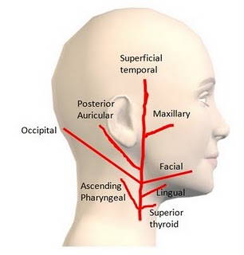
This diagram is showing the branches of the external carotid artery and the distribution of these branches to supply the head and neck area excluding the brain which is supplied by the internal carotid artery and the vertebral artery.

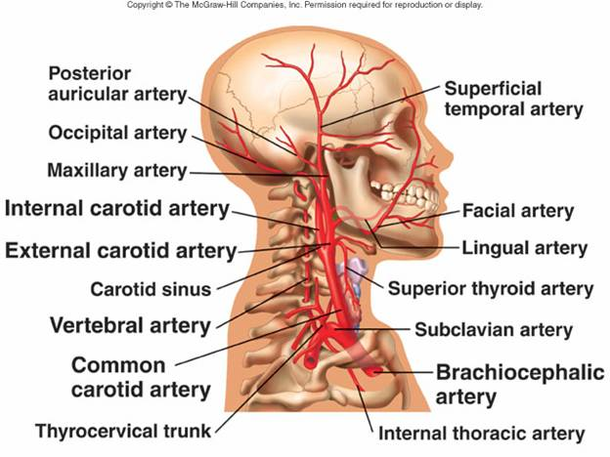
Origin and the branches of the arteries that supply the face and the brain.

Arterial Supply of the Face
The face receives a rich blood supply from two main vessels:
- the facial
- superficial temporal arteries

The facial artery: The facial artery (external maxillary artery in older texts) is a branch of the external carotid artery that supplies structures of the superficial face.

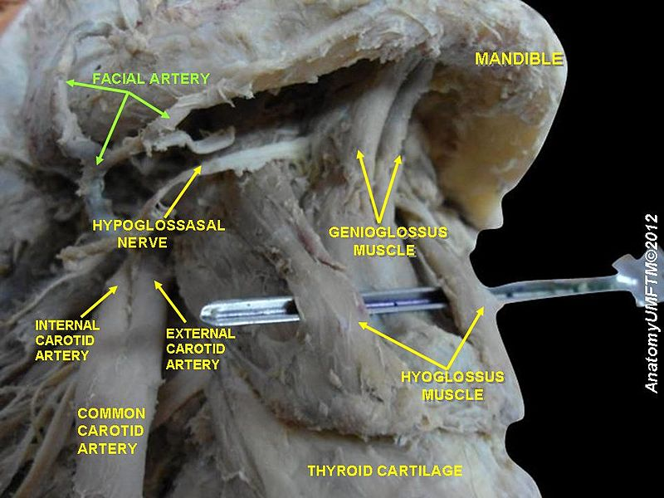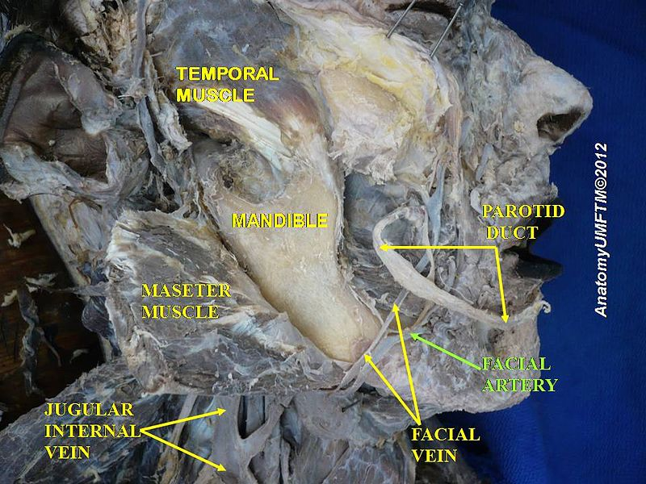

The facial artery arises in the carotid triangle from the external carotid artery a little above the lingual artery and, sheltered by the ramus of the mandible, passes obliquely up beneath the digastric and stylohyoid muscles, over which it arches to enter a groove on the posterior surface of the submandibular gland, it curves around the inferior margin of the body of the mandible at the anterior border of the masseter muscle. It runs upward in a tortuous course toward the angle of the mouth and is covered by the platysma and the risorius muscles. It then ascends deep to the zygomaticus muscles and the levator labii superioris muscle and runs along the side of the nose to the medial angle of the eye, where it anastomoses with the terminal branches of the ophthalmic artery

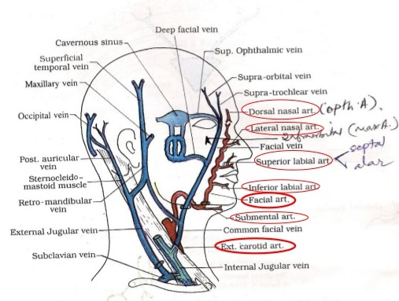
- The submental artery arises from the facial artery at the lower border of the body of the mandible. It supplies the skin of the chin and lower lip.
- The inferior labial artery arises near the angle of the mouth. It runs medially in the lower lip and anastomoses with its fellow of the opposite side.
- The superior labial artery arises near the angle of the mouth. It runs medially in the upper lip and gives branches to the septum and ala of the nose.
- The lateral nasal artery arises from the facial artery alongside the nose. It supplies the skin on the side and dorsum of the nose.
- The angular artery is the terminal part of the facial artery.

The branches of the facial artery are:
Cervical (in the neck):
- Ascending palatine artery
- Tonsillar branch
- Submental artery
- Glandular branches

Facial branches
- Inferior labial artery
- Superior labial artery
- Lateral nasal branch to nasalis muscle
- Angular artery - the terminal branch

Mnemonic: Go And Teach Science And I'll Learn Something
First letter corresponds to first letter of each branch.

The superficial temporal artery: the smaller terminal branch of the external carotid artery commences in the parotid gland. It ascends in front of the auricle to supply the scalp.
The transverse facial artery, a branch of the superficial temporal artery, arises within the parotid gland. It runs forward across the cheek just above the parotid duct.

The ophthalmic artery supplies the forehead area it has 2 branches: 1) the supraorbital artery 2) the supratrochlear artery. This artery is a branch of the internal carotid artery not from the external carotid, the artery is divided from the internal carotid artery [intra-cranially] and emerges from the orbit to divide and supply the forehead.

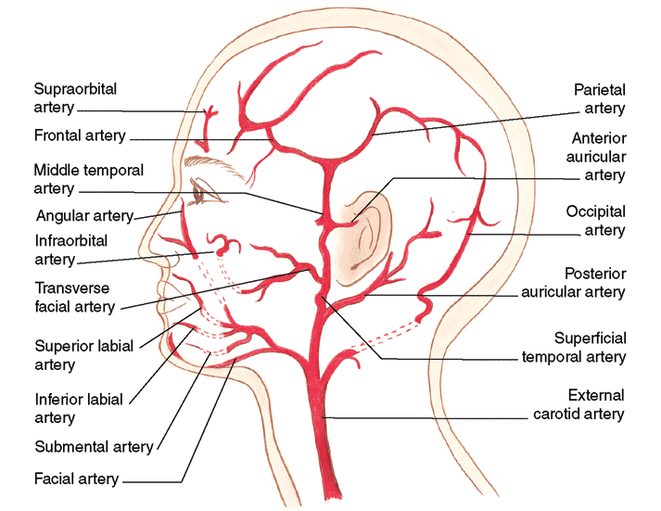

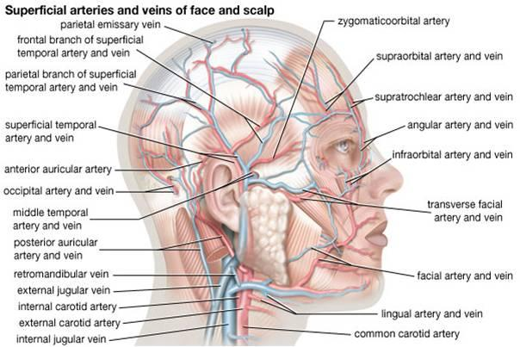

Arterial supply and the venous drainage of the face

Clinical:
Blood Supply of the Facial Skin
The blood supply to the skin of the face is profuse so that it is rare in plastic surgery for skin flaps to necrosis in this region.

Facial Arteries and Taking the Patient’s Pulse
The superficial temporal artery, as it crosses the zygomatic arch in front of the ear, and the facial artery, as it winds around the lower margin of the mandible level with the anterior border
of the masseter, are commonly used by the anesthetist to take the patient’s pulse

Section 3: Venous Drainage of the Face
The facial vein is formed at the medial angle of the eye by the union of the supraorbital and supratrochlear veins It is connected to the superior ophthalmic vein directly through the supraorbital vein. By means of the superior ophthalmic vein, the facial vein is connected to the cavernous sinus; this connection is of great clinical importance because it provides a pathway for the spread of infection from the face to the cavernous sinus. The facial vein descends behind the facial artery to the lower margin of the body of the mandible. It crosses superficial to the submandibular gland and is joined by the anterior division of the retromandibular vein. The facial vein ends by draining into the internal jugular vein.
Tributaries
The facial vein receives tributaries that correspond to the branches of the facial artery. It is joined to the pterygoid venous plexus by the deep facial vein and to the cavernous sinus by the superior ophthalmic vein. The transverse facial vein joins the superficial temporal vein within the parotid gland.

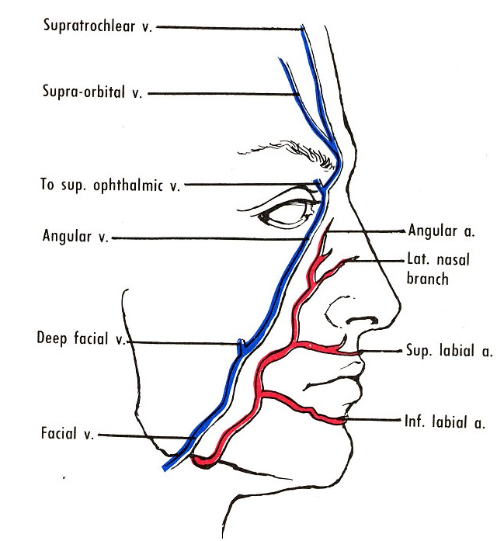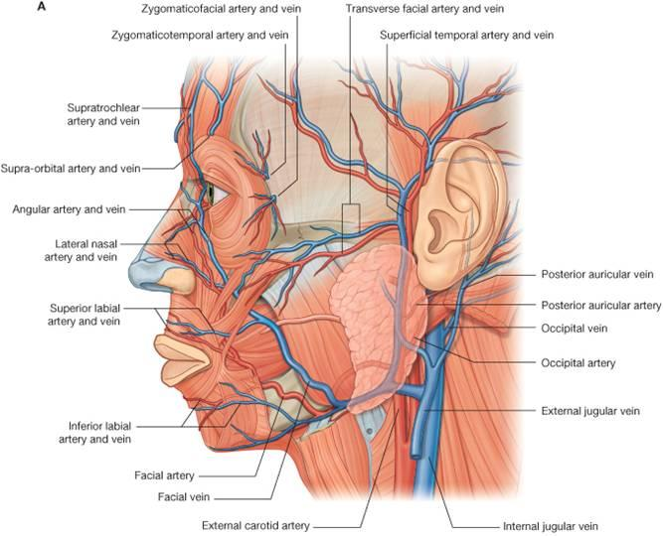

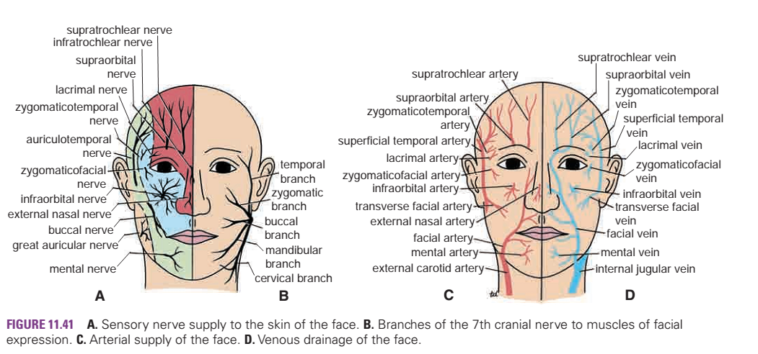

Section 4: The Facial Bones

The 14 bones of the skull not in contact with the brain are called facial bones. These bones, together with certain cranialbones (frontal bone and portions of the ethmoid and temporal
bones), give shape and individuality to the face. Facial bones also support the teeth and provide attachments for various muscles that move the jaw and cause facial expressions. With the exceptions of the vomer and mandible, all of the facial bones are paired.

Maxilla
The two maxillae unite at the midline to form the upper jaw, which supports the upper teeth. Incisors, canines (cuspids), premolars, and molars are anchored in dental alveoli,(tooth sockets), within the alveolar process of the maxilla The palatine process, a horizontal plate of the maxilla, forms the greater portion of the hard palate, or roof of the mouth. The incisive foramen is located in the anterior region of the hard palate, behind the incisors. An infraorbital foramen is located under each orbit and serves as a passageway for the infraorbital nerve (terminal end of the maxillary nerve (V2)) and artery to the nose. Opening within the maxilla is the inferior orbital fissure. It is located between the maxilla and the greater wing of the sphenoid and is the external opening for the maxillary nerve of the trigeminal nerve and infraorbital vessels. The large maxillary sinus located within the maxilla is one of the four paranasal sinuses.
Clinical Note
If the two palatine processes fail to join during early prenatal development (about 12 weeks), a cleft palate results. A cleft palate may be accompanied by a cleft lip lateral to the midline.These conditions can be surgically treated with excellent cosmetic results.

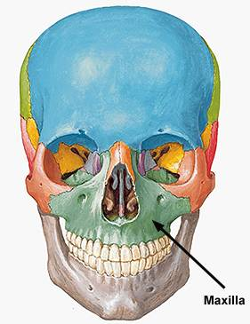

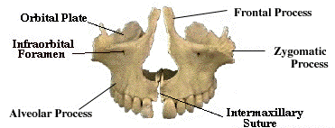

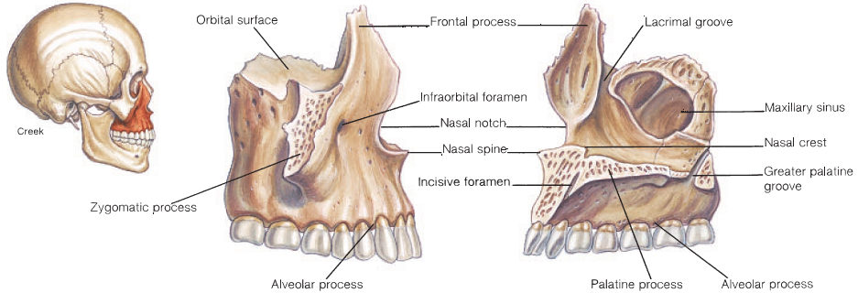

Palatine Bone
The L-shaped palatine bones form the posterior third of the hard palate, a part of the orbits, and a part of the nasal cavity. The horizontal plates of the palatines contribute to the formation of the hard palate. At the posterior angle of the hard palate is the large greater palatine foramen that provides passage for the greater palatine nerve and descending palatine vessels. Two or more smaller lesser palatine foramina are positioned posterior to the greater palatine foramen. Branches of the lesser palatine nerve pass through these openings.

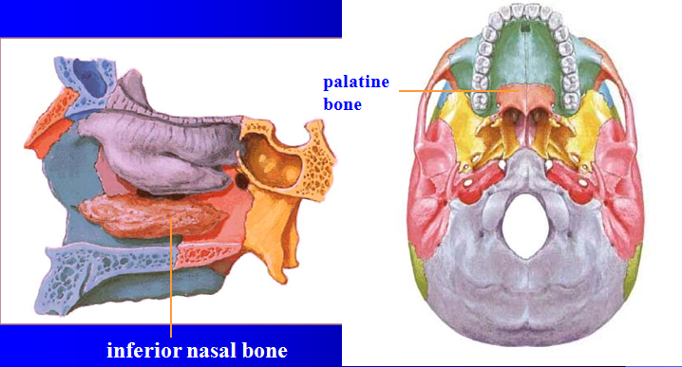

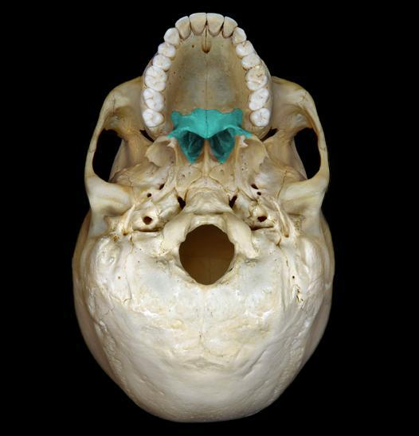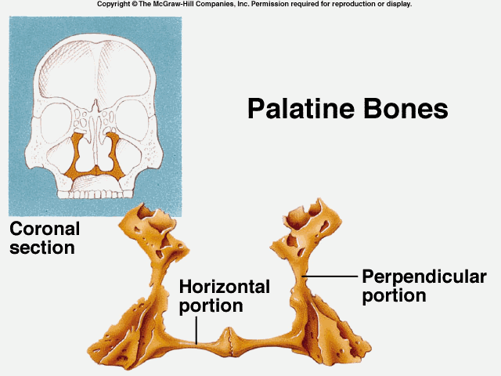

Zygomatic Bone
The two zygomatic bones (“cheekbones”) form the lateral contours of the face. A posteriorly extending temporal process of this bone unites with the zygomatic process of the temporal bone to form the zygomatic arch. The zygomatic bone also forms the lateral margin of the orbit. A small zygomaticofacial foramen, located on the anterolateral surface of this bone, allows passage of the zygomatic nerves and vessels.

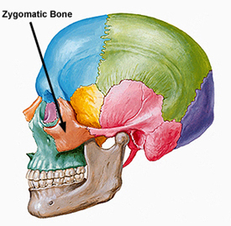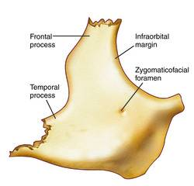

Lacrimal Bone
The thin lacrimal bones form the anterior part of the medial wall of each orbit.

Nasal Bone
The small, rectangular nasal bones join at the midline to form the bridge of the nose. The nasal bones support the flexible cartilaginous plates, which are a part of the framework of the nose.

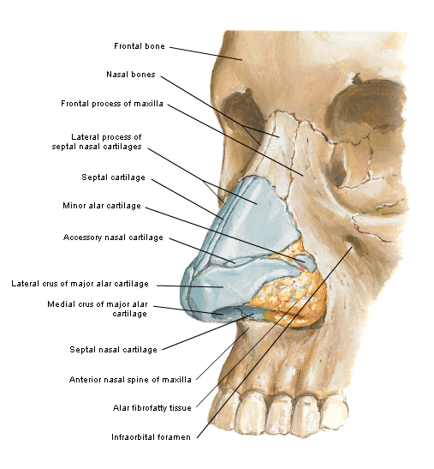

Vomer
The vomer is a thin, flattened bone that forms the lower part of the nasal septum. Along
with the perpendicular plate of the ethmoid bone, it supports the layer of septal cartilage that forms most of the anterior and inferior parts of the nasal septum.
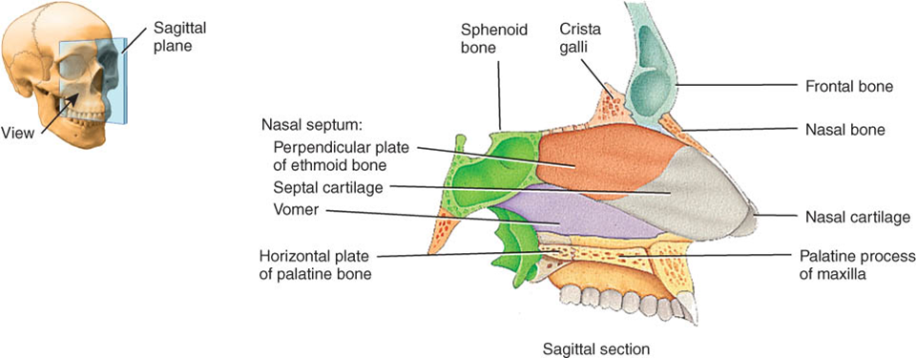
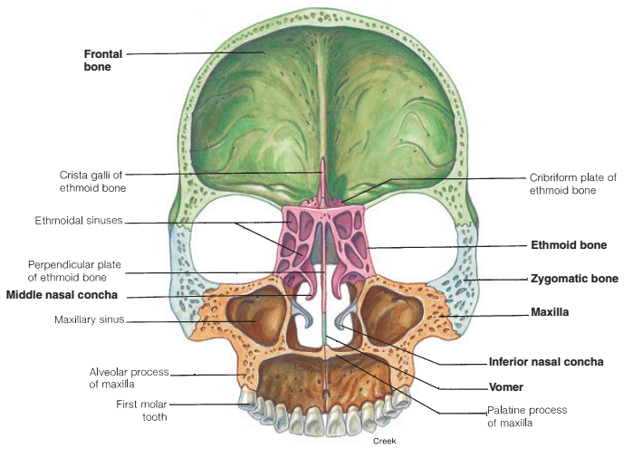
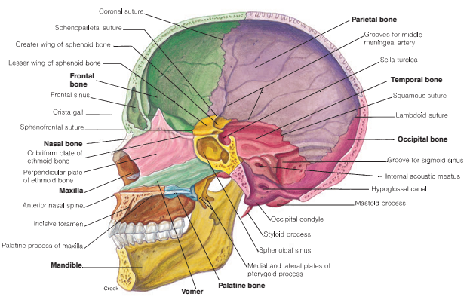

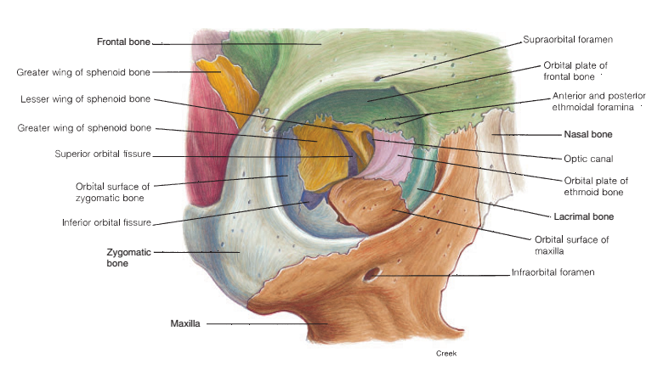
The Orbital cavity: Formed by combination of 6 bones. Al l participates in creating the cavity for the eye globe.
- Frontal bone
- Sphenoid bone
- Ethmoid bone
- Zygomatic bone
- Maxillary bone
- Lacrimal bone

The Mandible

The mandible (“jawbone”) is the largest, strongest bone in the face. It is attached to the skull by paired temporomandibular joints, and is the only movable bone of the skull.
The horseshoe-shaped front and horizontal lateral sides of the mandible are referred to as the body. Extending vertically from the posterior part of the body are two rami(ra'mi—
singular, ramus). At the superior margin of each ramus is a
knoblike condylar process, which articulates with the mandibular fossa of the temporal bone, and a pointed coronoid process for the attachment of the temporalis muscle. The depressed area between these two processes is called the mandibular notch. The
angle of the mandible is where the horizontal body and vertical ramus meet at the corner of the jaw.
Two sets of foramina are associated with the mandible: the mental foramen, on the anterolateral aspect of the body of the mandible below the first molar, and the mandibular foramen, on the medial surface of the ramus.
The mental nerve and vessels pass through the mental foramen, and the inferior alveolar nerve and vessels are transmitted through the mandibular foramen. Several muscles that close the jaw extend from the skull to the mandible. The mandible of an adult supports 16 teeth within dental alveoli, which occlude with the 16 teeth of the maxilla.

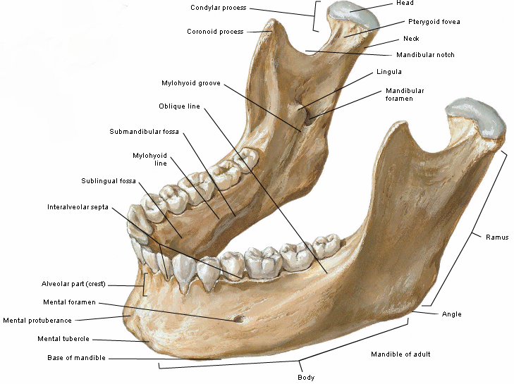

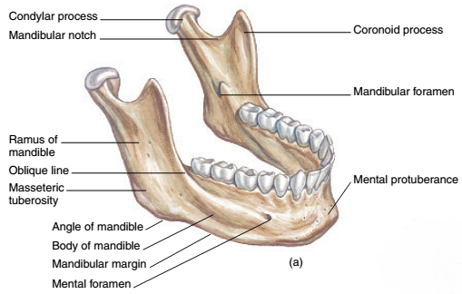

Hyoid Bone
The single hyoid bone is a unique part of the skeleton in that it does not attach directly to any other bone. It is located in the neck region, below the mandible, where it is suspended from the styloid process of the temporal bone by the stylohyoid muscles and ligaments. The hyoid bone has a body, two lesser cornu extending anteriorly, and two greater cornu , which project posteriorly to the stylohyoid ligaments.

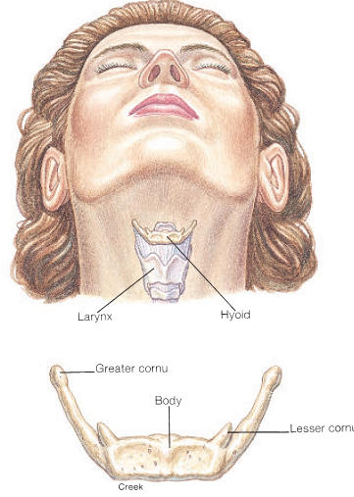
Clinical Note
This bone is carefully examined in an autopsy when strangulation is suspected, because it is frequently fractured during strangulation.

