Cranial Fossa

Before we start discussing the anatomical features of the inner cranial fossa we need to explain few terms that describe the features of bone.

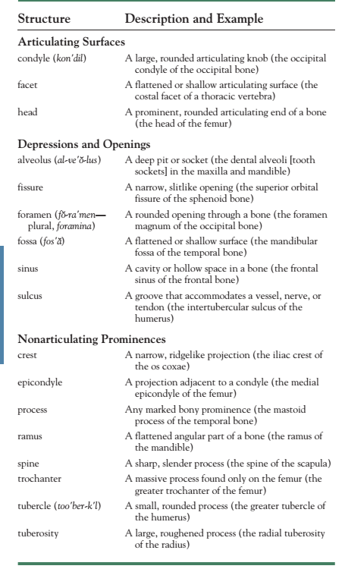
The Terms that you should be familiar with when studying bone in anatomy

The Base of the Skull

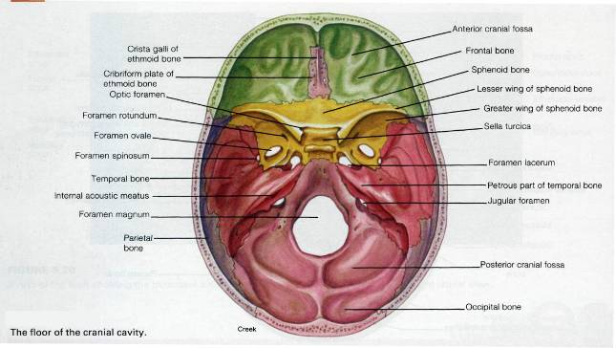

The transverse view of the cranial fossa showing the floor of the cranial cavity.

Base of the Skull

The base of the skull is divided into three cranial fossae:
1-anterior
2- middle
3- posterior.
The anterior cranial fossa is separated from the middle cranial fossa by the lesser wing of the sphenoid, and the middle cranial fossa is separated from the posterior cranial fossa by the petrous part of the temporal bone.

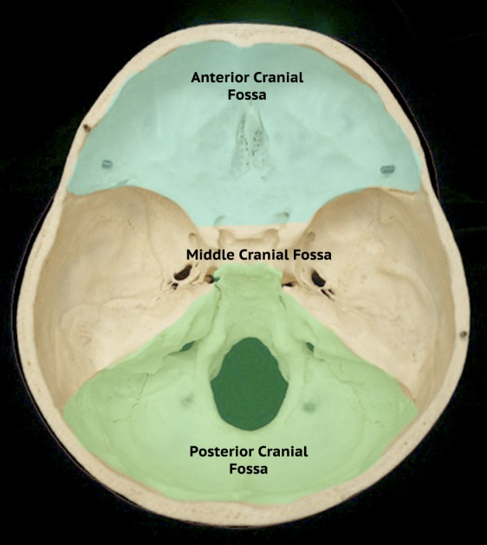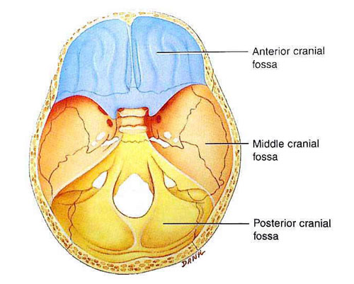

Cranial cavity divisions:
● Anterior cranial fossa—contains the frontal lobe of the brain
● Middle cranial fossa—contains the temporal lobe of the brain
● Posterior cranial fossa—contains the cerebellum

The anterior cranial fossa

The anterior cranial fossa lodges the frontal lobes of the cerebral hemispheres. It is bounded anteriorly by the inner surface of the frontal bone, and in the midline is a crest for
the attachment of the falx cerebri. Its posterior boundary is the sharp lesser wing of the sphenoid, which articulates laterally with the frontal bone and meets the antero-inferior angle of the parietal bone, or the pterion. The medial end of the lesser wing of the sphenoid forms the anterior clinoid process on each side, which gives attachment to the tentorium cerebelli. The median part of the anterior cranial fossa is limited posteriorly by the groove for the optic chiasma.
The floor of the fossa is formed by the ridged orbital plates of the frontal bone laterally and by the cribriform plate of the ethmoid medially. The crista galli is a sharp upward projection of the ethmoid bone in the midline for the attachment of the falx cerebri. Alongside the crista galli is a narrow slit in the cribriform plate for the passage of the anterior ethmoidal nerve into the nasal cavity. The upper surface of the cribriform plate supports the olfactory bulbs (1st cranial nerve), and the small perforations in the cribriform plate are for the olfactory nerves.

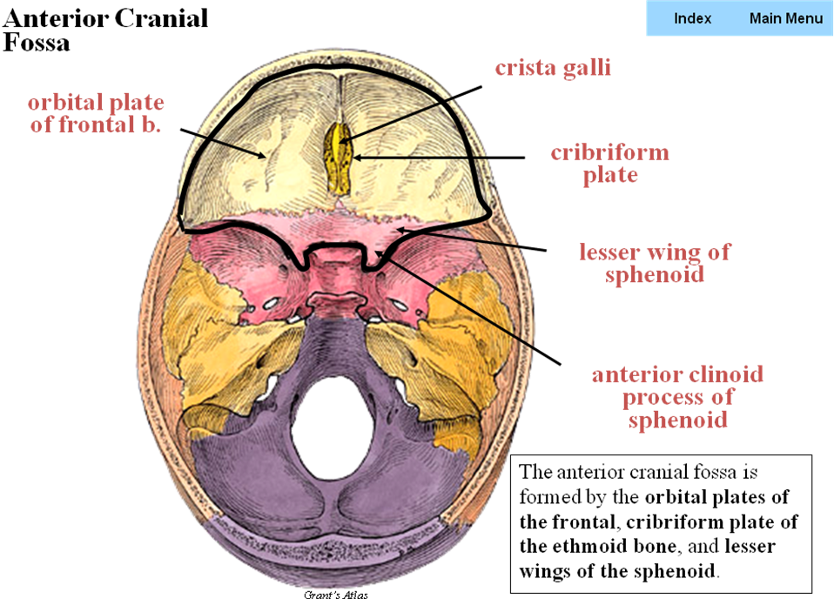
Attachment for the tentorium cerbelli
Small orifices for the passage of the 1st cranial nerve (olfactory bulb) into the nose
Attachment for the falx cerberi

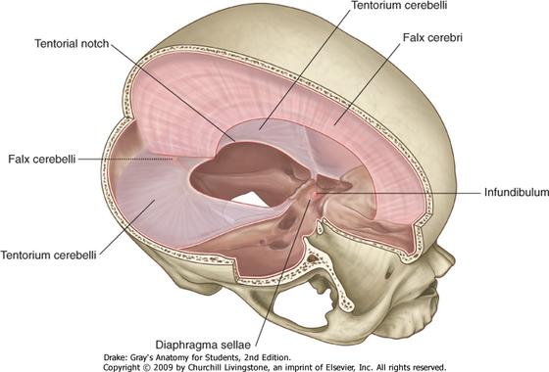
Internal occipital protubrance posterior attachment for the flax cerebri
Crista gali anterior attachment for flax cerebri
Anterior clinoid process Attachment for the tentorium cerebelli
The falx cerebri, also known as the cerebral falx, is a strong, arched fold of dura mater that descends vertically in the longitudinal fissure between the cerebral hemispheres.

It is narrow in front, where it is attached to the crista galli of the ethmoid; and broad behind, where it is connected with the upper surface of the tentorium cerebelli.

Its upper margin is convex, and attached to the inner surface of the skull in the middle line, as far back as the internal occipital protuberance; it contains the superior sagittal sinus.
Its lower margin is free and concave, and contains the inferior sagittal sinus.

The falx cerebri is known to calcify with age.

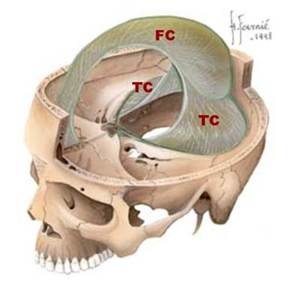

Quick Notes: The venous sinuses of the cranial cavity are blood-filled spaces situated between the layers of the dura mater ; they are lined by endothelium. Their walls are thick and composed of fibrous tissue; they have no muscular tissue. The sinuses have no valves. The main sinuses of the cranial cavity are (superior and inferior sagittal sinuses, straight sinus, left and right transverse sinuses, cavernous sinus and the sigmoid sinus)

Quick Notes: Meninges: Is strong membrane composed of 3 layers (Dura matter, arachnoid, and pia matter)surrounds the brain and the spinal cord for protection and it contains the CSF (CEREBRO-SPINAL FLUID) [which is important to provides mechanical and immunological protection for the brain]

Middle cranial fossa

The middle cranial fossa consists of a small median part and expanded lateral parts. The median raised part is formed by the body of the sphenoid, and the expanded lateral parts form concavities on either side, which lodge the temporal lobes of the cerebral hemispheres.
It is bounded anteriorly by the lesser wings of the sphenoid and posteriorly by the superior borders of the petrous parts of the temporal bones. Laterally lie the squamous parts of the temporal bones, the greater wings of the sphenoid, and the parietal bones.
The floor of each lateral part of the middle cranial fossa is formed by the greater wing of the sphenoid and the squamous and petrous parts of the temporal bone.

The sphenoid bone resembles a bat having a centrally placed body with greater and lesser wings that are outstretched on each side. The body of the sphenoid contains the sphenoid air sinuses, which are lined with mucous membrane and communicate with the nasal cavity; they serve as voice resonators.

Anteriorly
*The optic canal transmits the optic nerve and the ophthalmic artery, a branch of the internal carotid artery, to the orbit.
*The superior orbital fissure which is a Slit-like opening between the lesser and the greater wings of the sphenoid, transmits the lacrimal, frontal, trochlear, oculomotor, nasociliary, and abducent nerves, together with the superior ophthalmic vein.
The sphenoparietal venous sinus (small venous sinus) runs medially along the posterior border of the lesser wing of the sphenoid and drains into the cavernous sinus.

*Cavernous Sinus: within the human head, is a large collection of thin-walled veins creating a cavity bordered by the temporal bone of the skull and the sphenoid bone, lateral to the sella turcica. The cavernous sinus receives blood via the superior and inferior ophthalmic veins through the superior orbital fissure and from superficial cortical veins, and is connected to the basilar plexus of veins posteriorly. The internal carotid artery and cranial nerves III, IV, V (branches V1 and V2) and VI all pass through this blood filled space.

*The foramen rotundum, which is situated behind the medial end of the superior orbital fissure, perforates the greater wing of the sphenoid and transmits the maxillary nerve from
the trigeminal ganglion to the pterygopalatine fossa.

*The foramen ovale lies postero-lateral to the foramen rotundum. It perforates the greater wing of the sphenoid and transmits the large sensory root and small motor root of the mandibular nerve to the infratemporal fossa; the lesser petrosal nerve also passes through it.
*The small foramen spinosum lays postero-lateral to the foramen ovale and also perforates the greater wing of the sphenoid. The foramen transmits the middle meningeal
artery from the infratemporal fossa into the cranial cavity.

*Foramen lacerum lies between the apexes of the petrous part of the temporal bone
and the sphenoid bone. The inferior opening of the foramen lacerum in life is filled by cartilage and fibrous tissue, and only small blood vessels pass through this tissue
from the cranial cavity to the neck. The carotid canal opens into the side of the foramen
lacerum above the closed inferior opening. The internal carotid artery enters the foramen through the carotid canal and immediately turns upward to reach the side of the body
of the sphenoid bone. Here, the artery turns forward in the cavernous sinus to reach the region of the anterior clinoid process. At this point, the internal carotid artery turns vertically upward, medial to the anterior clinoid process, and emerges from the cavernous sinus. Lateral to the foramen lacerum is an impression on the apex of the petrous part of the temporal bone for the trigeminal ganglion.

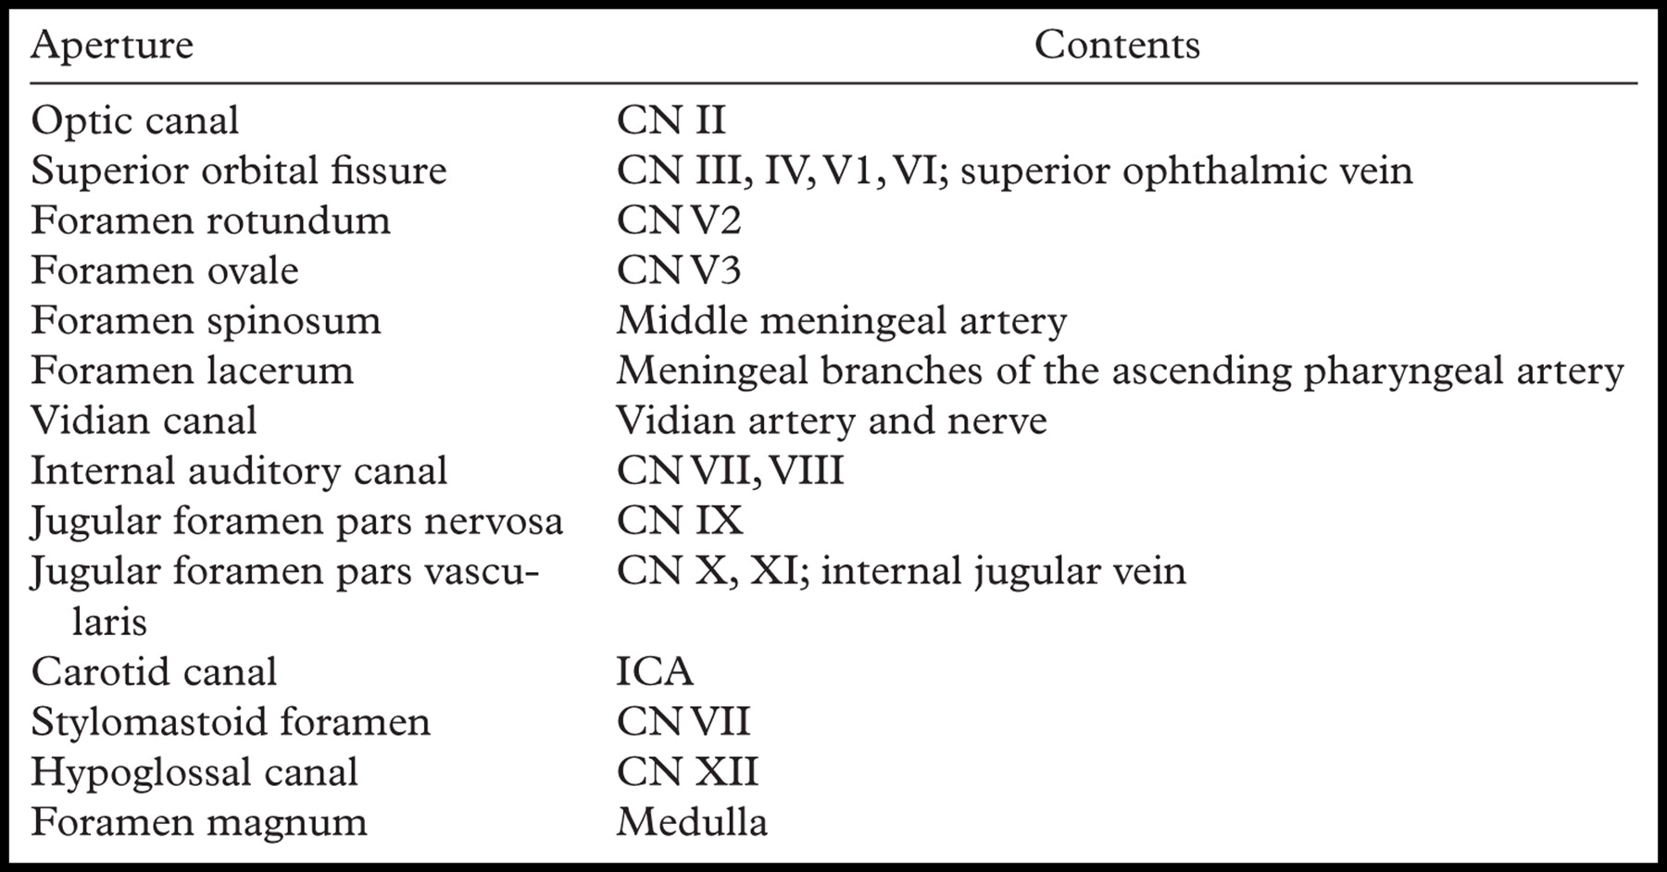

On the anterior surface of the petrous bone are two grooves for nerves; the largest medial groove is for the greater petrosal nerve, a branch of the facial nerve; the smaller lateral groove is for the lesser petrosal nerve, a branch of the tympanic plexus. The greater petrosal nerve enters the foramen lacerum deep to the trigeminal ganglion and joins the deep petrosal nerve(sympathetic fibers from around the internal carotid artery), to form the nerve of the pterygoid canal. The lesser petrosal nerve passes forward to the foramen ovale.
The abducent nerve bends sharply forward across the apex of the petrous bone, medial to the trigeminal ganglion. Here, it leaves the posterior cranial fossa and enters the cavernous sinus. The tegmen tympani,a thin plate of bone, is a forward extension of the petrous part of the temporal bone and adjoins the squamous part of the bone . From behind forward, it forms the roof of the mastoid antrum, the tympanic cavity, and the auditory tube. This thin plate of bone is the only major barrier that separates infection in the tympanic cavity from the temporal lobe of the cerebral hemisphere.

The median part of the middle cranial fossa is formed by the body of the sphenoid bone, In front is the sulcus chiasmatis, which is related to the optic chiasma and leads laterally to the optic canal on each side. Posterior to the sulcus is an elevation, the tuberculum sellae. Behind the elevation is a deep depression, the sella turcica, which lodges the pituitary gland. The sella turcica is bounded posteriorly by a square plate of bone called the dorsum
sellae. The superior angles of the dorsum sellae have two tubercles, called the
posterior clinoid processes, which give attachment to the fixed margin of the tentorium cerebelli.

Posterior Cranial Fossa

The posterior cranial fossa is deep and lodges the parts of the hindbrain, namely, the cerebellum, pons, and medulla oblongata. Anteriorly, the fossa is bounded by the superior
border of the petrous part of the temporal bone, and posteriorly it is bounded by the internal surface of the occipital bone. The floor of the posterior fossa is formed by the occipital bone and the mastoid part of the temporal bone; The roof of the fossa is formed by a fold of dura, the tentorium cerebelli, which intervenes between the cerebellum below and the occipital lobes of the cerebral hemispheres above.
*The foramen magnum occupies the central area of the floor and transmits the medulla oblongata and its surrounding meninges, the ascending spinal parts of the accessory nerves, and the two vertebral arteries.
*The hypoglossal canal is situated above the anterolateral boundary of the foramen magnum and transmits the hypoglossal nerve.
*The jugular foramen lies between the lower border of the petrous part of the temporal bone and the condylar part of the occipital bone. It transmits the following structures from before backward: the inferior petrosal sinus; the 9th, 10th, and 11th cranial nerves; and the large sigmoid sinus. The inferior petrosal sinus descends in the groove on the lower border of the petrous part of the temporal bone to reach the foramen. The sigmoid sinus turns down through the foramen to become the internal jugular vein.

Medical Notes

Fracture of the skull in young children occur less than fracture in adults and that is because the bones generally and the skull specifically is more resilience in young children than adults, the sutures of the skull in children are more fibrous so it work as shock absorber while when the person get older the sutures are calcified by age.

Fractures of the Anterior Cranial Fossa

In fractures of the anterior cranial fossa, the cribriform plate of the ethmoid bone may be damaged. This usually results in tearing of the overlying meninges and underlying mucoperiosteum. The patient will have bleeding from the nose (epistaxis) and leakage of cerebrospinal fluid into the nose (cerebrospinal rhinorrhea). Fractures involving the orbital plate of the frontal bone result in hemorrhage beneath the conjunctiva and into the orbital cavity, causing exophthalmos.

Fractures of the Middle Cranial Fossa

Fractures of the middle cranial fossa are common, because this is the weakest part of the base of the skull. Anatomically, this weakness is caused by the presence of numerous foramina and canals in this region; the cavities of the middle ear and the sphenoidal air sinuses are particularly vulnerable. The leakage of cerebrospinal fluid and blood from the external auditory meatus is common. The 7th and 8th cranial nerves may be involved as they pass through the petrous part of the temporal
bone. The 3rd, 4th, and 6th cranial nerves may be damaged if
the lateral wall of the cavernous sinus is torn. Blood and cerebrospinal fluid may leak into the sphenoidal air sinuses and then to the nose

Fractures of the Posterior Cranial Fossa

In fractures of the posterior cranial fossa, blood may escape into the nape of the neck deep to the postvertebral muscles. Some days later, it tracks between the muscles and appears in the posterior triangle, close to the mastoid process. The mucous membrane of the roof of the nasopharynx may be torn, and blood may escape there. In fractures involving the jugular foramen, the 9th, 10th, and 11th cranial nerves may be damaged. The strong bony walls of the hypoglossal canal usually protect the hypoglossal nerve from injury

The Meninges

The brain in the skull is surrounded by three protective membranes, or meninges:
The dura mater,
The arachnoid mater
The pia mater.
(The spinal cord in the vertebral column is also surrounded by three meninges).

The meningeal layer is the dura mater proper. It is a dense, strong, fibrous membrane covering the brain and is continuous through the foramen magnum with the dura mater of the spinal cord. It provides tubular sheaths for the cranial nerves as the latter pass through the foramina in the skull. Outside the skull, the sheaths fuse with the epineurium of the nerves.

The meningeal layer sends inward four septa that divide the cranial cavity into freely communicating spaces lodging the subdivisions of the brain. The function of these septa is
to restrict the rotatory displacement of the brain.
The falx cerebri is a sickle-shaped fold of dura mater that lies in the midline between the two cerebral hemispheres, Its narrow end in front is attached to the internal frontal crest and the crista galli. Its broad posterior part blends in the midline with the upper surface of the tentorium cerebelli. The superior sagittal sinus runs in its upper fixed margin, the inferior sagittal sinus runs in its lower concave free margin, and the straight sinus runs along its attachment to the tentorium cerebelli.
The tentorium cerebelli is a crescent-shaped fold of dura mater that roofs over the posterior cranial fossa. It covers the upper surface of the cerebellum and supports the occipital lobes of the cerebral hemispheres.
In front is a gap, the tentorial notch, for the passage of the midbrain thus producing an inner free border and an outer attached or fixed border. The fixed border is attached to the posterior clinoid processes, the superior borders of the petrous bones, and the margins
of the grooves for the transverse sinuses on the occipital bone.

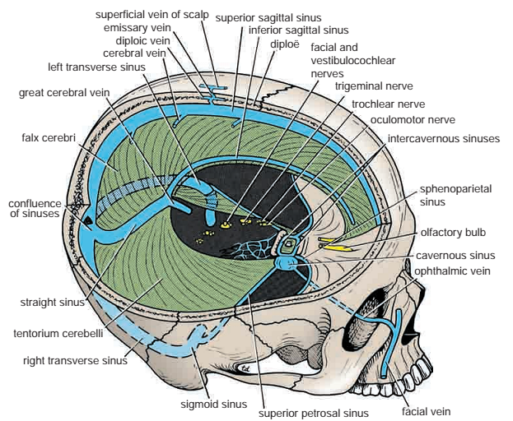

The diaphragma sellae is a small circular fold of dura mater that forms the roof for the sella turcica. A small opening in its center allows passage of the stalk of the pituitary gland

The falx cerebri and the falx cerebelli are attached to the upper and lower surfaces of the tentorium, respectively. The straight sinus runs along its attachment to the falx cerebri, the superior petrosal sinus along its attachment to the petrous bone, and the transverse sinus along its attachment to the occipital bone.

The falx cerebelli is a small, sickle-shaped fold of dura mater that is attached to the internal occipital crest and projects forward between the two cerebellar hemispheres. Its posterior fixed margin contains the occipital sinus.

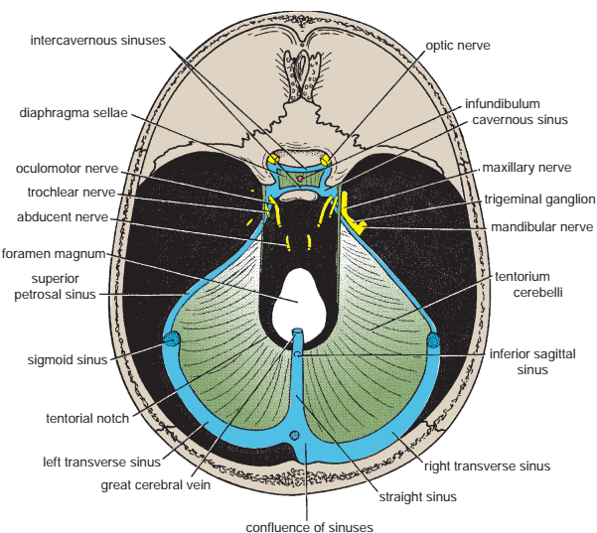

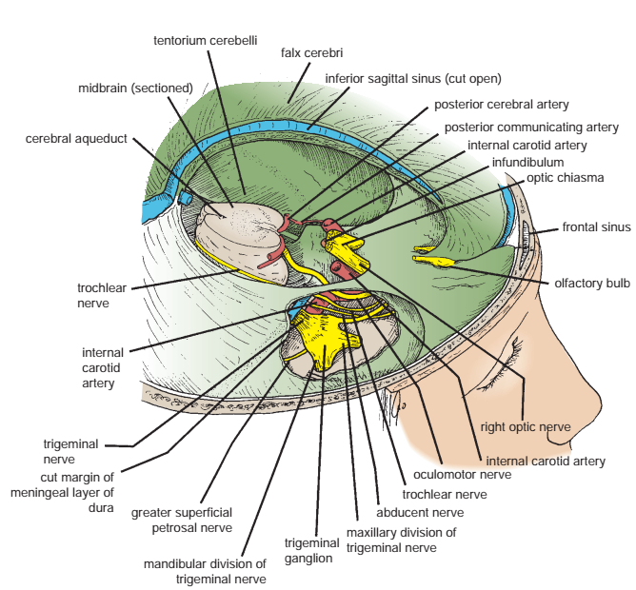

Dural Nerve Supply

Branches of the trigeminal, vagus, and first three cervical nerves and branches from the sympathetic system pass to the dura. Numerous sensory endings are in the dura. The dura
is sensitive to stretching, which produces the sensation of headache.

Dural Arterial Supply

Numerous arteries supply the dura mater from the internal carotid, maxillary, ascending pharyngeal, occipital, and vertebral arteries. From a clinical standpoint, the most important is the middle meningeal artery, which is commonly damaged in head injuries.

The middle meningeal artery arises from the maxillary artery in the infratemporal fossa. It enters the cranial cavity and runs forward and laterally in a groove on the upper surface of the squamous part of the temporal bone. To enter the cranial cavity, it passes through the foramen spinosum. The anterior (frontal) branch deeply grooves or tunnels the anteroinferior angle of the parietal bone, and its course corresponds roughly to the line of the underlying precentral gyrus of the brain. The posterior (parietal) branch curves backward and supplies the posterior part of the dura mater.

Dural Venous Drainage
The meningeal veins lie in the endosteal layer of dura. The middle meningeal vein follows the branches of the middle meningeal artery and drains into the pterygoid venous plexus or the sphenoparietal sinus. The veins lie lateral to the arteries.

Arachnoid Mater of the Brain
The arachnoid mater is a delicate, impermeable membrane covering the brain and lying between the pia mater internally and the dura mater externally. It is separated from the dura by a potential space, the subdural space, and from the pia by the subarachnoid space, which is filled with cerebrospinal fluid. The arachnoid bridges over the sulci on the surface of the brain, and in certain situations the arachnoid and pia are widely separated to form the subarachnoid cisternae. It is important to remember that structures passing to
and from the brain to the skull or its foramina must pass through the subarachnoid space. All the cerebral arteries and veins lie in the space, as do the cranial nerves.
In certain areas, the arachnoid projects into the venous sinuses to form arachnoid villi. The arachnoid villi are most numerous along the superior sagittal sinus. Aggregations of arachnoid villi are referred to as arachnoid granulations.

The cerebrospinal fluid is produced by the choroid plexuses within the brain. It escapes from the ventricular system of the brain through the three foramina in the roof of the fourth
ventricle and so enters the subarachnoid space. It now circulates both upward over the surfaces of the cerebral hemispheres and downward around the spinal cord. The spinal
subarachnoid space extends down as far as the second sacral vertebra. Eventually, the fluid enters the bloodstream by passing into the arachnoid villi and diffusing through their walls.
In addition to removing waste products associated with neuronal activity, the cerebrospinal fluid provides a fluid medium in which the brain floats. This mechanism effectively protects the brain from trauma.
Pia Mater of the Brain

The pia mater is a vascular membrane that closely invests the brain, covering the gyri and descending into the deepest sulci.

