Impacted 3rd Molar
Diagnosis, Indication, and Management
د. هاني الشيخ راضي

An impacted third molar is a developmental anomaly caused by an obstruction in the eruption path or by an ectopic position of the tooth. Not all unerupted teeth are impacted. A tooth is considered impacted when it has failed to fully erupt into the oral cavity within its expected developmental time period and can no longer reasonably be expected to do so .

Development of the Mandibular Third Molar

The mandibular third molar is the most commonly impacted tooth. It also presents the greatest surgical challenge and invites the greatest controversy when indications for removal are considered. When the surgeon is determining whether a specific third molar will become impacted and whether it should be removed, he or she needs to have a clear understanding of the development and movement of the third molar between the ages of 7 and 25 years. The mandibular third molar tooth germ is usually visible radiographically by age 9 years, and cusp mineralization is completed approximately 2 years later. At age
11 years, the tooth is located within the anterior border of the ramus with its occlusal surface facing almost directly anteriorly. The level of the tooth germ is approximately at the occlusal plane of the erupted dentition. Crown formation is usually complete by age 14 years, and the roots are approximately 50% formed by age 16 years. During this time the body of the mandible grows in length at the expense of resorption of the anterior border of the ramus. As this process occurs the position of the third molar relative to the adjacent teeth changes, with the third molar assuming a position at approximately the root level of the adjacent second molar. The angulation of the crown becomes more horizontal also. Usually the roots are completely formed with an open apex by age 18 years. By age 24 years 95% of all third molars that will erupt have completed their eruption. It is fairly well established that the position of retained third molars does not change substantially after age 25 years.
Most third molars do not follow this typical eruption sequence and, instead, become impacted teeth Approximately half do not assume the vertical position and remain as mesioangular impactions.

“If a third molar is considered erupted when any part of the crown has pierced the oral mucosa and become clinically visible, the mean age of eruption for lower third molars was 19 and 20 years of age for men and women respectively”

Reasons behind the impaction:
1- Difference in growth potential between the roots of the impacted tooth.
2- When the arch length is insufficient (i.e. no space for the tooth to erupt).
3- The growth and development is slower than the development of the jaw.

To evaluate the tooth and to decide whether the tooth will erupt or not we need to judge by 2 factors:

- The angulation of the tooth.
- Space available.

Type of Impaction:
1- Mesioangular: crown of the impacted tooth is towards the 2nd molar.
2- Distoangular: crown of the impacted tooth is away from the 2nd molar (i.e. towards the ramus).
3- Horizontal impaction: the tooth is horizontally within the bone.
4- Vertical: the tooth is straight within the bone.

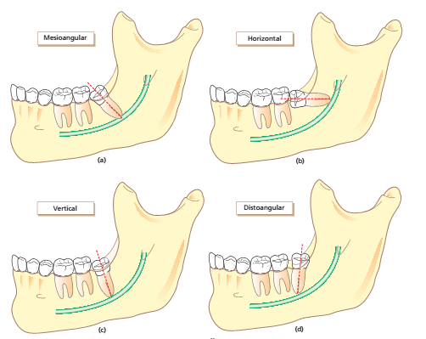

Pericoronitis: When a tooth is partially impacted with a large amount of soft tissue over the axial and occlusal surfaces, the patient frequently has one or more episodes of pericoronitis. Pericoronitis is an infection of the soft tissue around the crown of a partially impacted tooth and is usually caused by normal oral flora. In most patients, bacteria and host defences maintain a delicate balance, but even normal host defences cannot eliminate the bacteria. If host defences are compromised (e.g., during minor illnesses
such as influenza or an upper respiratory infection or because of immune-compromising drugs), infection can occur. Thus, although the impacted tooth has been present for some time without infection,
if the patient experiences even a mild, transient decrease in host defences, pericoronitis commonly results, even if the patient does not have any immunologic problems. Pericoronitis can also arise following minor trauma from a maxillary third molar. The soft tissue that covers the occlusal surface of the partially erupted mandibular third molar (known as the operculum) can be traumatized and become swollen. Often, the maxillary third molar further traumatizes the already swollen operculum, which causes a further increase in swelling that is now traumatized more easily. This spiralling cycle of trauma and swelling is often interrupted only by removal of the maxillary third molar.
Another common cause of pericoronitis is entrapment of food under the operculum. During eating, food debris may become lodged into the pocket between the operculum and the impacted tooth.
Because this pocket cannot be cleaned, bacteria colonize it, which results in pericoronitis.
It was found that 97.5% of the pericoronitis cases were partial soft tissue impactions and only 2.5% were fully impacted in soft tissue.

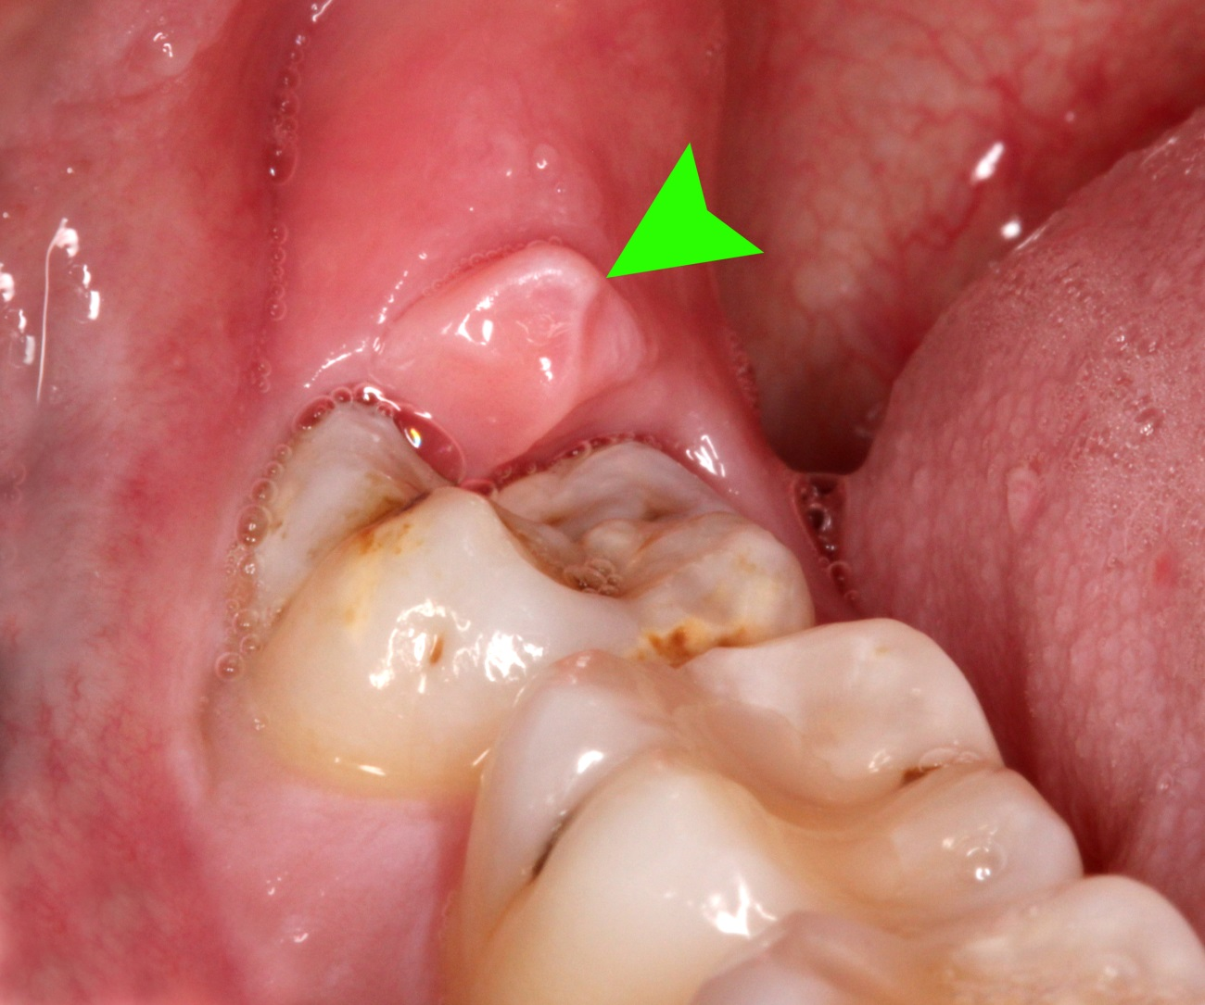

Indications for Extraction of the impacted 3rd molar
The average age for completion of the eruption of the third molar is age 20 years, although eruption may continue in some patients until age 25 years. During normal development, the lower third molar begins in a horizontal angulation, and as the tooth develops and the jaw grows the angulation changes from horizontal to mesioangular to vertical. Failure of rotation from the mesioangular to the vertical direction is the most common cause of lower third molars becoming impacted.
Early removal is recommended if indicated:

1- Reduces postoperative morbidity and allows for the best healing.
2- Younger patients tolerate the procedure better, recovering more quickly and with less interference to their daily lives.
3- Periodontal healing is better in younger patients because of better and more complete regeneration of the periodontal tissues on the distal of the second molar.
4- Recovery is better in these patients if the nerve is injured.
5- The procedure is easier to perform in younger patients because bone is less dense and root formation is incomplete.

The ideal time for removal of impacted third molars is when the roots of teeth are one third formed and before they are two thirds formed, usually during the mid- to late teenage years, between ages 17 and 20 years.

Although it is extremely controversial that if we must extract all impacted 3rd molars or we must leave them; there had been an extreme visions and the decision required special attention and study; however there are several guidelines published in literature and done by organizations governmental and non-governmental trying to achieve the ultimate decision.
Organizations such as “NICE” [National institute of clinical Excellency] and “SIGN” [Scottish Intercollegiate Guidelines Network].

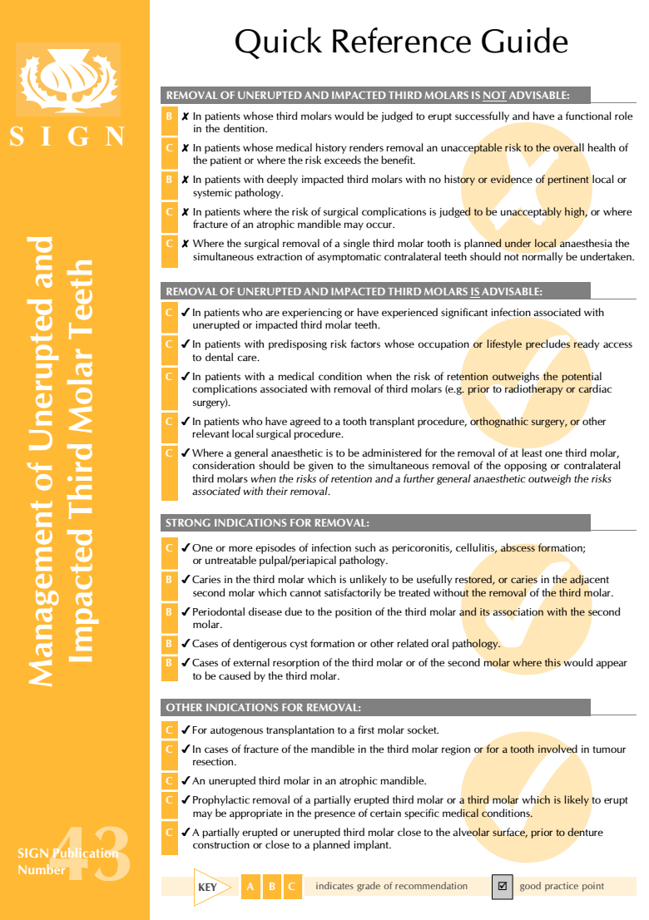

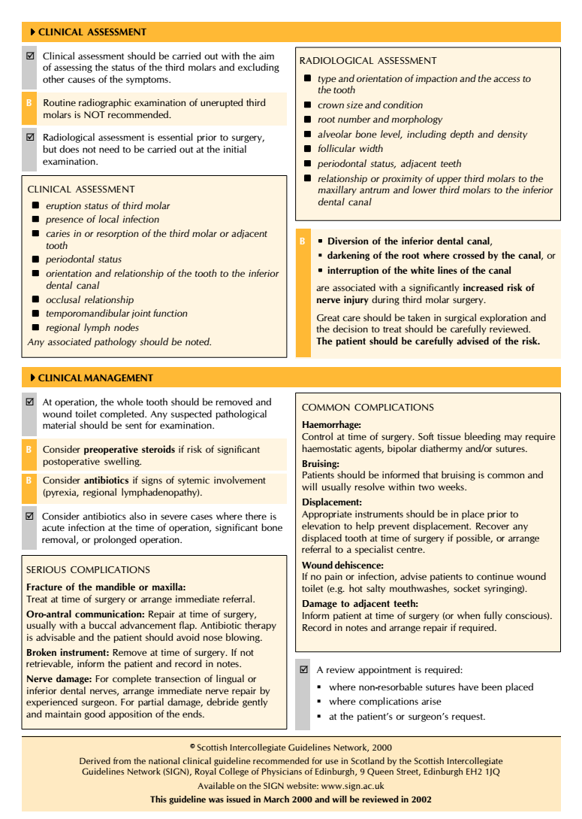

Brief notes from NICE guidelines:

- Point 1.3 from the guidelines “Surgical removal of impacted third molars should be limited to patients with evidence of pathology. Such pathology includes unrestorable caries, nontreatable pulpal and/or periapical pathology, cellulitis, abcess and osteomyelitis, internal/external resorption of the tooth or adjacent teeth, fracture of tooth, disease of follicle including cyst/tumour, tooth/teeth impeding surgery or reconstructive jaw surgery, and when a tooth is involved in or within the field of tumour resection”.

- Point 1.4 suggests “The degree to which the severity or recurrence rate of pericoronitis should influence the decision for surgical removal of a third molar remains unclear. The evidence suggests that a first episode of pericoronitis, unless particularly severe, should not be considered an indication for surgery. Second or subsequent episodes should be considered the appropriate indication for surgery”.

- Point 3.1 “There is no reliable research evidence to support a health benefit to patients from the prophylactic removal of pathology-free impacted third molar teeth”.

The Belgian health care governmental centre published in 2012 a result research on the benefits of prophylactic extraction of impacted 3rd molar; the results were absolute and suggested that routine prophylactic extraction for asymptomatic and disease free impacted teeth must be discontinued.

Cochrane Database Syst Rev. 2012 Jun 13;6:CD003879.
Surgical removal versus retention for the management of asymptomatic impacted wisdom teeth.
This published article on Cochrane Database which is consider the most trusted and reliable source for medical information suggest that routine prophylactic extraction of asymptomatic 3rd molar must be discontinued.

The decision to remove a given impacted tooth must be based on a careful evaluation of the potential benefits versus risks.

Indications for extraction

1- Pericoronitis Prevention or Treatment: first episode is treated with chlorhexidine gluconate mouth wash antibiotics can prescribed if there is systemic presentation such as fever and malaise; if the pain episodes recure then the tooth is best extracted. Historically an operation called (operculotomy) was indicated to excise the operculum (extra tissue above the tooth), nowadays this procedure is not recommended due to high risk of recurrence and create a scar and fibrosis above the tooth due to multiple operations within the site.

2- Orthodontic purposes:

a- Crowding within the anterior area: this a very controversial subject; however, nowadays all the published work suggest that there is no relation between the eruption of the 3rd molar and anterior crowding and the process is actually due to that the growth and development of mandible which ends almost at the time of the eruption of the 3rd molar.

b- Obstruction of orthodontic treatment: impacted 3rd molar must be extracted if it is an obstacle when the orthodontist tries to move the teeth distally.

c- interference with orthognathic surgery (الجراحة التقويمية)

3- Root resorption of adjacent teeth (2nd molar)

4- Odontogenic Cysts and Tumors: the follicular sac that was responsible for the formation of the crown may undergo cystic degeneration and form a dentigerous cyst.

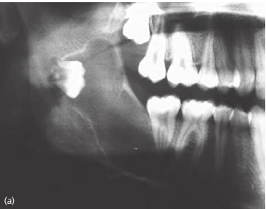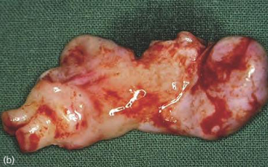

4- Prevention of jaw fracture: Patients who engage in contact sports, such as rugby, martial arts and boxing should consider having their impacted third molars removed to prevent jaw fracture during competition. An impacted third molar presents an area of lowered resistance to fracture in the mandible and is therefore a common site for fracture.

5- Management of Unexplained Pain: Occasionally patients complain of jaw pain in the area of an impacted third molar that has neither clinical nor radiographic signs of pathology. In these situations removal of the impacted third molar frequently results in resolution of this pain. At this time there is no clear explanation as to why this relief of pain occurs.

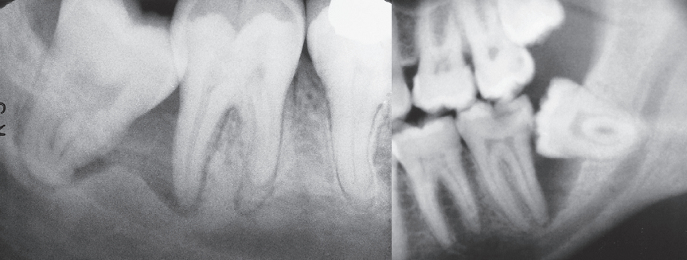

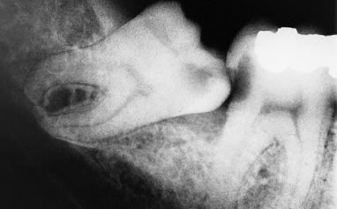
Caries in the distal surface of the 2nd molar

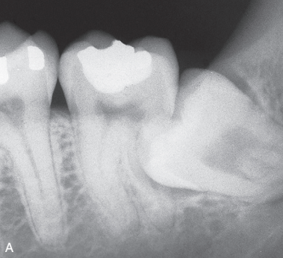
Resorption of the 2nd molar by the 3rd molar

Contraindications for Extraction

- Third molar buds in young people should not be enucleated.
- Asymptomatic and pathology-free third molars totally covered by bone should not be removed.
- Routine removal of asymptomatic pathology-free third molars totally or partially covered by soft tissue is not recommended.
- Third molar surgery is contraindicated in patients whose medical history or conditions expose the patient to an unacceptable risk to their overall health.
- Extreme age. [* increase healing time and posteoperative recovery period is increased as well * Increase bone density which make the expansion of bone more difficult and increase the risk of fracture].
- Extraction is contra-indicated if the process may damage adjacent vital structures such as lingual or inferior dental nerves.

Surgery and Perioperative Care

Assessment of extraction difficulty

Pell and Gregory classification
This is based on the relationship between the impacted lower wisdom tooth (3rd molar) to the ramus of the mandible (lower jaw) and the 2nd molar (based on the space available distal to the 2nd molar).

Class A. The occlusal plane of the impacted tooth is at the same level as the occlusal plane of the 2nd molar. (The highest portion of impacted 3rd molar is on a level with or above the occlusal plane).
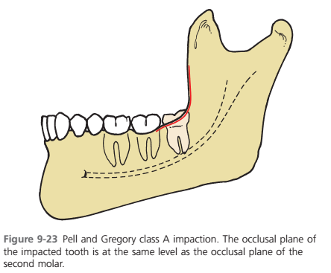
Class B. The occlusal plane of the impacted tooth is between the occlusal plane & the cervical margin of the 2nd molar. (The highest portion of impacted 3rd molar is below the occlusal plane but above the cervical line of the 2nd molar).
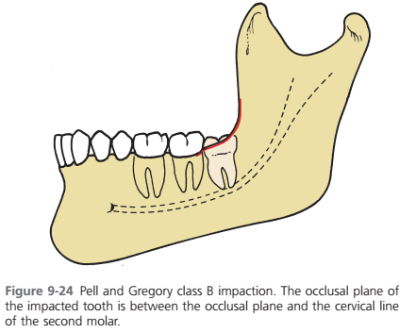

Class C. The impacted tooth is below the cervical margin of the 2nd molar. (The highest portion of impacted 3rd molar is below the cervical line of the 2nd molar).
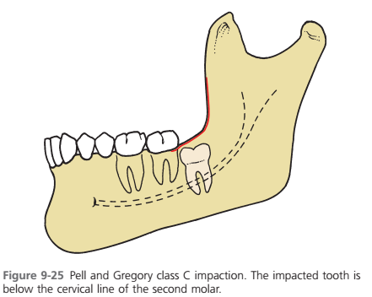

Class 1. There is sufficient space available between the anterior border of the ascending ramus & the distal aspect of the 2nd molar for the eruption of the 3rd molar.
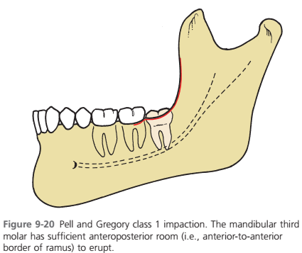

Class 2. The space available between the anterior border of the ramus & the distal aspect of the the 2nd molar is less than the mesio-distal width of the crown of the 3rd molar. It denotes that the distal portion of the 3rd molar crown is covered by bone of the ascending ramus.
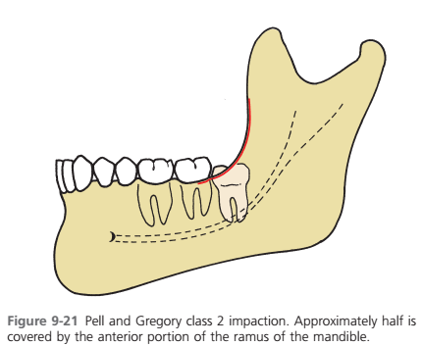

Class 3. The 3rd molar is totally embedded in the bone of the anterior border of the ascending ramus because of the absolute lack of space. It is obvious that Class 3 teeth present more difficulty in removal as a relatively large amount of bone has to be removed and there is a risk of damaging the ID nerve or fracturing the mandible (or both).
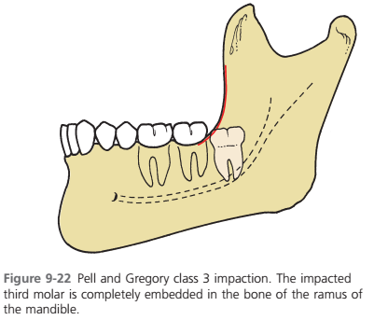

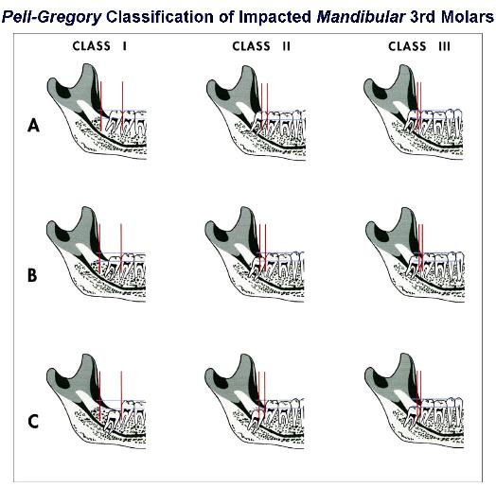

Winter’s Lines:
A method of assessing the angulation and extent of impaction of mandibular third molars, first described by G. B. Winter in 1926. A line drawn along the occlusal surfaces of the erupted mandibular molars demonstrates the axial inclination of the wisdom tooth; this also gives some indication of the depth of the tooth in the mandible. A second line, extending from the surface of the bone distal to the third molar to the crest of the interdental septum between the first and second molars, indicates the amount of alveolar bone enclosing the impacted tooth. A third perpendicular line is drawn from the second line to the amelo-cemental junction on the mesial surface of the impacted tooth (elevator application point) and is used to determine the depth of impaction of the tooth within the bone.

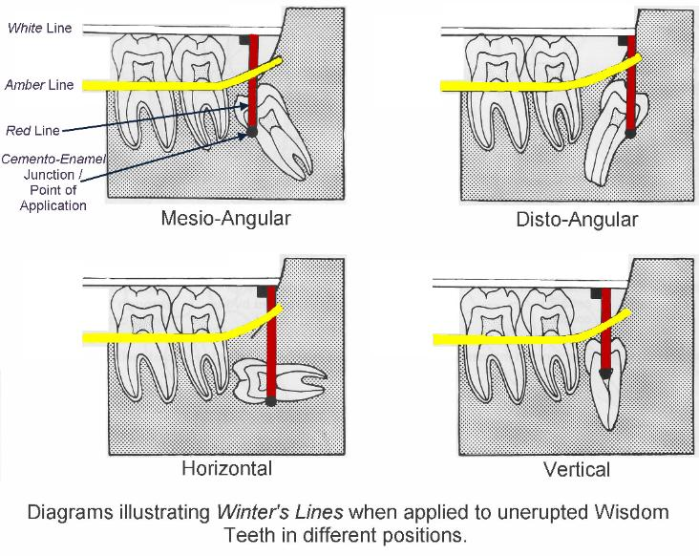

Determining Surgical Difficulty
- It is generally acknowledged that the mesioangular impaction, which accounts for approximately 45% of all impacted mandibular third molars, is the least difficult to remove. The vertical impaction (40% of all impactions) and the horizontal impaction (10%) are intermediate in difficulty, whereas the distoangular impaction (5%) is the most difficult.
- Teeth buried within the ramus are much more difficult to remove than teeth within the alveolar area.
- The depth of the impaction under the hard and soft tissues is likewise an important consideration in determining the degree of difficulty. If the teeth is impacted and covered by more than 5 mm of bone is usually an indication for surgery under General anaesthesia due to the difficulty of the procedure to both the surgeon and the patient.
- Root shape, divergent roots can pose a difficult extraction procedure.
- Age of the patient. When impacted teeth are removed before age 20 years, the surgery is almost always less difficult to perform. The roots are usually incompletely formed and thus less bone removal is required for tooth extraction. There is usually a broader pericoronal space formed by the follicle of the tooth, which provides additional access for tooth extraction without bone removal. Because the roots of the impacted teeth are incompletely formed, they are usually separated from the inferior alveolar nerve.
In summary, the degree of difficulty of the surgery to remove an impacted tooth is determined primarily by two major factors:
(1) The depth of impaction and type of overlying tissue.
(2) The age of the patient.
Full bony impactions are always more difficult to remove than are soft tissue impactions and, given two impactions of the same depth, the impaction in the older patient is always more difficult than the one in the younger patient.

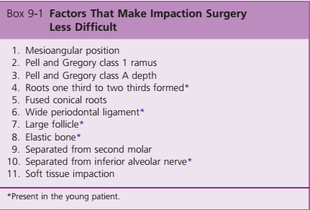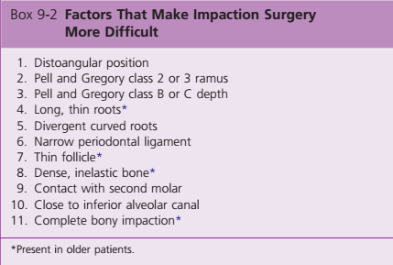

Surgical Technique

- The initial step in removing impacted teeth is to reflect a mucoperiosteal flap. Envelop flap is commonly used the flap extended to the mesial side of the 1st molar; however if we require more access then we make a releasing incision to create 2 sided flap the releasing incision is usually created from the distal side of the 1st molar.

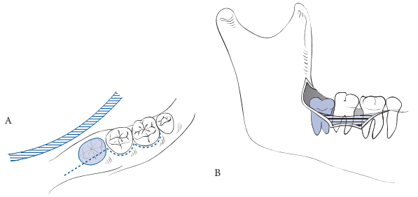

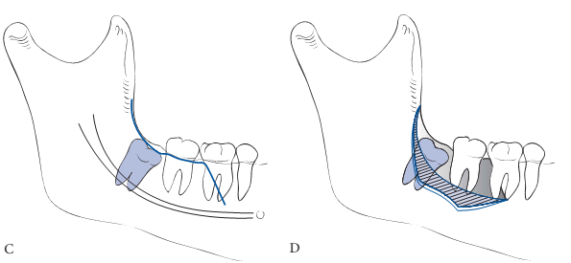

- The second major step is bone removal from around the impacted tooth. Most surgeons use a high-speed low-torque air-driven handpiece, although a few surgeons still choose to use a chisel for bone removal. The most recent advance is the relatively high-speed high-torque electric drill, which has some significant advantages in reducing the time required for bone removal and tooth sectioning. It is essential that the air propelled away from the surgical site to avoid surgical emphysema.
- The bone on the occlusal, buccal, and cautiously on the distal aspects of the impacted tooth is removed down to the cervical line.
- It is advisable not to remove any bone on the lingual aspect because of the likelihood of damage to the lingual nerve.
- Once the tooth has been sufficiently exposed, it is sectioned into appropriate pieces so that it can be delivered from the socket. The direction in which the impacted tooth is divided is dependent on the angulation of the impaction. Tooth sectioning is performed either with a bur or chisel, but with the advent of high-speed drills, the bur is most commonly used because it provides a more predictable plane of sectioning. The tooth is usually divided three-quarters of the way through to the lingual aspect and then split the remainder of the way with a straight elevator or a similar instrument. This prevents injury to the lingual cortical plate and reduces the possibility of damage to the lingual nerve.

  - The mesioangular impaction is usually the least difficult to remove. After sufficient bone has been removed, the distal half of the crown is sectioned off from the buccal groove to just below the cervical line on the distal aspect of the tooth. This portion of the tooth is delivered, and the remainder of the tooth is removed with a small straight elevator placed at a purchase point on the mesial aspect of the cervical line. An alternative is to prepare a purchase point in the tooth with the drill and use a crane pick or a Cryer elevator in the purchase point to deliver the tooth.

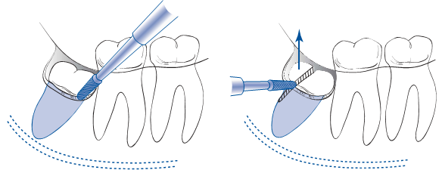

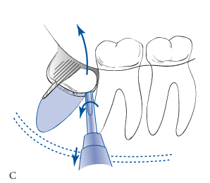

  - The horizontal impaction usually requires the removal of more bone than does the mesioangular impaction. The crown of the tooth is usually sectioned from the roots and delivered with a Cryer. The roots are then displaced into the socket that was previously occupied by the crown and are delivered into the mouth.

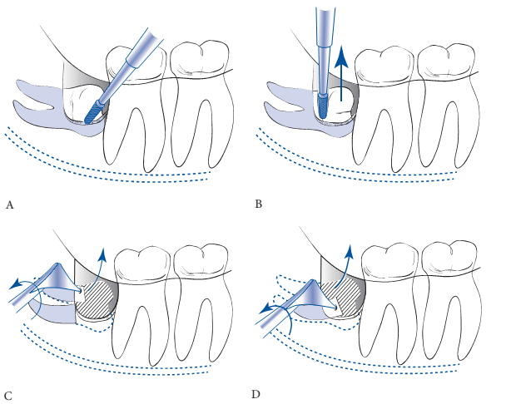

  - The vertical impaction is one of the more difficult ones to remove, especially if it is deeply impacted. The procedure for bone removal and sectioning is similar to that for the mesioangular impaction in that occlusal, buccal, and judicious distal bone is removed first. The distal half of the crown is sectioned and removed, and the tooth is elevated by applying a small straight elevator at the mesial aspect of the cervical line. The option of preparing a purchase point in the tooth is also frequently used, as for the mesioangular impaction.

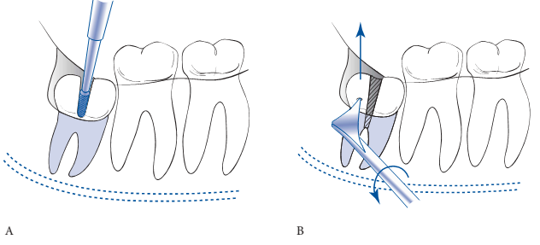

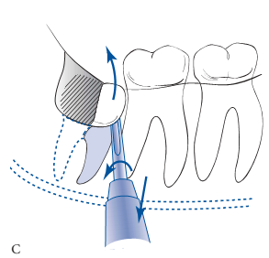

  - The most difficult tooth to remove is one with a distoangular impaction. After the removal of bone, the crown is usual sectioned from the roots just above the cervical line and delivered with a Cryer elevator. A purchase point is then prepared in the tooth, and the roots are delivered together or sectioned and delivered independently with a Cryer elevator. Extraction of this impaction is more difficult because more distal bone must be removed and the tooth tends to be elevated posteriorly into the ramus portion of the mandible.
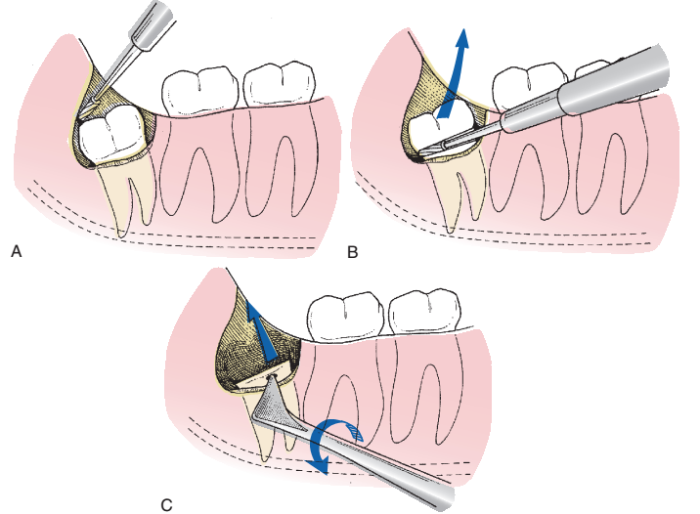

- Once the impacted tooth is delivered from the alveolar process, the surgeon must pay strict attention to débriding the wound of all particular bone chips and other debris. The best method to accomplish this is to mechanically débride the socket and the area under the flap with a periapical curette. A bone file should be used to smooth any rough sharp edges of the bone. A mosquito hemostat is usually used carefully to remove any remnant of the dental follicle. Finally, the socket and wound should be thoroughly irrigated with saline or sterile water (30 to 50 mL is optimal).

- The flap is returned to its original position, and the initial resorbable (vicryl 3-0 or 4-0); however, silk suture can be used although it carry an increased risk of infection at the site of the surgery because its filaments can be harboured by micro-organisms suture is placed at the posterior aspect of the second molar. Additional sutures are placed as necessary.

- The most commonly used incision used for the maxillary third molar is also an envelope incision It extends posteriorly from the distobuccal line angle of the second molar and anteriorly to the first molar. A releasing incision is rarely necessary for the maxillary third molar, although it may be useful when the occlusal surface of the third molar is at or superior to the midportion of the second molar root.

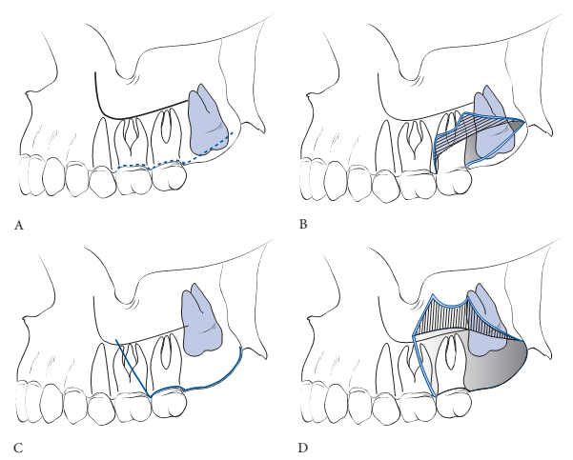

- Maxillary teeth, bone removal is done primarily on the lateral aspect of the tooth down to the cervical line to expose the entire clinical crown. Frequently, the bone on the buccal aspect is thin enough that it can be removed with a periosteal elevator or a chisel using manual digital pressure.

- Impacted maxillary third molars are rarely sectioned because the overlying bone is thin and relatively elastic. In patients with thicker bone, the extraction is usually accomplished by removing additional bone rather than by sectioning the tooth. The tooth should never be sectioned with a chisel because it may be displaced into the maxillary sinus or infratemporal fossa when struck with the chisel.

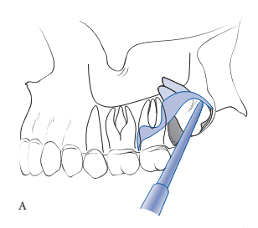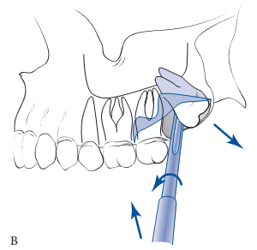

The Perioperative and Post-operative care

Antibiotics: It is not mandatory to give antibiotics to all patients who undergo surgical extraction of impacted 3rd molars, many studies have shown that there is a percentage of 5% risk of infection that all the surgeon will face from all the extraction procedure no matter if the surgeon gave antibiotics or not; however, studies have shown that the risk of dry socket is decreased when patients were given antibiotics but it also shown that antibiotic alone didn’t reduce the risk of dry socket, the tissue handling, good perioperative irrigation with saline, removing all the debris, and bone filing all together reduced the risk not the antibiotic alone.

Pre or peri-operative steroids: it is well documented that using steroids within the operation or before the operation will reduce the risk of postoperative morbidity such as swelling and trismus. The protocol within the University of London hospitals / maxillofacial unit is to give the patient 8 mg dexamethasone intravenously 1 hour preoperatively. We can give the steroids during the operation as well and some published work indicates the injection of steroids locally at the site of the operation during the procedure. Dexamethaosne has the least effect on leukocytes chemotaxis so it will not halt the immune system completely.
Common dosages of dexamethasone are 4 to 12 mg IV at the time of surgery. Additional oral dosages of 4 to 8 mg bid on the day of surgery and for two days afterward result in the maximum relief of swelling, trismus, and pain.

Expected complications and their management

Bleeding: minimized by using a good surgical technique and by avoiding the tearing of flaps or excessive trauma to the overlying soft tissue. If a vessel injured during the procedure it must stopped or it will create postoperative problems to the patient.

Swelling
Postsurgical edema or swelling is an expected sequela of third molar surgery. As discussed earlier, the parenteral administration of corticosteroids is frequently employed to help minimize the swelling that occurs. The application of ice packs to the face may make the patient feel more comfortable but has no effect on the magnitude of edema. The swelling usually reaches its peak by the end of the second postoperative day and is usually resolved by the fifth to seventh day.

Stiffness
Trismus is a normal and expected outcome following third molar surgery. Patients who are administered steroids for the control of edema also tend to have less trismus. Like edema, jaw stiffness usually reaches its peak on the second day and resolves by the end of the first week.

Pain
Another postsurgical morbidity expected after third molar surgery is pain. The postsurgical pain begins when the effects of the local anesthesia subside and reaches its maximum intensity during the first 12 hours postoperatively. Women should be prescribed larger dose of pain killers than men as their pain threshold is less than men. Combinations between Acetylsalicylic acid (Aspirin) and Acetaminophen (Paracetamol / Panadol), Codeine and Iburofen can be enough to control pain. Sometimes we may prescribe an intramuscular shot of pain killers such as Diclofenac Sodium (Voltarin) in severe cases.

The most important determinant of the amount of postoperative pain that occurs is the length of the operation. Neither swelling nor trismus correlates with the length of time of the surgery. There is, however, a strong correlation between postoperative pain and trismus, indicating that pain may be one of the principal reasons for the limitation of opening after the removal of impacted third molars.

The Principles of Pre-emptive analgesia to control pain: It is a pain control strategy that depends mainly on controlling the central sensitization of pain. The idea is to start the administration of pain killers before the surgical procedure. The idea is that when the pain perception initiated after the anesthesia is resolved the pain killer dosage is on its peak with the body so it will act immediately on pain receptors and mediators.

Infection
An uncommon postsurgical complication related to the removal of impacted third molars is infection. About 50% of infections are localized subperiosteal abscess-type infections, which occur 2 to 4 weeks after a previously uneventful postoperative course. These are usually attributed to debris that is left under the mucoperiosteal flap and are easily treated by surgical debridement and drainage. Of the remaining 50%, few postoperative infections are significant enough to warrant surgery, antibiotics, and hospitalization. Infections occur in the first postoperative week after third molar surgery approximately 0.5 to 1% of the time. This is an acceptable infection rate and would not be decreased with the administration of prophylactic antibiotics. The general incidence of infection post 3rd molar extraction is only about 1.7% – 2.8% of all the surgical procedures.

Fracture
One of the most frequent problems encountered in removing third molars is the fracture of a portion of the root, which may be difficult to retrieve. In these situations the root fragment may be displaced into the submandibular space, the inferior alveolar canal, or the maxillary sinus. Uninfected roots left within the alveolar bone have been shown to remain in place without postoperative complications. The pulpal tissues undergo fibrosis, and the root becomes totally incorporated within the alveolar bone. Aggressive and destructive attempts to remove portions of roots that are in precarious positions seem to be unwarranted and may cause more damage than benefit. Radiographic follow-up may be all that is required.

Alveolar Osteitis
The incidence of alveolar osteitis or dry socket following the removal of impacted mandibular third molars varies between 3 and 25%. The pathogenesis of alveolar osteitis has not been clearly defined, but the condition is most likely the result of lysis of a fully formed blood clot before the clot is replaced with granulation tissue. Its occurrence can be reduced by several techniques, most of which are aimed at reducing the bacterial contamination of the surgical site. Presurgical irrigation with antimicrobial agents such as chlorhexidine reduces the incidence of dry socket by up to 50%. Copious irrigation of the surgical site with large volumes of saline is also effective in reducing dry socket. The goal of treatment of dry socket is to relieve the patient’s pain during the delayed healing process. This is usually accomplished by irrigation of the involved socket, gentle mechanical debridement (not scrapping the socket), and placement of a dressing, which usually contains eugenol such as (Alvogyl).

Nerve Injuries:
Inferior alveolar nerve injury is most likely to occur in specific situations. The first and most commonly reported predisposing factor is complete bony impaction of mandibular third molars. The angulation classifications most commonly involved are usually mesioangular and vertical impaction. In some cases, nerve proximity to the root is indicated by:

- An apparent narrowing of the inferior alveolar canal as it crosses the root.
- Severe root dilaceration adjacent to the canal.
- Radiographic signs are diversion of the path of the canal by the tooth.
- Darkening of the apical end of the root indicating that it is included within the canal.
- Interruption of the radiopaque white line of the canal.

Other rare complications,

- Maxillary 3rd molar into the infratemporal fossa.
- Maxillary 3rd molar into the maxillary sinus.
- Fracture of the mandible.

