The definition of an impacted tooth is “tooth that cannot, or will not, erupt into its normal functioning positions, and is, therefore, pathologic and requires treatment”.

Causes of impacted permanent teeth include:
Systemic and local factors

Systemic factors:
1- Hereditary syndrome of cleidocranial dysplasia.

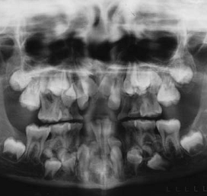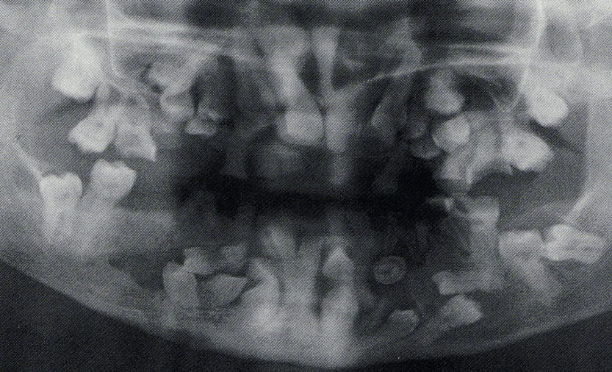

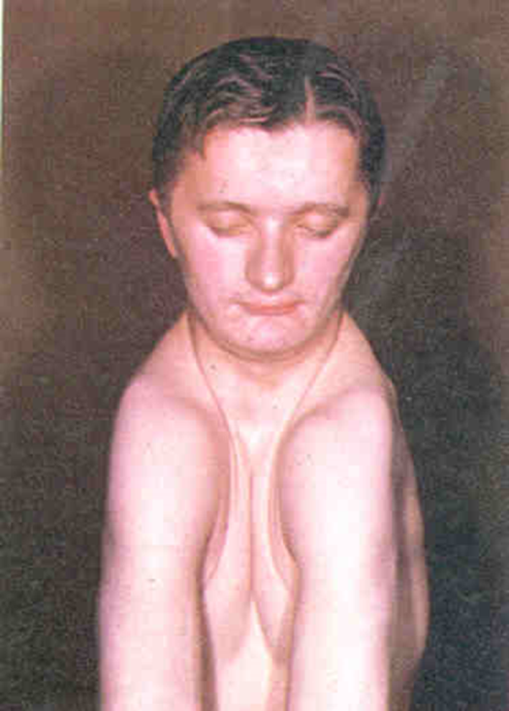
Multiple Impacted teeth in cleidocranial dysplasia

2- Endocrine deficiencies (hypothyroidism and hypopituitarism), febrile diseases, Down syndrome,
and irradiation are other systemic factors that may influence impaction of permanent teeth.

[In systemic conditions usually the patient suffer from multiple impacted teeth]

Local factors:
- Prolonged deciduous tooth retention.
- malposed tooth germs.
- Arch-length deficiency.
- Supernumerary teeth.
- Odontogenic tumors.
- Abnormal eruption path.
Cleft lip and palate.

- Maxillary canines are the most commonly impacted teeth, second only to third molars, with double incidence in female when compared to male.
- The maxillary canine travels almost 22 mm during the time of eruption.
- Arch length discrepancy and space deficiency may result in the canine becoming (labially) impacted.
- *** Studies have shown that Palatal impacted canine is related to presence of space such as missing lateral incisors.
- Other possible causes are trauma to the anterior maxilla at an early age, pathologic lesions, odontomas, supernumerary teeth, and ankylosis.

Localization:

The position of the impacted canine is important when deciding management options for patients. Localization requires inspection, palpation, and radiographic evaluation. Position of the lateral incisor can give a clue to the canine position. The crown of the lateral root may be proclined if the canine is lying labial to the
lateral incisor. The impacted canine can be palpated on the labial or palatal aspect. The surgeon can take a series of periapical radiographs along with a panoramic radiograph to locate its position.

X-ray localization: Standard radiographic techniques may be used to localize the unerupted teeth. These include:
- The tube shift method: The tube shift method uses two periapical radiographs, shifting the tube
horizontally between exposures. If the unerupted tooth moves in the same direction in which the tube is shifted, it is localized on the lingual or palatal side. A facial or buccally located tooth moves in the opposite direction to the tube shift.

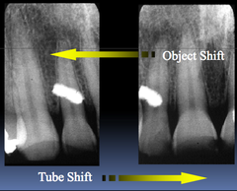

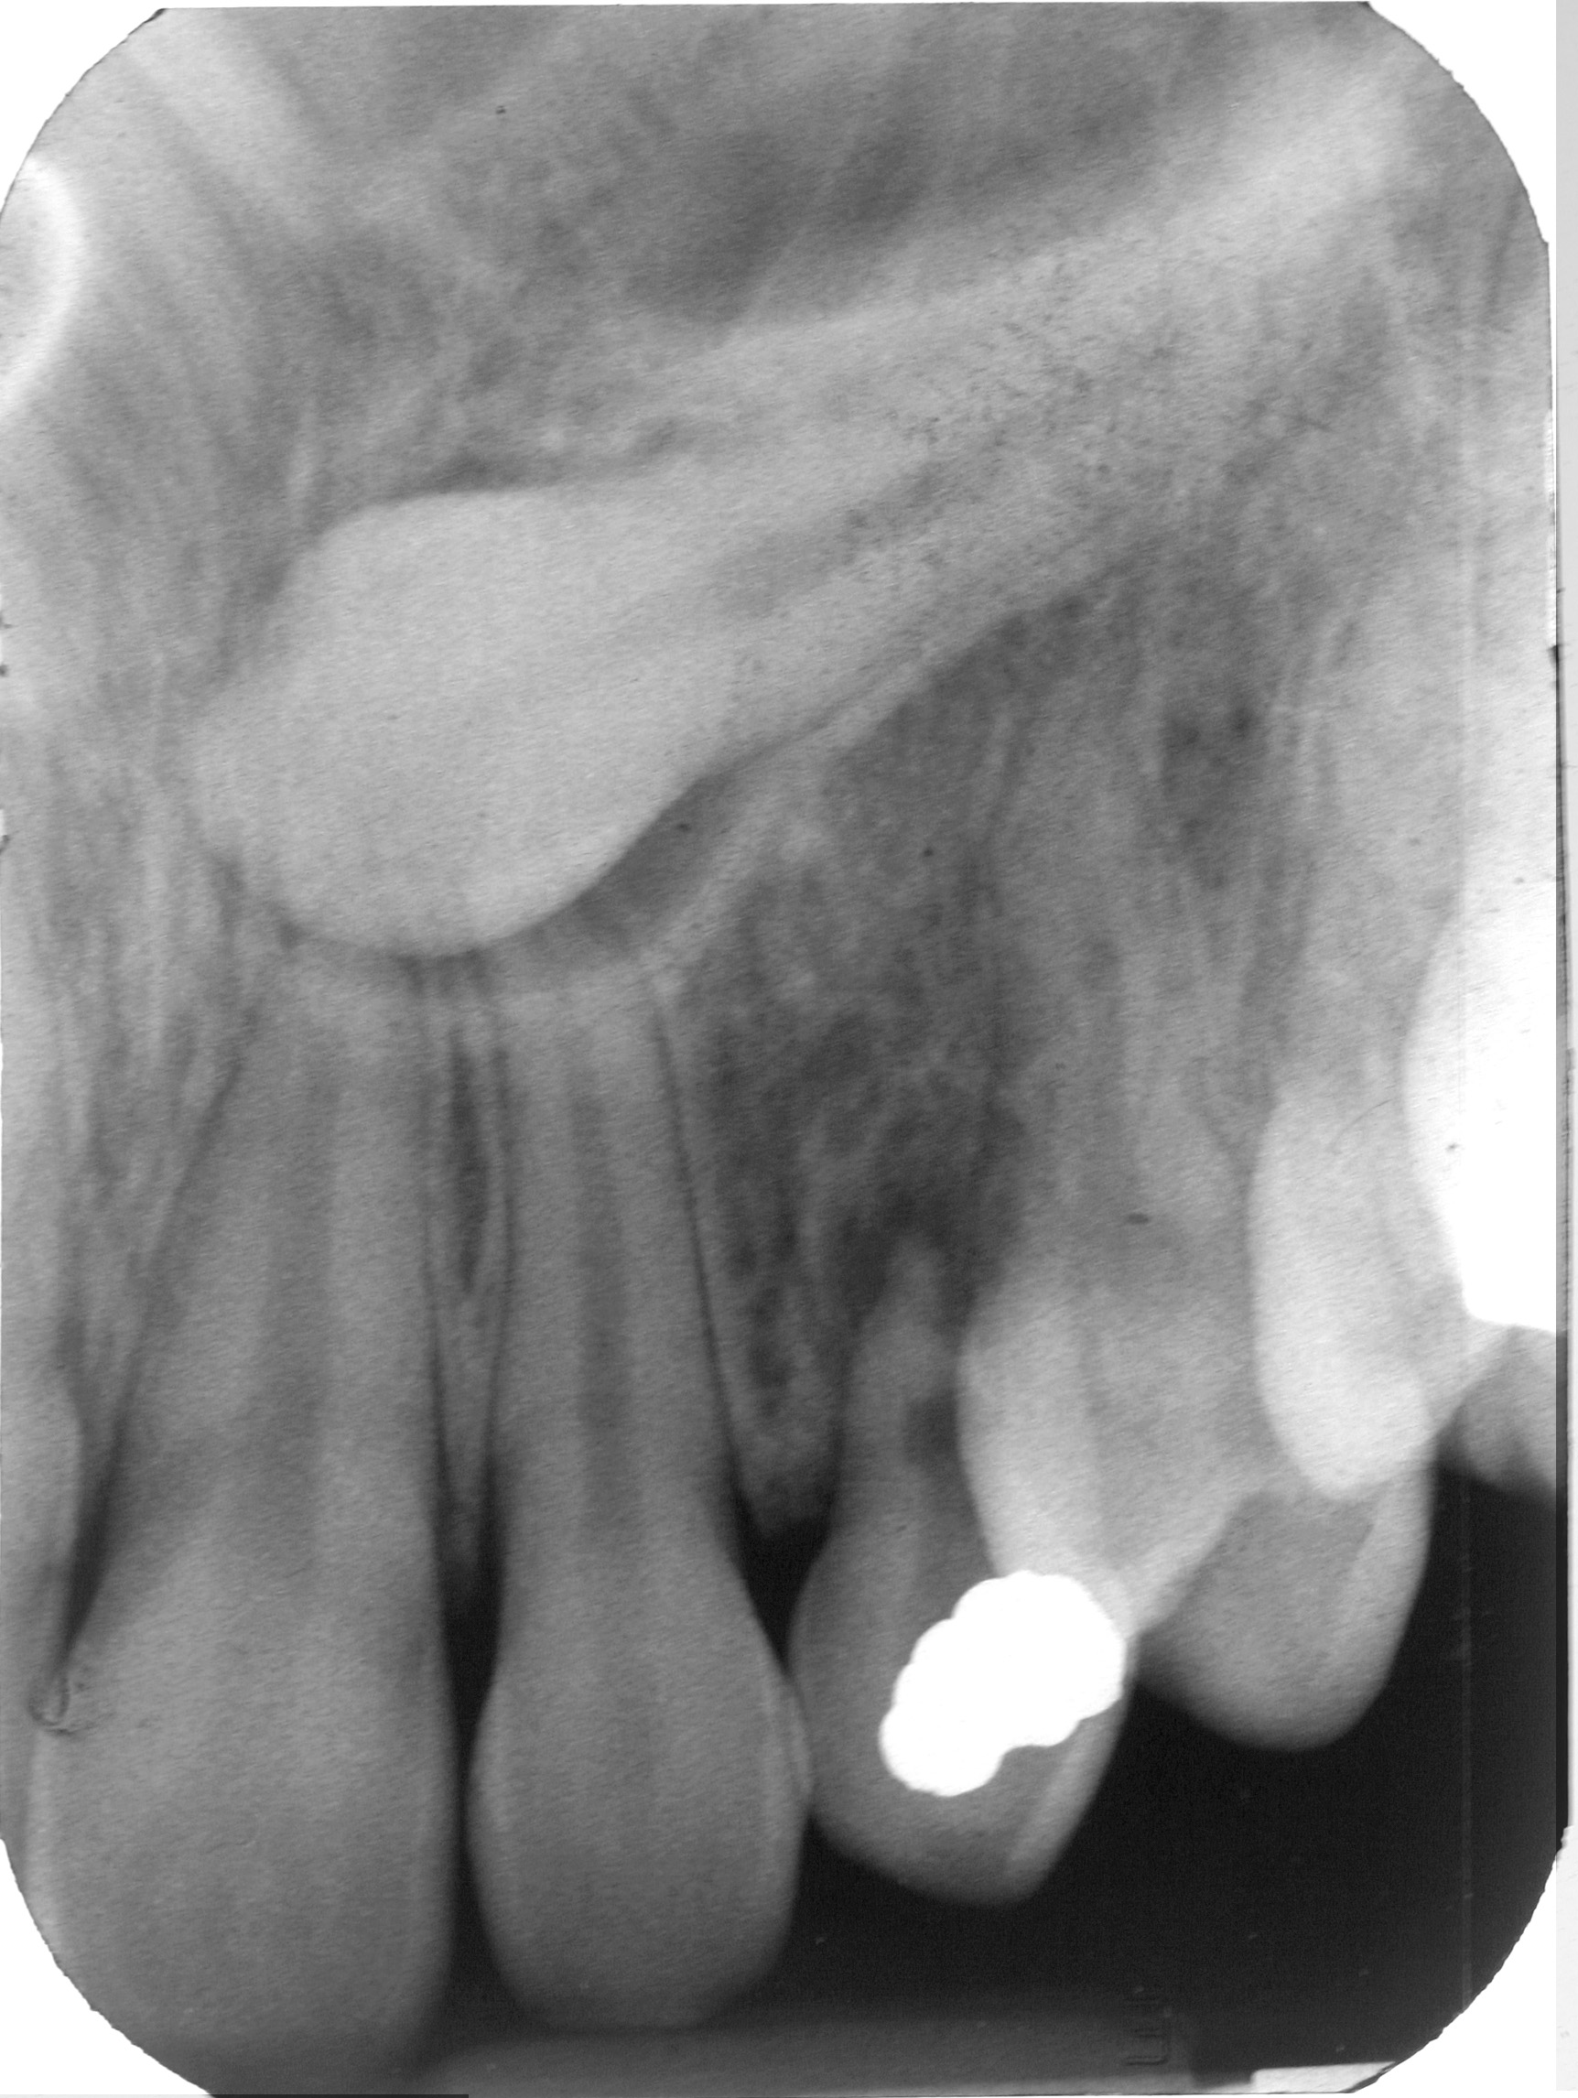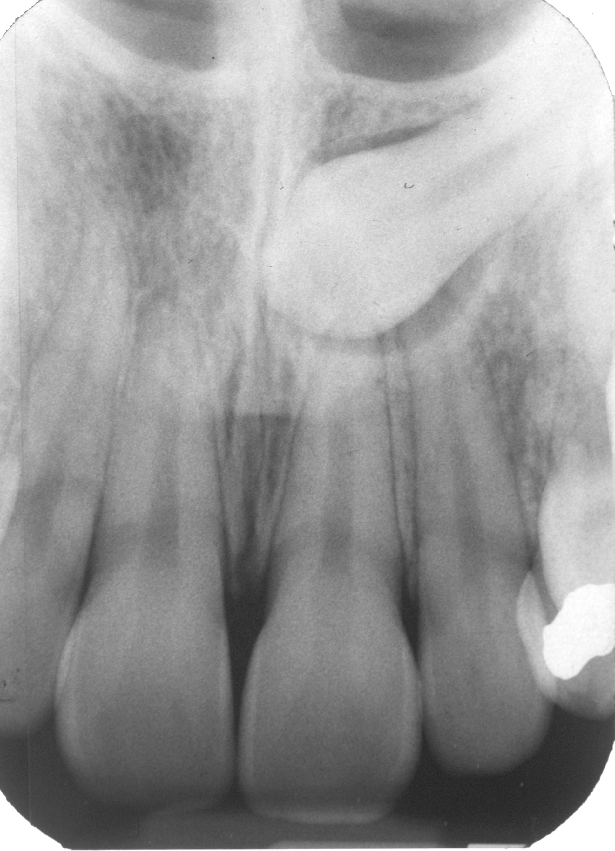

- Buccal object rule: The buccal object rule uses two radiographs taken with different vertical angulations of the x-ray beam. An object located on the buccal side moves inferiorly with the beam
directed inferiorly, whereas an object located in a lingual or palatal position moves superiorly.

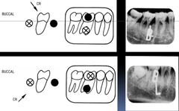

- Periapical occlusal method: The periapical occlusal method uses the periapical radiograph
taken with a standard technique and an occlusal radiograph to give two different views of the impacted tooth.

Localization continued:

- If you need to extract the over retained primary canine, the resorption pattern on the root provides a clue to localization of the crown of the impacted cuspid. After we extract the retained primary canine we check the roots of the deciduous.
- Sometimes you can feel the crown when giving your infiltration anesthesia on the buccal and palatal mucosa.

Treatment options:

Treatment options include:

(1) No treatment except monitoring: No treatment is recommended if the canine is in good position and without contact with the lateral incisor and first premolar. If there is no evidence of pathology or root resorption of the adjacent teeth or the patient refuses treatment, the patient can be monitored periodically

(2) Interceptive removal of primary canine: Extraction of the primary canine is recommended if the patient is between 10 and 13 years, the maxillary canine is not palpable, and localization confirms a palatal position. Then if the canine position does not improve over a 12-month period, alternative treatment is indicated.

(3) Surgical removal of the impacted canine: Surgical extraction of the impacted canine is indicated when there is poor position for orthodontic alignment, there is early evidence of resorption of adjacent teeth, the patient is too old for exposure, and the degree of displacement does not allow for surgical reposition or transplantation. The treatment of choice for replacement of the canine is a dental implant.

(4) Surgical exposure with orthodontic alignment

Flap design: the flap design depends on the positon of the impacted canine which were detrmined by the process of localization.

Buccal located canine: If the impacted canine is located buccally, we have three options depending on the level of the tooth impaction.
1- Gingival crest incision can be made in the gingival sulcus.
2- If the impacted canine is high, the incision can be made horizontally above the papillae (flap with release incision).
3- Vestibular incisions made at the level of the mucogingival junction should be made only when the impacted canine is above the root apices.

Palatal positioned canine: require long incision to avoid damage to the neurovascular bundles (nasopalatine bundles & the greater palatine bundle)

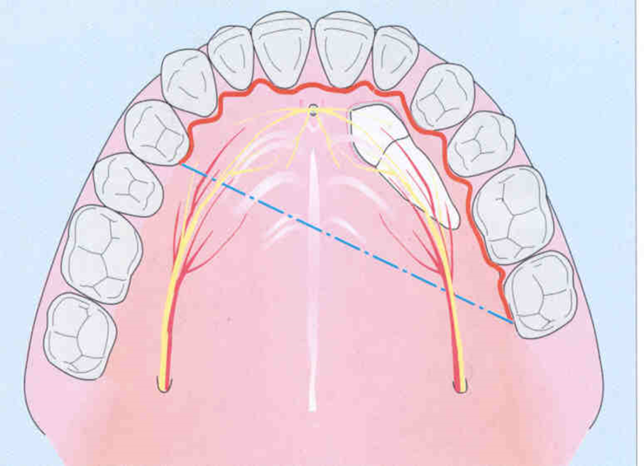

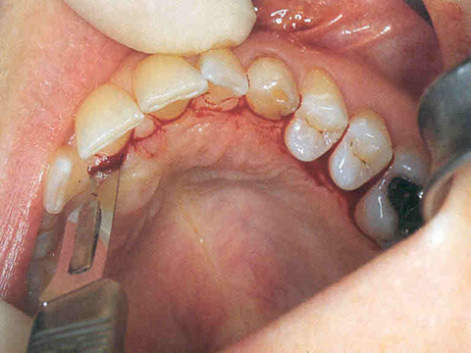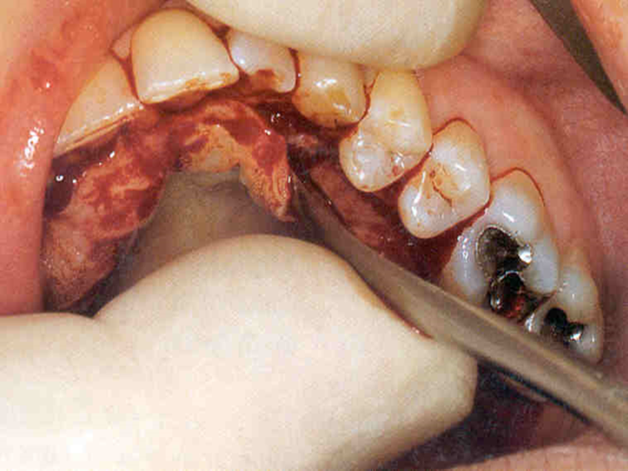
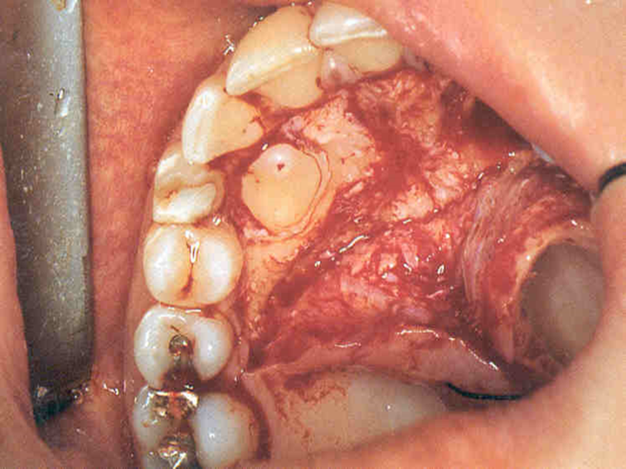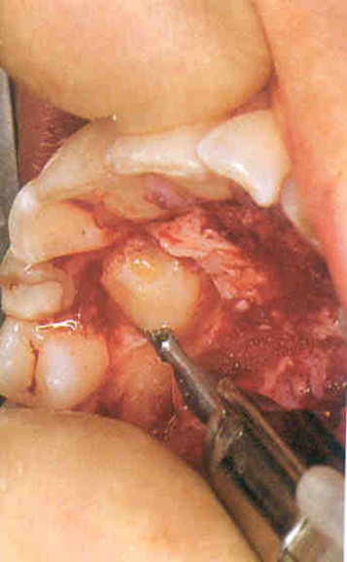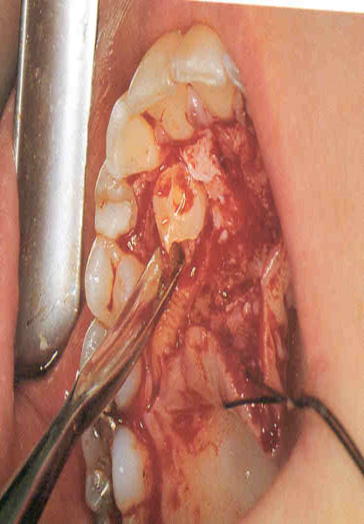
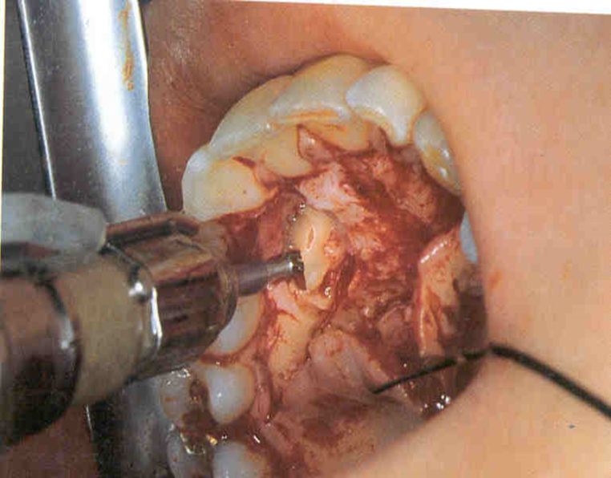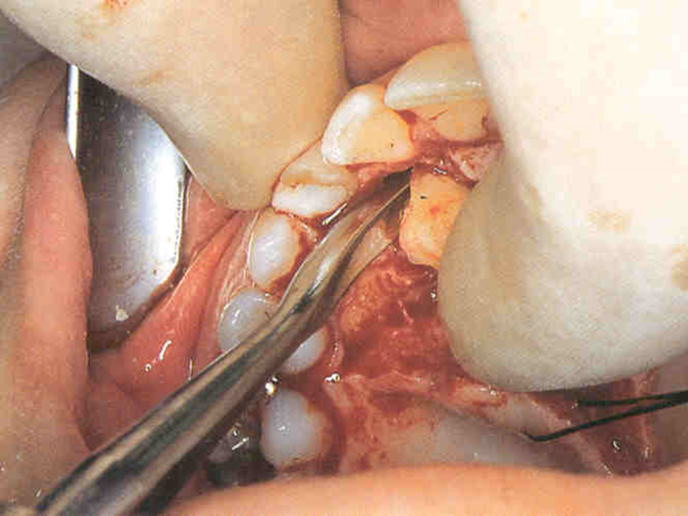

Steps of surgical extraction of the palataly impacted canine

If the canine impacted transversely (in the middle of the ridge) we have to make 2 flaps one labially and the other one palataly.

The surgical extraction of impacted canine is achieved by removing the bone around the crown with surgical bur and with good irrigation, and then we remove the tooth by the aid of elevator.

Surgical exposure
Surgical exposure is the conventional treatment for impacted canines. There are 2 methods used for surgical exposure and orthodontic alignment:

(1) Open surgical exposure: If the canine has correct inclination, the open surgical exposure is the treatment of choice. Excision of the gingiva over the canine with bone removal is sufficient to allow eruption of the canine.
(2) Surgical exposure with orthodontic alignment: three surgical approaches can be used.
a- The replacement flap technique replaces the mucoperiosteal flap over the exposed canine after the bracket and chain are applied. A disadvantage of this technique is that bonding can fail and re-exposure is necessary.
b-The excisional exposure removes the mucosa overlying the crown of the impacted canine.
c- The apically repositioned flap is used to preserve the attached gingiva. This approach minimizes potential periodontal complications after orthodontic alignment.

(The main goal that we should keep in mind when we select our flap is to choose a technique that exposes the canine within a zone of keratinized mucosa without involvement of the cemento-enamel junction of the tooth).

(5) Autotransplantation of the canine: Selected maxillary impacted canines can be autotransplanted. This technique may be recommended when the degree of malposition is too great to make successful orthodontic alignment or interceptive measures have failed. This procedure surgically is more difficult than orthodontic repositioning. To increase the success rate of the procedure planned as early as possible when the root is 50%
to 75% formed. The transplanted tooth must be held in place for 2 to 3 months with an orthodontic appliance. If endodontic treatment is necessary, it should be performed when the immobilization device is removed.

Impacted mandibular canine
The mandibular canine is ten times less frequently impacted than the maxillary canine. The mandibular cuspid has the largest root of all the teeth. The mandibular canine follicle forms at the level of the inferior border of the mandible. Because the body of the mandible is labial to the alveolus, it may explain the fact that most impacted mandibular canines are labially impacted. Localization is achieved in the same manner as impacted maxillary canines. Impacted mandibular canines are usually vertically impacted close to the labial surface. Occasionally, they can be located beneath the apices of the mandibular incisor. They are rarely found in a horizontal position.
Management of impacted mandibular canines includes the following treatment options:
1- No treatment with clinical and radiographic observation

2- Surgical extraction: If the impacted mandibular canine is not in an upright position, extraction should be considered. Surgical extraction is accomplished by using a labial or lingual mucoperiosteal flap with
possible releasing incisions. The removal of bone over the crown is achieved with a round bur. The tooth can be luxated and removed with an elevator.

3- Surgical exposure to aid eruption: If the mandibular canine impaction is caused by an overlying impediment, the impediment can be removed surgically. Then a bony pathway for eruption can be created.

4- Surgical exposure with orthodontic guidance: Four types of incisions can be used for
exposing the impacted mandibular canine:
(1) The labial gingival crevice incision: The labial gingival crevice incision is an incision in the gingival sulcus from the right first premolar to the left first premolar that preserves the interdental papilla. A vertical releasing incision can be used if additional access is required.

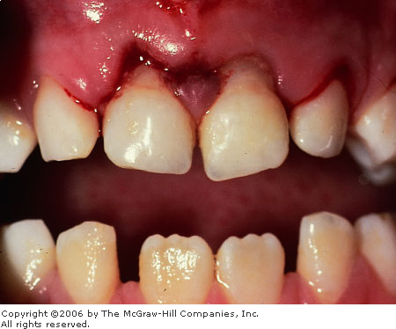

(2) Alternative labial gingival crevice incision: is a horizontal incision made at the base of the interdental papilla.
(3) Free mucosal incision: The free mucosal incision is used when the impacted mandibular canine is located at the level of the apices of the incisors or lingual to them. The incision is placed a few millimetres away from the mucogingival junction in the nonkeratinized mucosa horizontally. The incision should remain anterior to the mental foramen to avoid the mental neurovascular bundle.

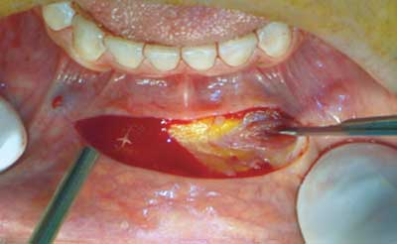

(4) Lingual gingival crevice incision: If the impacted maxillary canine is lingual to the incisors, the lingual gingival crevice incision should be used. The incision is made in the lingual gingival sulcus from the mandibular right first premolar to the mandibular left first premolar. The incision should be extended to provide adequate access. Releasing incisions should not be used. If the lingually impacted mandibular canine is below the level of the apices of the incisors, an extraoral approach may be necessary.

5- Transplantation: Transplantation of the mandibular canine can be successful if the apex of its root has not closed. The canine can be transplanted to its correct position in the dental arch or even to a different site. The difficulty is in removing the tooth without damaging the root surface or apical end. The canine must be firmly immobilized for at least 2 months. The endodontic procedure can be performed on this tooth after immobilization.

Complications and side effects
Complications and side effects with the treatment of the impacted maxillary and mandibular canine are as follows:

1- Ecchymosis of the upper lip or lower lip and chin: ecchymotic area can occur in the soft tissue if proper hemostasis is not achieved before closure. It also can occur if the patient is on aspirin or herbal medications that increase bleeding time.

2- Infection: Any surgical wound can develop an infection even with the best aseptic technique. With maxillary impacted canines, infections can develop in the lip, canine space, or palate. With the mandibular impacted canine, infections can develop in the lip, submental space, and sublingual space. Treatment consists of antibiotics and incision and drainage.

3- Paresthesia: When the mandibular impacted canine’s location is near the neurovascular bundle, paresthesia may be a sequela of surgery. If the maxillary canine is impacted palatally, the nasopalatine nerve may be affected, although it rarely presents a problem for the patient. If the mandibular canine is located near the mental foramen, the patient may have a paresthesia of the lower lip and chin. Surgery performe midsymphysis may produce altered sensation in the incisors and gingiva.

4- Damage to adjacent structures: If the impacted canines are near the roots of neighbouring teeth, the surgery could damage the impacted tooth or adjacent teeth. Displacement of a root into the maxillary sinus or nasal cavity can occur during surgical removal. Rarely, an oral-antral or oral nasal fistula can follow surgical removal in the maxilla.

5- Loss of soft tissue flap: Loss of the soft tissue flap is the result of interruption of its blood supply or infection. Flaps that are thin may have compromised blood supply. Allowing the acid etch material to come into contact with the tissues can comprise the vitality of the flap.

6- Lack of attached gingiva: Poor quality gingival mucosa may occur with exposure of labially impacted maxillary canine. The flap technique must preserve keratinized tissue. A connective tissue graft can be placed to correct this problem.

7- Devitalization of the pulp: If symptoms of pulpitis develop when the impacted canine is bein orthodontically moved, the orthodontic therapy should be stopped and the canine should be evaluated for possible endodontic treatment. If adjacent teeth develop symptoms of pulpitis, endodontic therapy should be considered. This complication is rare in young individuals.

8- Pain: Patients experience some pain with any surgical procedure; however, there is slightly more postoperative pain from maxillary impacted canine surgery than surgery of other impacted teeth. Postoperative management during the first 24 hours should include nonsteroidal anti-inflammatory drugs and long-acting local anesthesia. Narcotic agents occasionally are necessary to relieve postoperative pain.

